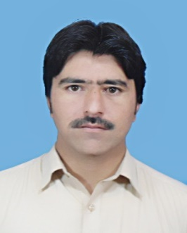

**CURRICULUM VITAE**

**Personal Information**

Name: **Sultanat khan**

Father Name: **Shamsul Haq Permanent Address**

Gender: Male Village Alagram & post office Sundovi

NIC No: 15505-1657871-9 Tehsil Puran and District Shangla KPK Pakistan.

DOB: Jan 17, 1988

Location: Shangla; (KPK) **Contact Information**

Religion: Islam. Cell No: +923428011456

Marital status: Single sultanat2010@ gmail.com

Nationality: Pakistani

# **C a r e e r O b j e c t i v e**

* Seeking a chance in developed organization with a competitive and progressive environment in order to enhance my qualification, skills, abilities, having an international exposure.

# **E d u c a t i o n**

##### 

##### Doctor of Pharmacy University of Malakand

**(Session 2010-2015)**

* **Major Subjects:**
  + - * Pharmacology & Therapeutics
      * Biochemistry
      * Human Physiology & Anatomy
      * Pharmaceutics
      * Industrial Pharmacy
      * Clinical Pharmacy
      * Microbiology & Pathology
      * Quality Control
      * Medicinal Chemistry
* **CGPA 3. 29 (Overall)**
* **First Division.**

##### F. Sc. GDC Puran Shangla

**(2009)**

* **Major Subjects:** Zoology, Botany, Chemistry and Physics.
* **Scored 77.63%** in the final examination.

##### S.S.C GHS Dehrai Puran Shangla

**(2007)**

* Major subjects: Biology, Chemistry, Physics, Mathematics
* Scored 71.7% in the final examination.

# **Skills and Capabilities**

* Demonstrate sound written, verbal and presentation skills.
* Possess good inter-personnel, leadership and analytical skills.
* Ability to take initiatives and accept challenges.
* Self-motivated and enthusiastic.

# **Work Experience**

* Internship at postgraduate Medical Institute Govt Lady Reading Hospital Peshawar.
* Job at Swan pharmaceutical Islamabad Pakistan

# **Language Skills**

* English Fluently Speak, Read & Write.
* Urdu Fluently Speak, Read & Write.
* Pashto Fluently Speak, Read & Write.

# **Field of Interest and Future Plans**

Field of Interest

* Research

Future Plans

* Job opportunity that enhances my qualification, skills and abilities.

# **R e f e r e n c e s**

* + **Dr sayed Wadood Ali Shah**

Assistant professor, department of Pharmacy, University of Malakand

Contact No: 03449277177