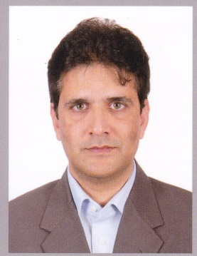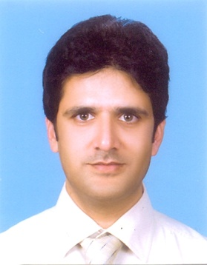***SYED AAMIR AHMED***

**ADDRESS:**

HOUSE # R-325 SECTOR 15-A/1

BUFFER ZONE

## KARACHI

## Cell # 0301-8224414

E-mail: syedamirahmed@yahoo.com.sg

**OBJECTIVE:**

To be associated with an organization where the acquired knowledge and skills can be brought to application and the professional skills could be further developed.

**PROFESSIONAL EXPERIENCE:**

**CURRENT EMPLOYMENT:**

I am working as a **Business Manager** (Head of Sales and Marketing) in **Ghazi Healthcare** from November2014 to till date. (Dermatology, Cosmetology, Infection control unit chemicals and equipment)

**JOB RESPONSIBILITIS AS BUSINESS MANAGER:**

Looking after all Marketing & Sales related affairs of “Dermatology” “Cosmetology” and “Infection control unit” teams including the responsibilities:

* Accomplishing marketing and sales human resource objectives by recruiting, selecting, orienting, training, assigning, scheduling, coaching, counseling, and disciplining employees; communicating job expectations; planning, monitoring, appraising, and reviewing job contributions; planning and reviewing compensation actions; enforcing policies and procedures.
* Achieving marketing and sales operational objectives by contributing marketing and sales information and recommendations to strategic plans and reviews; preparing and completing action plans; implementing production, productivity, quality, and customer-service standards; resolving problems; completing audits; identifying trends; determining system improvements; implementing change.
* Meeting marketing and sales financial objectives by forecasting requirements; preparing an annual budget; scheduling expenditures; analyzing variances; initiating corrective actions.
* Determining annual and gross-profit plans by forecasting and developing annual sales quotas for regions; projecting expected sales volume and profit for existing and new products; analyzing trends and results; establishing pricing strategies; recommending selling prices; monitoring costs, competition, supply, and demand.
* Accomplishing marketing and sales objectives by planning, developing, implementing, and evaluating advertising, merchandising, and trade promotion programs; developing field sales action plans.
* Identifying marketing opportunities by identifying consumer requirements; defining market, competitor's share, and competitor's strengths and weaknesses; forecasting projected business; establishing targeted market share.

**PAST EMPLOYMENT:**

1. Worked as a **Business Manager** in **Allmed Laboratories** from June2013 to October 2014. (Gynae, Antibiotics, General medicine, Urology, Nephrology, hired 3 new teams for Gynae, General medicine and Urology/ Nephrology)
2. Worked as a **Business Manager** in **Himont Pharmaceuticals** from August2012 to May 2013. (Paeds & Gynae)
3. Worked as a **Senior Product Manager** in **ATCO LABORATORIES LIMITED** from April 2011 to 31st July 2012. (Dermatology, made all products in top 5 ranking in IMS)
4. Worked as a **Product Manager** in **ATCO LABORATORIES LIMITED** from 13th March 2009 to April 2011. (Dermatology, Launched awareness campaign and made “Conaz” 2nd product in IMS, launched Anti Scabies “ScabFree” and made it 5th product in 2 years in IMS ranking, launched a range of 5 medicated soaps)
5. Worked as an **Assistant Product Manager** in **ATCO LABORATORIES LIMITED** from January 1st 2008 to 13th March 2009. (Dermatology, launched new campaign for “Conaz” and made it 3rd product in IMS)
6. Worked as a **District Manager** in **ATCO LABORATORIES LIMITED** from January 1st 2006 to December 31, 2008.
7. Worked as a **Product Specialist** in **ATCO LABORATORIES LIMITED** from July 1st 2004 to December 31, 2005.
8. Worked as a **Territory Manager** in **ATCO LABORATORIES LIMITED** from July 1st 2003 to June 30, 2004.
9. Worked as a **Sales Promotion Officer** in **ATCO LABORATORIES LIMITED** from November 27th 2001 to June 30, 2003.

**OTHER EXPERIENCE:**

* One and half Year Job in a Private school as Principal
* One and half Year Job in a coaching center as English language teacher**.**

**CERTIFICATES:**

* Certificate course in “Community based education in South Asia” from Institute of Educational Development Agha Khan University.
* Certificate in Fine arts & Textile designing from Mashkoor Art School

**COMPUTER LITRACY:**

Having sufficient Knowledge in,

* Microsoft Access
* M.S word.
* M.S Excel.
* Power point

**PERSONAL PROFILE**:

* Father’s Name : Syed Ruknuddin Ahmed (Late)
* Date of Birth: May 28th 1976
* Nationality: Pakistani
* Religion: Islam
* Marital Status: Married
* N.I.C # 42101-1769314-1

**ACADEMIC QUALIFICATION**:

* **BSc.** from Ship owner’s College in 1997.
* **Intermediate (Pre-Medical**) from Govt. College For Men Nazimabad in 1993.
* **Matriculation** from Tameer e Nau Govt. Boys Secondary School Nazimabad in 1991.