**Objectives**

**Educational**

**Record**

**Computer skills**

**Internship Record**

**Best Educational**

**Achievement**

**Personal details**

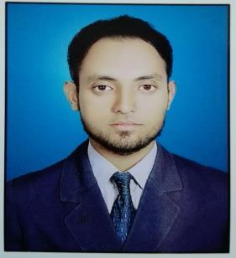SYED JUNAID HUSSAIN

Email: scorpionperson27@gmail.com

***Applied as a Pharmacist***

Seeking a better position as Pharmacist in a Reputed organization that can fully tap my Educational, Organizational, Technical and Intellectual potentials with Nourishing environment to contribute in a Best possible way for the betterment of the Organization and Self.

***Shah Abdul Latif University, Khairpur.***

Pharm-D (Doctor of Pharmacy) with 1st Division (3.98 G.P) in 2015.

***Govt. Islamia Science College Sukkur.***

Intermediate with “B” Grade in 2010.

***Govt. (N) Modern High School Sukkur.***

Matriculation with “A” Grade in 2008.

***Mr. IBM computer institute, Sukkur.***

Certificate in Information technology in 2008.

Better Typing speed.

Traineeship experience in Sheikh Zayed Hospital/Medical College Rahim Yar Khan, Punjab as a Clinical Pharmacist. I performed many duties in various Departments of the Hospital and proved myself as a responsible Pharmacist.

Recently I with my two class fellows participated in DUHS DICE Health Exhibition which was held in EXPO centre, Karachi on 21st and 22nd August of current year and got Position on the topic of Treatment Hepatitis-C.

Father’s Name: Muzammil Hussain

Caste: Syed

C.N.I.C No. 45504-2110875-7

Marital status: Un-married.

Cell Phone: 0323-3374664

0312-3323466

Residential Address: H.No. 13/6, Area 37/C, Landhi # 3, Karachi

**Languages** Spoken and Ability:

Urdu, English, and Sindhi.

**References** Will be provided on demand.