**Resume**

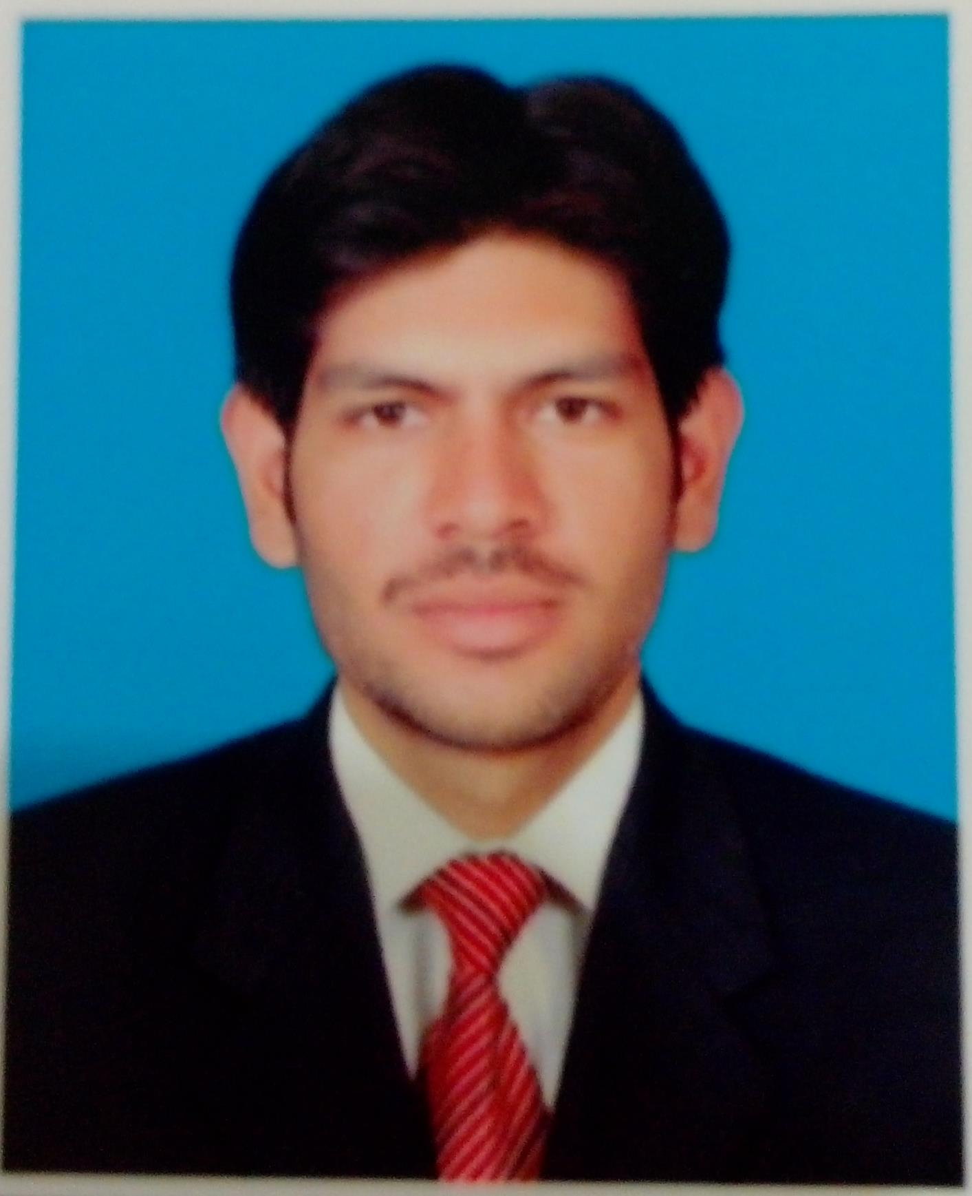

**Muhammad Umar Latif**

S/O Muhammad Latif

Gender: Male

DATE OF BIRTH: July1991

PHONE# 00923224688214

E- MAIL ID: [umarn1582@gmail.com](mailto:umarn1582@gmail.com)

ADDRESS: House no 32, Chaudhary Colony, Matchis Factory

Islam Pura, Shahdara, Lahore, Pakistan

**OBJECTIVE:** To be a competent Managing Director of a reputable Pharmaceutical Industry in 10 years.

**EDUCATION:**

**Subjects of Interest:**

* Pharmacology
* Clinical Pharmacy
* Marketing Management

**MBA 2014--2016**

**National College of Business Administration and Economics Lahore, Pakistan**

**Pharm-D (Doctor of Pharmacy) 2009--2013**

**University of Veterinary & Animal Sciences (UVAS), Lahore, Pakistan**

CGPA: 3.48/4

**Hobbies:**

* Playing Chess
* Love to Travel
* Playing Cricket

**F.Sc. (Pre-Medical) 2009**

**Government Islamia College Civil lines, Lahore, Pakistan**

Grade: A+ (84%)

**Matriculation (Science) 2006**

**Govt. Central Model School, Samanabad Lahore, Pakistan**

Grade: A (79%)

**PAST ACTIVITIES:-**

* **Bio-Equivalence:** Bio-Equivalence/Bioavailability study in BEst center in Uvas on Montelukast

Pak. J. Pharm. Sci., Vol.26, No.2, March 2013, pp.255-259

* **Research Work:** Done research work (Adherence of Practitioners with the National Tuberculosis treatment Guidelines) in Gulab Devi Hospital, Lahore, Pakistan

**SKILLS:-**

Good Analytical Skills Good Communication skills

Excellent Team Leader Good Intrapersonal skills

Fluent in English and Urdu Language

**EXPERIENCE:-**



1. **I worked in Wimits pharmaceuticals as a Business development Officer (June 2013 to June 2014)**
2. **I worked in Getz Pharma as a Territory Manager (Lahore, Pakistan) in A3 group and promoted Nexum (Esomeprazole), Cytopan (Diclofenac sodium & Misoprostol), Amclav (Amoxicillin plus Clavulanic acid), Cinita (Cinitapride), Zavget (Escitalopram), Gabix (Gabapentine), Lilac (Lactulose), Regasta (Itopride). (June 2014 to September 2015)**



* **I Achieved YTD on Market 125%.**
* **The best T.M in Quarter I.**
* **Got 1st position in New Induction Training with 96% marks.**
* **Gave Presentation on newly Launched Product Regasta in P.C Muzaffarabad, AJK.**

1. **I worked in Schazoo Pharmaceutical Laboratories (Lahore, Pakistan) as Product Manager (Marketing Department) and looking after the Neuropsychiatry division. ( September 2015 to April 2016)**



* **Managing the team of 42 MIOs (Medical Representatives) and 12Dm’s (District Managers) and 3 SM’s all over Pakistan.**
* **Providing the necessary technical skills to field force.**
* **Launched Gabafit (Pregabalin)**
* **Conducted Excellent Neuro Conference in Ramada Hotel Isb and Avari Hotel, Lhr.**

1. **Now working in Mac&Rains UK (Lahore based) as Product Manager. (May 2016 to Still Continue)**



* + - **Looking after the portfolio of Vitamin D3, Strontium, Ciprofloxacin, Ceftriaxone, Tramadol, and Ketorolac.**