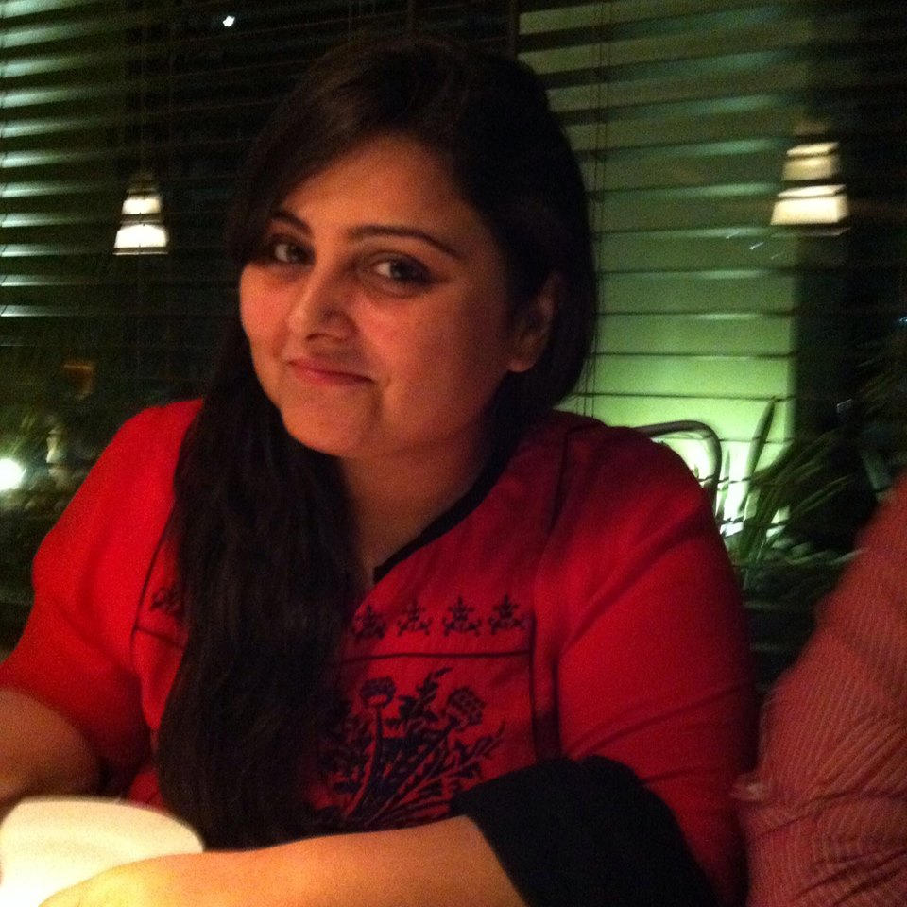**Wajiha Zafar**

**House No. 773 Phase-1 DOHS Malir Cant,**

**Karachi, Pakistan.**

**Res # : 02134150187**

**Cell #: 03456109998**

**E-mail: wajiha_83@hotmail.com**

**Objective:**

A position as an active employee, involving responsibility and working with others as a team member to achieve advancement and growth for the company**.** Seeking a challenging and rewarding position in which I can utilize skills and competencies.

**Profile:**

A team player and motivator with strong interpersonal and communication skills include initiative, and commitment of total quality. Ability to respond to adverse situations. Ability to multi-task in a highly competitive environment, effective and accurate decision making skills. Excellence in computer skills and talent for analyzing problems, developing, and simplifying procedures and finding innovative solutions. Strong background in user training and support documentation.

**Work Experience:**

**Senior Executive HR**

In Right Solutions

Karachi, Pakistan.

(August 2015-till present)

**Duties & Responsibility:**

To maintain and enhance the human resource mission and objectives, through strategic planning, and evaluating employee relations, human resources policies, practices and procedures.

* Create and monitor a human resources system that complies with top organizational objectives.
* Create comprehensive human resources policies and procedures update as necessary.
* Analyze wage and salary reports; create a comprehensive and competitive compensation program that is industry specific and aligns with organizational objectives.
* Oversee the maintenance, communication and destruction of personnel records as required.
* Plan, monitor and implement employee performance appraisal on set schedule. Train managers on appraisal system, and coach employees accordingly.
* Establish and maintain employee benefit programs. Analyze and assess trends in benefits and recommend adjustments in benefits as appropriate.
* Responsible for recruitment and retention of staff. Employee engagement. Orientation of new staff members, and training. Responsible for pre-screening, background investigation and credentialing of new staff members, identify staffing needs, and identify hiring potentials based on budget.
* Responsible for human resources budget, including establishing annual human resources budget and identifying budgetary needs and reporting to GM, Director as appropriate.
* Employee relations, counseling and disciplining employees. Terminations, providing exit interviews.

**Assistant Manager HR**

In Aimviz

Karachi, Pakistan.

(May 2014-February 2015)

**Duties & Responsibility:**

* Conceptualize business needs and acquire technical resources
* Manage department’s expectation throughout the recruitment process
* Utilize techniques related to HR analytics, prepare reports and present findings to management.
* Maintain healthy relationship with employee and cater grievances.
* Conduct exit interviews and prepare report accordingly.

**HR Team Lead**

In Meritocracy

Karachi, Pakistan.

(May 2013-May 2014)

**Duties & Responsibility:**

* Managing all HR functions.
* Formulating and Introducing HR organizational polices for the smooth working environment.
* Actively involved in recruitment and selection plan.
* Preparing job classification, job descriptions, organogram and salary scales.
* Employee Orientation. Give trainings to the new employees when hire.
* Initiate annual appraisal process and prepare annual increment plan on behalf of Management.
* Post leaves, over times and other benefits according to the policies, and also look after administrative affairs of the department.

**HR & Admin specialist**

In CUBIX LABS.

Karachi, Pakistan.

(June 2011-December 2011).

**INTERNSHIP**

In Dubai Islamic Bank

Karachi, Pakistan.

(Sept 2009 – Feb 2010).

**Education Profile:**

BBA (HONS)

Majors: human resources management.

Hamdard University

Karachi, Pakistan

**Business Skills:**

1. Excellent team management skills and good friendly work approach in pressure environment.
2. A talented, result driven and team-oriented professional with a highly successful track record.
3. Proven capacity to successfully manage several projects and deadlines.
4. Able to learn new concepts in short span of time.
5. Good at time and Pressure management.
6. Excellent communication and presentation Skills.

**Computer Skills:**

Well versed in Microsoft office products.