**W A Q A R K H A L I L**

E-MAIL:WAQARLODHI93@GMAIL.COM MOBILE: (92) 301 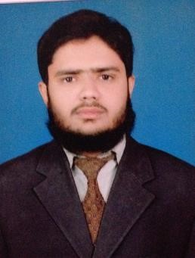2091070

# APPLIED AS: PHARMACIST

**OBJECTIVE**

To attain Job at your esteem organization and to contribute my knowledge, skills and experience for the advancement of organization and making myself grow with the organization. I want to be a part of the team that excelled in work towards the achievement of goal which in the process will satisfy my craving for learning.

## EXPERIENCE

2(two) months internship (as Hospital Pharmacist) at

**PNS SHIFA** Hospital Karachi

## EDUCATIONAL INFORMATION

* **PHARM-D**: (Doctor of Pharmacy) from Shah Abdul Latif University

Khairpur with 1st Division (CGPA=3.93 )

* **INTERMEDIATE:**  BISE Sukkur secure “A” grade in 2010
* **MATRIC:** BISE Sukkur secure “A” grade in 2008

## BEST EDUCATIONAL ACHIEVEMENTS

Recently got fifth position in All Pakistan DUHS DICE 2015 along two members more on the topic “ Hepatitis C “ give new concept in the advancement of the therapy.

## PERSONAL INFORMATION

|  |  |
| --- | --- |
| • Date of birth | Feb 16, 1993 |
| • Father‘s Name | Khalil-ur-Rehman Khan |
| • Marital status | Single |
| • CNIC No. | 45504-4436200-3 |

• Present Address H no: B-37 11C-1 Adam town north Karachi.

## OTHER SKILLS

* **Computer Proficiency:**
* Excellent in usage of MS Word, MS Excel, MS PowerPoint,
* Excellent knowledge of Windows 95, 98, NT, 2000, ME, XP, Linux, 10 • C.I.T from SAKI Institute.
* Basic computer hardware technical skills.

* **Technical Skill:**
* Excellent skills in preparing Pharmaceutical extemporaneous preparations

* **Languages**
* English: Excellent
* Urdu: Excellent
* Sindhi: Good

References of resume will be furnished on demand.