**Curriculum Vitae**

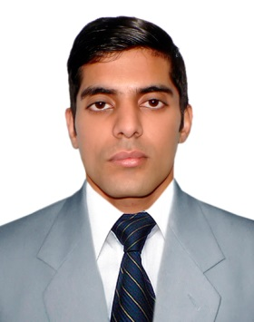**YOUSAF SHAHZAD**

**Objective**

The main aim is to work in outstanding environment to implement my professional skills. The position should provide progressive and dynamic challenges so that my involvement could contribute positively towards the growth and success of the organization and myself and provide learning opportunities.

**Personal Data**

|  |  |
| --- | --- |
| **Name** | **Yousaf Shahzad** |
| **Father Name** | **Abdul Salam** |
| **Date of Birth** | **28/12/1992** |
| **Nationality** | **Pakistani** |
| **National I.d card** | **16202-4294469-7** |
| **Address** | **G-7/4 Islamabad** |
| **Religion** | **Islam** |
| **Contact** | **03339453432** |

**Qualification**

|  |  |  |
| --- | --- | --- |
| ***Exams*** | ***Year*** | ***Institution*** |
| ***Pharm.D*** | *2016* | *Riphah International University* |
| ***Hssc*** | *2009* | *Tameer-e-Seerat Public School & College* |
| ***Ssc*** | *2007* | *Quaid-e-Azam Public School* |

**Courses and Diplomas**

* Three months course of English language
* Attending Conferences about Antibiotic Resistance and Role of Clinical pharmacist in Pakistan

**Experience**

* **Worked as Internship in DHQ Swabi**
* **Worked as Internship in Polyclinic hospital Islamabad**
* **Working in Drug Regulatory Authority Of Pakistan And Experienced In Regulatory Affairs**

**Workshops and Conferences**

* Participated in the **Clinical Pharmacy Seminar Titled FUTURE OF CLINICAL AND COMMUNTIY PHARMACIST IN PAKISTAN**

**Computer Skills**

* Microsoft Office
  + Microsoft Word,
  + Microsoft Excel,
  + Microsoft PowerPoint, etc.
* Windows installation
* Windows repairing

**Communication Skills**

* English
* Urdu
* Pashto

**Distinct Features**

Initiative talking, Planning, Decision making, Energetic and good interpersonal skills.