Code and Architecture Summary

Code and Software Architecture summary:

The architecture is designed to modularize the development of Backend pythonic API to connect with applications integrated into the Django middleware. The code itself is modularized revolving around objective methods, to build up modularized API to connect to Django frameworks as needed which intern connects to Rest API’s on the front end to serve as request and response nodes for user data collected from a GUI.

The architecture has the following format:

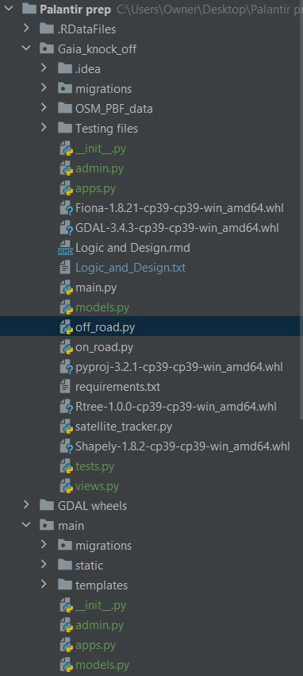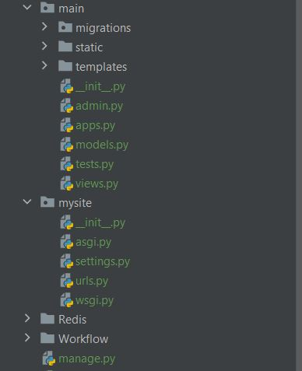

The logic is displayed in the Power Point and stated in Gaia_knock_off/Logic_and_Design.txt.