Orlenko Dmitry  Born 1990  Location: Odessa, Ukraine.  Ready to relocate.  Skype: orlik01.04  E-mail: orlenko.dmitry@bk.ru | 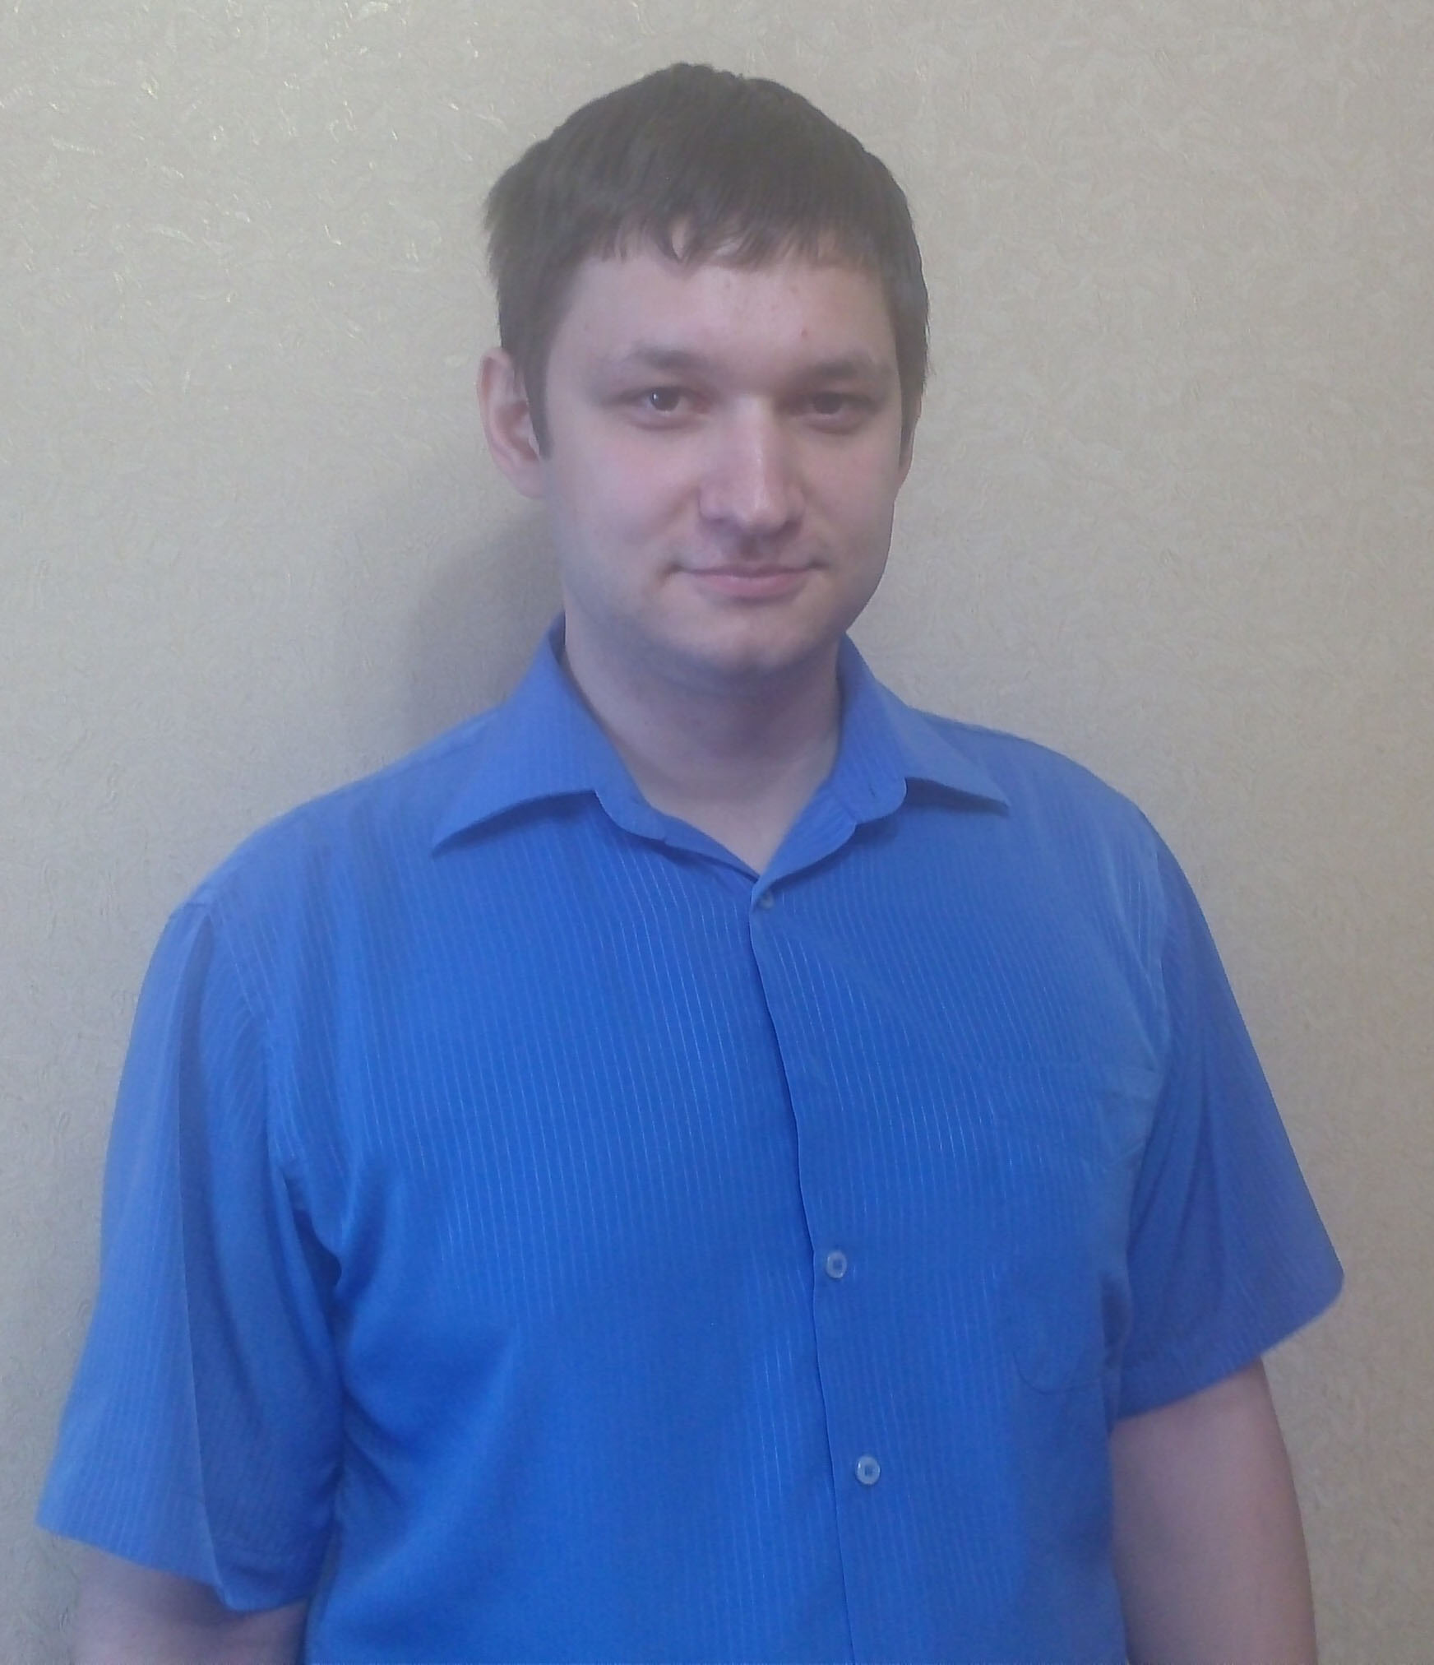

Aim:
Looking for frontend-developer position.

Education:
2008-2013 Odessa National Polytechnic University, Machine-building (specialty: Robotic systems and complexes)
2015-2016 HTML Academy (an interactive online courses);
2016 Geekbrains (Basics of programming, HTML/CSS - basics of creating websites, Object-oriented programming, Git - fast start, JavaScript - interactive web applications).

Skills:
- Higher technical education.
- Strong knowledge of HTML, CSS.
- Experience with JavaScript, jQquery.
- Practical experience with versions control systems GIT.
- Ability to work with graphics editor Photoshop.
- Experience with the framework bootstrap.
- Usage of preprocessor LESS and build system Gulp.
- Experience in creating responsive website.
- Usage of modern practices – mobile first, optimization of graphics, SVG.
- Semantic, valid, cross-browser layout.
- Ability to understand the code of another programmer.
- Intermediate English level. Willing to improve my English to upper-intermediate level.

My portfolio: http://orlenko-dmitry.github.io

Work Experience:

06/2015- to the present time QWERT Media, Kiev, Ukraine.

Front-end developer (project cooperation)
- Working daily in HTML, CSS, JavaScript, JQuery;
- Converting PSDs into pixel perfect sites;
- Resolving cross browser compatibility issues;
- Writing clean structured and well documented code.

07/2015-05/2016 Bender Media Centre, Moldova

Maker-up designer
- Text documents formatting;
- Image processing in Photoshop ;
- Publishing layout pages in InDesign.

11/2014-03/2015 InterDnestrCom, Moldova

Call Center operator

Technical support of international clients

03/2013-10/2014 Profico Company, Odessa, Ukraine

Head of Sales department

- Problem definition, planning, monitoring, and appraising job results of the sales team;

- Client debts control;
- Development of quantitative and qualitative distribution and distribution channels;
- Procurement of commodities;
- Maintenance and development of dealer network;
- Reporting.

09/2012-02/2013 Damar Group, Odessa, Ukraine

Sales representative
- Services existing accounts, obtains orders, and establishes new accounts by planning and organizing daily work schedule to call on existing or potential sales outlets and other trade factors;
- Active development of network;
- Negotiating, conclusion of delivery contracts;
- Keeping the customer base;
- Client debts control.

05/2012 -08/2012 IDS Aqua Service, Odessa, Ukraine

Sales representative
- Active and and constant search for new customers and distribution channels;
- Negotiating, conclusion of delivery contracts;
- Meeting the sales plans.

Expectations for salary – to be discussed.

