🦷 DentalBoutique

Company Services Catalogue & Clinical Service Standards
Version 1.0 – Patient-Facing + Operational Overview
This document outlines all core services offered at DentalBoutique, including clinical scope, pricing ranges, duration, materials used, and operational benchmarks.

1️⃣ General & Preventive Dentistry

1.1 Comprehensive Oral Exam

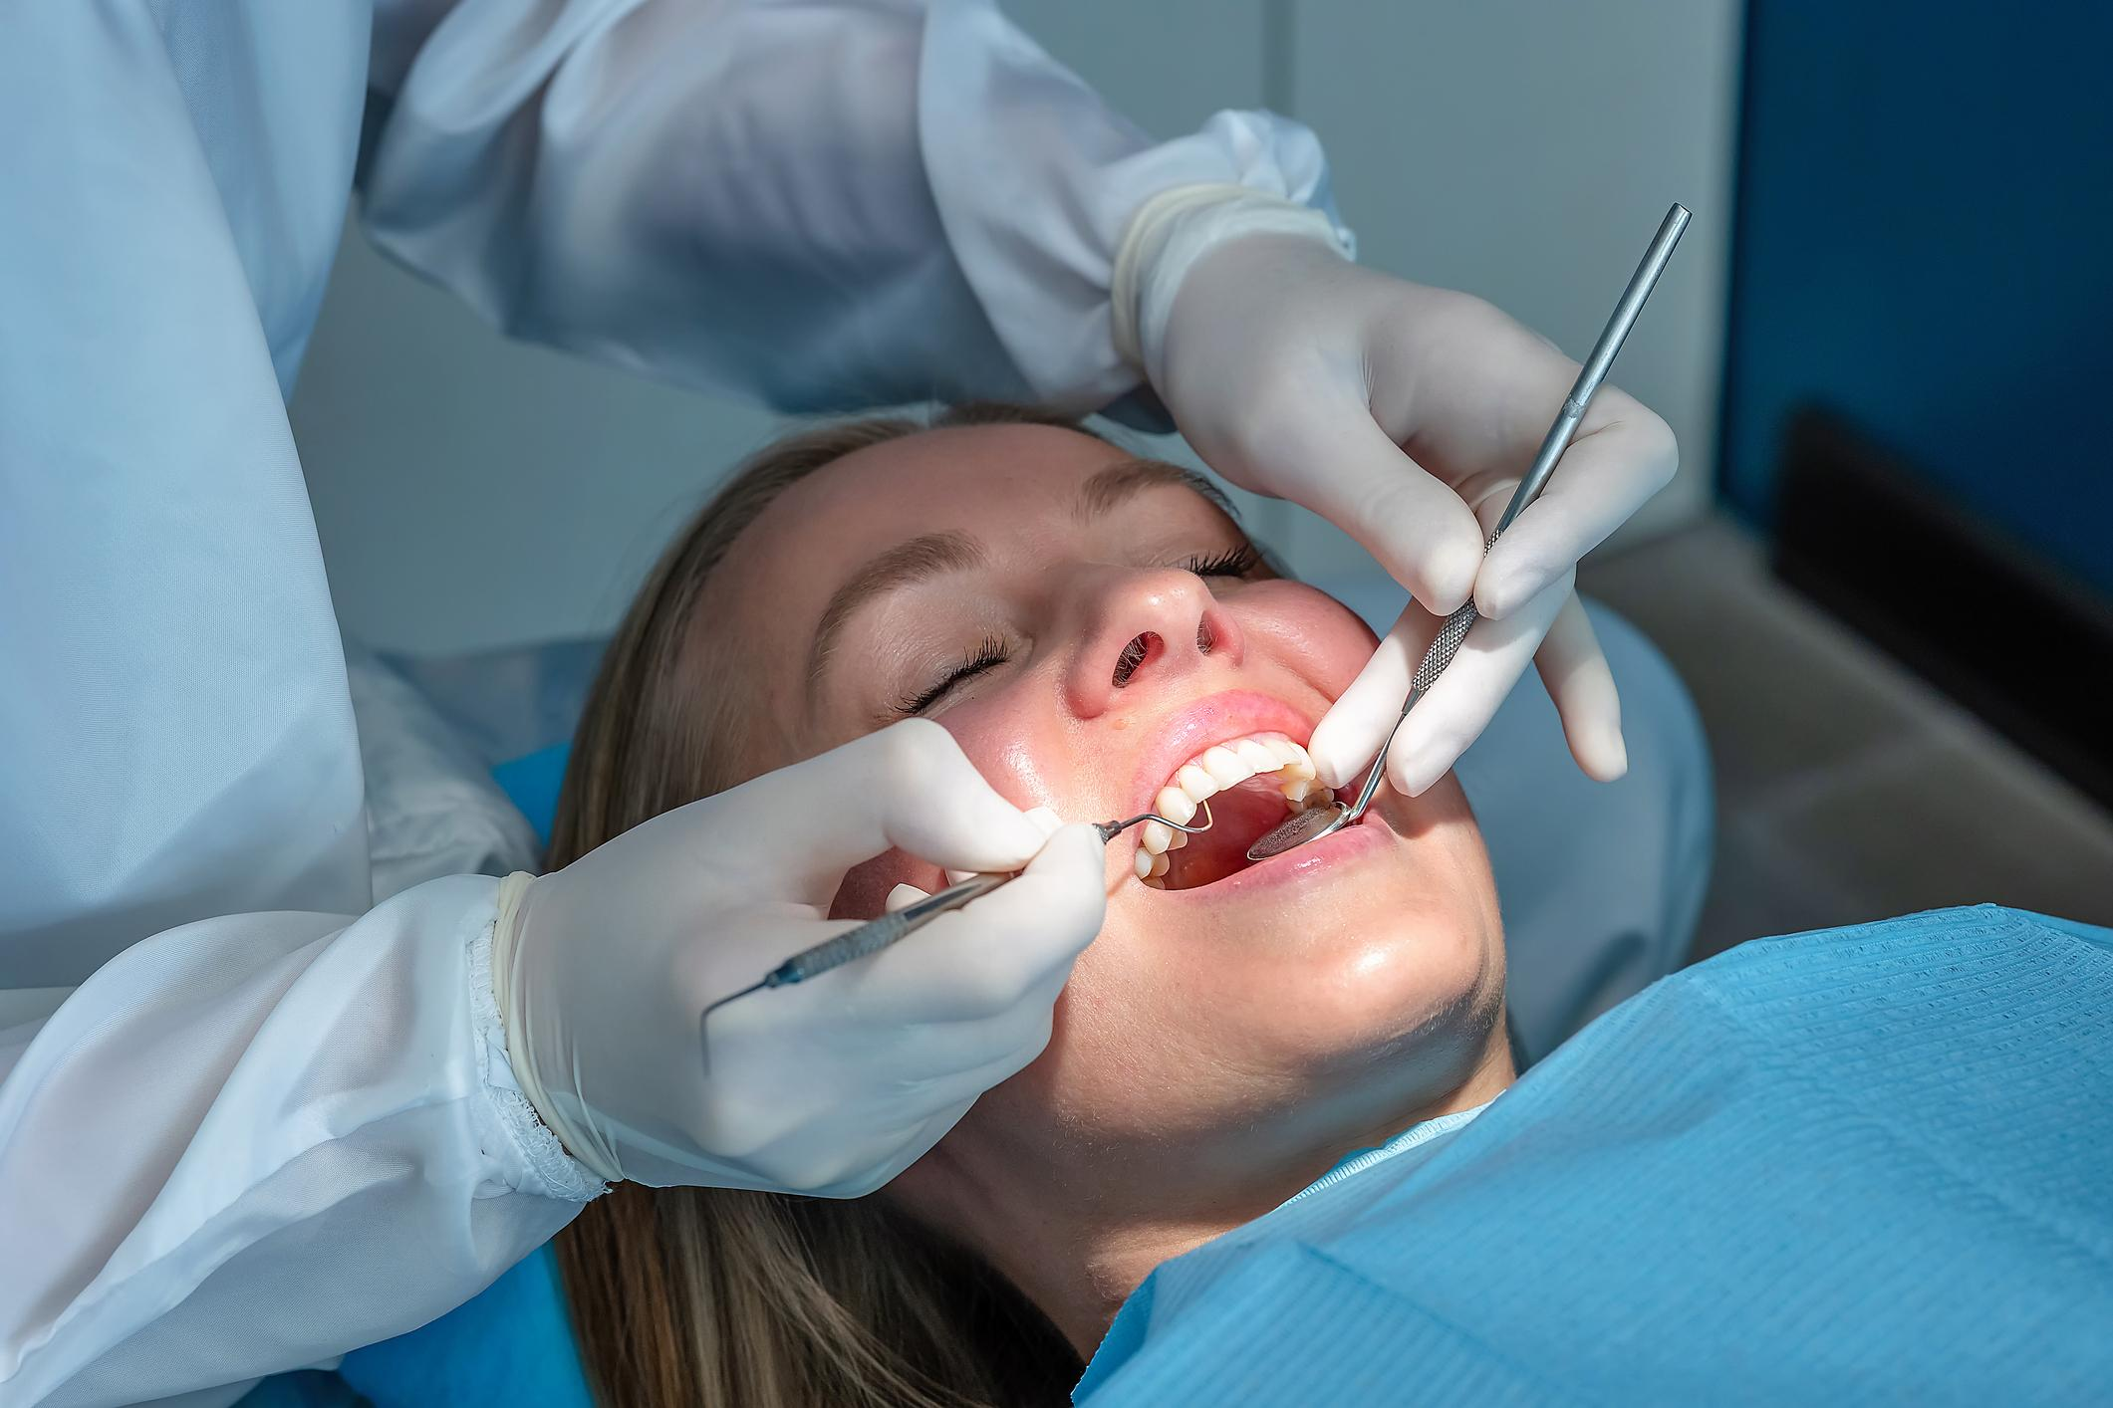

4
Purpose: Full diagnostic evaluation of teeth, gums, and oral structures
- Duration: 45–60 minutes
- Includes: Oral exam, gum assessment, occlusion review, oral cancer screening
- X-rays: 2–4 bitewings (if needed)
- Price Range: $120–$250
- Recommended Frequency: Every 6–12 months
Operational KPI:
- Diagnosis documentation rate: 100%
- Treatment plan presentation rate: ≥ 95%

1.2 Professional Dental Cleaning (Prophylaxis)

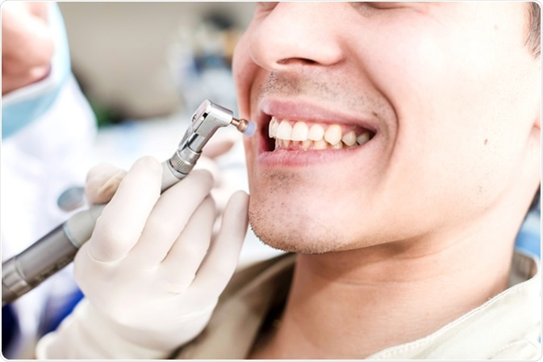
4
- Duration: 45–60 minutes
- Includes scaling, polishing, fluoride (optional)
- Price Range: $150–$300
- Frequency: Every 6 months
Hygiene Rebooking Target: ≥ 85%

1.3 Deep Cleaning (Scaling & Root Planing)
- Duration: 60–90 minutes per quadrant
- Typically 2 appointments
- Price Range: $250–$400 per quadrant
- Local anesthesia required
Clinical Benchmark:
- Post-treatment pocket reduction ≥ 1–2mm improvement

2️⃣ Restorative Dentistry

2.1 Composite Fillings

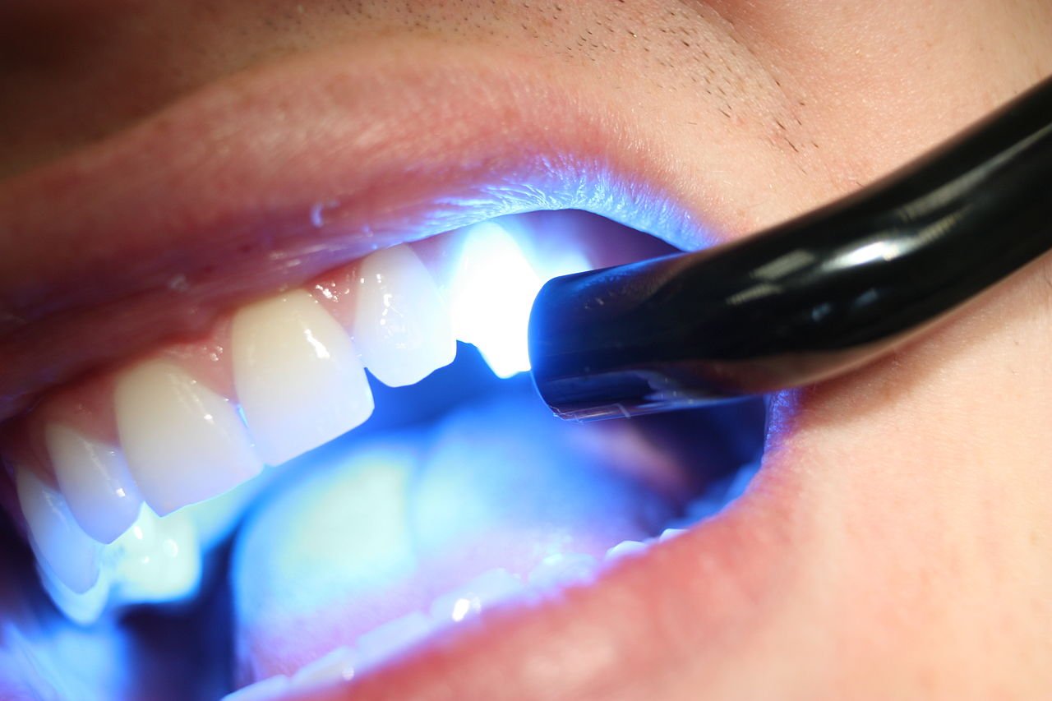
4
Used for: Cavities and minor tooth damage
- Duration: 30–60 minutes
- Material: Tooth-colored composite resin
- Price Range: $180–$450 (depending on surface count)
- Longevity: 5–10 years
Remake Rate Target: < 3%

2.2 Dental Crowns

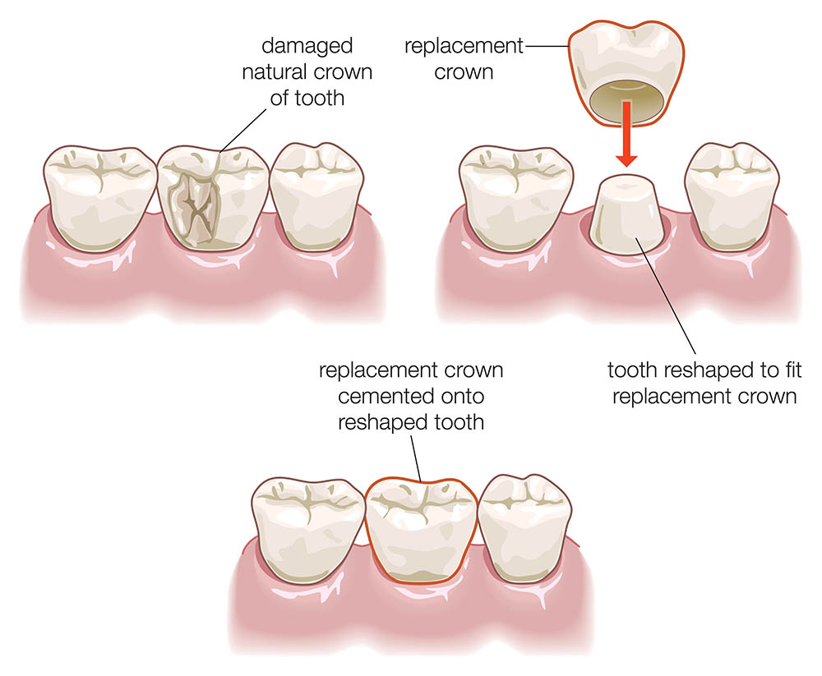
4
- Duration: 90 minutes prep + 20 min placement
- Material: Zirconia or porcelain
- Price Range: $1,200–$1,800
- Lab turnaround: 7–10 days
Warranty: 2 years (under normal use)

2.3 Dental Bridges
- Duration: 90 minutes prep
- Price Range: $2,500–$4,500
- Lifespan: 10–15 years

3️⃣ Endodontics

3.1 Root Canal Therapy
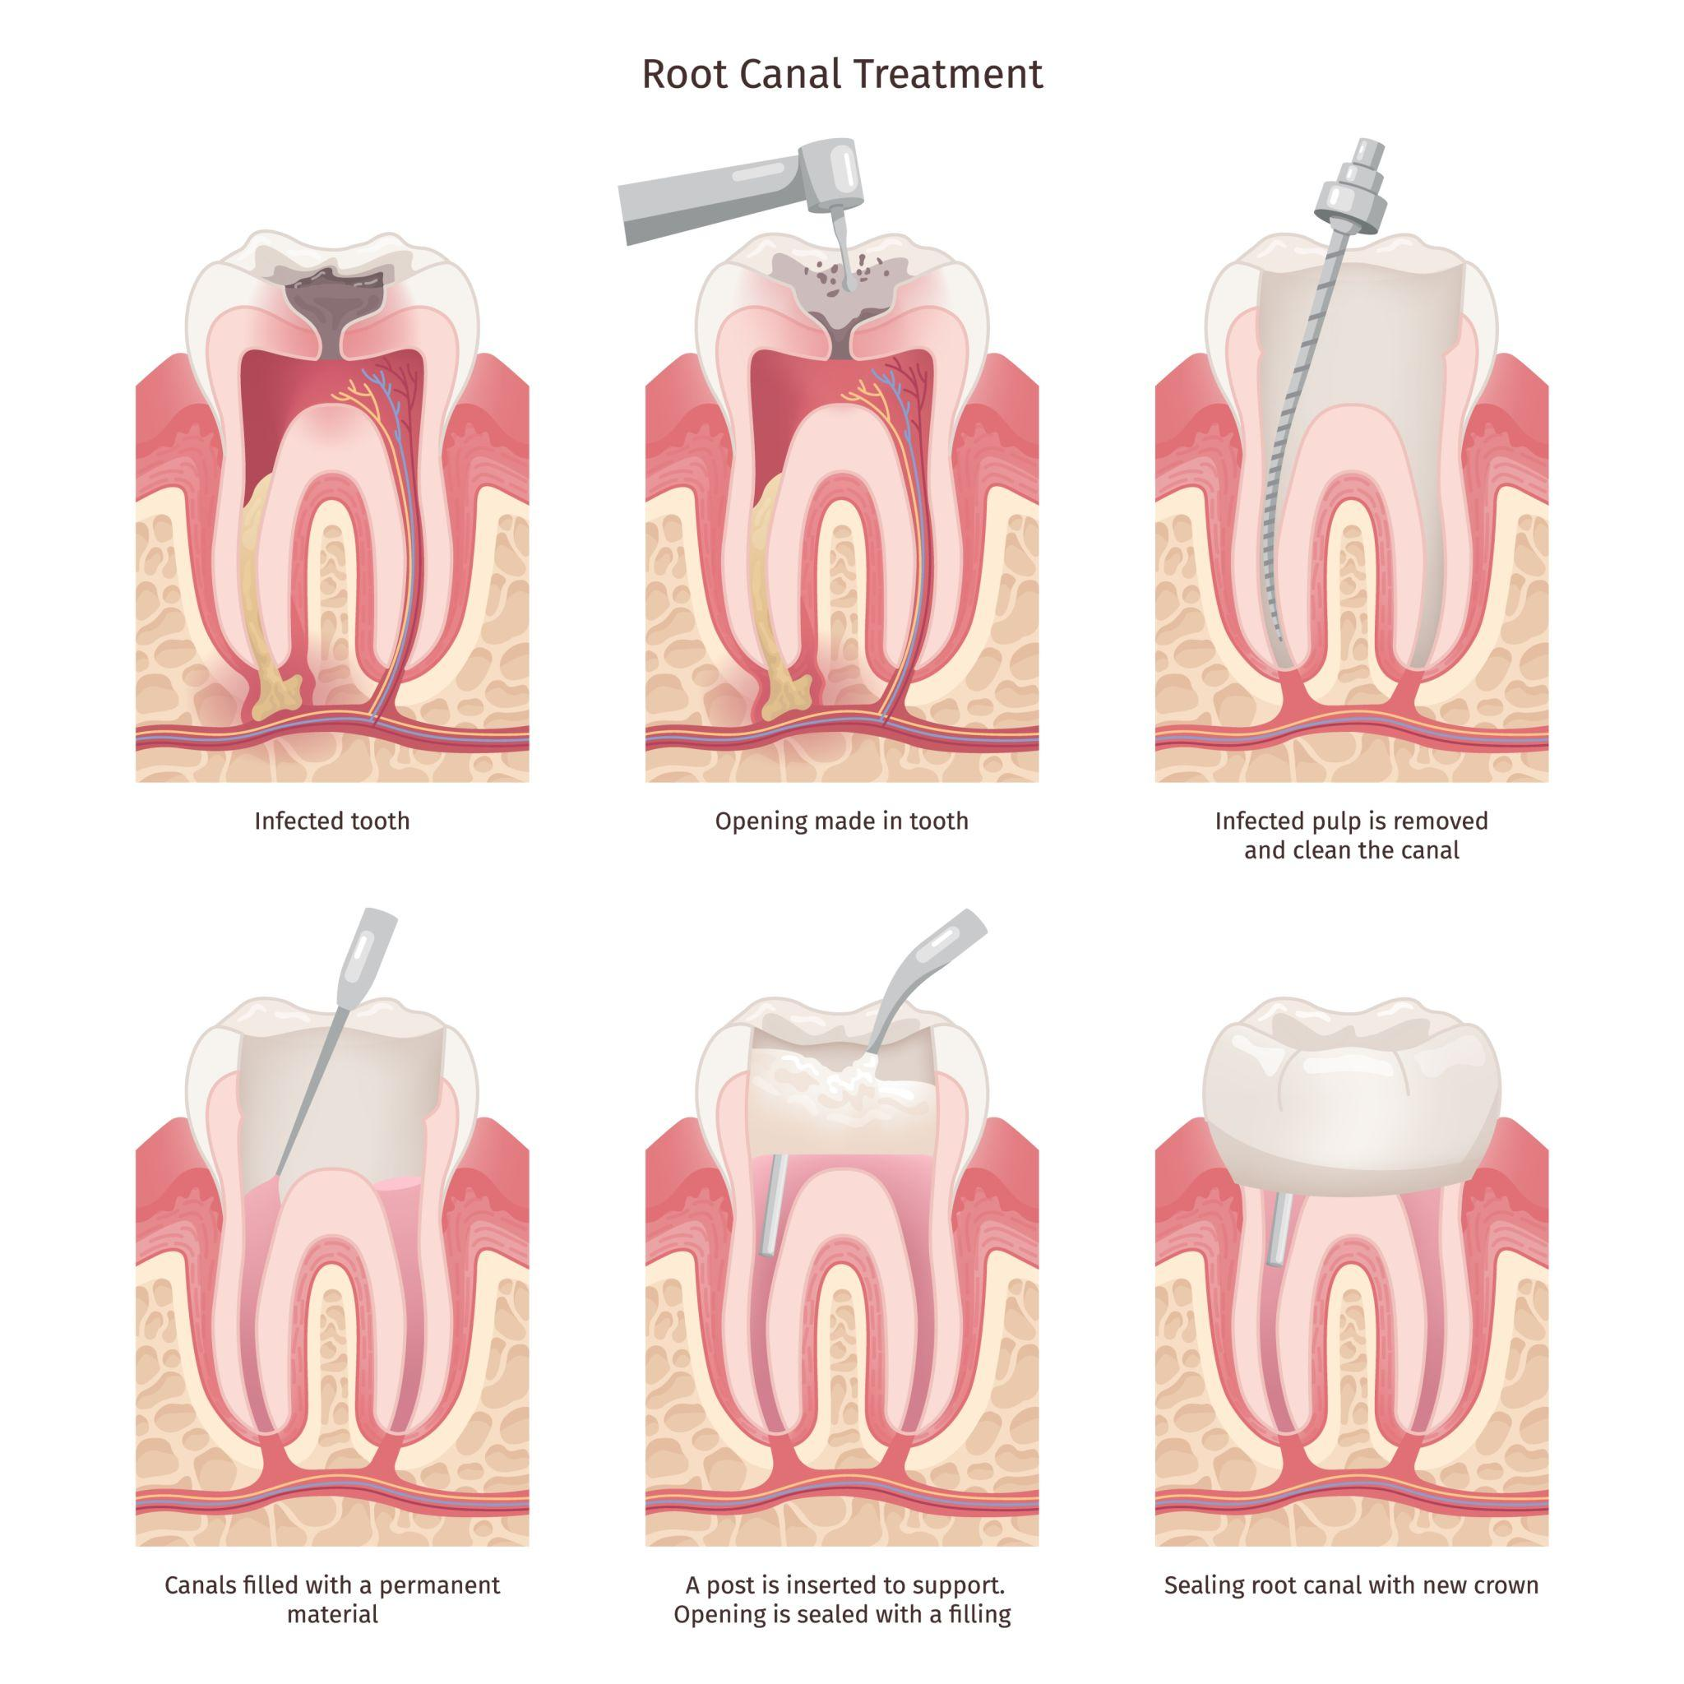

Used for: Infected tooth pulp
- Duration: 90–120 minutes
- Price Range:
  - Front tooth: $900–$1,200
  - Premolar: $1,100–$1,400
  - Molar: $1,300–$1,800
- Requires crown placement after
Success Rate Target: ≥ 90%

4️⃣ Cosmetic Dentistry

4.1 Professional Teeth Whitening
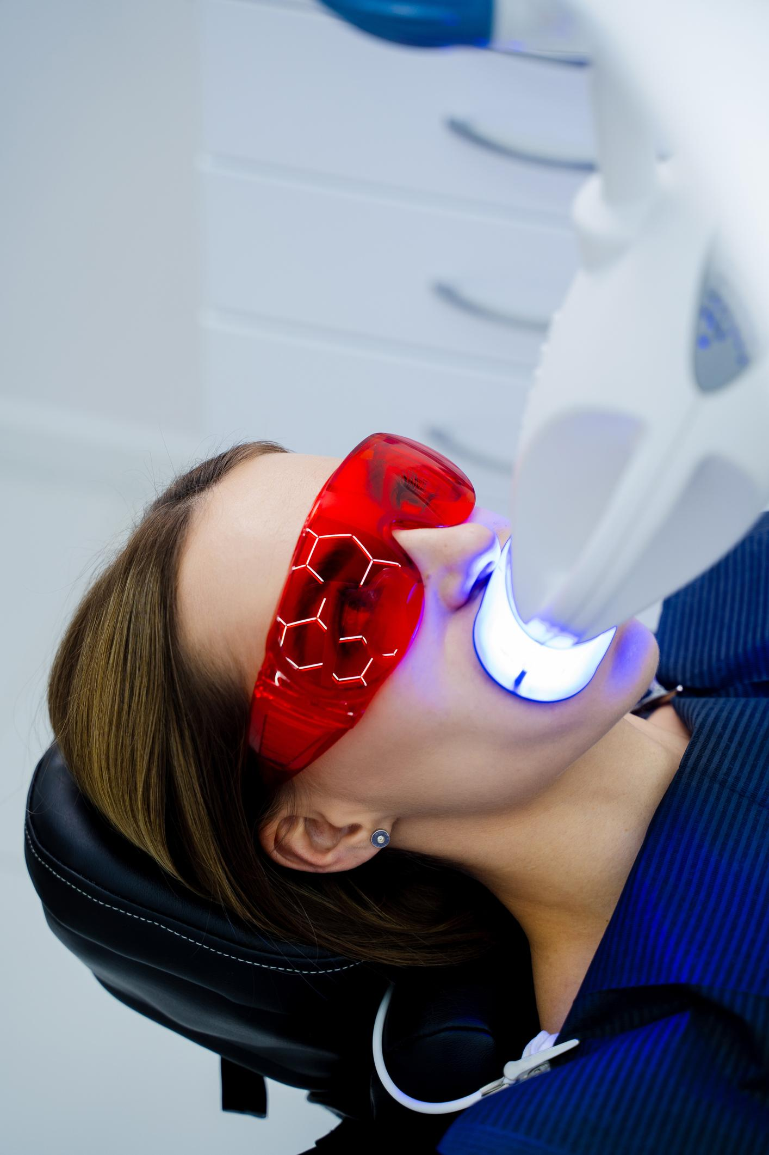

4
- In-office duration: 60–90 minutes
- Take-home kit option available
- Price Range:
  - In-office: $400–$700
  - Take-home kit: $250–$400
Shade Improvement Goal: 2–6 shades lighter

4.2 Porcelain Veneers
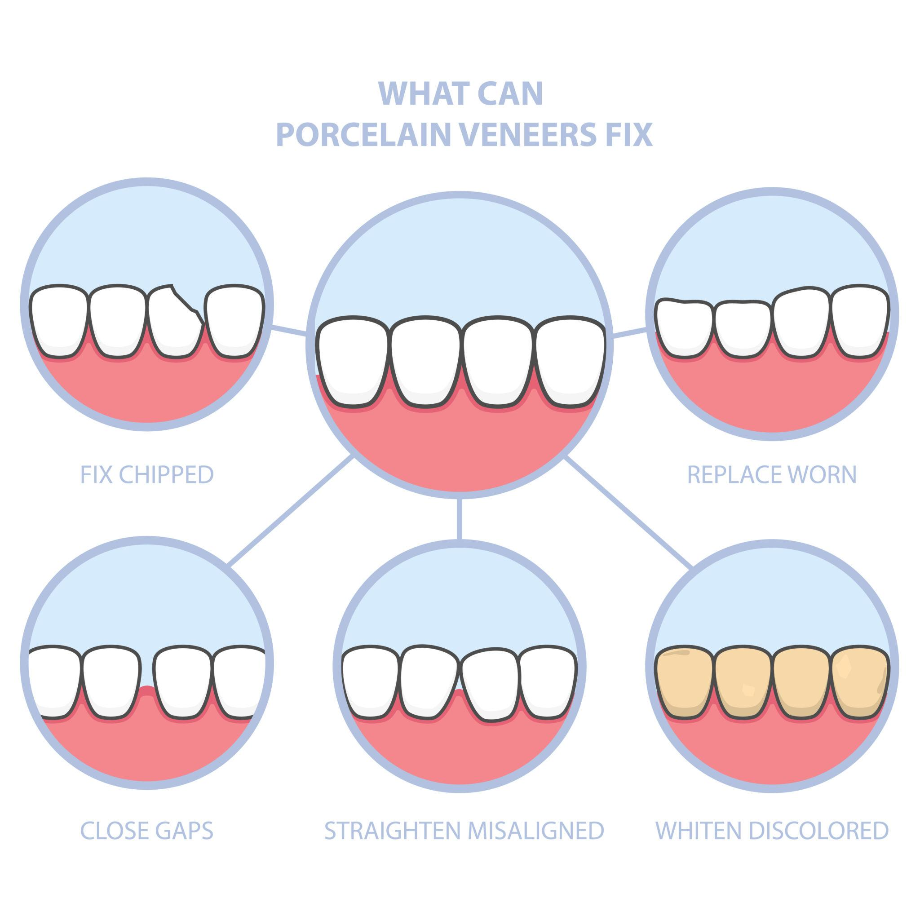

4
- Duration: 2 visits
- Price per tooth: $1,200–$2,000
- Lifespan: 10–15 years
Case Acceptance Target: ≥ 60% for cosmetic consults

5️⃣ Orthodontics

5.1 Clear Aligners (e.g., Invisalign-style)

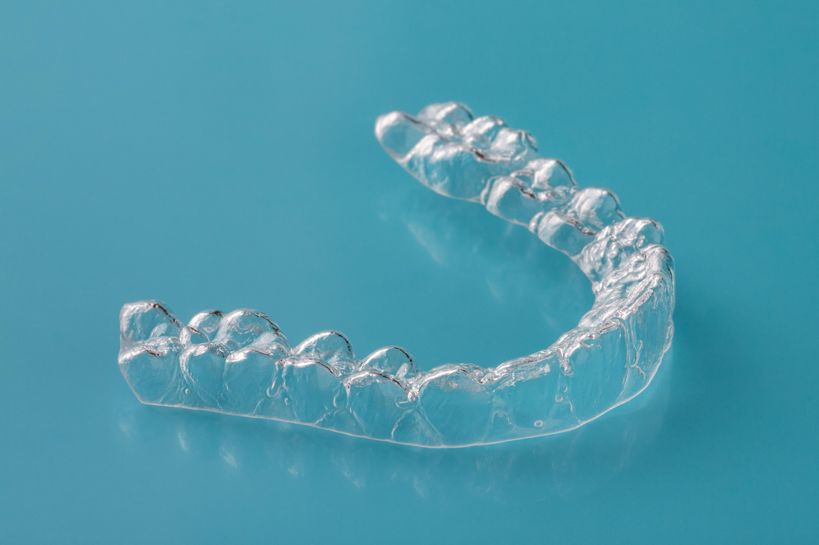

4
- Duration: 6–18 months
- Digital scan required
- Price Range: $3,500–$6,500
- Payment plans available
Completion Rate Target: ≥ 90%

6️⃣ Oral Surgery

6.1 Tooth Extractions
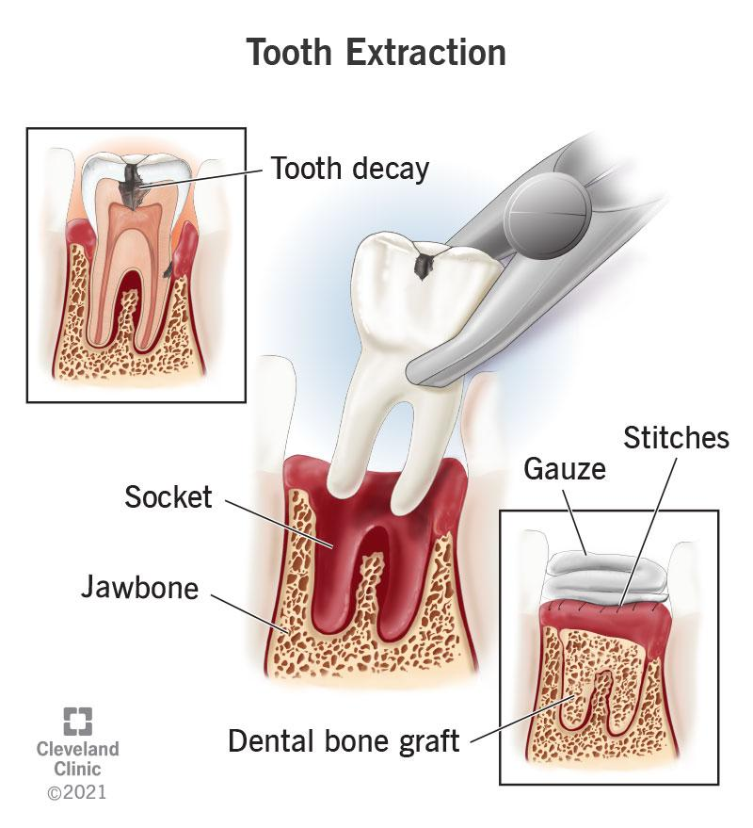

4
- Simple Extraction: $200–$350
- Surgical Extraction: $350–$800
- Duration: 30–60 minutes

6.2 Dental Implants

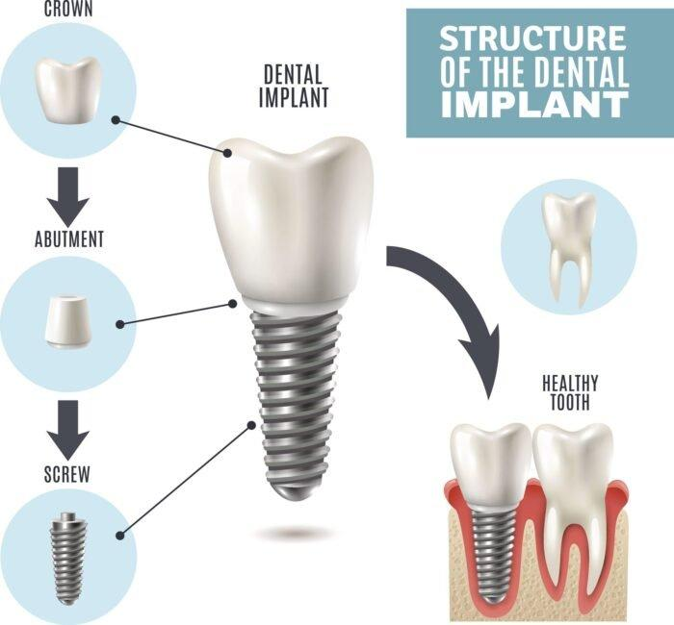

4
- Duration: 3–6 month process
- Includes implant placement + crown
- Price Range: $3,000–$5,000 per tooth
- Success Rate: ≥ 95%

7️⃣ Pediatric Dentistry
- Child exam: $100–$180
- Fluoride treatment: $40–$70
- Sealants: $50–$90 per tooth
Goal: First visit by age 1

8️⃣ Emergency Dentistry
- Emergency Exam: $100–$200
- Same-day relief treatment
- Average Visit Duration: 30–60 minutes
- Target Seating Time: ≤ 30 minutes

9️⃣ Membership Plans (Optional Revenue Model)
DentalBoutique Smile Plan:
- Individual: $299/year
- Family (4): $999/year
Includes:
- 2 cleanings
- 2 exams
- 1 set of X-rays
- 15% discount on treatments

🔟 Financial Options
- Insurance billing direct
- Payment plans (6–24 months)
- 0% financing options
- Deposit required for treatments > $1,000 (minimum 20%)

📊 Revenue Mix Target (Per Location)
Category | Target % of Revenue
Preventive | 30%
Restorative | 30%
Cosmetic | 15%
Orthodontics | 15%
Surgery/Implants | 10%

