# Romania Problem: Find Shortest Path from Arad to Bucharest

|  |  |  |  |  |  |  |  |
| --- | --- | --- | --- | --- | --- | --- | --- |
| *hSLD*(*n*) | | | | | | | |
| **Arad** | 366 | **Mehadia** | 241 | **Fagaras** | 176 | **Sibiu** | 253 |
| **Bucharest** | 0 | **Neamt** | 234 | **Giurgiu** | 77 | **Timisoara** | 329 |
| **Craiova** | 160 | **Oradea** | 380 | **Hirsova** | 151 | **Urziceni** | 80 |
| **Drobeta** | 242 | **Pitesti** | 100 | **Iasi** | 226 | **Vaslui** | 199 |
| **Eforie** | 161 | **Rimnicu Vilcea** | 193 | **Lugoj** | 244 | **Zerind** | 374 |

# 8-Puzzle Problem: slide tile to empty square from *Start State* to *Goal State*

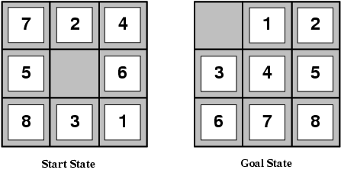

# n-Queen Problem: Place n queens on n x n board so that no queen can attack another

