Mr. Phiphat Chomchit 630631028

Test 1: Truly Random Number Generator (7/8/2021)

In classical computing we cannot really generate a random number. The best we can do is to generate a pseudorandom number to approximate the real random number. However, in quantum computation, we can generate a truly random number. In this assignment you are asked to create a quantum program on IBM Q to generate a truly random 5-bit number.

**Method 1**

OPENQASM 2.0;

include "qelib1.inc";

qreg q[5];

creg c[5];

reset q[0];

reset q[1];

reset q[2];

reset q[3];

reset q[4];

h q[0];

measure q[0] -> c[0];

h q[1];

measure q[1] -> c[1];

h q[2];

measure q[2] -> c[2];

h q[3];

measure q[3] -> c[3];

h q[4];

measure q[4] -> c[4];

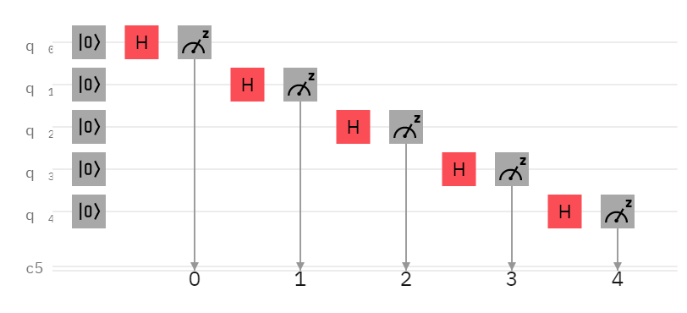

This approach uses Hadamard gate to change probability qubit to 50 percent of 1 state and 50 percent of 0 state. **Method 1**: Run the circuit one time then we get 5 random classical bits (i.e., 10101).

**Method 2**

OPENQASM 2.0;

include "qelib1.inc";

qreg q[1];

creg c[1];

reset q[0];

h q[0];

measure q[0] -> c[0];

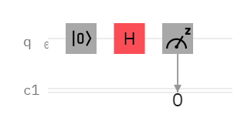

Method 2: Run this circuit 5 time and then we get 5 random classical bits like a **Method** **1**.