北京科技大学 2008—2009 学年 第 一 学期
数字电子技术（双语） 试卷（A）
院(系) 班级 学号 姓名
装 订 线 内 不 得 答 题
自 觉 遵 守 考 试 规 则，诚 信 考 试，绝 不 作 弊
试卷卷面成绩 (占课程考核成绩的70%) |  |  |  |  |  | 平时 成绩 | 课程考核成绩
题号 | 一 | 二 | 三 | 四  五  六  七 | 小计 | 平时 成绩 | 课程考核成绩
得分

- 单项选择（15分）
得 分

- A quantity having discrete values is ( ).
(a) a digital quantity (b) an analog quantity
(c) a binary quantity (d) a natural quantity
- In a certain digital waveform, the period is twice the pulse width. The duty cycle is ( ).
(a) 100% (b) 50% (c) 200%
- The binary number 11011101 is equal to the decimal number ( ).
(a) 121 (b) 221 (c) 441 (d) 256
- The 1’s complement of 10111001 is ( ).
(a) 01000111 (b) 01000110 (c) 11000110 (d) 10101010
- The output of an OR gate with inputs A, B and C is a 1 (HIGH) when ( ).
(a) A=1, B=1, C=1 (b) A=0, B=0, C=1
(c) A=0, B=0, C=0 (b) answers (a), (b), and (c) (e) only answers (a) and (b)
- The Boolean expression 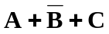 is ( )
(a) a sum term (b) a literal term (c) a product term (d) a complemented term
- The domain of the expression  is ( ).
(a) A and D (b) B only (c) A, B, C and D (d) none of this
- An example of a sum-of-products expression is ( ).
(a) 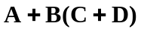 (b) 
(c) 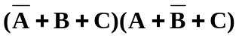 (d) both answers (a) and (b)
- A full-adder is characterized by ( ).
(a) two inputs and two outputs (b) three inputs and two outputs
(c) two inputs and three outputs (d) two inputs and one output

- If an octal-to-binary priority encoder has its 0, 2, 5 and 6 inputs at the active level, the active-HIGH binary output is ( ).
(a) 110 (b) 010 (c) 101 (d) 000
- The output pulse width of a nonretriggerable one-shot depends on ( ).
(a) the trigger intervals (b) the supply voltage
(c) a resistor and capacitor (d) the threshold voltage
- The purpose of the clock input to a flip-flop is to ( ).
(a) clear the device (b) set the device (c) always cause the output to change states
(d) cause the output to assume a state dependent on the controlling (S-R, J-K or D) inputs.
- A DRAM must be ( ).
(a) replace periodically (b) refreshed periodically
(c) always enabled (d) programmed before each use
- An DAC is a ( ).
(a) digital-to-analog computer (b) digital analysis calculator
(c) data accumulation converter (d) digital-to-analog converter
- The quantization process ( ).
(a) converts the sample-and-hold output to binary code
(b) converts a sample impulse to a level
(c) converts a sequence of binary codes to a reconstructed analog signal
(d) filters out unwanted frequencies before sampling takes place

- 基本电路分析（40分）
得 分

- (10’)Simplify the following expressions as much as possible.
(1)

(2)

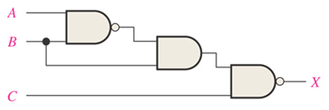
- (12’) Analyze the circuit in Figure2-2.
- Write the output expression for the circuit.
Figure 2-2
- Develop the truth table for the circuit.

装 订 线 内 不 得 答 题
自 觉 遵 守 考 试 规 则，诚 信 考 试，绝 不 作 弊
- Minimize the gates required to implement the function.

- Implement (实现) the circuit by using only NOR gates.

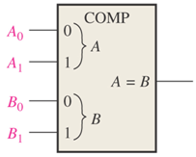
- (4’)The waveforms in Figure 2-3 are applied to the comparator as shown. Determine the output (A=B) waveform.
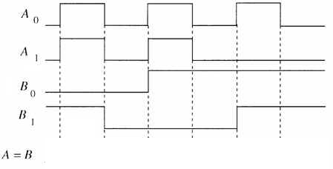
Figure 2-3

- (8’) A 74178 shift register is described by the given table. All state changes occur on the 1→0 transition of the clock. The shift register is connected as shown. Complete the timing diagram.
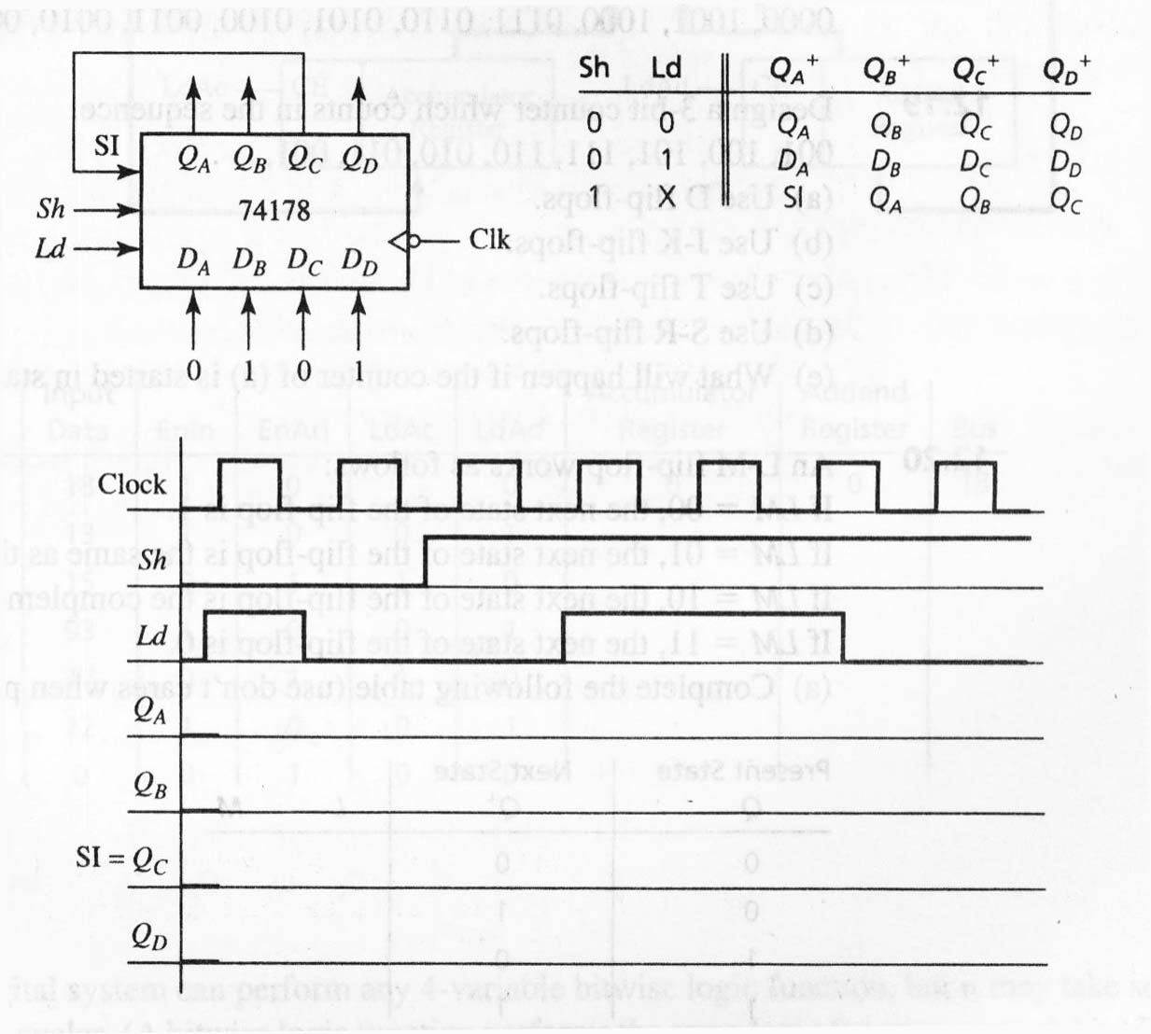
- (6’)Analyze the circuit in Figure 2-5, then answer the questions
(1)What is the word length, word capacity and address line of each memory?
(2)What is the word length, word capacity and address line of the expansion memory?
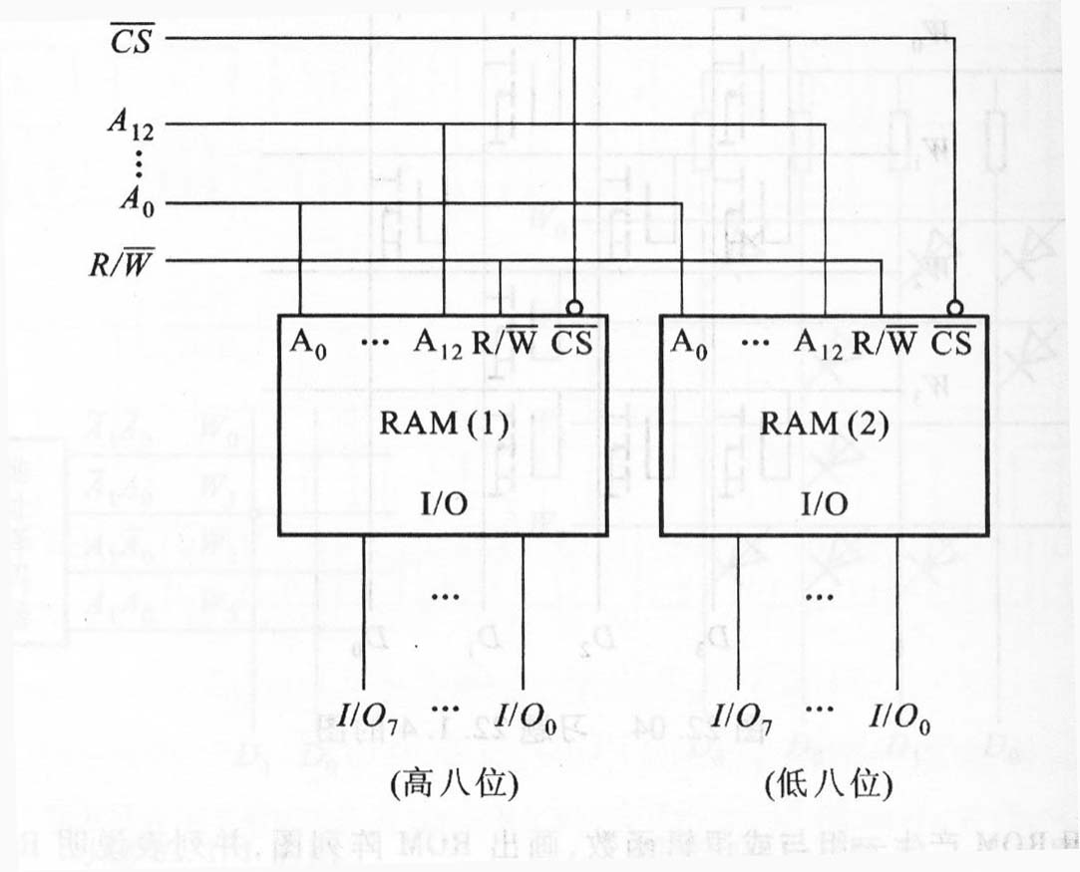

Figure 2-5

- 电路分析与设计（30分）
得 分

- (6’)You wish to detect only the presence of the codes 1110, 1001, 0101 and 1011. An active-HIGH output is required to indicate their presence. Develop the logic circuit with a single output that will indicate when any one of these codes is on the inputs. For any other code, the output must be LOW. Please use a 4-line-to-16-line decoder with fewer gates as needed.
装 订 线 内 不 得 答 题
自 觉 遵 守 考 试 规 则，诚 信 考 试，绝 不 作 弊
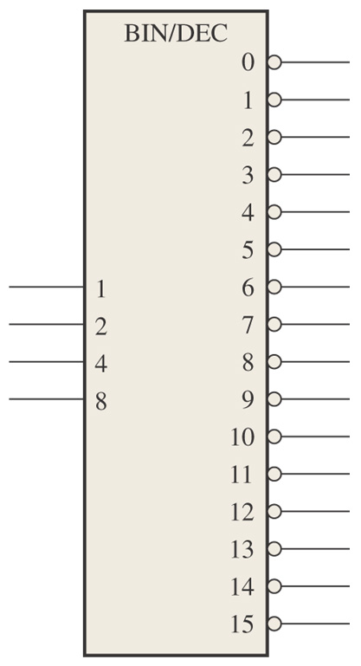

- (8’)Show how to connect two 74LS160s for a modulus-35 counter.

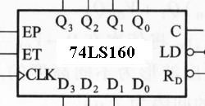

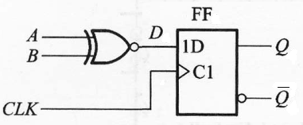
- (4’)A D flip-flop is connected as shown in Figure 3-3. Determine the Q output in relation to the clock and inputs.

Figure 3-3
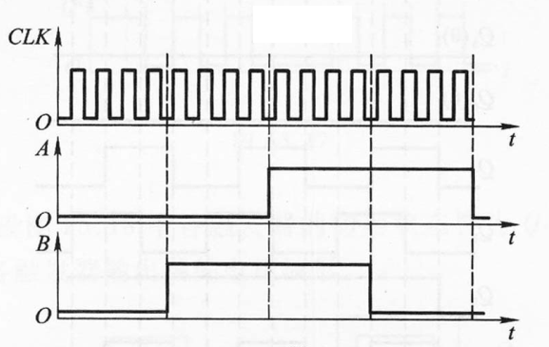

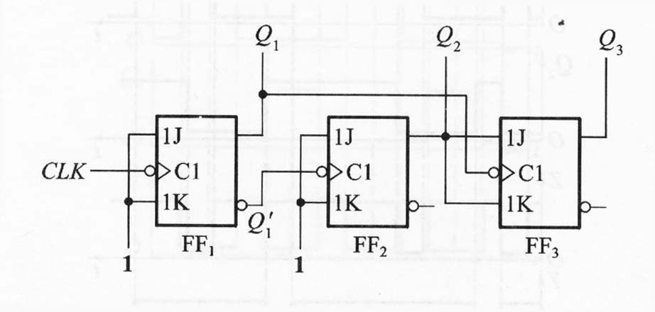
- (12’)Determine the sequence of the counter in Figure 3-4, showing the Q₁, Q₂ and Q₃ waveforms.

Figure 3-4
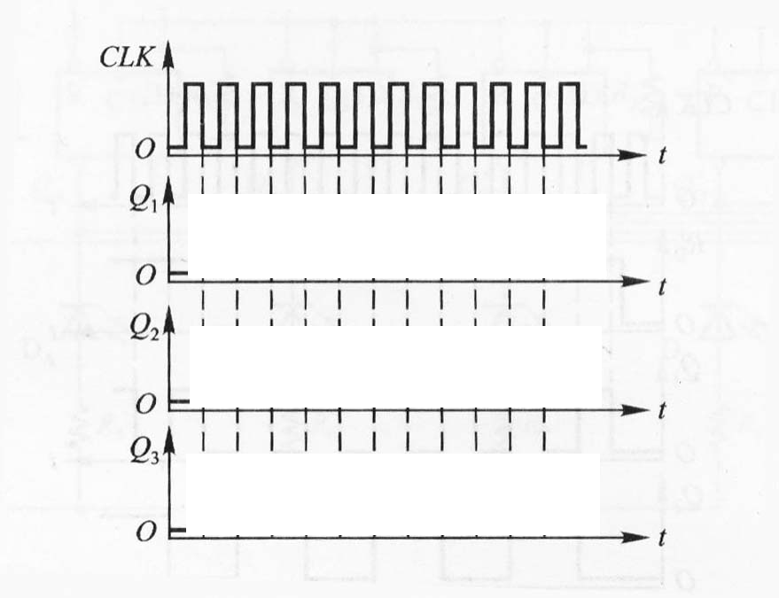

- 综合提高（15分）
得 分
Examine the circuit in Figure 4-1carefully. Answer the following questions. 74HC151 is a 1-of-8 Multiplexer and 74LS161 is a modulus-16 synchronous counter.
- What is the circuit connected by a 555 timer？A one-shot or an astable multivibrator?
- Illustrate how does the circuit works?
- Determine the output V_{o} waveform. Assume that the 74HC151 has input waveforms as shown in Figure 4-1.
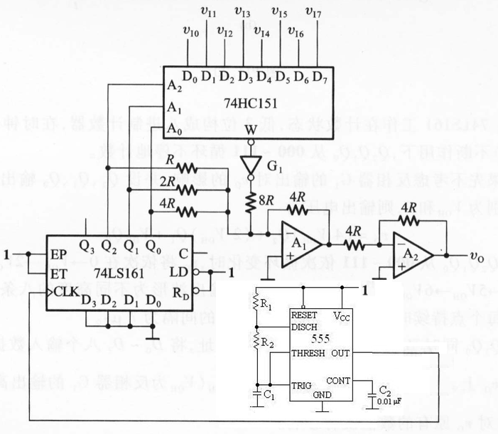
装 订 线 内 不 得 答 题
自 觉 遵 守 考 试 规 则，诚 信 考 试，绝 不 作 弊
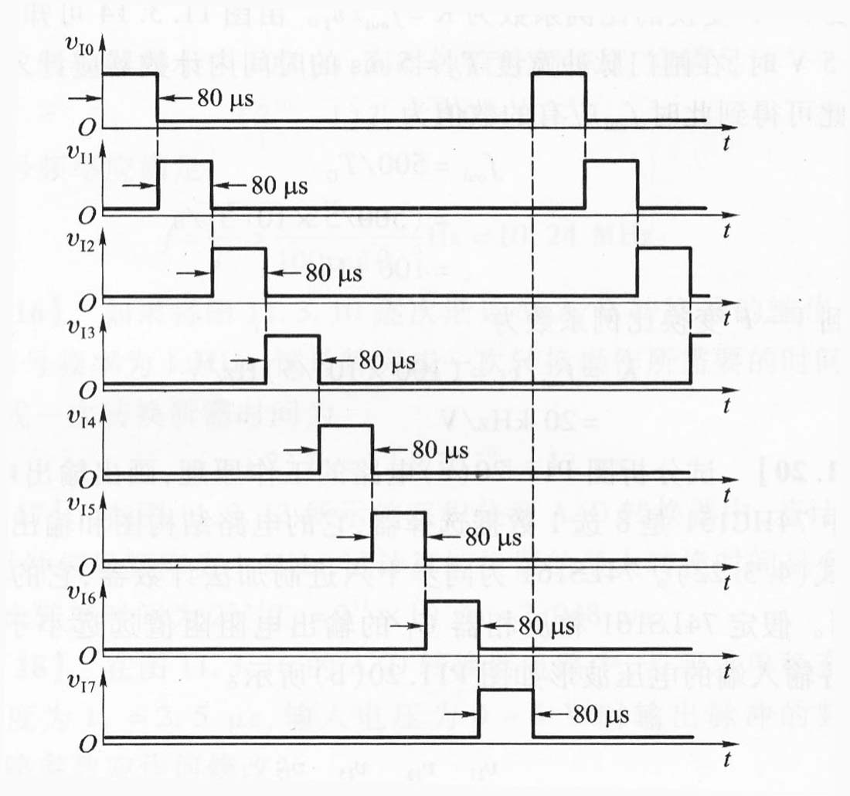注：本题题目给得不完全，仅做参考！
Figure 4-1

Function Table of 74LS160 (moudulus-10)/ 74LS161 (moudulus-16)
CP | 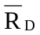 | 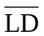 | EP | ET | FUNCTION
X | 0 | X | X | X | clear
↑ | 1 | 0 | X | X | load
X | 1 | 1 | 0 | 1 | keep
X | 1 | 1 | X | 0 | keep(but C=0)
↑ | 1 | 1 | 1 | 1 | counting
