Order Management
Student: Orosz Barbara Veronika

Group:30422
Assignment 3

CONTENTS

1. Assignment Objective 3
2. Problem Analysis, Modeling, Scenarios, Use Cases 3
3. Design 3
4. Implementation 3
5. Results 3
6. Conclusions 3
7. Bibliography 3

1.Assignment Objectives
- The main objective of the theme is the design and implementation of a simulation application that processes orders from clients. Additionally, this simulator must ensure:
- the use of object-oriented programming concepts;
- storing clients, products, and orders in a relational database;
- its development using an layered architectural pattern;
- its development using at least four packages: business logic, data access, presentation, and model;
- using JavaDoc for documenting classes;
- using reflection technique;
- user interaction with the simulator through a user-friendly graphical interface, to facilitate navigation through the application: the user has a panel for operations with clients, such as creating, searching, editing, or deleting them, a panel for operations with products, such as creating, searching, editing, or deleting them, and a panel for operations with orders, such as creating, searching, or displaying them;
- issuing a fiscal receipt for each placed order, in the "bill.txt" file;
- testing and debugging the program to verify the functionality of the application.
2.Problem Analysis, Modelling, Scenarios, Use Cases
2.1 Analysis
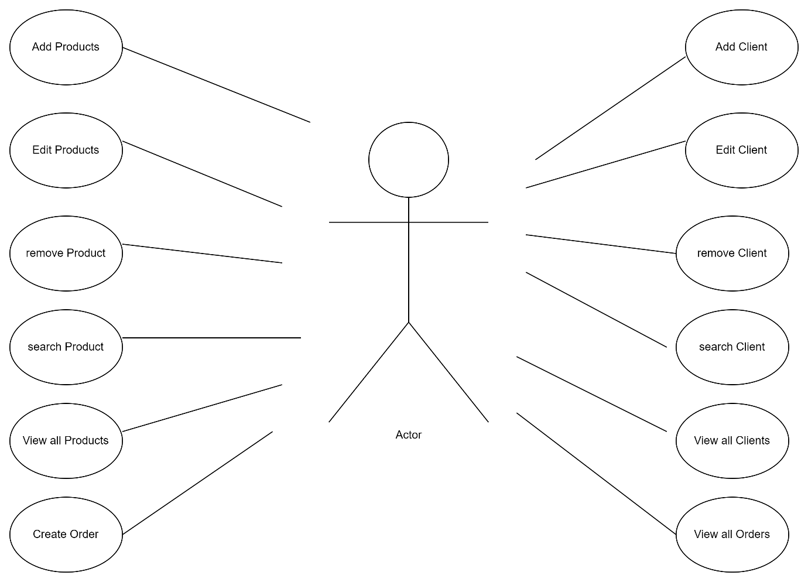

For implementing the instruction for managing such an warehouse we need to meet some criterias:
Functional requirements
- Add Client: Adds new Client with information such as name ,address , age and email.
- Edit Client: Modifies a client based on its id.
- Remove Client: removes a client based on its id.
- Search Client :searches a client based on its id.
- View all Clients: Puts out a table containing all of its clients.
- Add Products: Adds new Product with information such as name ,description , price and stock.
- Edit Product: Modifies a product based on its id.
- Remove Product: removes a product based on its id.
- Search Product :searches a product based on its id.
- View all Products: Puts out a table containing all of its products.
- Create new Order : Based on a client and product a new order is made.
- View all Orders: : Puts out a table containing all of its products.
- Create new Order : Puts out a table containing all of its orders.
- Bill: our orders are put in a bill file.
Non-Functional requirements
- User-interaction: Should be intuitive and easy to use by the user
- Stability: The operations should operate reliably without crashing or freezing under normal usage conditions , also databsse connection should be established.
- Modularity: Design the warehouse in a modular and well-structured manner, making it easy to maintain and extend in the future.
2.2 Modelling
The user will be able to use the warehouse of the calculator by introducing the needed information. They need to select the which table they want to work with than the operation they want to perform
- Client Add ,Edit ,Search ,Remove , View.
- Product Add ,Edit ,Search ,Remove , View.
- Order Create , View.

The result of the operation will be displayed in the userface .

2.3 Scenarios and use cases
The use cases are strongly connected with the steps made by the use and because of this same reason the userface was designed to be as user-friendly as possible.
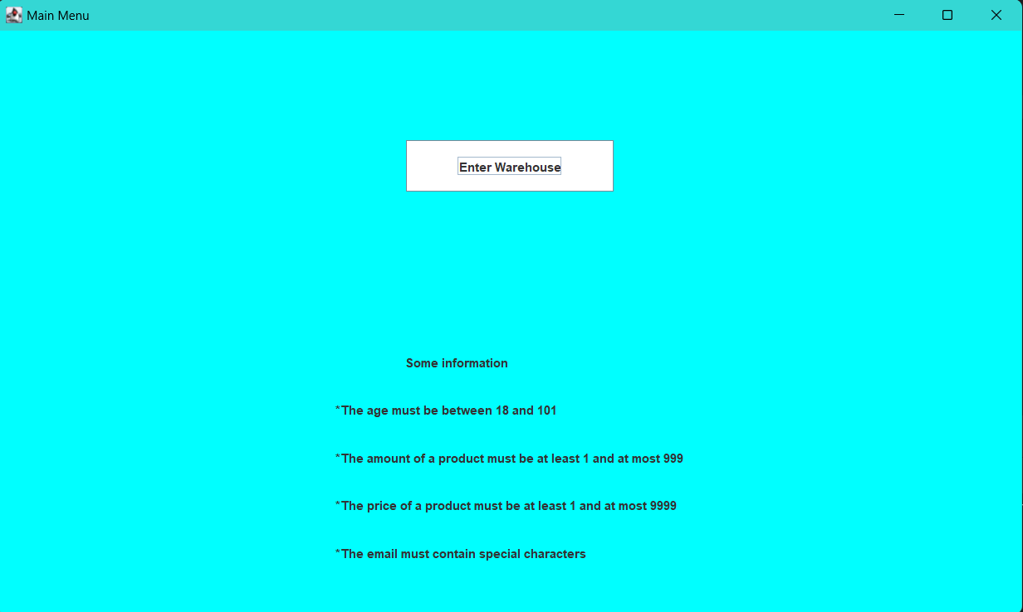

After the user presses the button they will be transferred to the main application , where they can select with which table to work with:
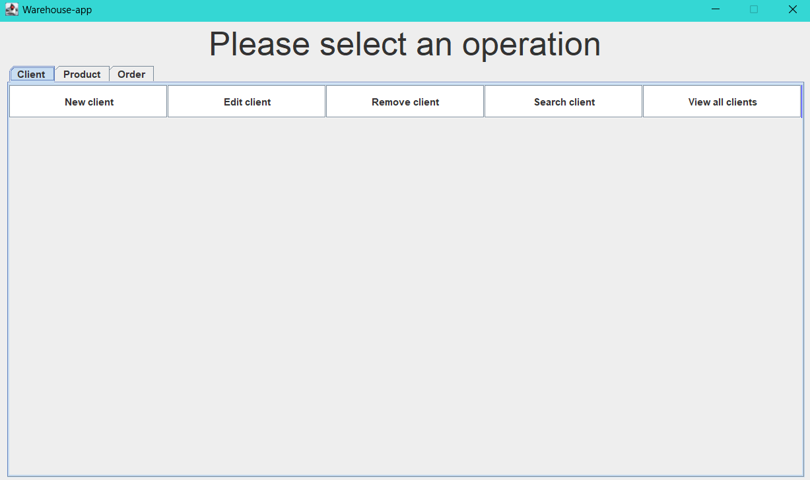

If they want to work with a certain table , the user will have just select the corresponding tab.

Let’s see how each operation is used for each table:
For Client and Product:
Add:
Use Case: adds a new Client:
user Main Success Scenario:
1. The user inserts the data for a new user
2. The user selects the “add” operation .
3. A popup message will be displayed if the operation was succesful.
Edit:
Use Case: edits an existing client:
user Main Success Scenario:
1. inserts the id of the required client.
2. A new panel will be displayed to modify the old data .
3. Press the “edit” button.
4. A popup message will be displayed if the operation was succesful.
Search:
Use Case: searches a Client :
user Main Success Scenario:
1. inserts the id of our required client.
2. A new Panel with the information will be displayed.

Remove:
Use Case: removes a client:
user Main Success Scenario:
1. inserts the id of the client needed to be deleted.
2. Press the “remove” button.
3. A popup message will be displayed if the operation was successful.
View:
Use Case: displays all clients:
User Main Succes Scenario:
- A table containing all clients will be displayed.

For Order
Add:
Use Case: adds a new order:
user Main Success Scenario:
1. User selects the client and product.
2. The user presses the “add” button .
3. . A popup message will be displayed if the operation was successful.
View:
Use Case: displays all orders:
User Main Succes Scenario:
- A table containing all orders will be displayed.

3. Design
Level 1 : Overall system design
Essentially our calculator has 2 inputs that it will transform as output presented in our interface.
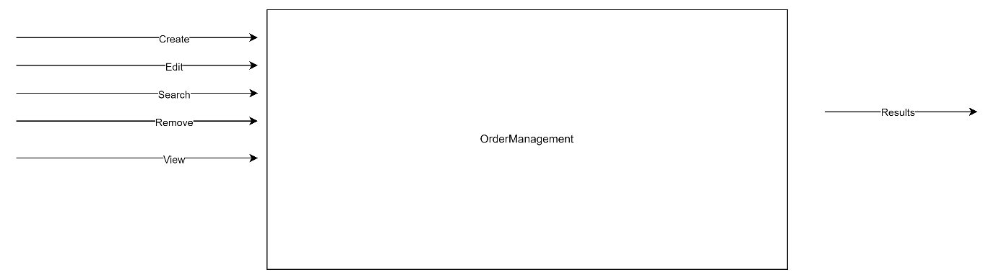

Level 2 : Division into packages
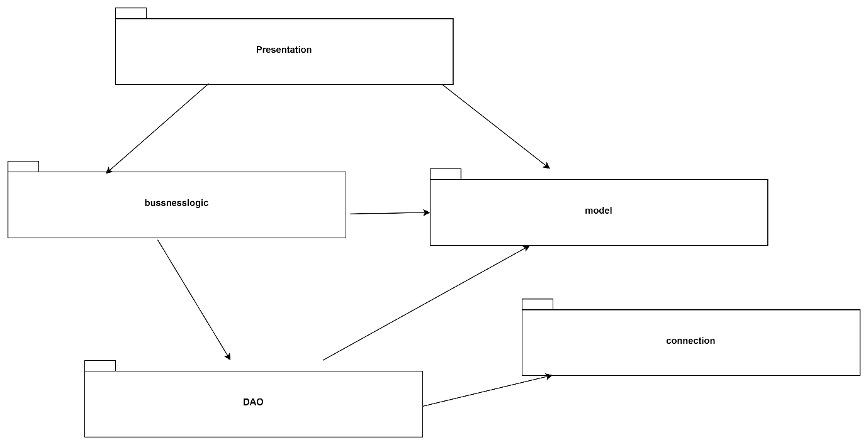

4. Implementation
a) Diagrams
It is a little too complex so I will explain what each of the packets do:

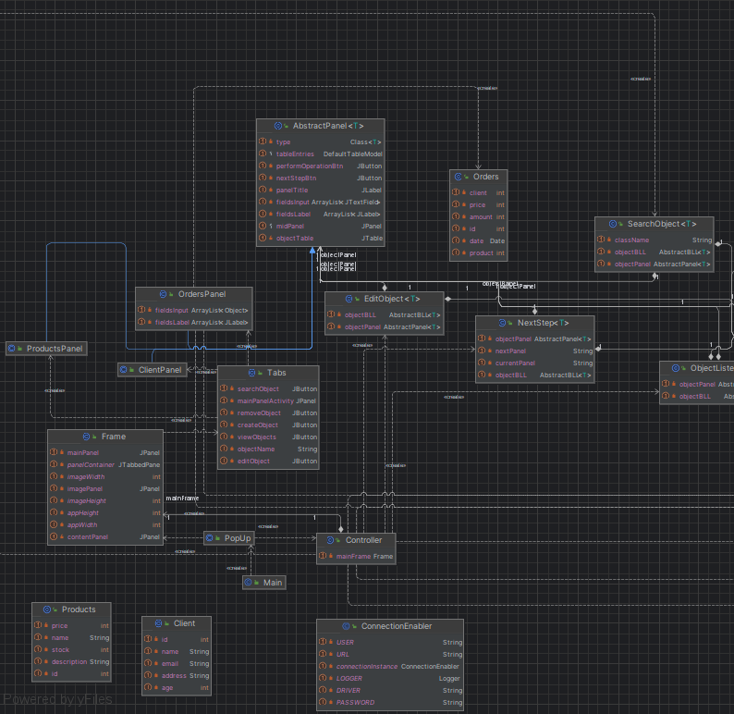
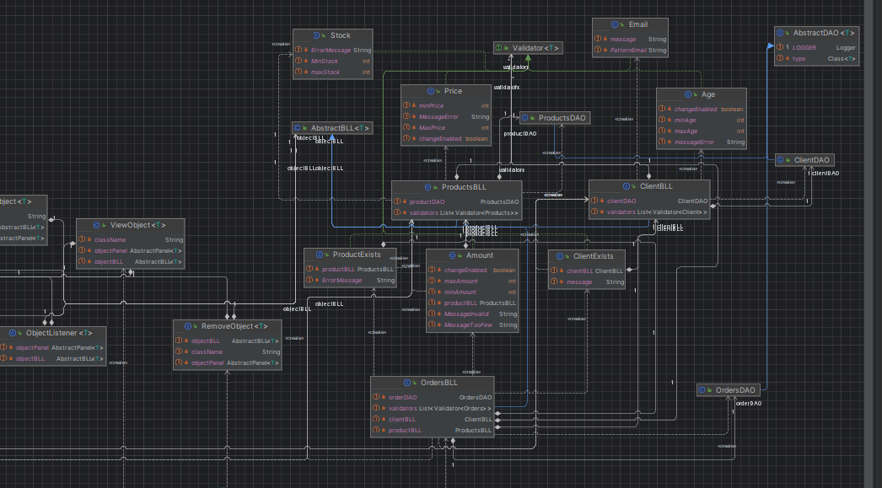

4.1 Presentaion Packet
The package contains classes that comprise the graphical interface of the application; the panels containing operations on clients, products, or orders. The Frame class is responsible for displaying the graphical interface.
The class contains String and int constants, then a list of panels and buttons. The construction of the window has been divided into several steps, each step being dictated by the class constructor. For example, void setUpFrame() is responsible for preparing the JFrame (the application window), setting its size, title, etc., so each function does what its name implies. Successively, the left part of the interface is added, containing the image related to the application theme, information about the author, the application title, and other simulation-related details. Next comes the interesting part.
Observing that each area corresponding to operations on the objects manipulated by this simulation contains the same information, we created the AbstractPanel class, which extends the JPanel class and contains a list of JLabels and JTextFields. Using reflection, the text displayed in JLabel is modified to display the corresponding information (specifically, for a client, the name, address, age, and email will be displayed, for a product, the name, description, price, and stock, etc.). With the help of different methods, the illusion of the existence of multiple inner panels is created: Depending on the selected operation, certain texts are deleted from the panel and others are displayed (for example, the void showCreateObjectPanel() method will display almost all the inputs related to a client, except for the input for the id, as this will be automatically calculated when entering a client in the database).
Another important feature of this class is how objects from the database are displayed in tables. Using reflection, the fields describing an object mapped in the database are retrieved and the column names are set. Two other important methods are T getFields(), which retrieves information from the input fields provided to the user and returns an object of type T, where T will take the place of Client, Product, or Order, and the void setFields(T object) method, which receives an object of type T and will put the information related to it in the graphical interface, useful for displaying information about the object, editing it, etc.
Finally, besides getters and setters, there are methods present that will be used by the Controller to add functionality to the buttons.
4.2. Model Package
The package contains the three classes mapped in the database, namely Client, Product, and Order. Each is defined by specific instance variables of the object, such as its name, age (in the case of a client), price (in the case of a product), or date (in the case of an order), different constructors, which will be manipulated by reflection in the next presented package, getters, and setters.
4.3. Business Logic
Package This package contains the classes that ensure the application's logic. Among these, we mention the classes that modify the objects in the database. These classes receive objects created by the classes in the Presentation package with the help of the Controller. Before manipulating the database, these objects must be validated, each according to its type. In the case of a client, we must ensure that their age falls within legal norms, or that their email address follows a certain pattern. Or, an order must be made by an existing client, and only if there are enough products of that type. If validation is successful, these classes make the final call to the classes and methods that query the database.
Also in this package, classes have been defined to ensure user interaction with the program. The main class, Controller, assigns each button in the graphical interface a function. Thus, each button in the program has a corresponding class that serves as a different "listener" (for example, CreateObjectListener is added to the add button, which, when pressed, will retrieve values from the dedicated input areas, validate them, and if they are correct, will insert the object into the database).
4.4. Data Access
Package This package contains the classes that will actually manipulate the entries mapped in the tables of the database. In the AbstractDAO class, CRUD methods have been defined using reflection, valid for any object. For simplicity, and because the rest of the methods work on the same principle, we will focus on the insert method. This method receives a generic object, which is taken from the fields in the graphical interface and inserts it into the database, returning the id of the corresponding entry in the table. The createInsertQuery method is used to form the query to insert an object into the database. Later, this string will be filled with the values from the respective object and the insertion into the database will be performed.
An interesting method in this class is the createObjects method, which receives a ResultSet obtained from a database query, and from a list of entries from the database returns a list of objects that Java can manipulate. By iterating through the fields of the object using reflection, the values of that object are set using setters, after which it is added to the final list of objects.
The ClientDAO and OrderDAO classes extend the AbstractDAO class, but the ProductDAO class, in addition to this, uses two other methods used in creating a new order, decrementStock and getPrice.

4.Results
For this application we can see the following:
First PopUp: 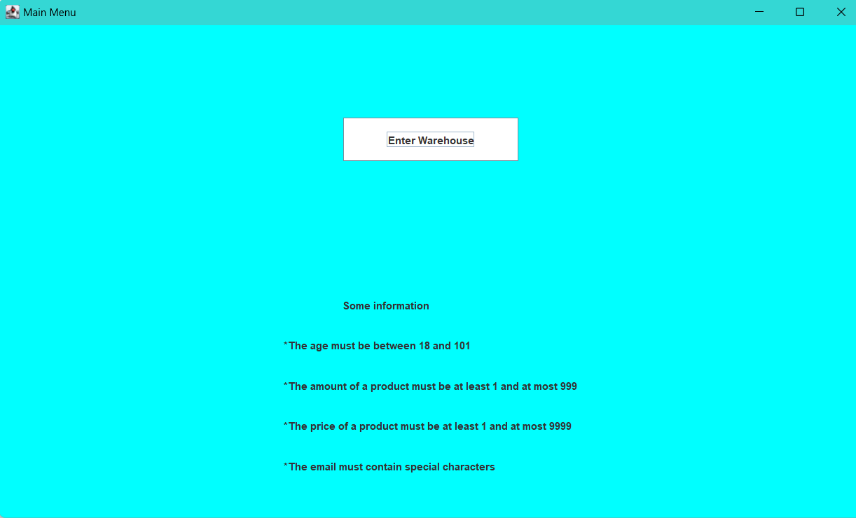

If we work with clients:
Add Client: 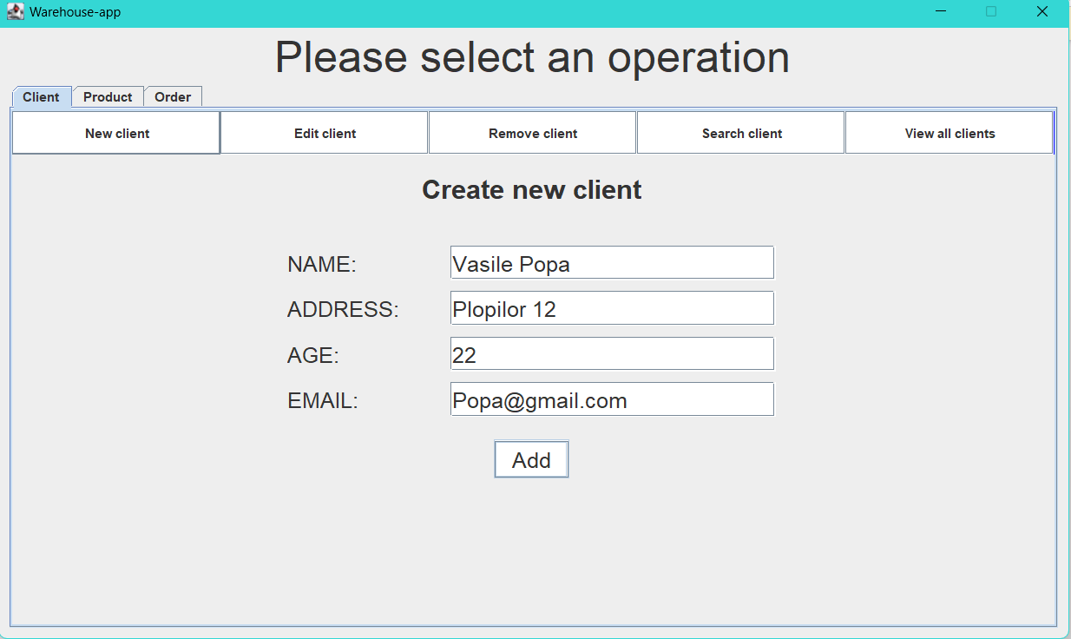
If it was succesful: 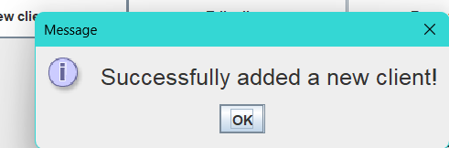
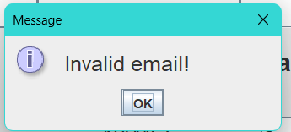
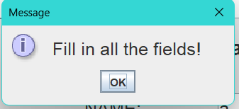
Else if we can have several warning:

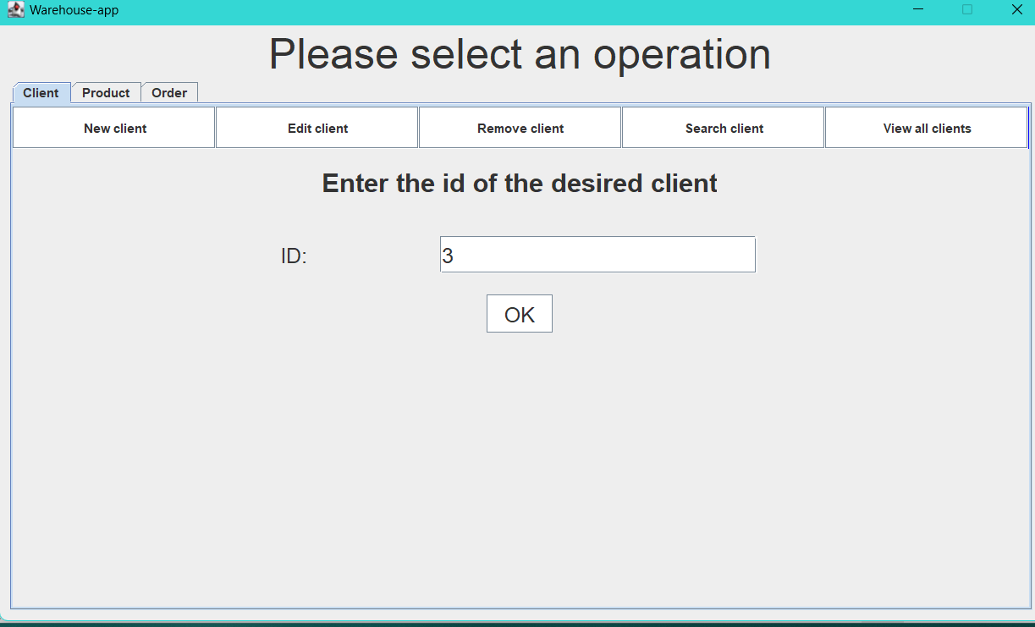
For editing:

If succesful we get to edit:

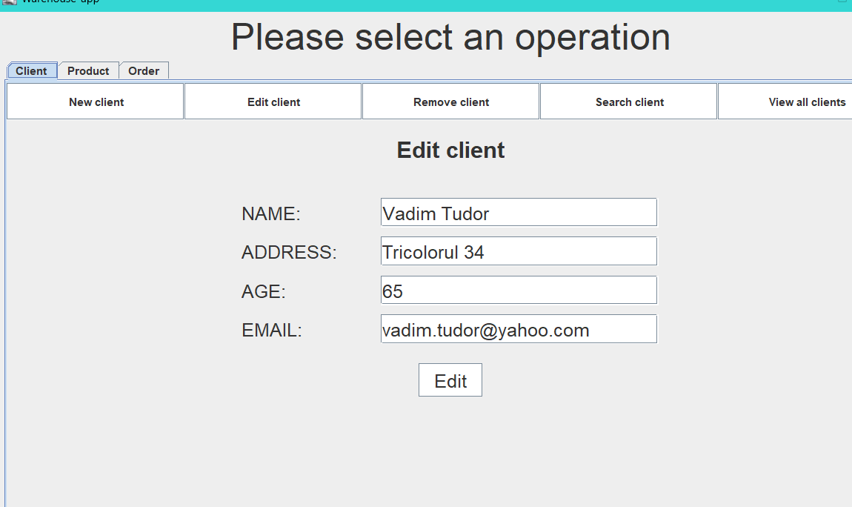


Else if the id wasn’t found:
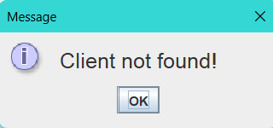

For searching and removing it is the same principal as edit .

For viewing:
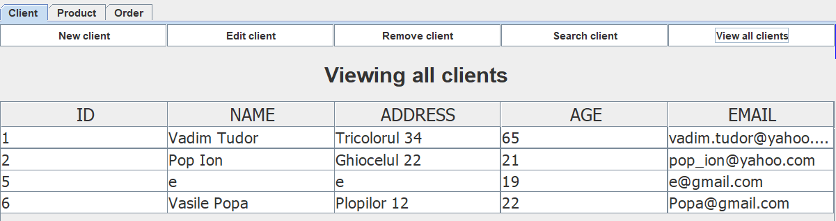

For the Products Tabel it has the same operations but different attributes.
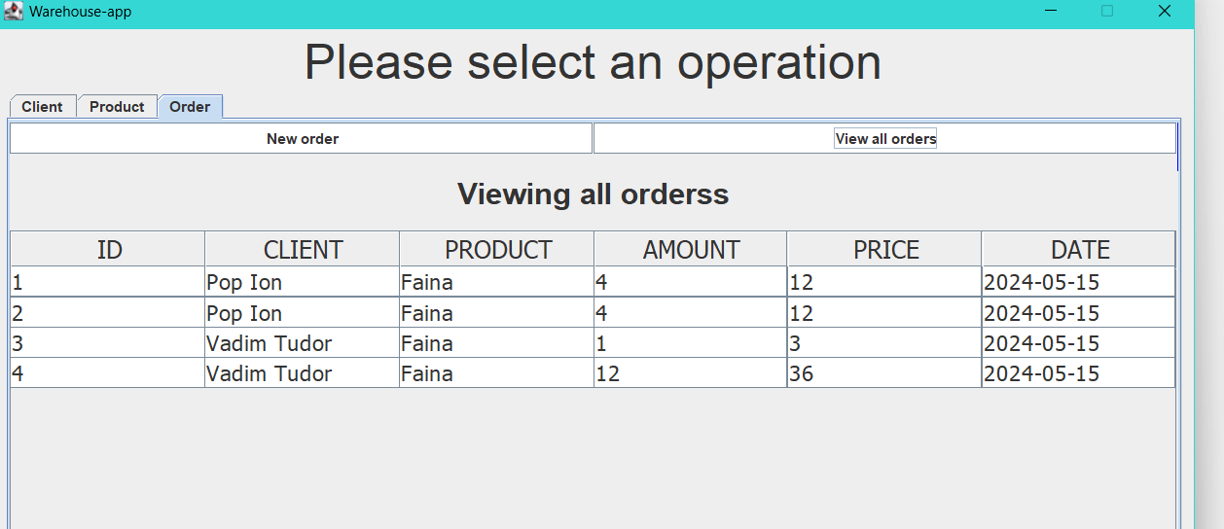
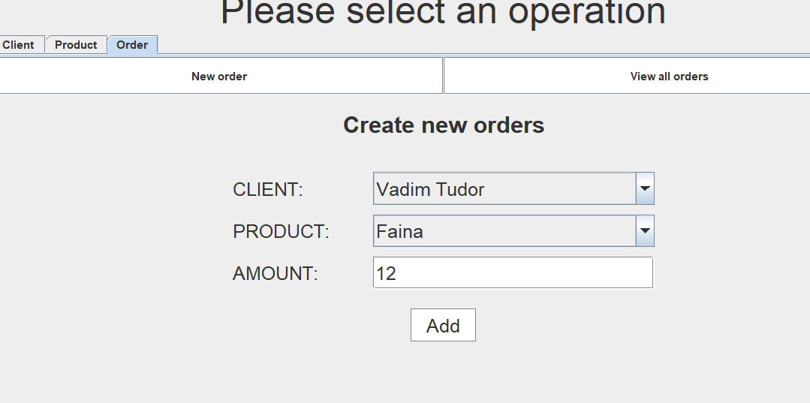
For Orders:
Here are some of the warning that pop up during the operations:
If we entered a wrong age or email:
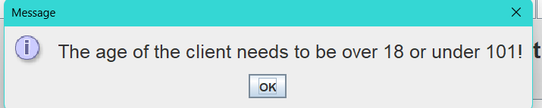
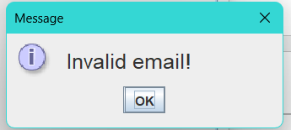
Else if succesful:
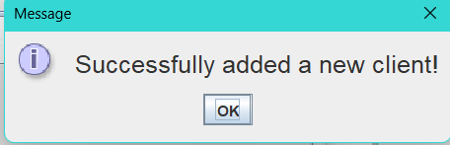
If we want to edit and the id is not found:
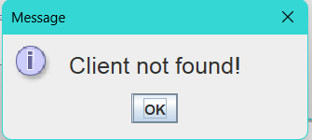
Else if succesful and we want to delete the client from our database this will be displayed to make sure if we want to delete this client:
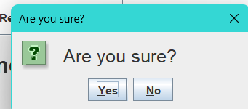

6.Conclusions
As a result of this assignment, I believe I have improved my programming style by adhering to Java naming conventions and organizing code into packages and subpackages. Additionally, I have strengthened my existing knowledge of object-oriented programming concepts, such as inheritance, polymorphism, or elements of graphical user interface from the Java.swing package, as well as generic types, laying the groundwork for new Java techniques, such as reflection.
At present, the application allows for the creation of orders with a single product, but in the future, it could be developed to allow for the addition of multiple products to the same order. Additionally, a version could be developed where products have suggestive images, not just names and descriptions. Similarly, this could be done for clients, each having the option to have an avatar.
Another possible future development could involve searching for a client by name, address, or email, as well as for a product or, more importantly, an order. Taking the real world as an example, each client could have a certain amount of money, which, like the stock of products when placing new orders, decreases; similarly, this amount of money could be treated. In the case of a client who places regular orders or orders of higher value, they could receive a certain discount.

7.Bibliography
https://www.vogella.com/tutorials/MySQLJava/article.html
https://www.geeksforgeeks.org/reflection-in-java/
https://www.baeldung.com/java-reflection
https://www.baeldung.com/java-reflection
https://www.jetbrains.com/help/idea/javadocs.html
https://www.oreilly.com/library/view/software-architecture-patterns/9781491971437/ch01.html
https://www.baeldung.com/cs/layered-architecture

