The Sampling Theorem, Aliasing and Bandlimited Waveform Generation

The Nyquist-Shannon sampling theorem is arguable one of the most important foundations for digital sound processing in general, including synthesis. It says that any real continous signal can be sampled without any loss of information if and only if the highest frequency of the signal is a equal or under to half the sampling frequency. The proof is mathematically rather complex, so I won't outline it here and direct readers to [INSERT LINK TO SAMPLING THEOREM PROOF] instead.
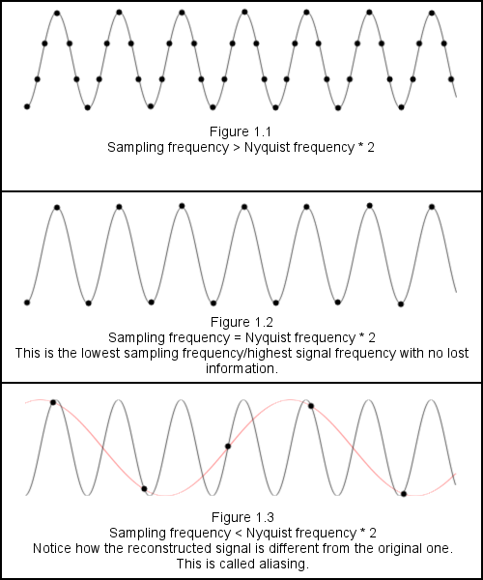
This highest permissable frequency is called the Nyquist freqency, and it is equal as stated above to half the sampling rate (see Figure 1.2).
When a or several frequencies in the signal are above the Nyquist frequency, a phenomenon called aliasing takes place. It is a problem in any task concerned with sampling like image rendering, not just sound synthesis.
What happens is that the frequencies above Nyquist get misinterpreted as low frequency noise (See Figure 1.3), which often manifistates in sound synthesis as a low buzzing tone.

This effect appears in a great number of applications, and is almost always a problem. Not surprisingly, many different strategies for countering or minimising it have been developed.
Specifically in sound synthesis, the main issue with aliasing is that it creates a low buzz, which is often described as “distorted” and “unnatural”. Sometimes this is desired, but usually it too is a problem.

One of the concrete areas where it is an issue is generation of the primary waveforms. Some waveforms, like the omnipresent “sawtooth” and “square” waves, have discontinuities in them, which translates to an infinite frequency. Obviously, this isn't a good thing in combination with digital synthesis.

Sawtooth waveforms (named after the shape, see Figure 2.1) are the backbone of electronic music, the vast majority of synthesized sounds base in some way off it. There are of course many ways to generate one, the simplest being

This, of course, has an infinite amount of frequencies, which means that no matter the sampling rate aliasing will occur.
There are different ways to approach the problem, all of which are computationally much more expensive, this is the one I chose:
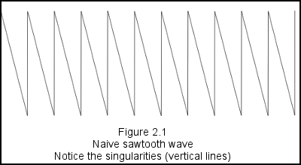
The ideal sawtooth wave has a simple frequency spectrum; it is composed of all harmonics at amplitude 1/n for the nth harmonic. This means it can be written as an infinite sum of sinc waves (identical to the naïve version, see Figure 2.1).
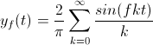

(the 2/pi normalizes the result; we want it between -1 to 1)

The kth element of this sum represents the kth harmonic, so this formula “builds” the sawtooth starting by the lowest frequencies and going up.
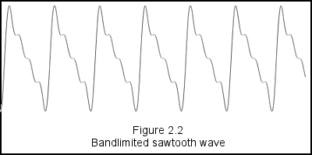
Of course, instead of adding infinite frequencies, we could also stop when we have reached the Nyquist limit (Figure 2.2).
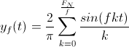

(F_{N} = Nyquist frequency)

Surprisingly, the performance losses were not as large as I originally feared, as long as one makes sure t cycles in fixed bounds (performance drops sharply when doing this with numbers above 10⁶). Apart from that, no optimisation modifications were required, so the formula can be implemented almost verbatim in code.

// Sawtooth wave generator
double result = 0;
for (int k=1; k*freq<Constants.SAMPLING_RATE/2; k++)
{
result += Math.sin(time*freq*Constants.pi_times_2*k + phase)/k;
}
return Math.min(1, Math.max(-1, 2*result/Math.PI));

Square waves are nearly identical, the only difference is that even harmonics have an amplitude of 0.
So the code changes very slightly and becomes the following (notice the k+=2). Results in Figure 2.3.

// Square wave generator
double result = 0;
for (int k=1; k*freq<Constants.SAMPLING_RATE/2; k+=2)
{
result += Math.sin(time*freq*Constants.pi_times_2*k + phase)/k;
}
return Math.min(1, Math.max(-1, 2*result/Math.PI));

