ECD system UI catalog
Screenshots of Sisitemu y'Ubwitabire bw'Abana across public auth, Umurezi (caretaker), ECD director, Akarere (district), and NCDA admin. Captured from the local app on 8 September 2026. Passwords are not included.
Source: http://localhost:5174
Pages captured: 96

Contents

Public / authentication
- Role selection — /
- Login — Umurezi / ECD director — /login/caretaker
- Login — Akarere — /login/district
- Login — NCDA — /login/ncda
- Forgot password — /forgot-password

Umurezi (caretaker)
- Home — /caretaker
- Children list — /caretaker/abana
- Attendance — /caretaker/ubwitabire
- Growth — /caretaker/imikurire
- Monthly growth roster — /caretaker/imikurire/ukwezi
- More (Ibindi) — /caretaker/ibindi
- Register child — /caretaker/kwiyandikisha
- Feeding (Imirire) — /caretaker/imirire
- Feeding monthly report — /caretaker/imirire/raporo
- STED — /caretaker/sted
- STED wizard — /caretaker/sted/new
- STED history — /caretaker/sted/amateka
- Notifications — /caretaker/amatangazo
- Impugukirwa — /caretaker/impugukirwa
- Reports — /caretaker/raporo
- Settings — /caretaker/igenamiterere

ECD director
- Home — /caretaker
- Center overview (Ikigo) — /caretaker/ikigo
- Management hub — /caretaker/imicungire
- Center users — /caretaker/abakoresha
- Transfers — /caretaker/kwimura
- Self-evaluation — /caretaker/isuzuma
- Self-evaluation wizard — /caretaker/isuzuma/new
- ECD Book hub — /caretaker/igitabo
- Book VIII — Parent contributions — /caretaker/igitabo/umusanzu
- Book IX — Parenting sessions — /caretaker/igitabo/ibiganiro
- Book X — Committee (capture failed) — /caretaker/igitabo/komite (not captured)
- Book XI — Educators — /caretaker/igitabo/abarezi
- Book XII — Support — /caretaker/igitabo/ubufasha
- Book XIII — Visitors — /caretaker/igitabo/abashyitsi
- Book XIV — Staff training — /caretaker/igitabo/amahugurwa
- Children list — /caretaker/abana
- Attendance — /caretaker/ubwitabire
- Growth — /caretaker/imikurire
- Notifications — /caretaker/amatangazo
- Impugukirwa — /caretaker/impugukirwa
- Settings — /caretaker/igenamiterere

Akarere (district)
- Dashboard — /district
- Centers — /district/ibigo
- Center detail — /district/ibigo/ECD0003
- Children — /district/abana
- Child detail — /district/abana/f62e3d8e-9961-44ce-89df-e16514b88712
- Demographics — /district/demografi
- Imikorere overview — /district/imikorere
- Imikorere — Attendance — /district/imikorere/ubwitabire
- Imikorere — Growth — /district/imikorere/imikurire
- Imikorere — Feeding — /district/imikorere/imirire
- Imikorere — STED — /district/imikorere/sted
- Impugukirwa — /district/impugukirwa
- Notifications — /district/amatangazo
- Reports — /district/raporo
- Referrals — /district/referrals
- Map (Ikarita) — /district/ikarita
- ECD Book hub — /district/igitabo
- Book — Parent contributions — /district/igitabo/umusanzu
- Book — Parenting sessions — /district/igitabo/ibiganiro
- Book — Committee — /district/igitabo/komite
- Book — Educators — /district/igitabo/abarezi
- Book — Support — /district/igitabo/ubufasha
- Book — Visitors — /district/igitabo/abashyitsi
- Book — Staff training — /district/igitabo/amahugurwa
- Caregivers — /district/abakoresha
- Settings — /district/igenamiterere

NCDA admin
- Overview dashboard — /ncda/dashboard
- Gukurikirana overview — /ncda/gukurikirana
- Gukurikirana — Attendance — /ncda/gukurikirana/ubwitabire
- Gukurikirana — Growth — /ncda/gukurikirana/imikurire
- Gukurikirana — Feeding — /ncda/gukurikirana/imirire
- Gukurikirana — STED — /ncda/gukurikirana/sted
- Impugukirwa — /ncda/gukurikirana/impugukirwa
- Inspections — /ncda/inspections
- Children — /ncda/children
- Demographics — /ncda/demographics
- Notifications — /ncda/amatangazo
- Users — /ncda/users
- User detail — /ncda/users/71c272e1-fdfd-4731-a832-5fa466b1e447
- Roles — /ncda/roles
- Settings — /ncda/settings
- Audit logs — /ncda/audit-logs
- Audit log detail — /ncda/audit-logs/81e272f3-ed52-4dfb-98da-a08a5104636e
- Districts — /ncda/districts
- Centers — /ncda/centers
- Center detail — /ncda/centers/ECD0003
- ECD Book hub — /ncda/igitabo
- Book — Parent contributions — /ncda/igitabo/umusanzu
- Book — Parenting sessions — /ncda/igitabo/ibiganiro
- Book — Committee — /ncda/igitabo/komite
- Book — Educators — /ncda/igitabo/abarezi
- Book — Support — /ncda/igitabo/ubufasha
- Book — Visitors — /ncda/igitabo/abashyitsi
- Book — Staff training — /ncda/igitabo/amahugurwa
- WASH — /ncda/wash

Public / authentication

Role selection
Route: /
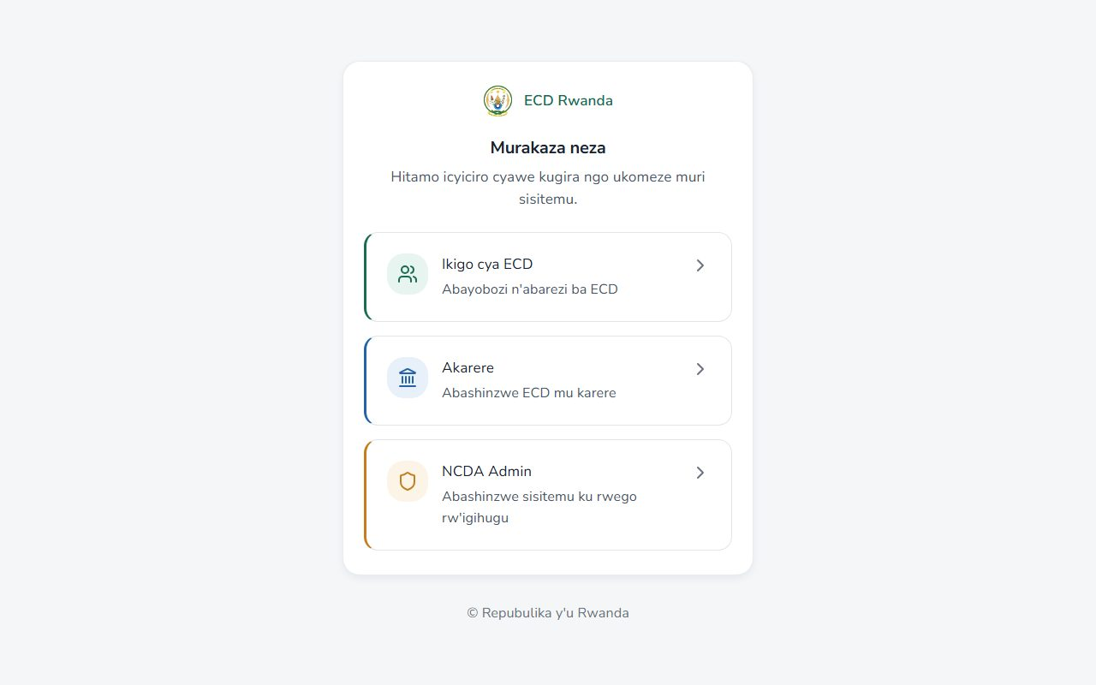

Login — Umurezi / ECD director
Route: /login/caretaker
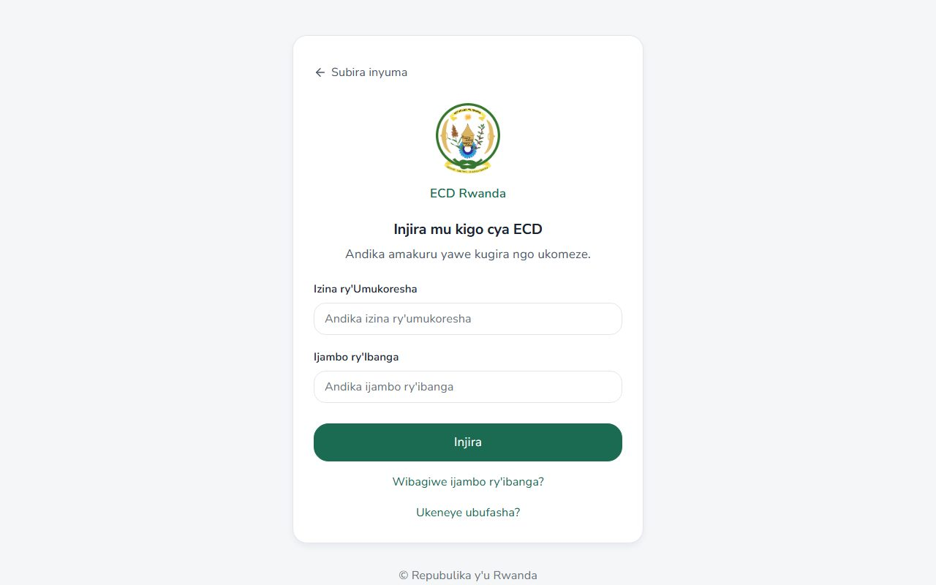

Login — Akarere
Route: /login/district
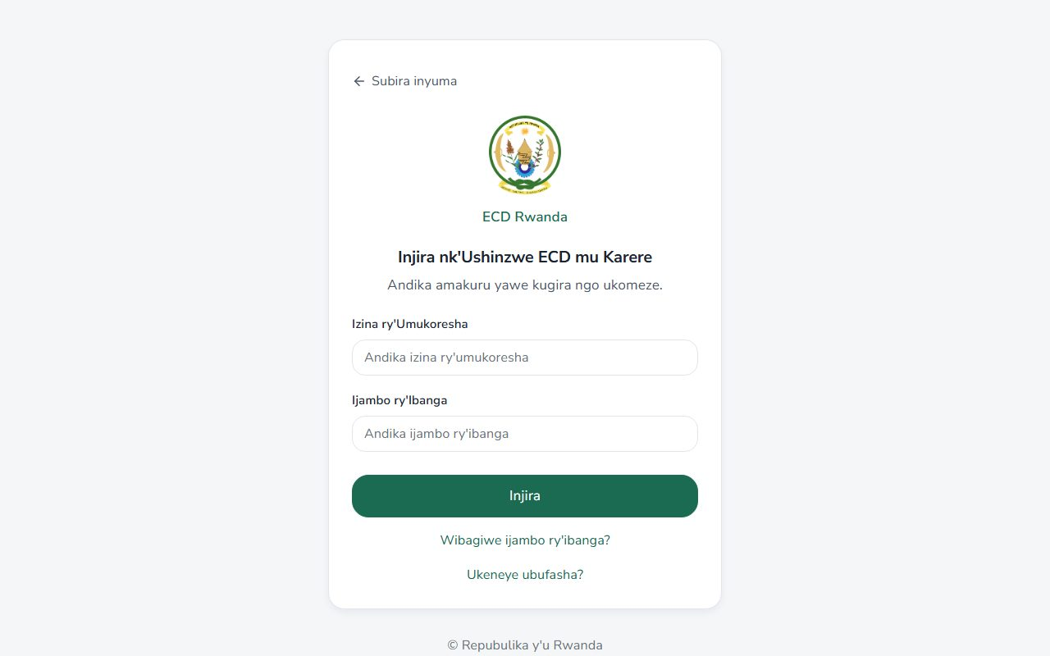

Login — NCDA
Route: /login/ncda
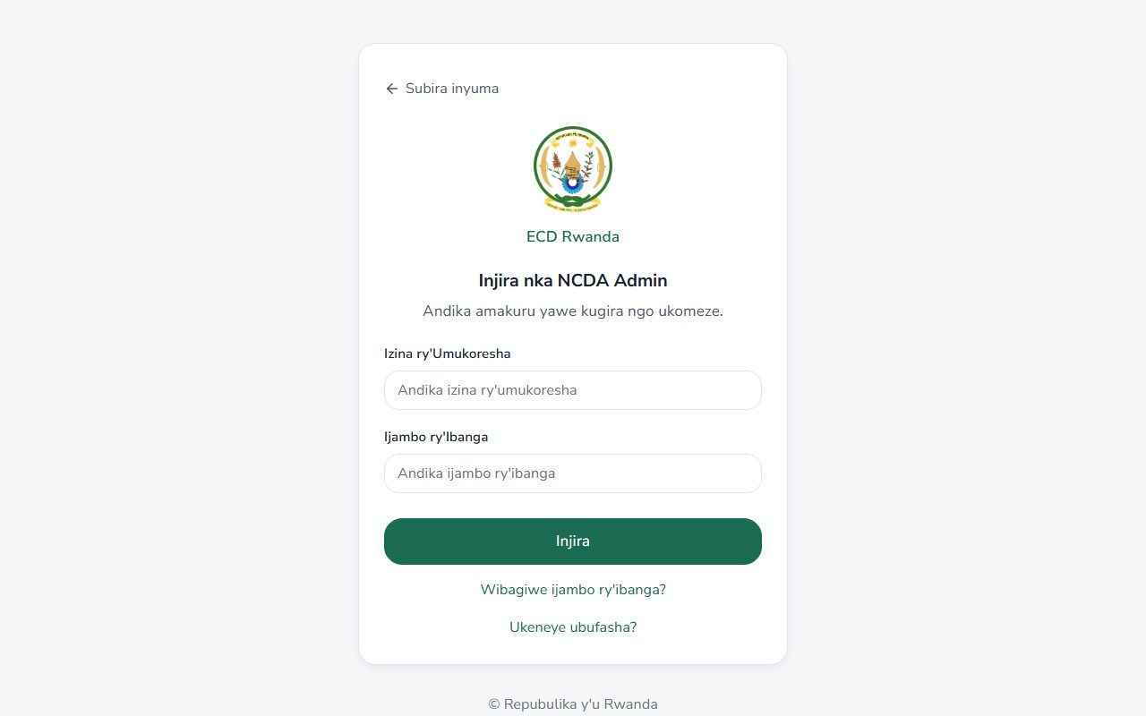

Forgot password
Route: /forgot-password
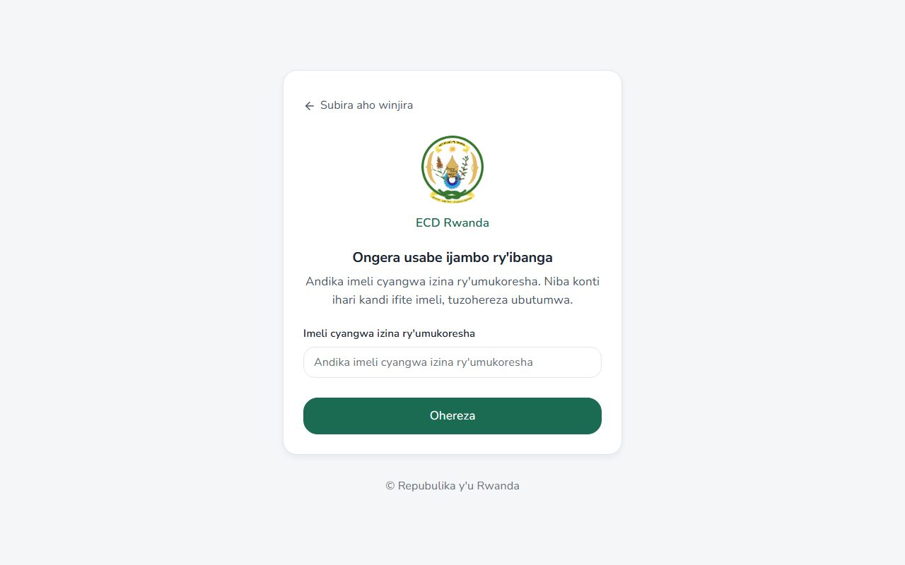

Umurezi (caretaker)

Home
Route: /caretaker
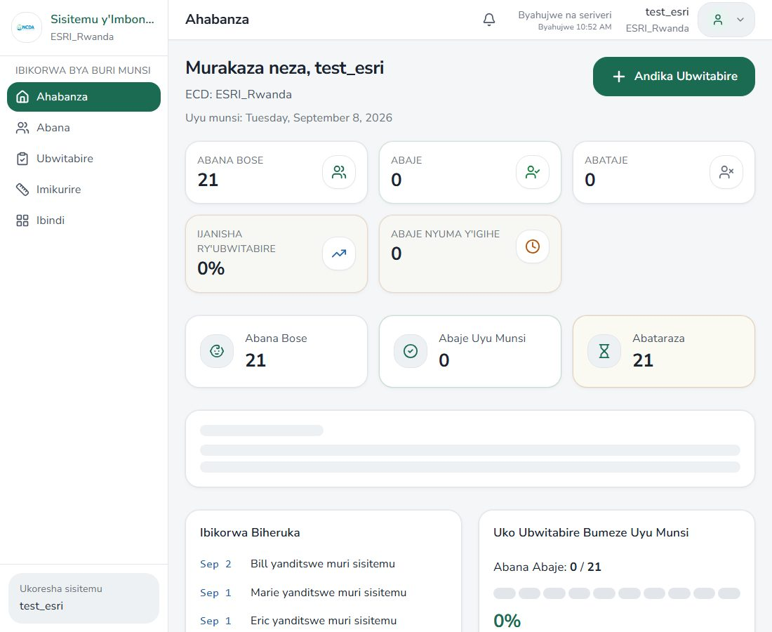

Children list
Route: /caretaker/abana
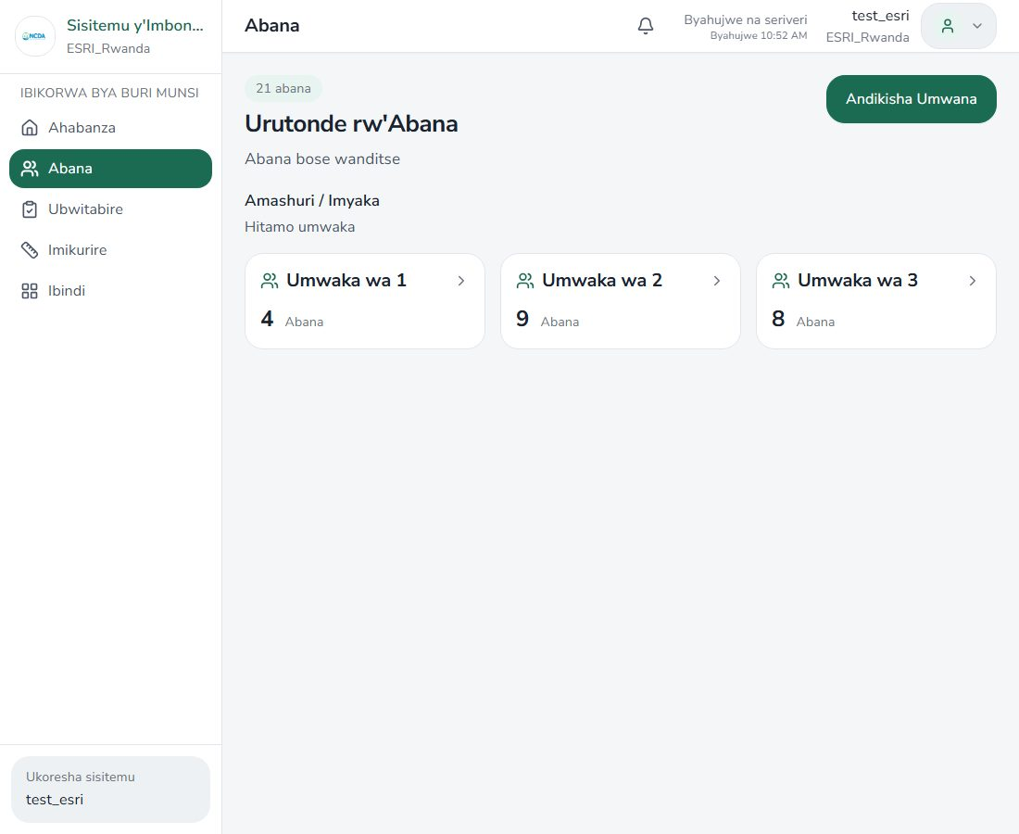

Attendance
Route: /caretaker/ubwitabire
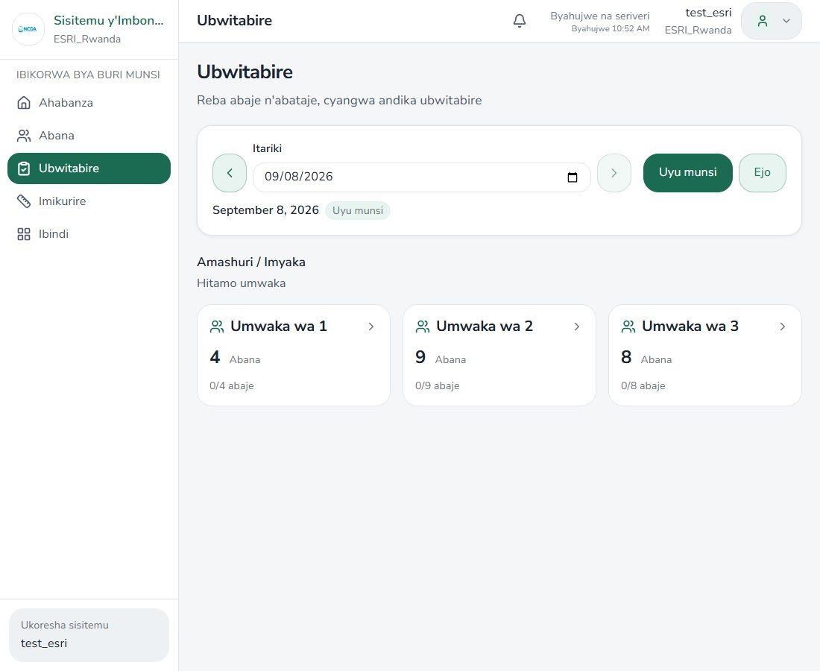

Growth
Route: /caretaker/imikurire
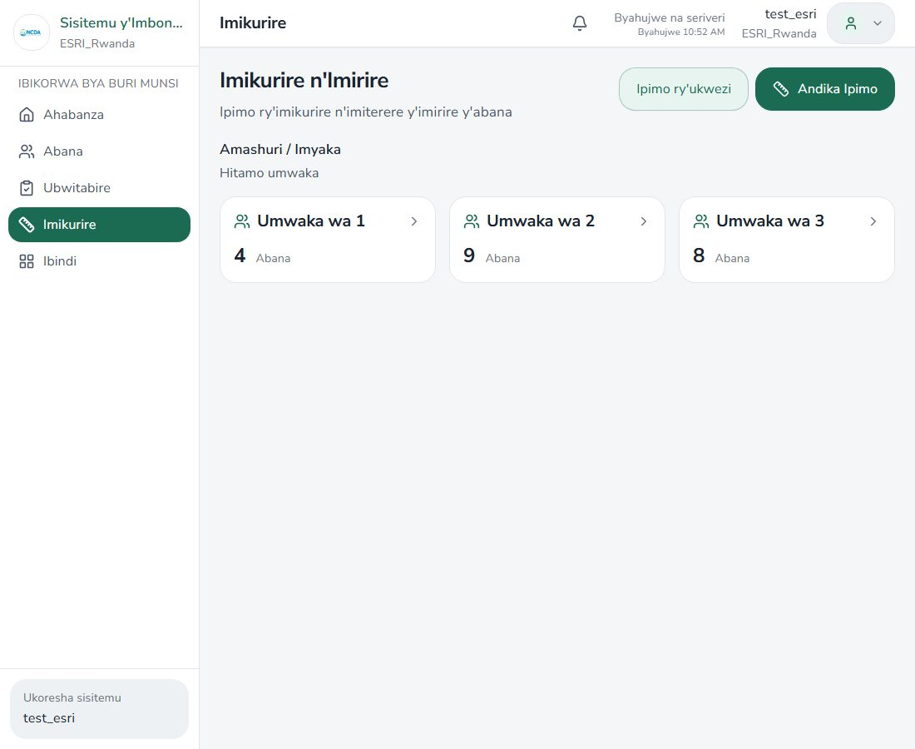

Monthly growth roster
Route: /caretaker/imikurire/ukwezi
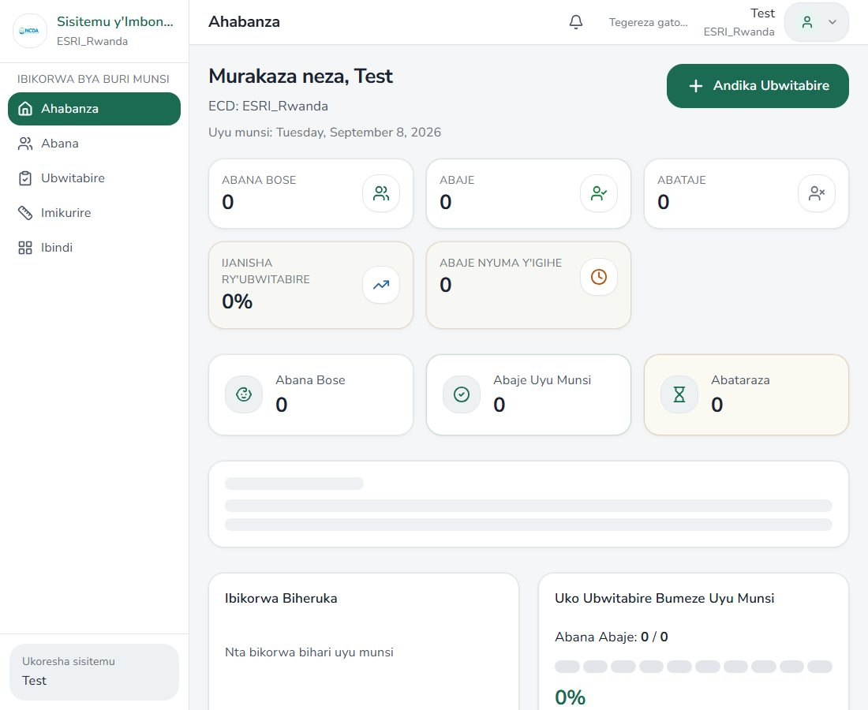

More (Ibindi)
Route: /caretaker/ibindi
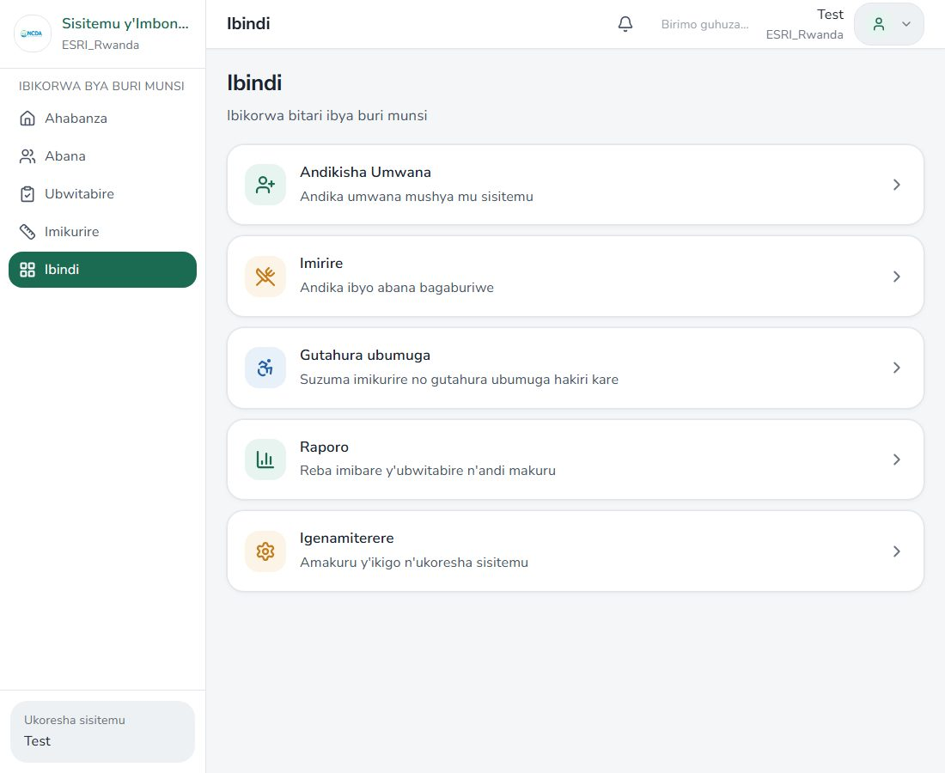

Register child
Route: /caretaker/kwiyandikisha
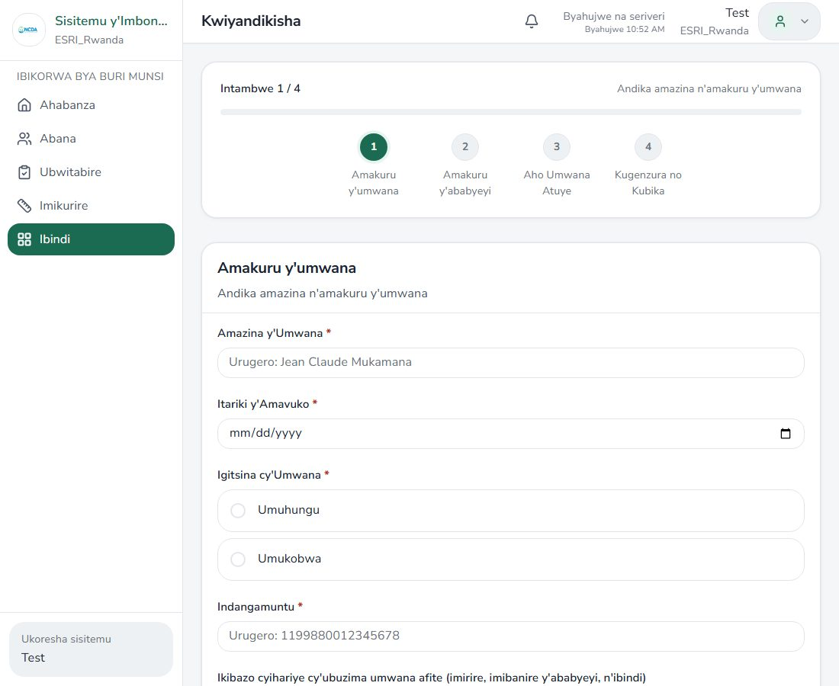

Feeding (Imirire)
Route: /caretaker/imirire
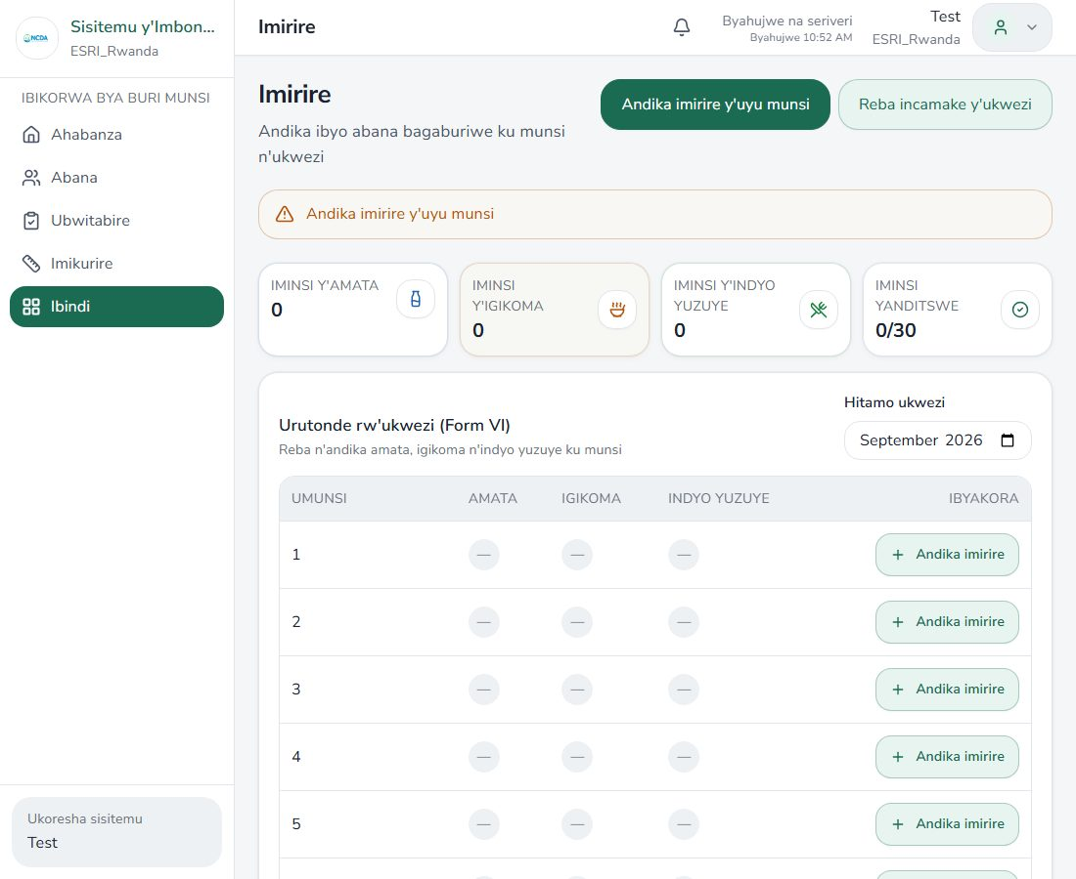

Feeding monthly report
Route: /caretaker/imirire/raporo
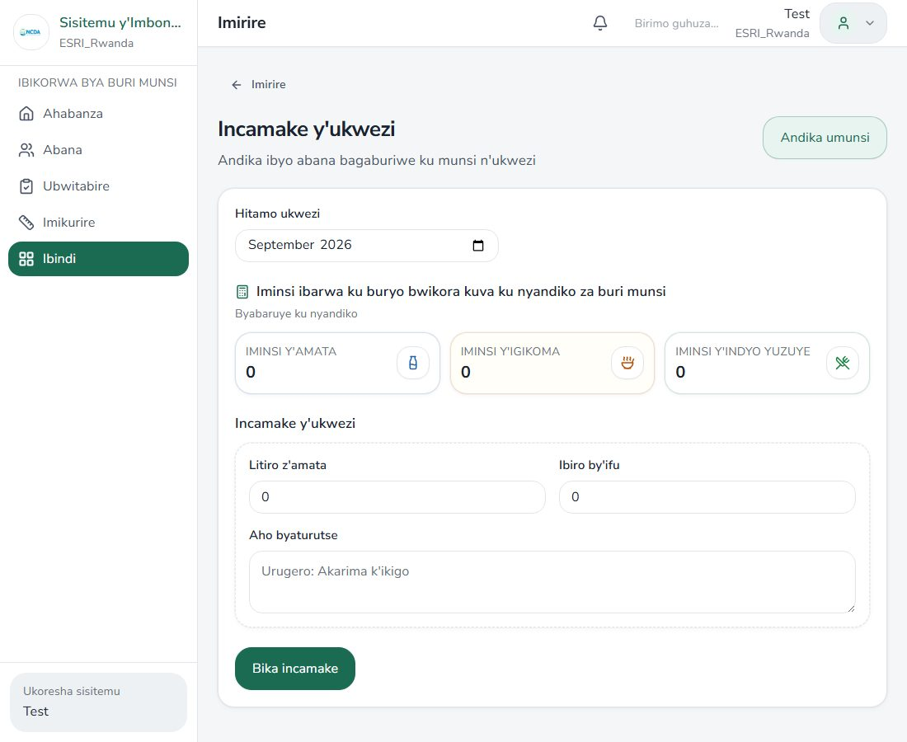

STED
Route: /caretaker/sted
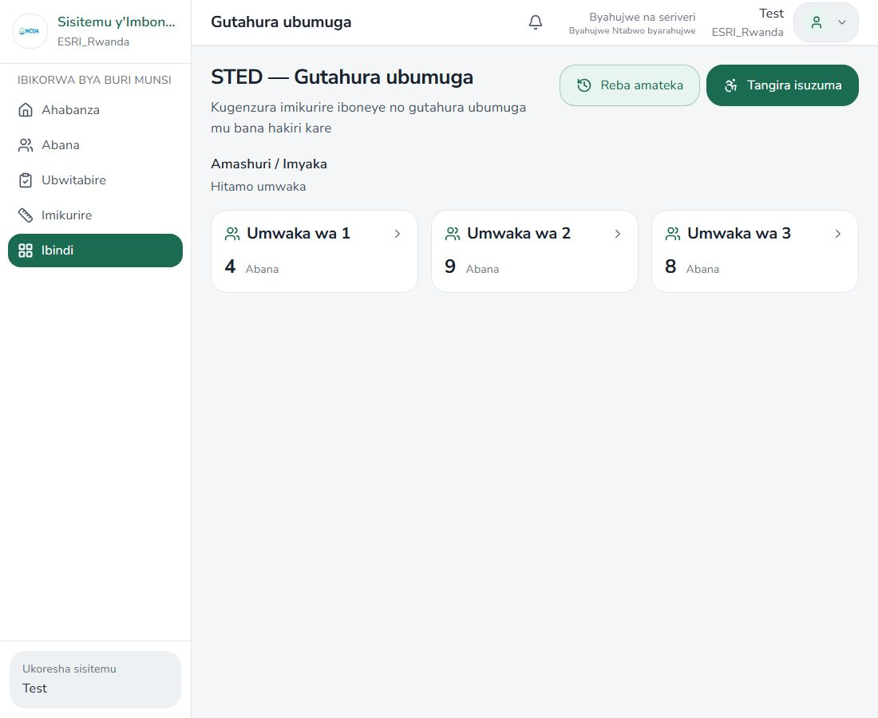

STED wizard
Route: /caretaker/sted/new


STED history
Route: /caretaker/sted/amateka
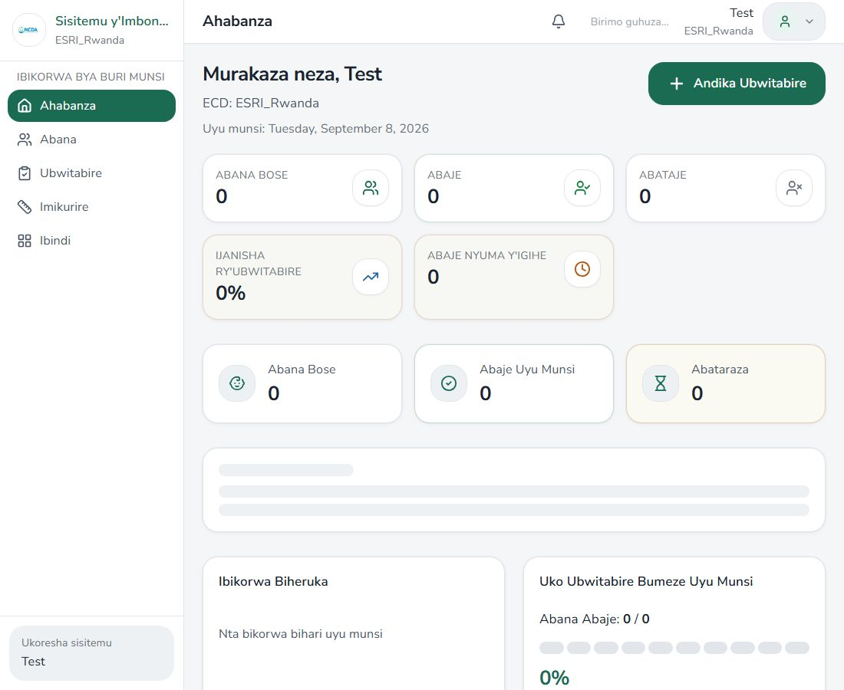

Notifications
Route: /caretaker/amatangazo


Impugukirwa
Route: /caretaker/impugukirwa
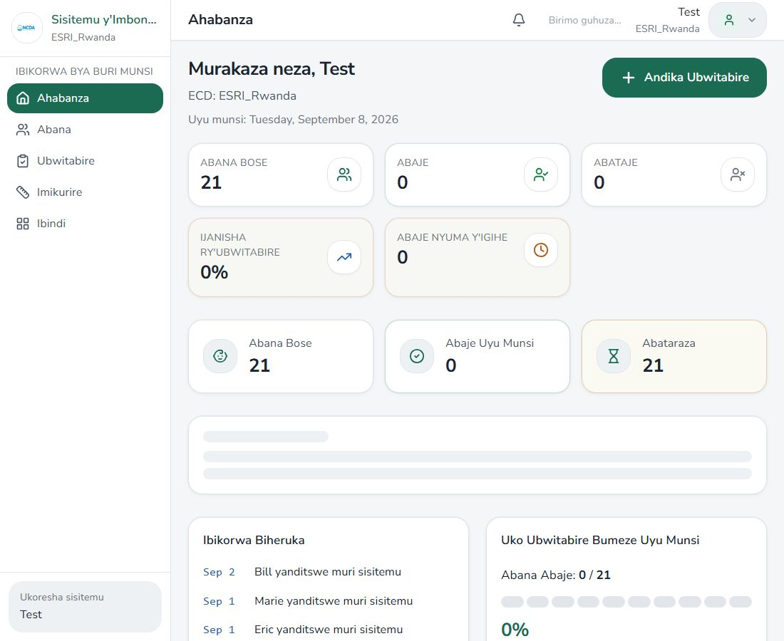

Reports
Route: /caretaker/raporo
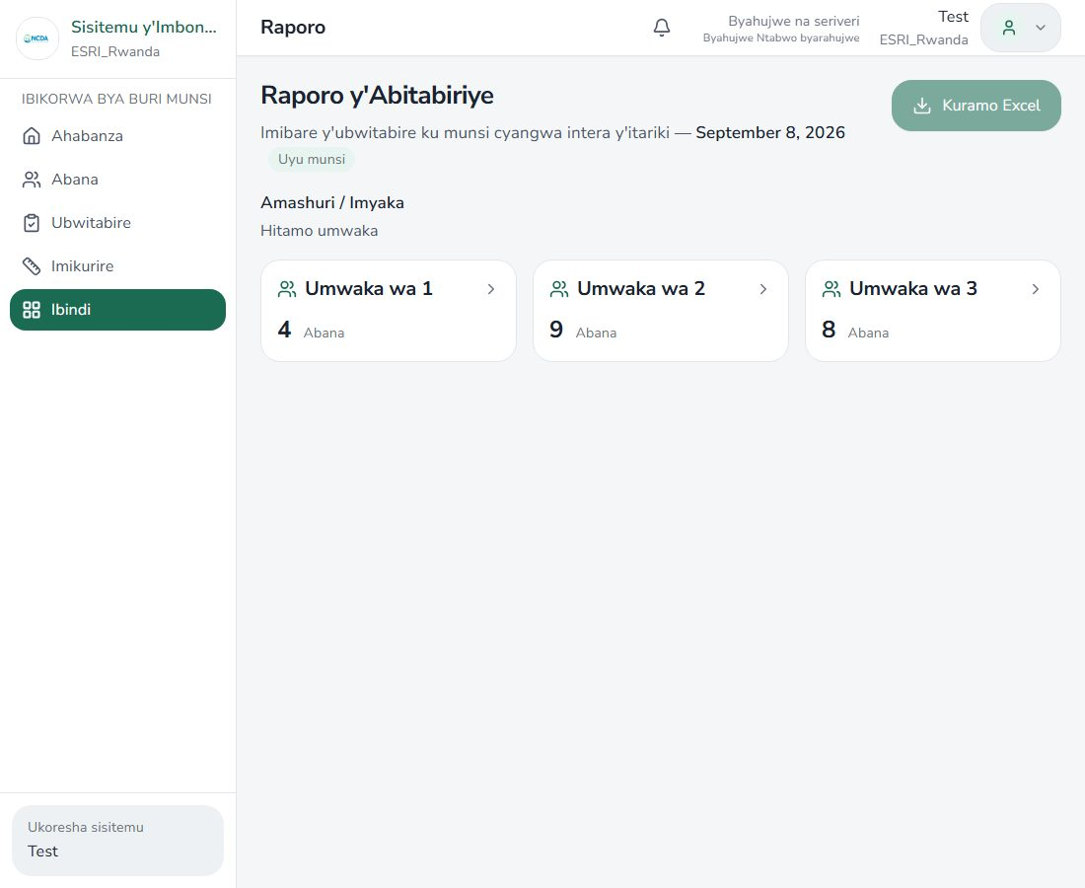

Settings
Route: /caretaker/igenamiterere
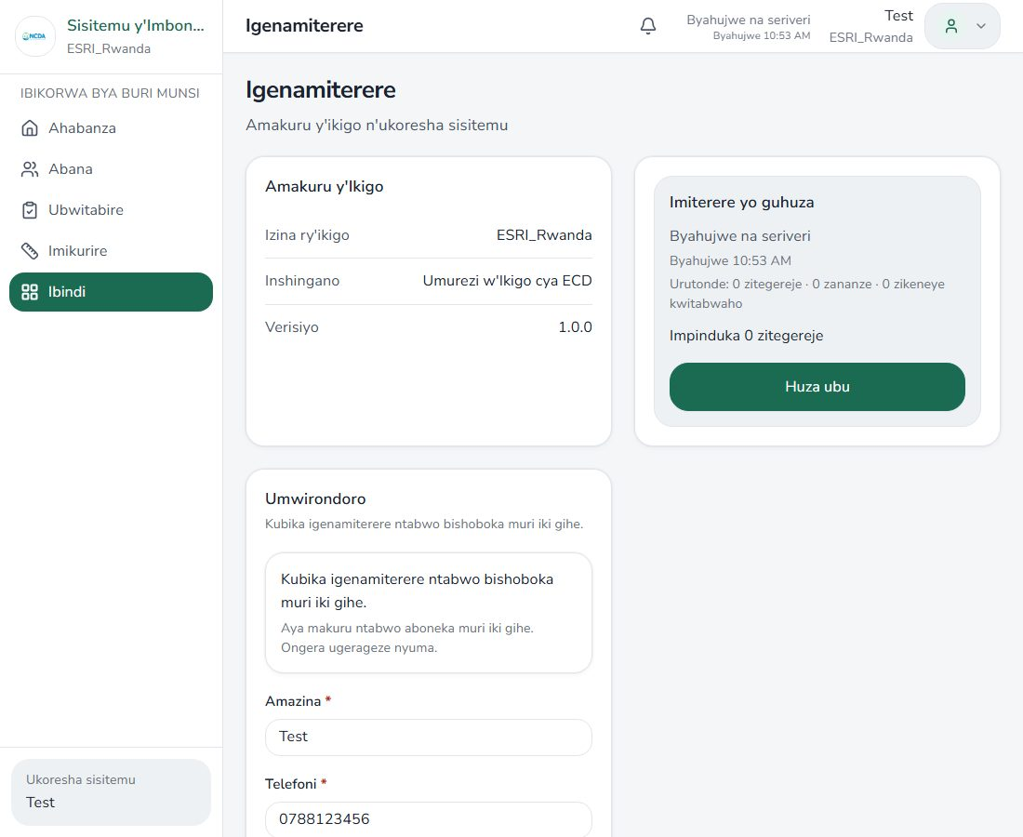

ECD director

Home
Route: /caretaker
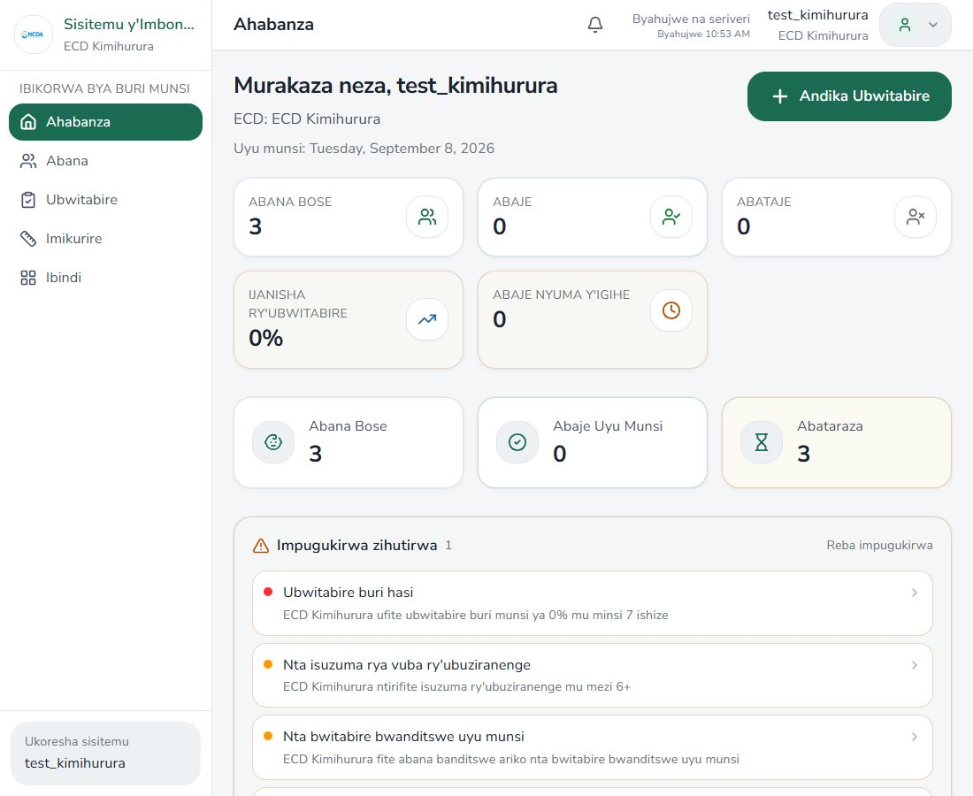

Center overview (Ikigo)
Route: /caretaker/ikigo
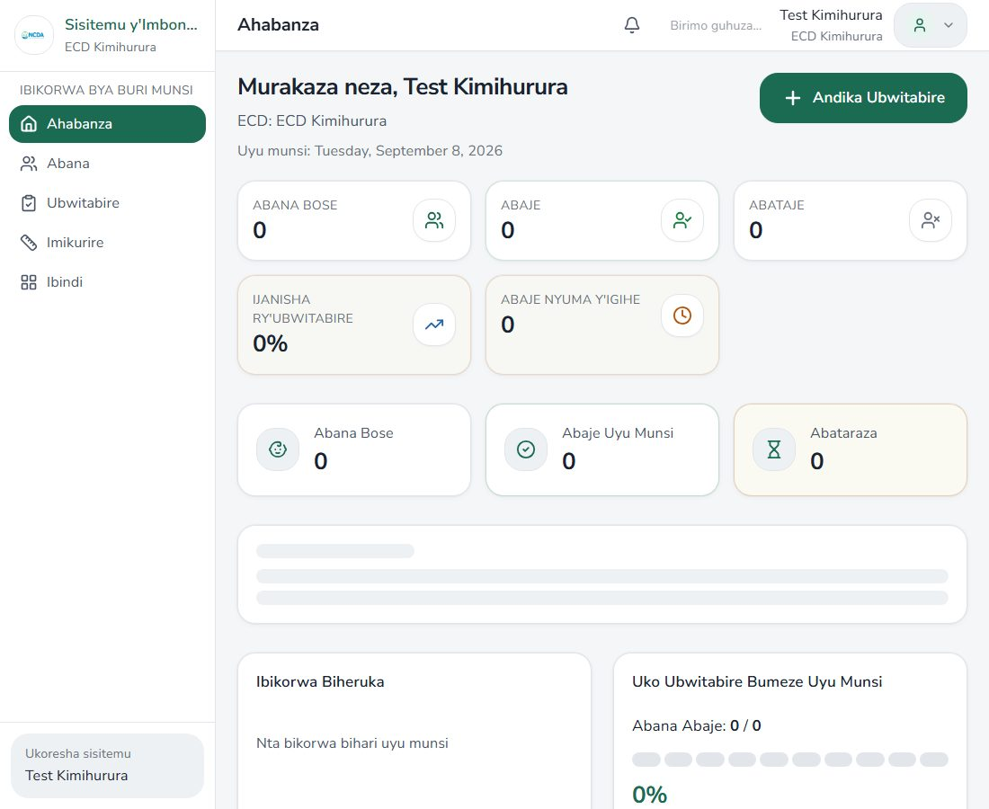

Management hub
Route: /caretaker/imicungire


Center users
Route: /caretaker/abakoresha


Transfers
Route: /caretaker/kwimura
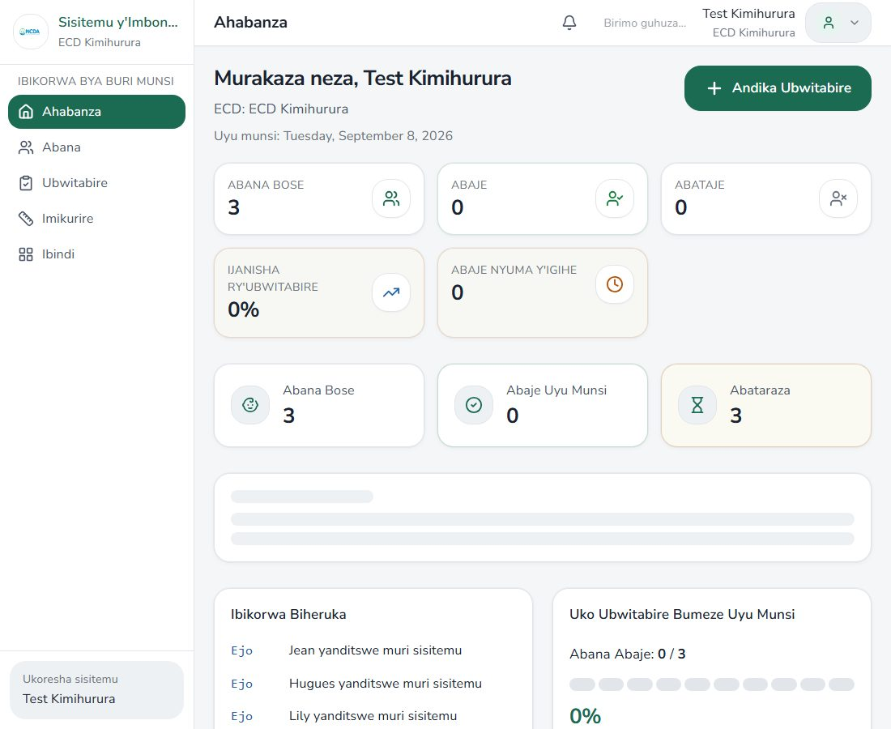

Self-evaluation
Route: /caretaker/isuzuma


Self-evaluation wizard
Route: /caretaker/isuzuma/new


ECD Book hub
Route: /caretaker/igitabo
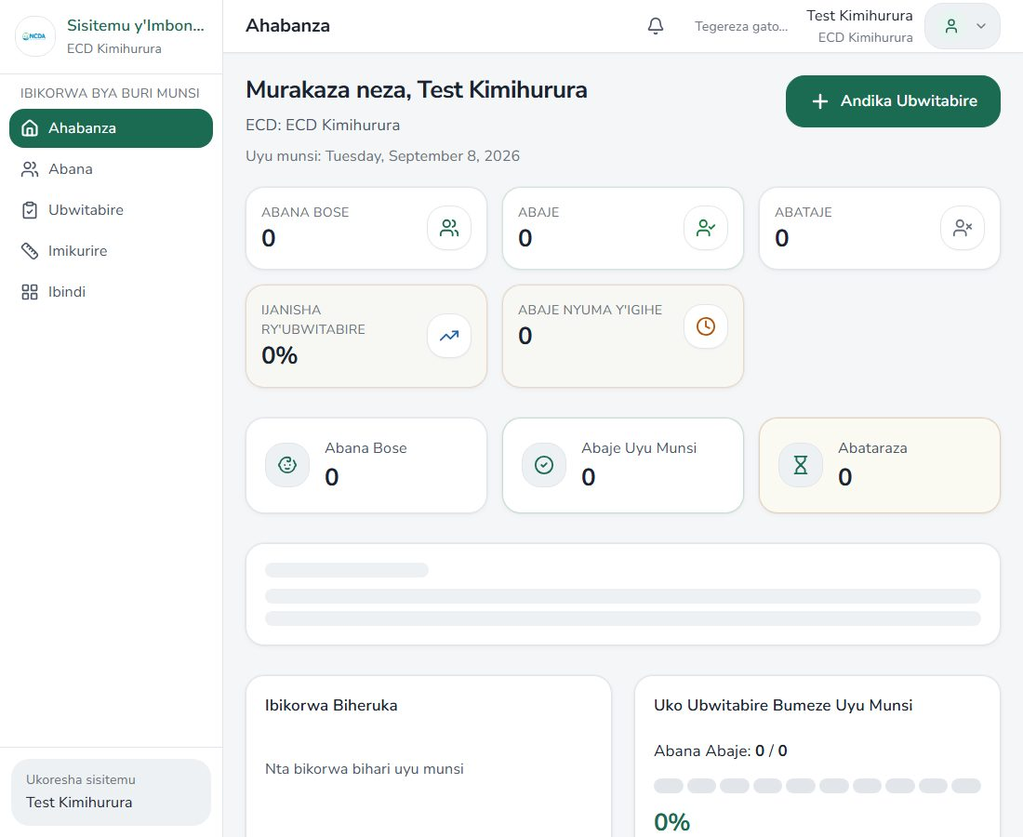

Book VIII — Parent contributions
Route: /caretaker/igitabo/umusanzu


Book IX — Parenting sessions
Route: /caretaker/igitabo/ibiganiro


Book X — Committee (capture failed)
Route: /caretaker/igitabo/komite
Capture error: Page.screenshot: Protocol error (Page.captureScreenshot): Unable to capture screenshot
Call log:
- taking page screenshot
- disabled all CSS animations
- waiting for fonts to load...
- fonts loaded

Book XI — Educators
Route: /caretaker/igitabo/abarezi


Book XII — Support
Route: /caretaker/igitabo/ubufasha


Book XIII — Visitors
Route: /caretaker/igitabo/abashyitsi


Book XIV — Staff training
Route: /caretaker/igitabo/amahugurwa


Children list
Route: /caretaker/abana
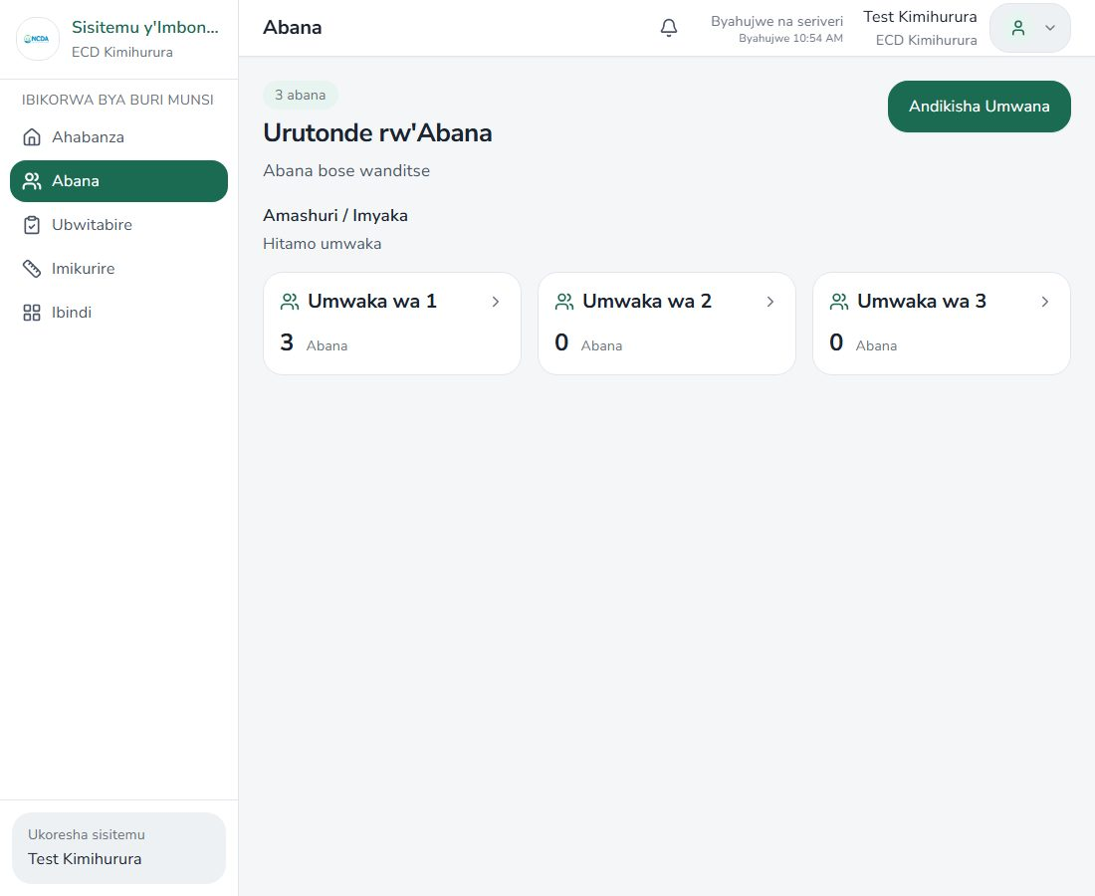

Attendance
Route: /caretaker/ubwitabire
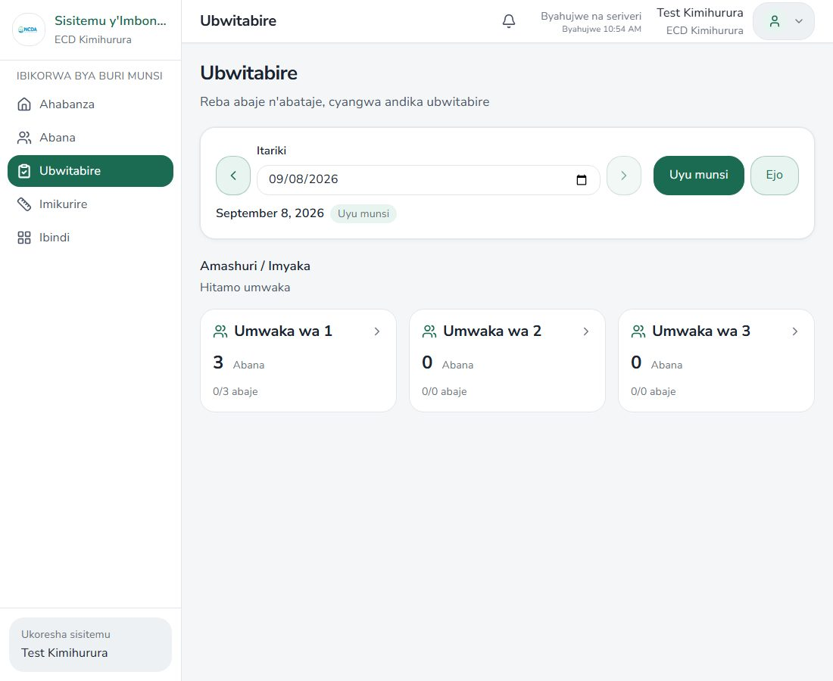

Growth
Route: /caretaker/imikurire
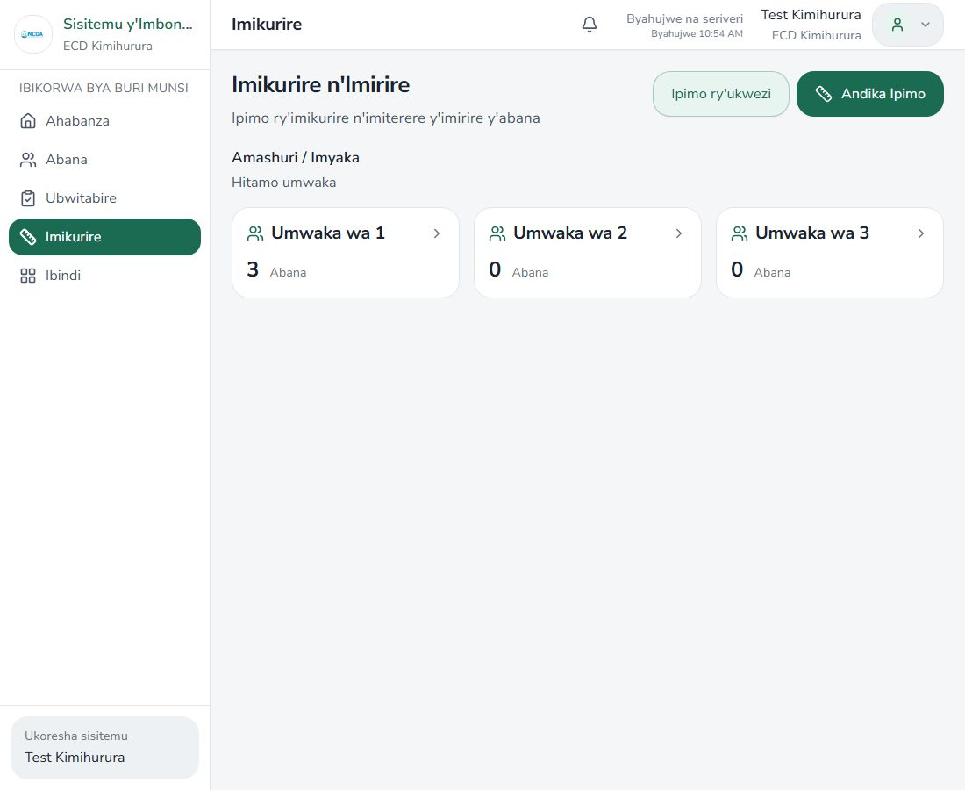

Notifications
Route: /caretaker/amatangazo


Impugukirwa
Route: /caretaker/impugukirwa


Settings
Route: /caretaker/igenamiterere


Akarere (district)

Dashboard
Route: /district
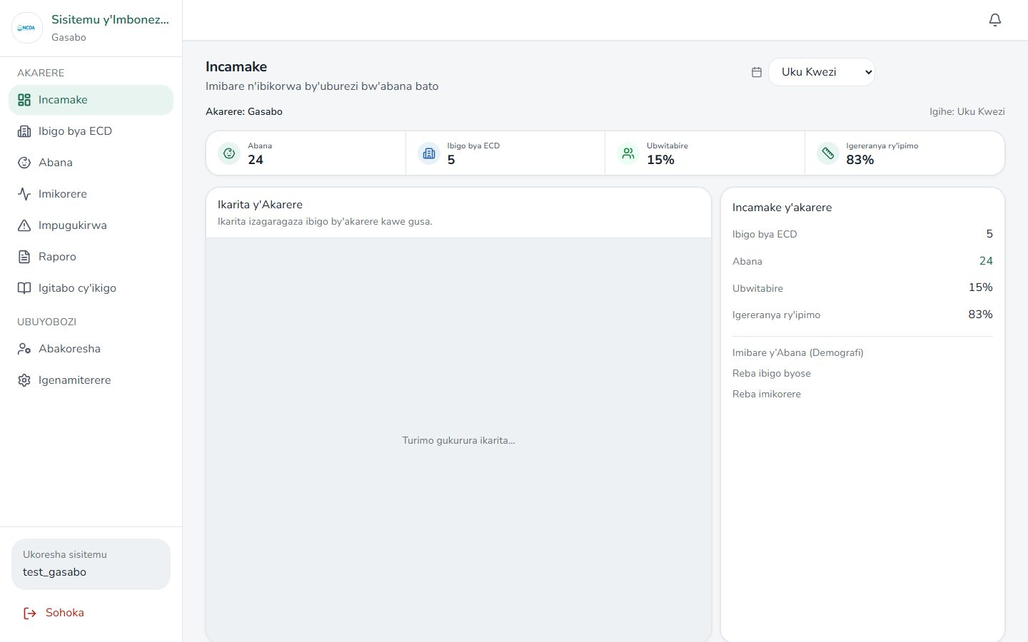

Centers
Route: /district/ibigo
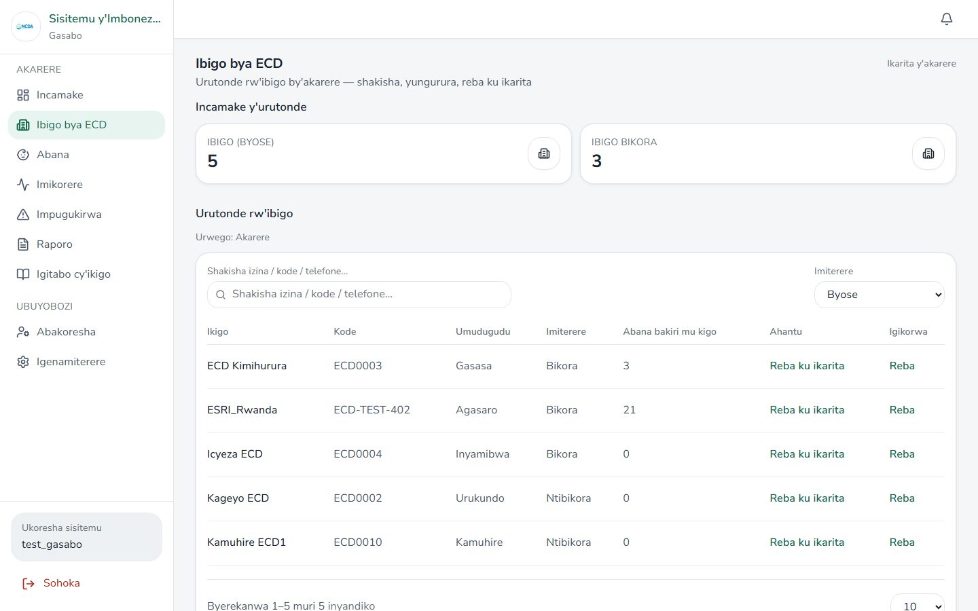

Center detail
Route: /district/ibigo/ECD0003
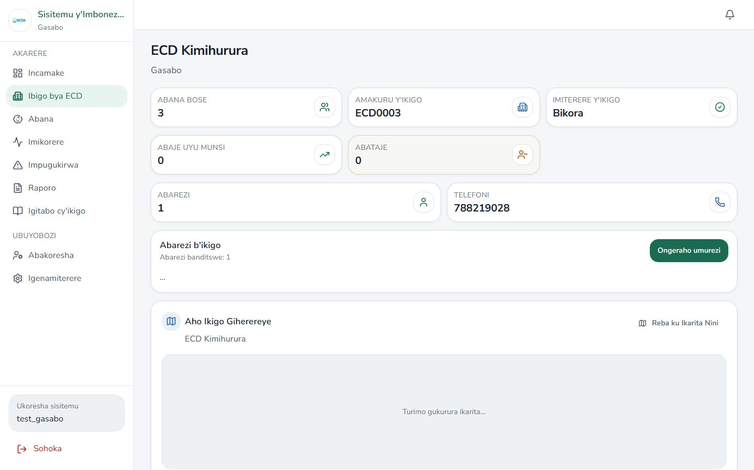

Children
Route: /district/abana
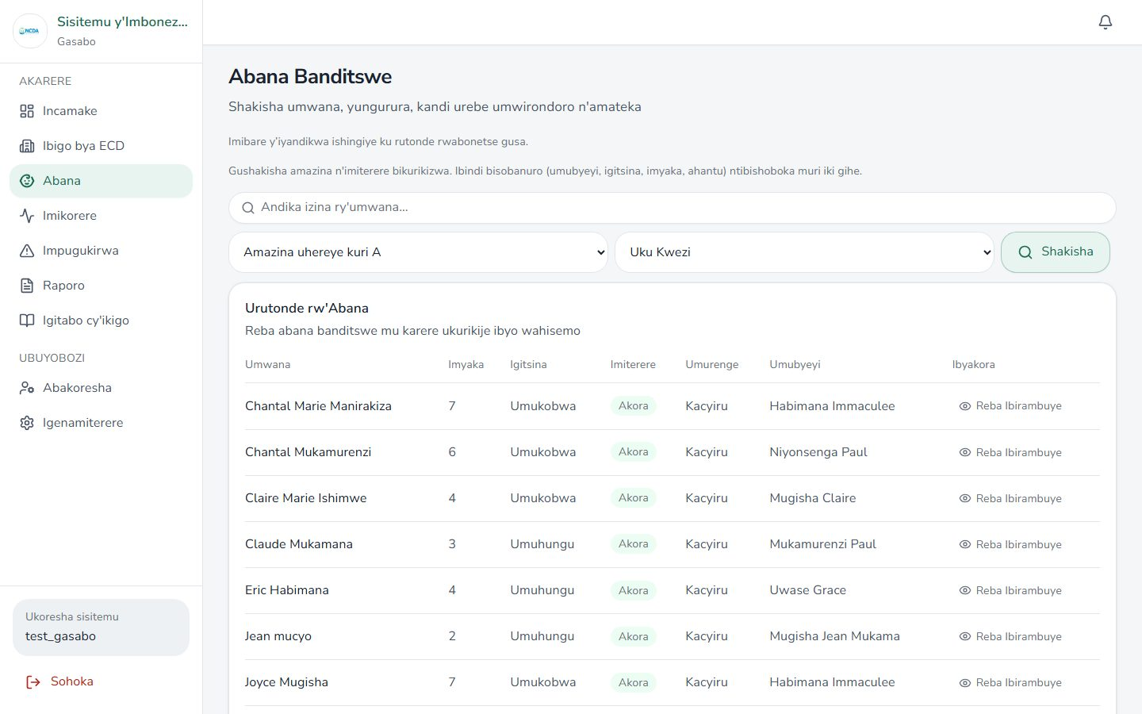

Child detail
Route: /district/abana/f62e3d8e-9961-44ce-89df-e16514b88712
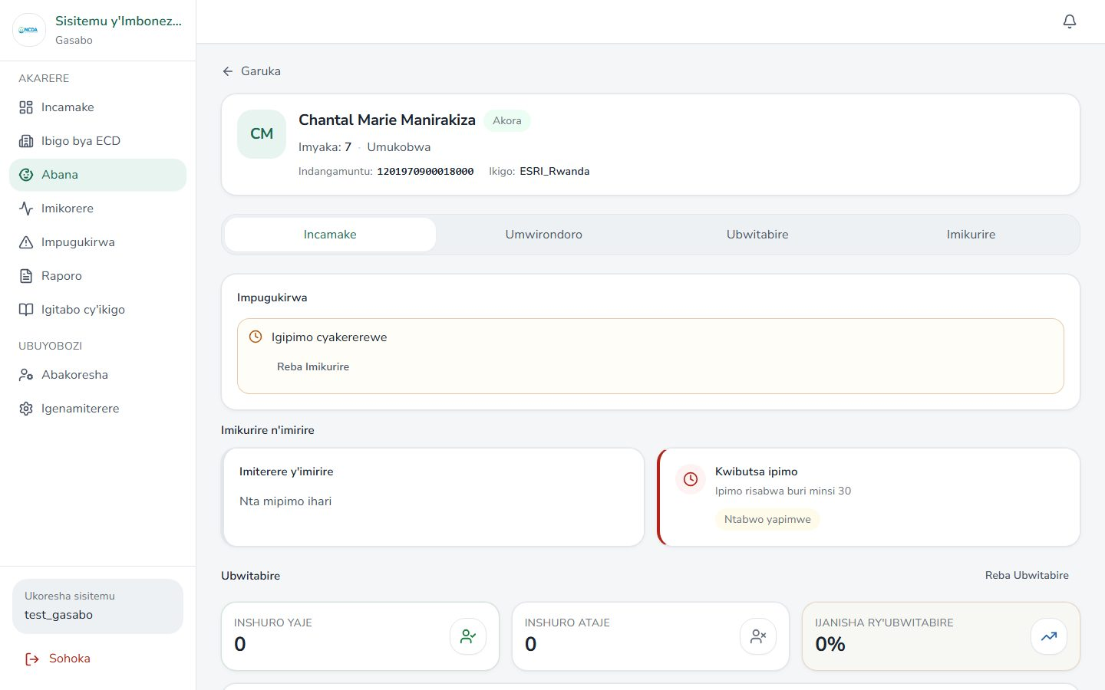

Demographics
Route: /district/demografi
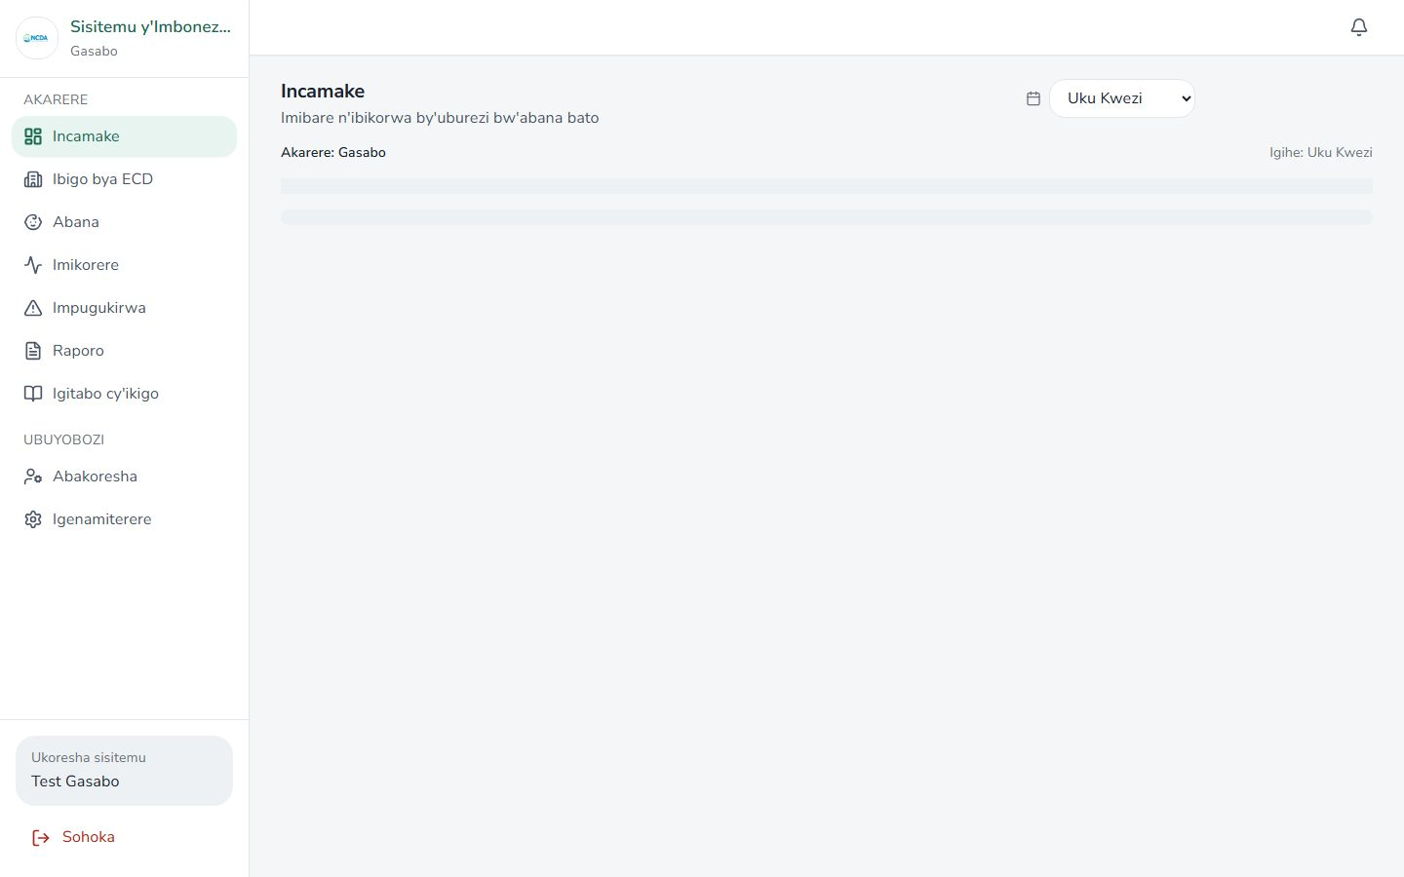

Imikorere overview
Route: /district/imikorere
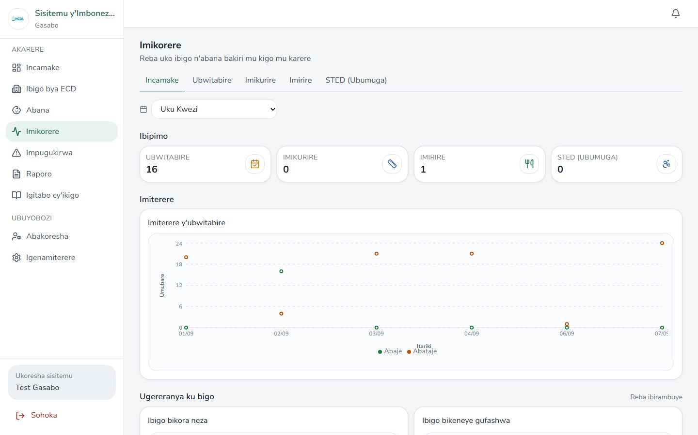

Imikorere — Attendance
Route: /district/imikorere/ubwitabire
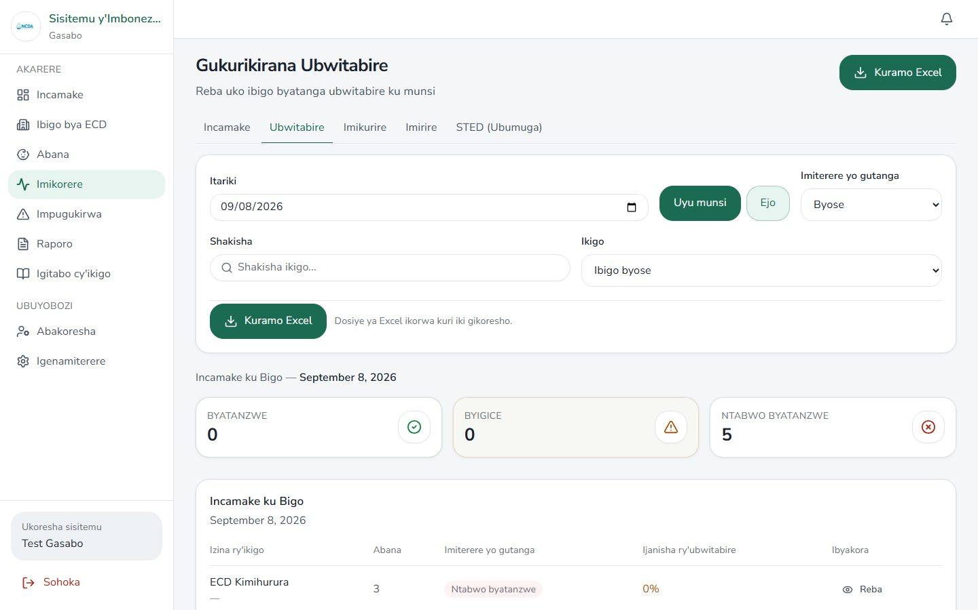

Imikorere — Growth
Route: /district/imikorere/imikurire
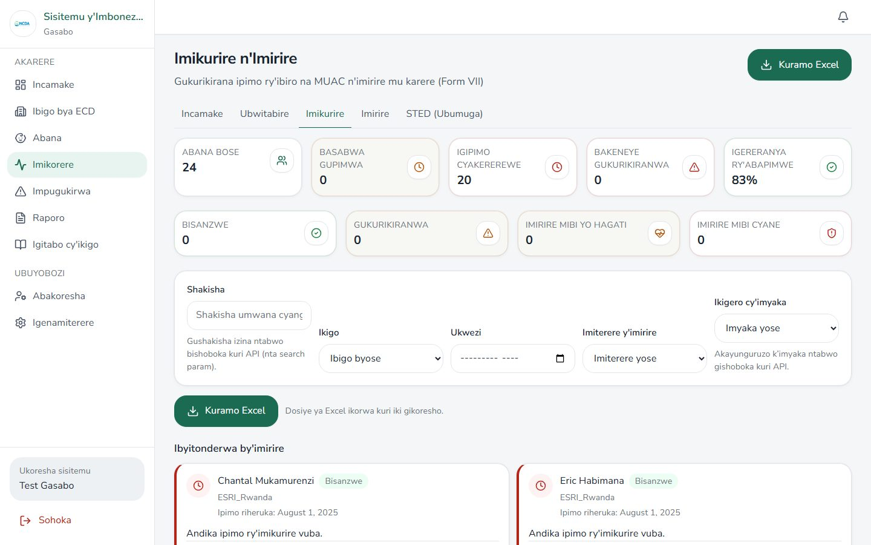

Imikorere — Feeding
Route: /district/imikorere/imirire
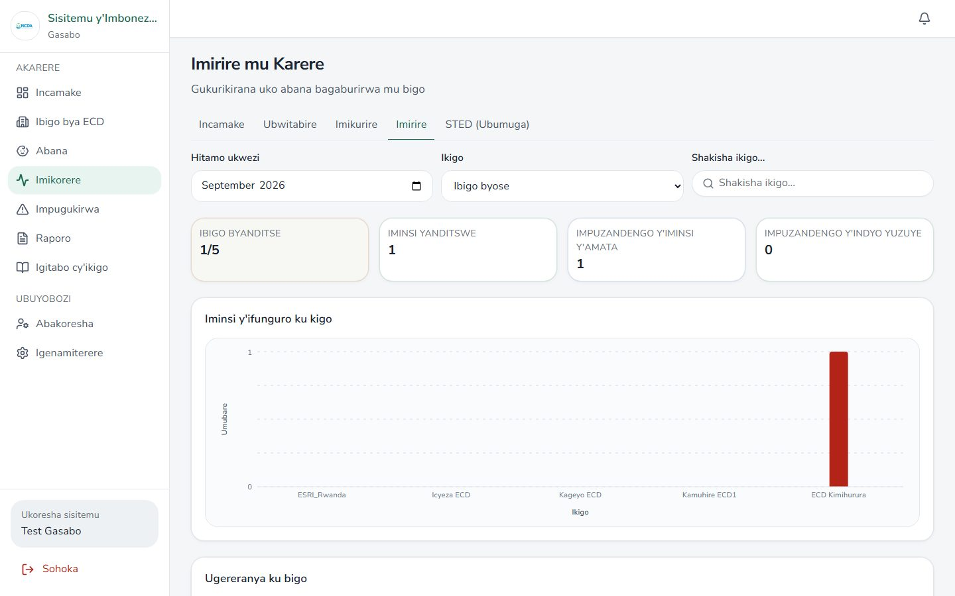

Imikorere — STED
Route: /district/imikorere/sted
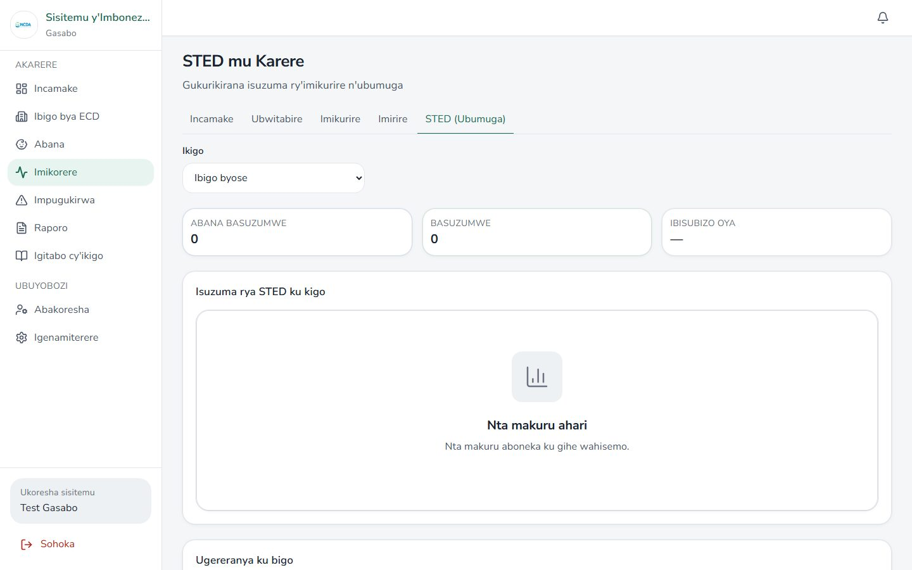

Impugukirwa
Route: /district/impugukirwa
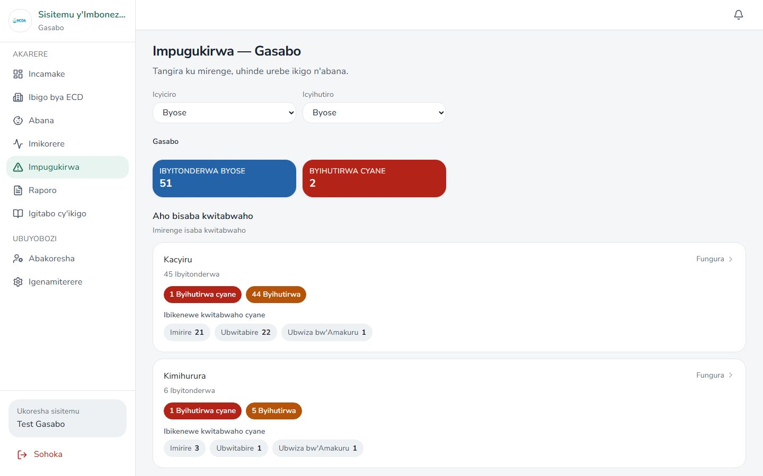

Notifications
Route: /district/amatangazo


Reports
Route: /district/raporo
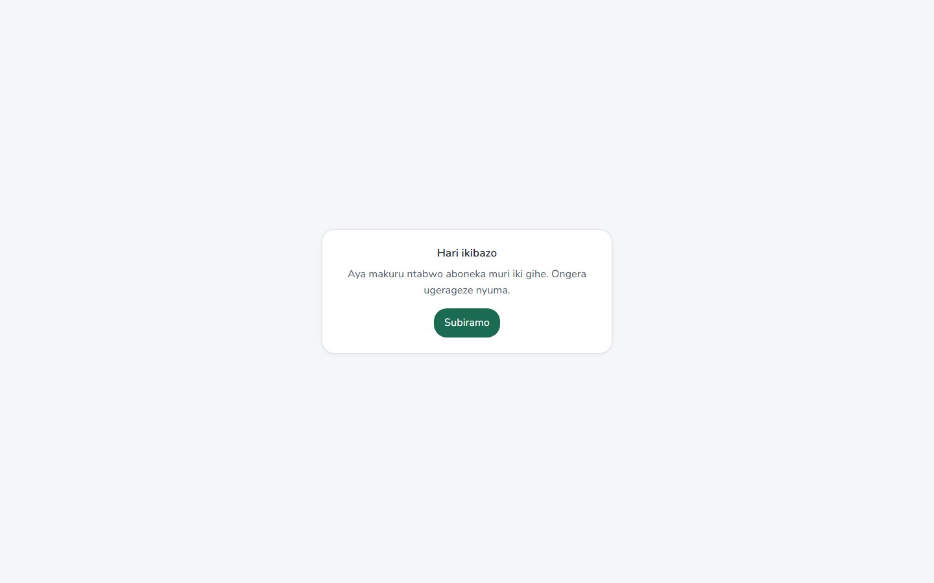

Referrals
Route: /district/referrals


Map (Ikarita)
Route: /district/ikarita
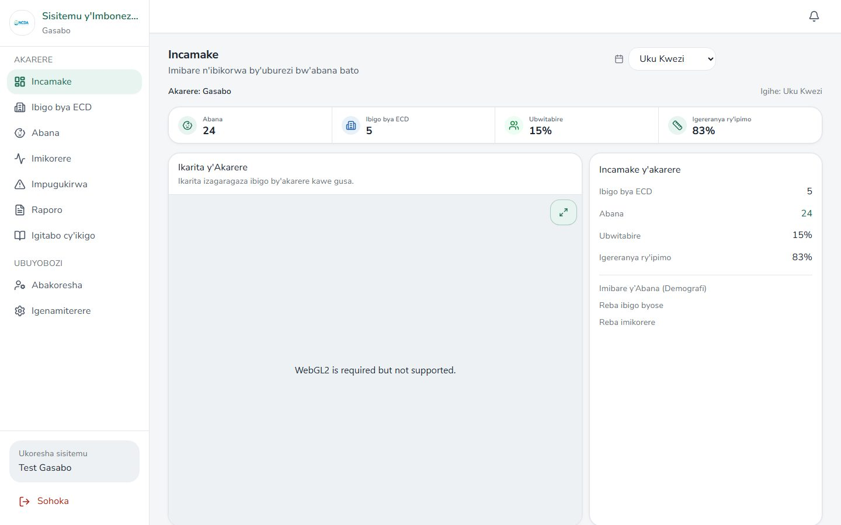

ECD Book hub
Route: /district/igitabo
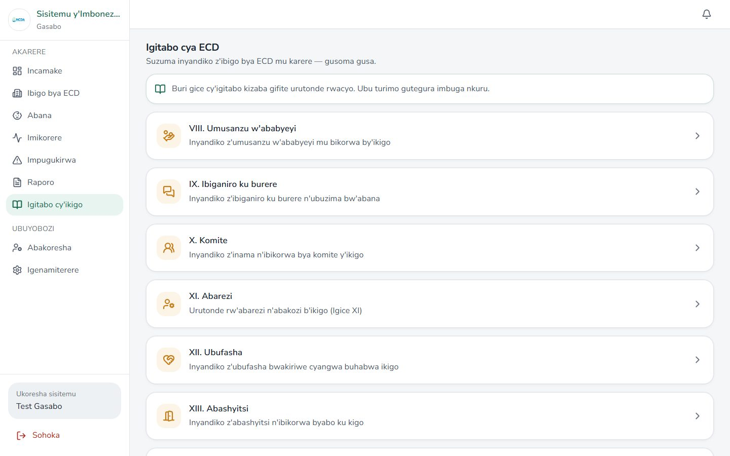

Book — Parent contributions
Route: /district/igitabo/umusanzu


Book — Parenting sessions
Route: /district/igitabo/ibiganiro


Book — Committee
Route: /district/igitabo/komite


Book — Educators
Route: /district/igitabo/abarezi


Book — Support
Route: /district/igitabo/ubufasha


Book — Visitors
Route: /district/igitabo/abashyitsi


Book — Staff training
Route: /district/igitabo/amahugurwa


Caregivers
Route: /district/abakoresha
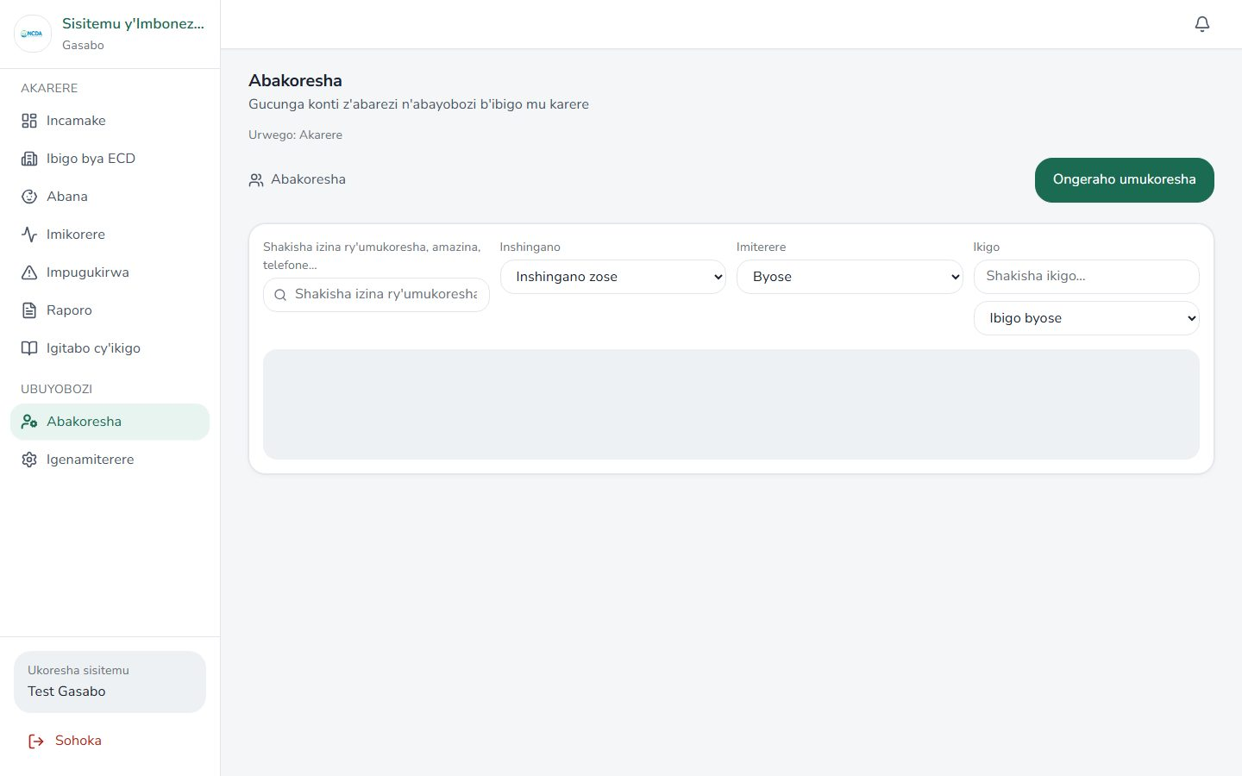

Settings
Route: /district/igenamiterere
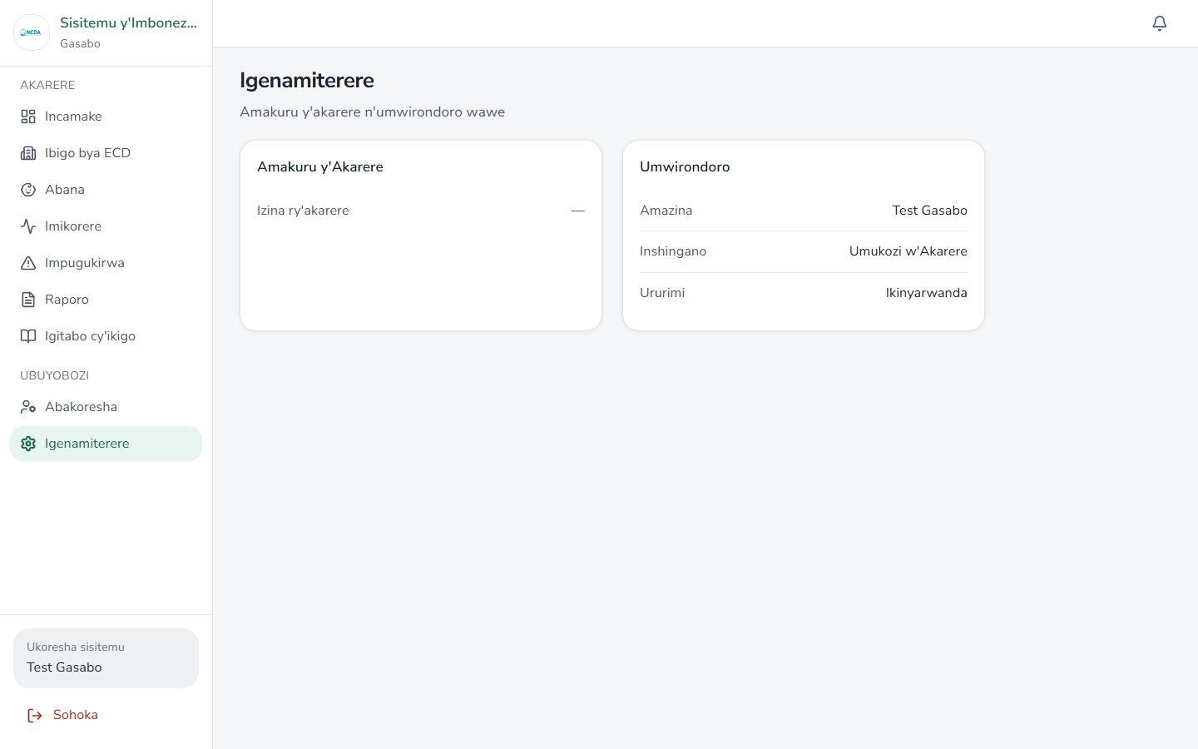

NCDA admin

Overview dashboard
Route: /ncda/dashboard
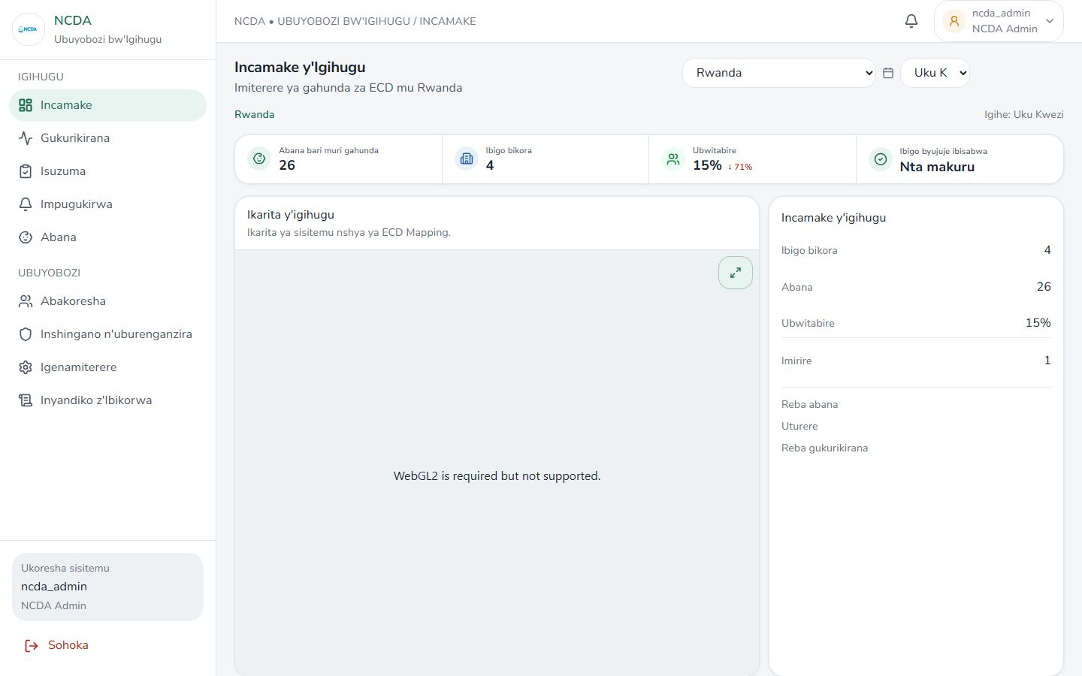

Gukurikirana overview
Route: /ncda/gukurikirana
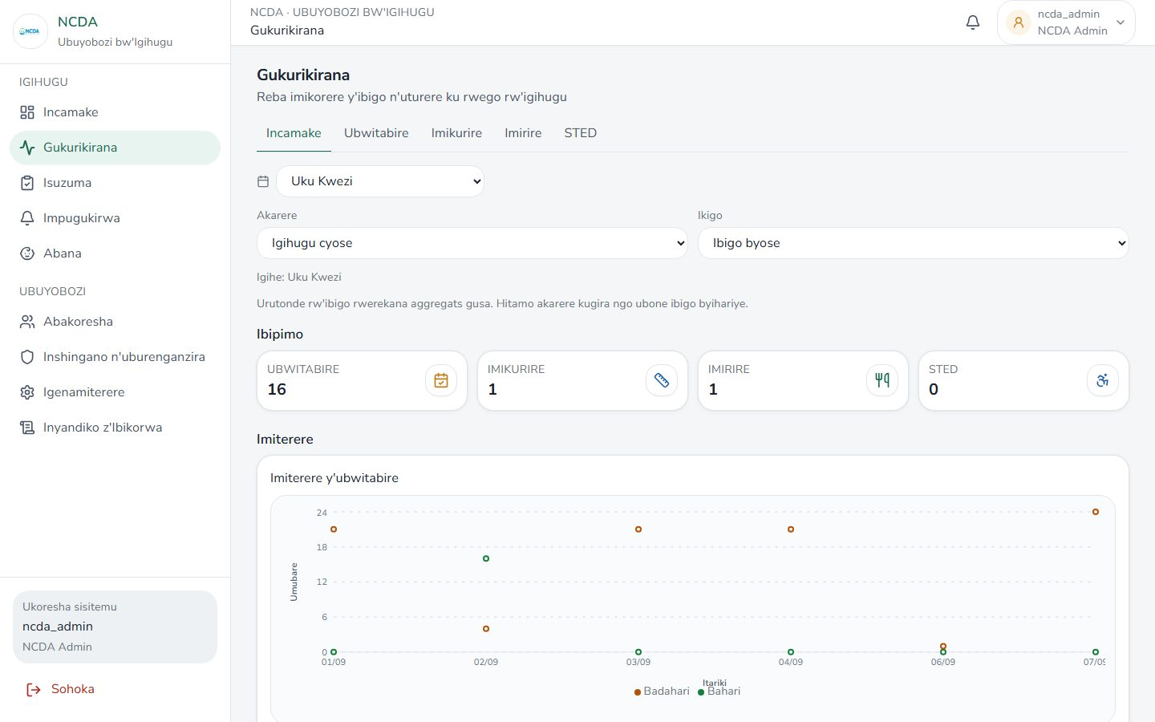

Gukurikirana — Attendance
Route: /ncda/gukurikirana/ubwitabire
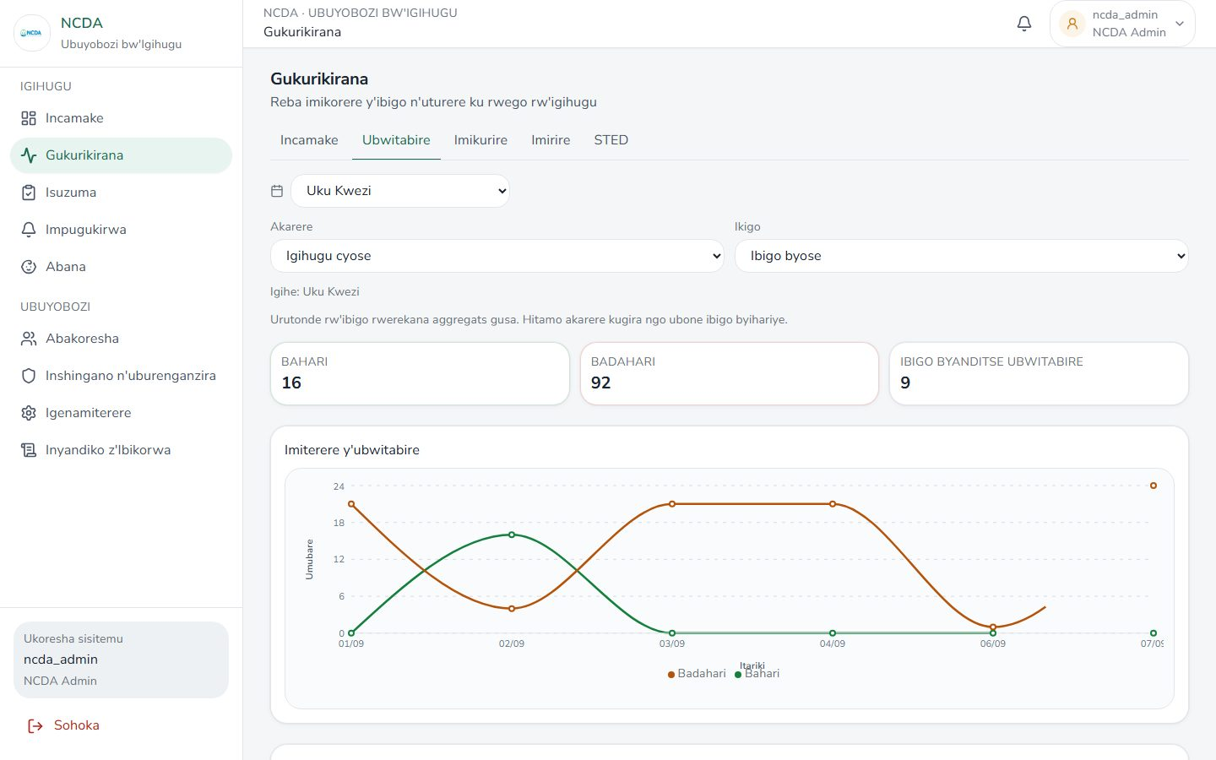

Gukurikirana — Growth
Route: /ncda/gukurikirana/imikurire
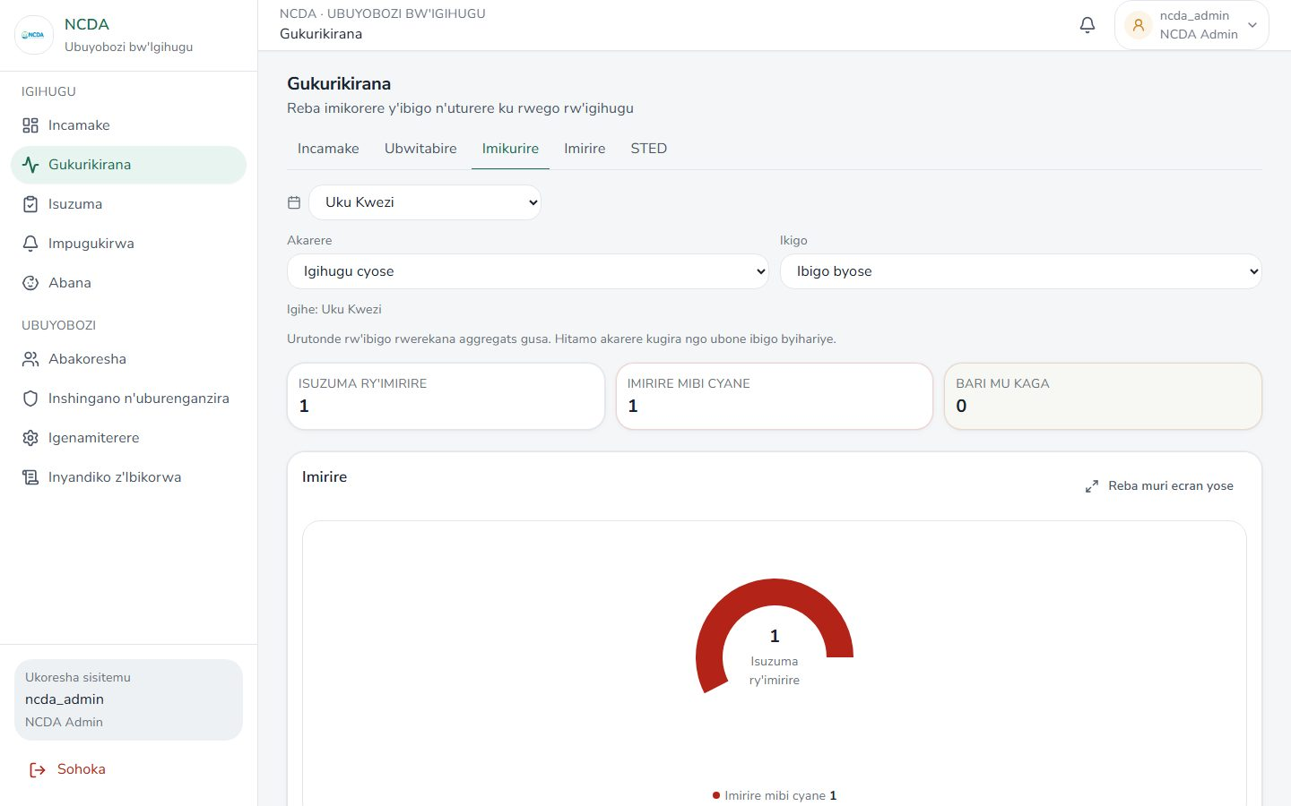

Gukurikirana — Feeding
Route: /ncda/gukurikirana/imirire
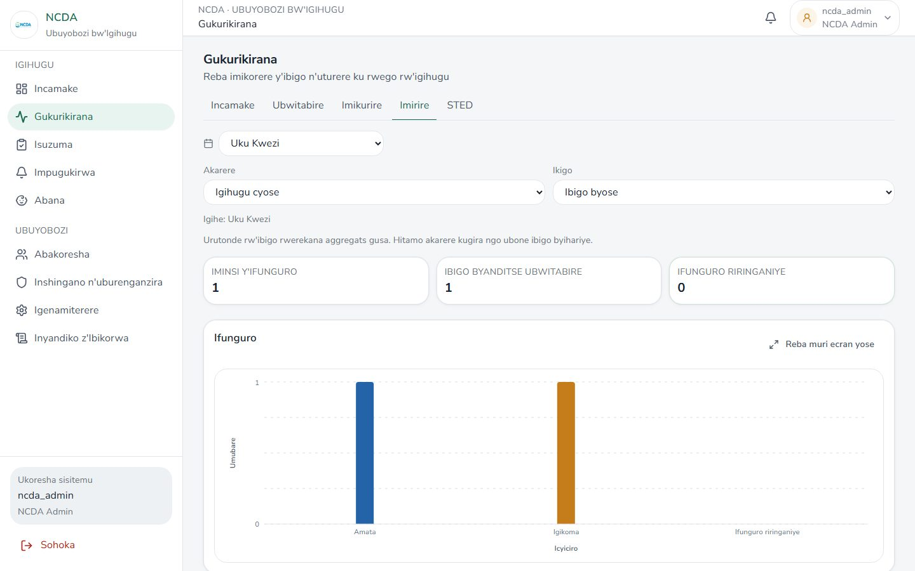

Gukurikirana — STED
Route: /ncda/gukurikirana/sted
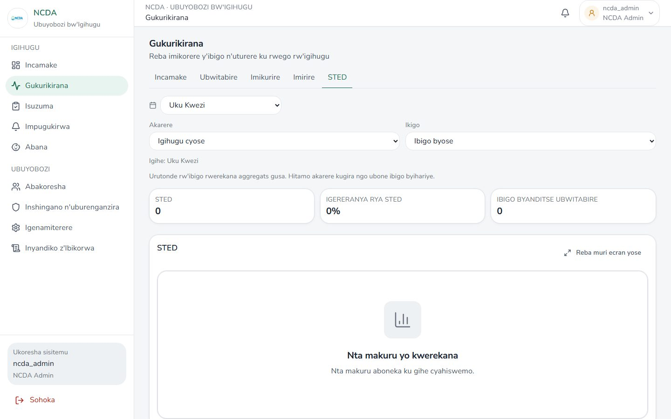

Impugukirwa
Route: /ncda/gukurikirana/impugukirwa
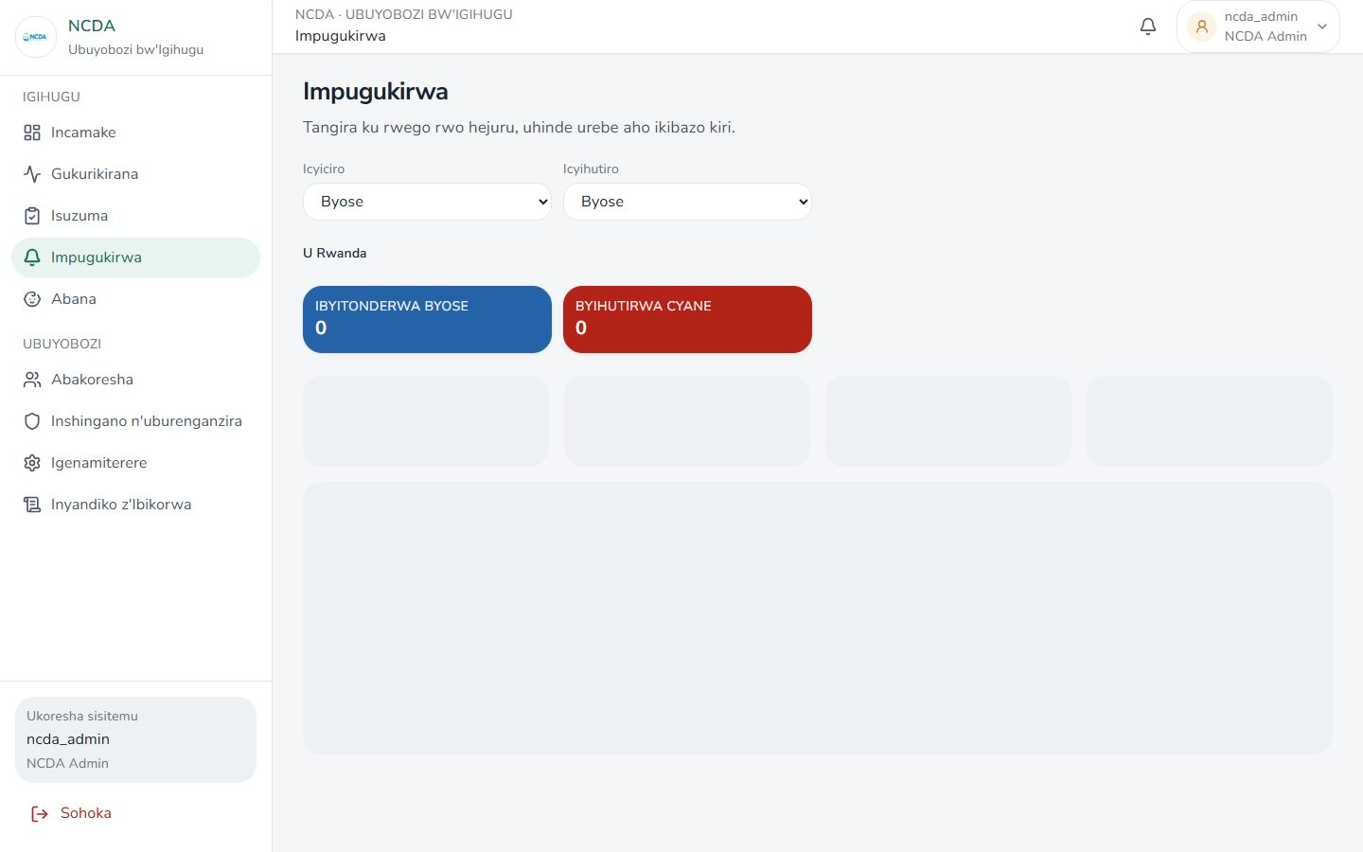

Inspections
Route: /ncda/inspections
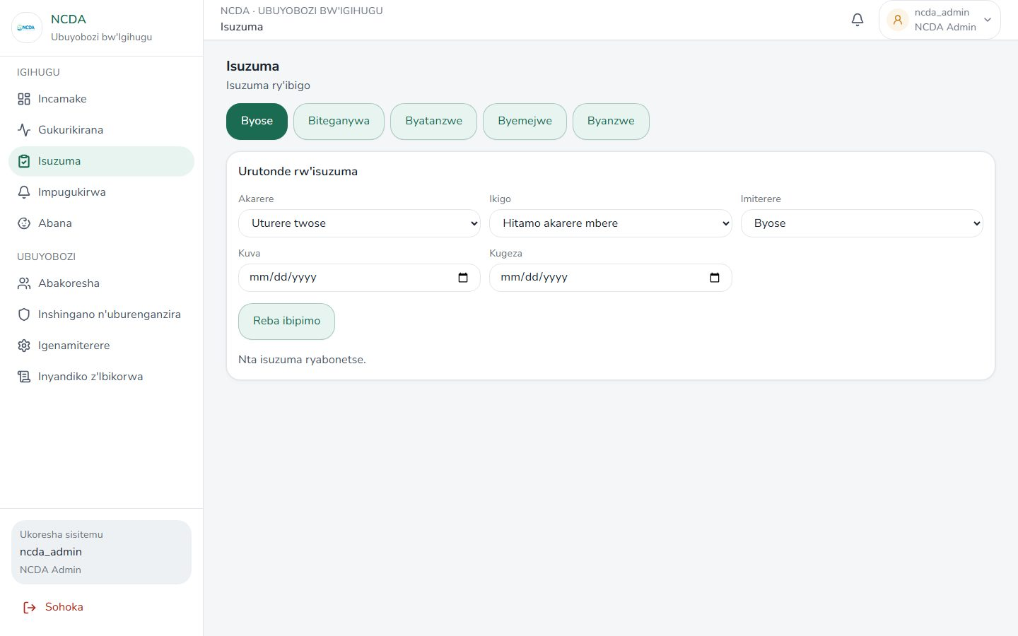

Children
Route: /ncda/children
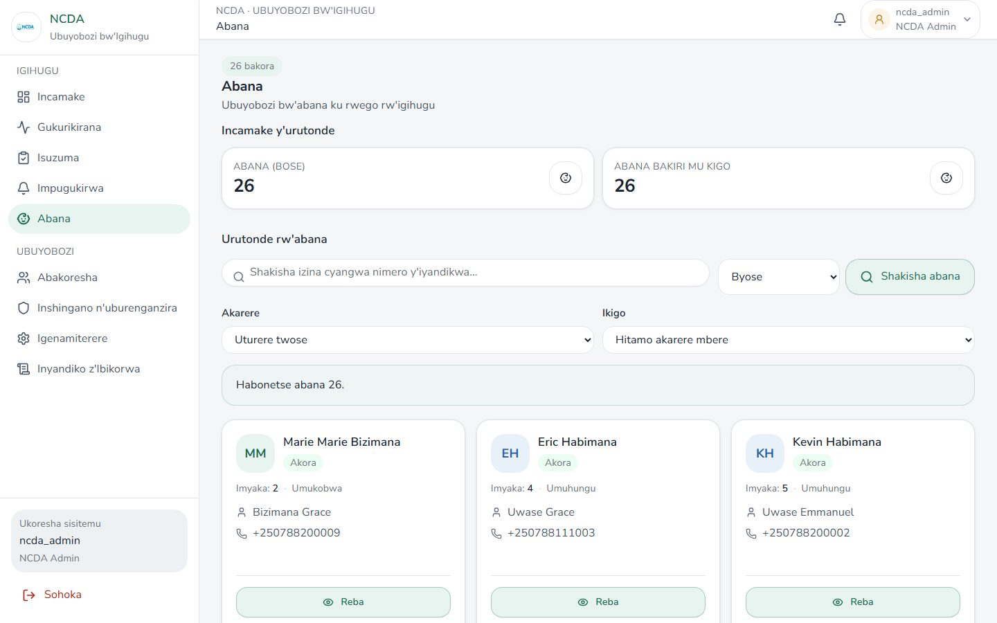

Demographics
Route: /ncda/demographics
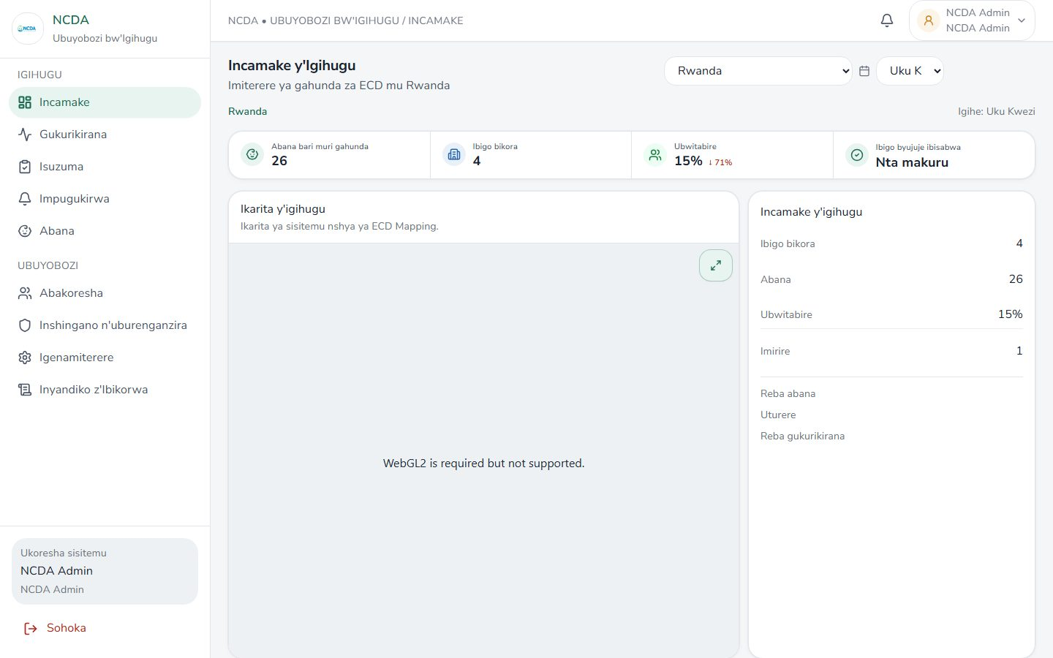

Notifications
Route: /ncda/amatangazo


Users
Route: /ncda/users
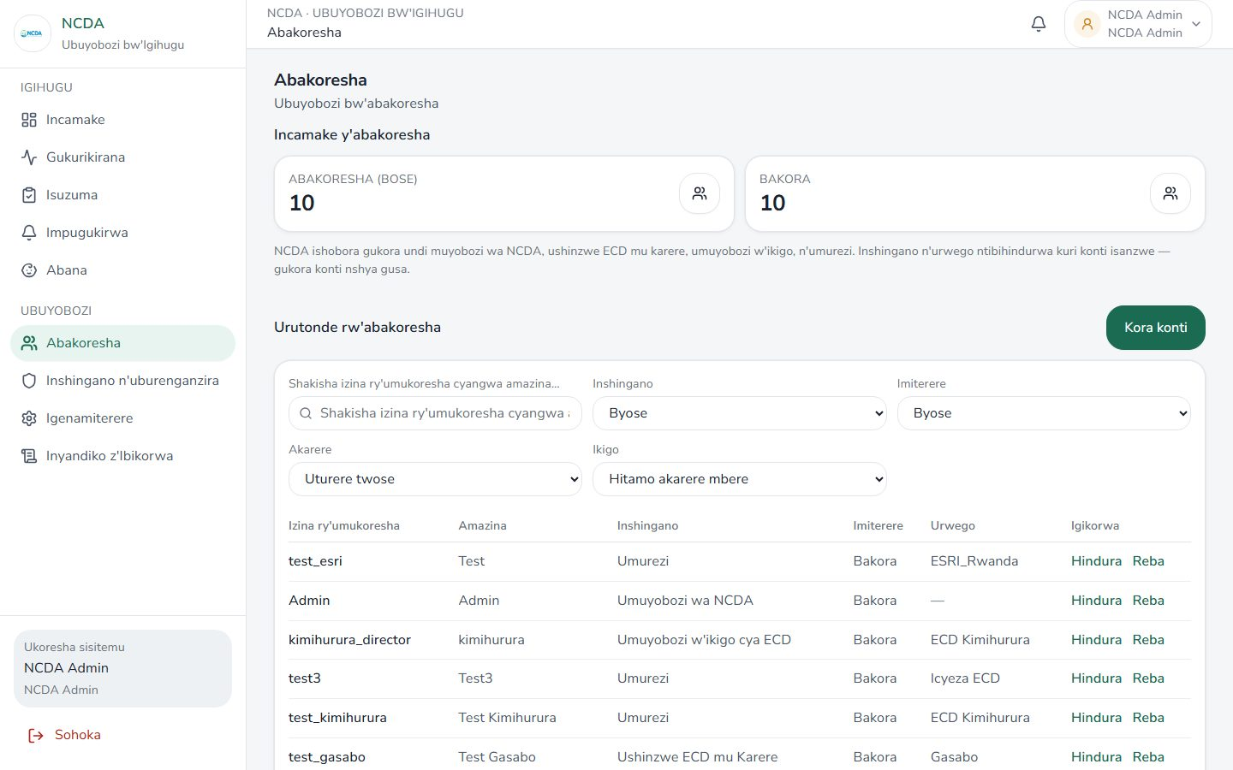

User detail
Route: /ncda/users/71c272e1-fdfd-4731-a832-5fa466b1e447
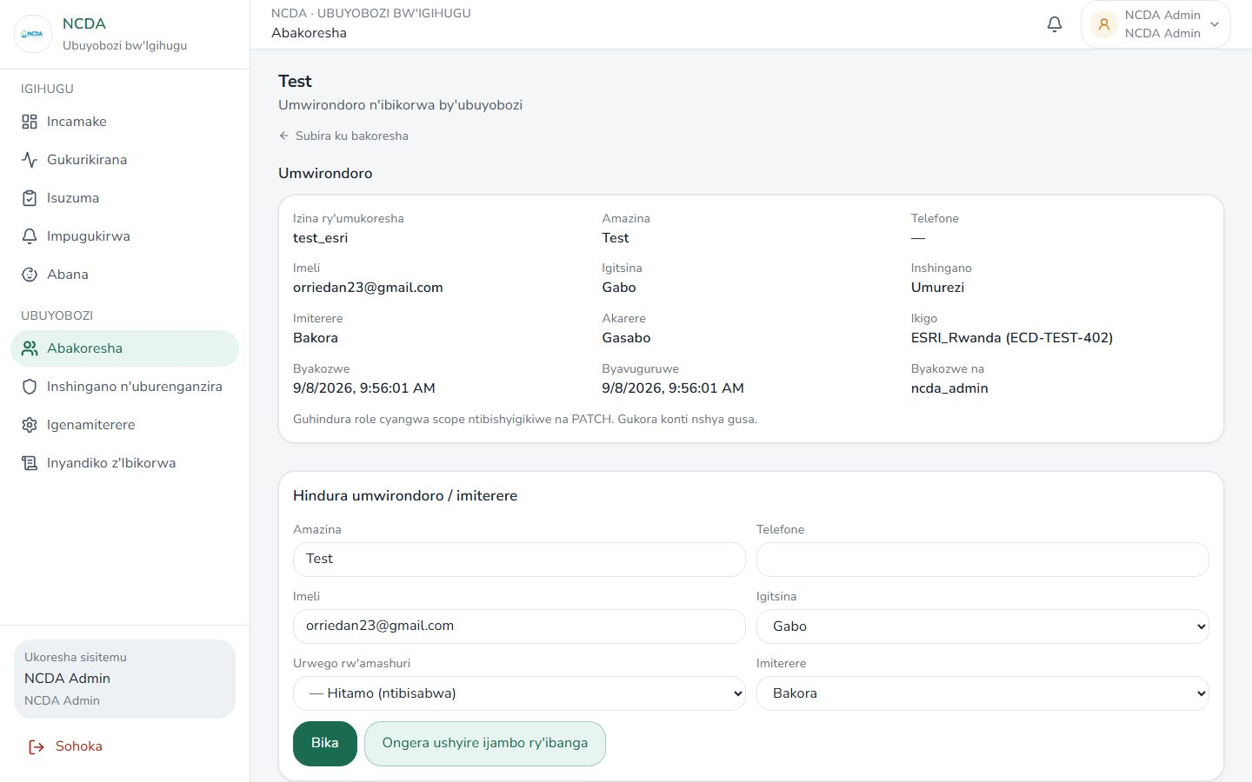

Roles
Route: /ncda/roles
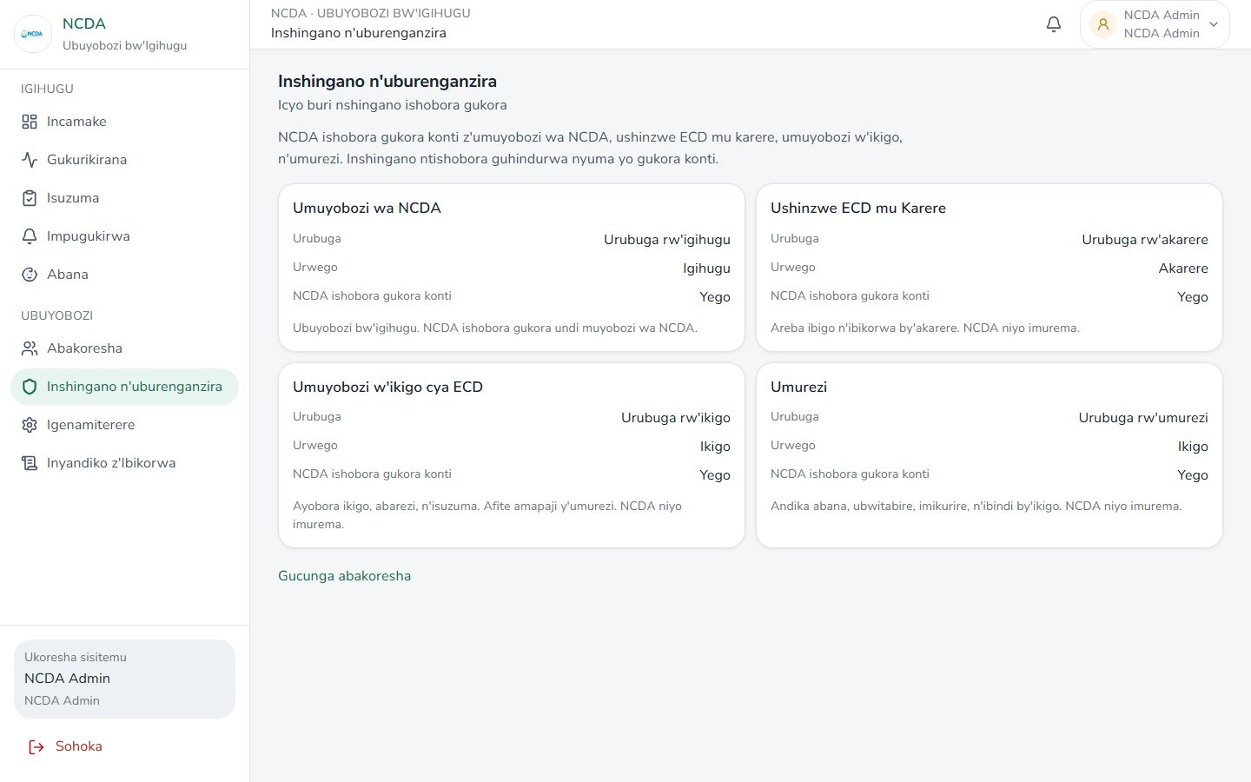

Settings
Route: /ncda/settings
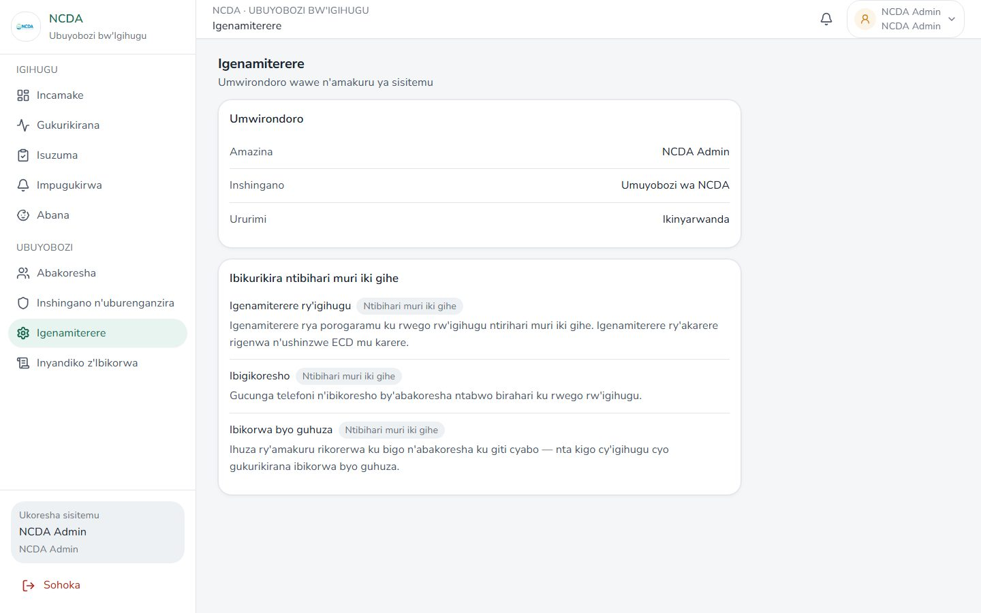

Audit logs
Route: /ncda/audit-logs
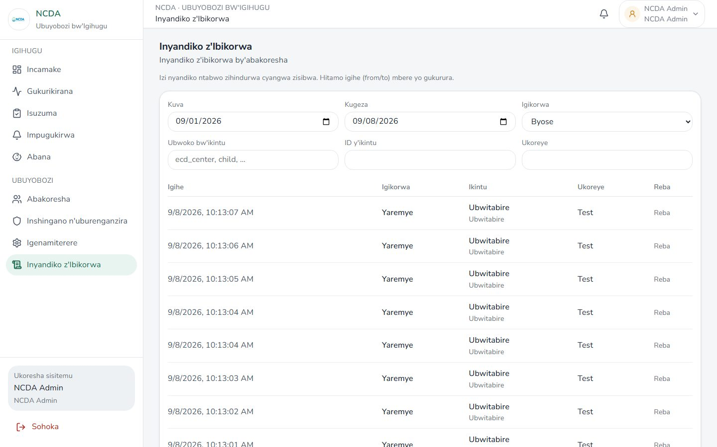

Audit log detail
Route: /ncda/audit-logs/81e272f3-ed52-4dfb-98da-a08a5104636e
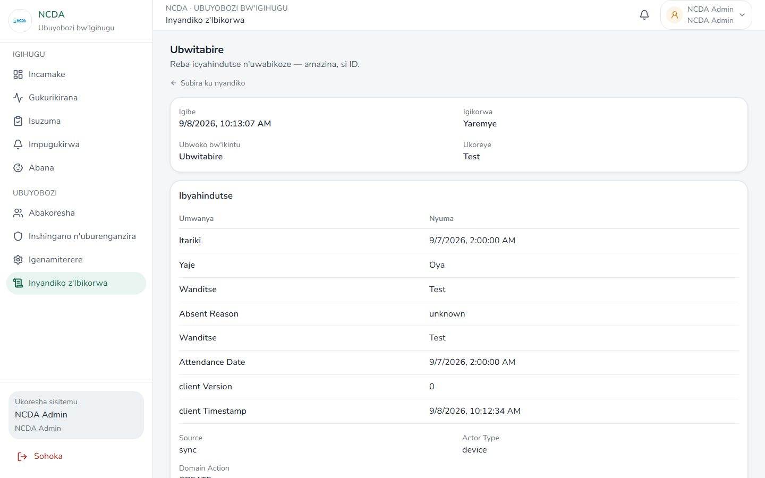

Districts
Route: /ncda/districts


Centers
Route: /ncda/centers
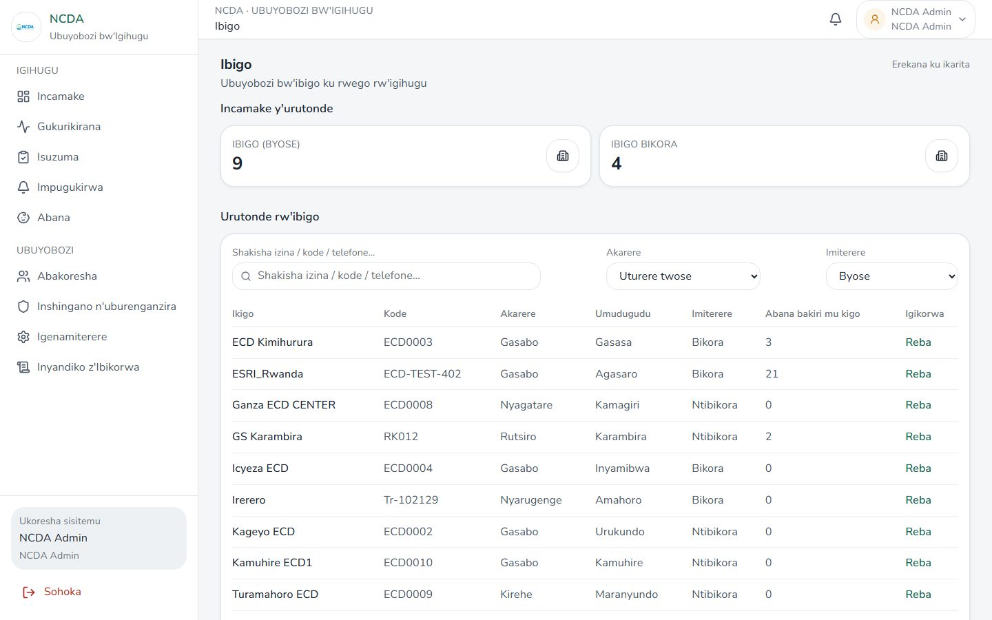

Center detail
Route: /ncda/centers/ECD0003
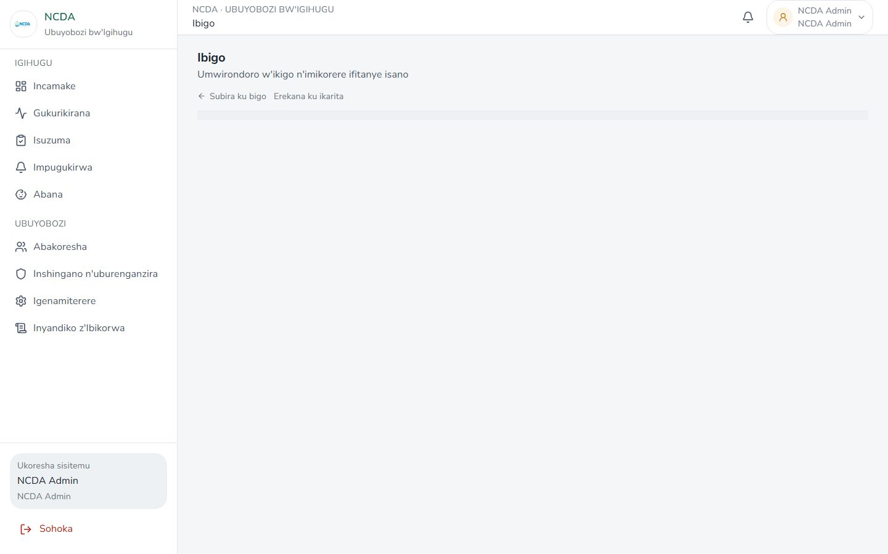

ECD Book hub
Route: /ncda/igitabo


Book — Parent contributions
Route: /ncda/igitabo/umusanzu


Book — Parenting sessions
Route: /ncda/igitabo/ibiganiro
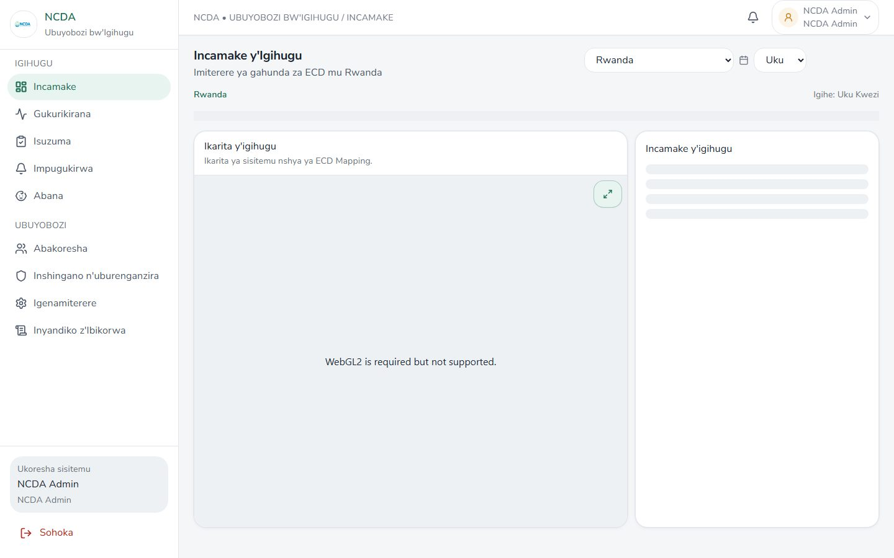

Book — Committee
Route: /ncda/igitabo/komite
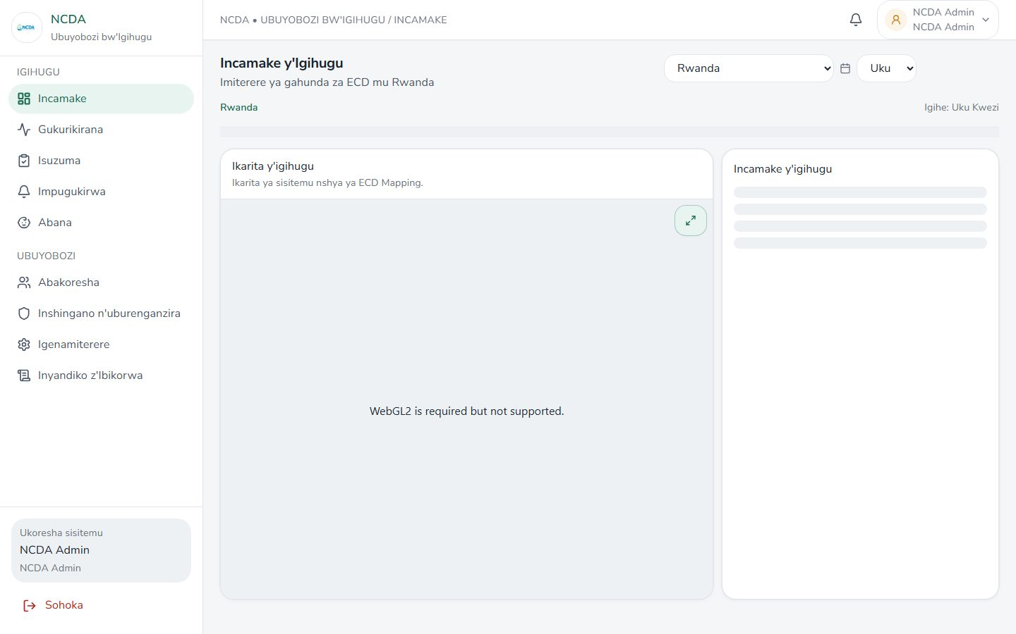

Book — Educators
Route: /ncda/igitabo/abarezi


Book — Support
Route: /ncda/igitabo/ubufasha


Book — Visitors
Route: /ncda/igitabo/abashyitsi


Book — Staff training
Route: /ncda/igitabo/amahugurwa


WASH
Route: /ncda/wash


