Modeling Human Activity States Using Hidden Markov Models
Machine Learning Techniques II · Formative 2
Orrie-Dan · 1 November 2026 · Code and data: github.com/Orrie-Dan/Human-Activity-HMM

1. Background and Motivation
Physiotherapy after a knee, ankle or hip injury depends on exercises the patient does alone at home, and adherence to such programs is often low. The physiotherapist sees the patient only every week or two and has to rely on what the patient remembers. Our use case is a home-rehabilitation adherence monitor that runs on the patient's own smartphone, which is carried at the waist during the exercises. It recognizes the four activities that make up a typical lower-limb program: standing (balance and weight-bearing holds), walking (gait training), jumping (plyometric hops in the late stage of rehab) and still (the phone is lying on a table). The still state matters as much as the others: it tells the system that the phone is not being carried, so a session with no data is not wrongly counted as rest. Because the true activity is never observed directly, only noisy accelerometer and gyroscope readings, and because activities persist over time and switch in plausible orders, a Hidden Markov Model is a natural fit: hidden states are the activities, the sensor features are the observations, and the transition matrix encodes how long people keep doing one exercise.

2. Data Collection and Pre-processing
All data was recorded by one person (solo submission) with the Sensor Logger app (v1.68) on an iPhone 11 Pro (iOS 18.7.8), logging the accelerometer and gyroscope (x, y, z) with a nanosecond timestamp per sample. For standing, walking and jumping the phone was held in the right hand at waist height; for still it lay flat on a table. Each recording was exported as CSV and stored as a folder p01_<activity>_<nn>/ with a metadata log (data/raw/metadata.csv) noting device, app, rate and any handling problems.
Member | Phone / app | Recorded rate | Measured rate | Harmonized rate
Orrie-Dan (p01) | iPhone 11 Pro / Sensor Logger 1.68 | 100 Hz (10 ms) | 99.8 Hz | 50 Hz
Table 1. Sampling rate per group member (solo submission).
Activity | Recordings | Raw time | After 1 s trim | Windows
Standing | 16 | 112 s | 80 s | 104
Walking | 17 | 127 s | 93 s | 126
Jumping | 13 | 98 s | 72 s | 99
Still | 19 | 137 s | 99 s | 133
Total | 65 | 475 s | 345 s | 462
Table 2. Training data (data/raw/). Every activity has more than 1 min 30 s of recordings.
Videos. One video per activity shows the full body while recording:
Standing · Walking · Jumping · Still
Cleaning. Starting and stopping the app moves the phone, so 1 s is trimmed from each end. Each stream is then validated: strictly increasing timestamps, no missing values, no gap longer than 0.1 s, a rate of at least 50 Hz, and at least 2 s left after trimming. All 65 recordings passed. Five recordings still contain handling after the trim (noted in the metadata); we kept them as realistic noise.
Different sampling rates. Phones and apps log at different rates (commonly 50, 100 or 200 Hz), and even on one phone the accelerometer and gyroscope are sampled at slightly different instants. We therefore never use the raw rate directly: both sensors are linearly interpolated onto one shared 50 Hz grid. 50 Hz (Nyquist 25 Hz) keeps all human-movement information, which lies below about 20 Hz (walking ≈ 1 Hz, jumping ≈ 2 Hz), and it is a rate every common phone exceeds, so data from any group member's device could be put on the same grid without upsampling.
Window size. Features are computed on 2 s windows with a 0.5 s step (75 % overlap). Because the window is defined in seconds on the harmonized grid, it is always 100 samples (step 25 samples), whatever the original rate. Two seconds covers several strides or jumps, so statistics are stable, and an FFT over 100 samples at 50 Hz has 0.5 Hz resolution, fine enough to separate walking (~1 Hz) from jumping (~2 Hz, ~4 Hz in the magnitude). One-second windows would give only 1 Hz resolution; longer windows would leave the short recordings with almost no windows.
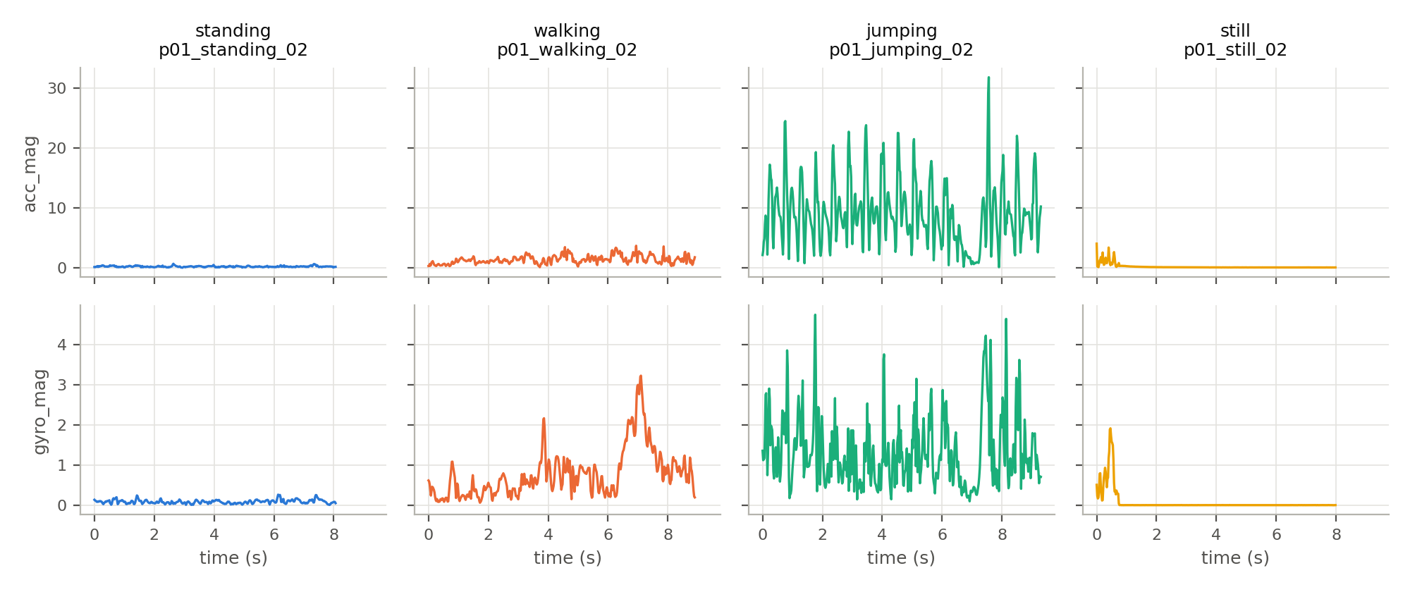
Figure 1. One recording per activity after trimming and resampling: magnitude of acceleration (m/s², gravity removed) and rotation rate (rad/s).

3. HMM Setup and Implementation

3.1 Features and normalization
For each of 8 channels (the 6 axes plus the orientation-independent magnitudes acc_mag and gyro_mag) we compute 6 features, plus 4 per sensor, giving 56 features per window:
Feature | Domain | Why it separates the activities
Mean | Time | Average movement intensity: still ≈ 0 < standing < walking < jumping.
Standard deviation | Time | Variability: sensor noise (still), hand tremor (standing), large periodic swings (walking, jumping).
Min / max | Time | Peaks: jumping has 20–30 m/s² landing impacts that no other activity reaches.
Signal magnitude area | Time | Mean of |x|+|y|+|z|: total movement energy, independent of direction.
Axis correlations | Time | Periodic movement correlates the axes; for still they are noise (≈ 0).
Dominant frequency (FFT) | Frequency | Movement rhythm: ~1 Hz for walking, ~4 Hz in the jumping magnitude.
Spectral energy (FFT) | Frequency | Signal power from the spectrum; orders the activities by intensity.
Table 3. Extracted features (7 time-domain, 2 FFT-derived frequency-domain).
Features are z-score normalized, x' = (x − μ)/σ, with μ and σ fitted on the training recordings only and then applied unchanged to held-out and test windows. Z-scoring suits this model for three reasons: the raw features span very different scales (acc_max ≈ 30 m/s², correlations in [−1, 1], still's gyro std ≈ 0.001); the Gaussian emissions are parameterized by mean and variance, so unit-variance features make the variance floor (10⁻³) equally meaningful for all of them; and unlike min-max scaling, it is not dominated by a single extreme window such as one landing spike.

3.2 Model components
Element | In this project
Hidden states Z | 4 activities: standing, walking, jumping, still (one state each).
Observations X | Sequence of 56-dim standardized feature vectors, one per 2 s window.
Transitions A | A_ij = P(z_t+1 = j | z_t = i), estimated from label counts + pseudocount 1 (Figure 2).
Emissions B | Gaussian, x_t | z_t = k ~ N(μ_k, diag σ²_k) (Figure 3); diagonal, since a full 56 × 56 covariance (~1,600 parameters per state) is too much for 462 windows.
Initial π | P(z_1 = k) from first windows + pseudocount: 0.25 / 0.26 / 0.20 / 0.29.
Table 4. HMM components.

3.3 Algorithms and implementation
The HMM is implemented from scratch in NumPy (src/hmm.py), with all recursions in log space to avoid underflow. The choice of algorithms follows the evaluation: sensitivity, specificity and accuracy score one label per window, so we need the single best label sequence. Viterbi gives exactly that (the jointly most likely path) and, unlike per-window posterior decoding, cannot produce isolated one-window flickers, which matters when activities change. Forward-backward computes the sequence likelihood and the posteriors γ and ξ. Training has two stages: (1) supervised maximum likelihood from the labeled windows; the pseudocount on A is essential because each training recording contains one activity, so without it A would be the identity and the model could never switch; (2) optional Baum-Welch (EM) refinement without labels, which stops when the log-likelihood improves by less than ε = 10⁻⁴ (here after 5 iterations, log-likelihood 122 → 7660). The code is modular (loading, preprocessing, features, HMM, training, evaluation) with 95 unit tests.
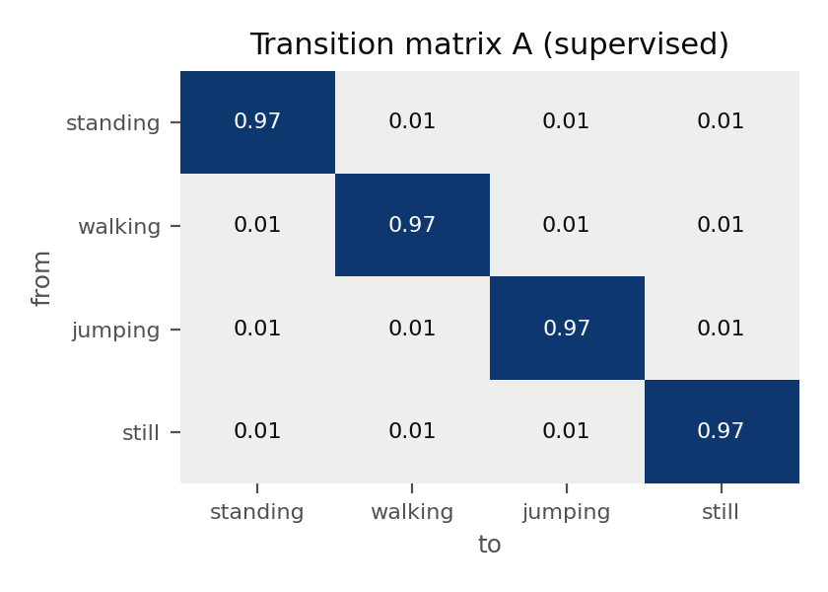
Figure 2. Learned transition matrix (supervised model).
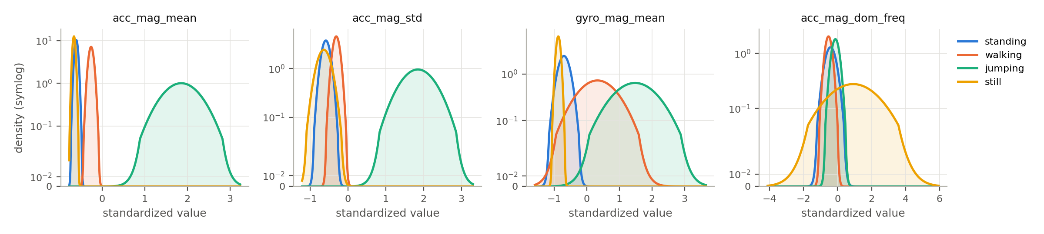
Figure 3. Emission probabilities: per-state Gaussian densities of four key features (standardized units, symlog density axis).

4. Results and Interpretation
Unseen test data. After all training data had been collected, we recorded two new files in a separate session (1 Nov, 16:03 and 16:05). Unlike the training data, each is a continuous ~60 s recording in which the activity changes 4–5 times, including the real handling between activities (picking the phone up, starting to jump): p01_mixed_01 walking → still → jumping → standing → still → walking; p01_mixed_02 still → jumping → walking → standing → walking. They are stored separately (data/test/) and never used for training, scaling or model selection. Segment boundaries are listed in data/test/labels.csv; a window is scored only if it lies fully inside one segment (193 windows), and the 53 windows overlapping a change are decoded but not scored. The model is trained once on all 65 training recordings.
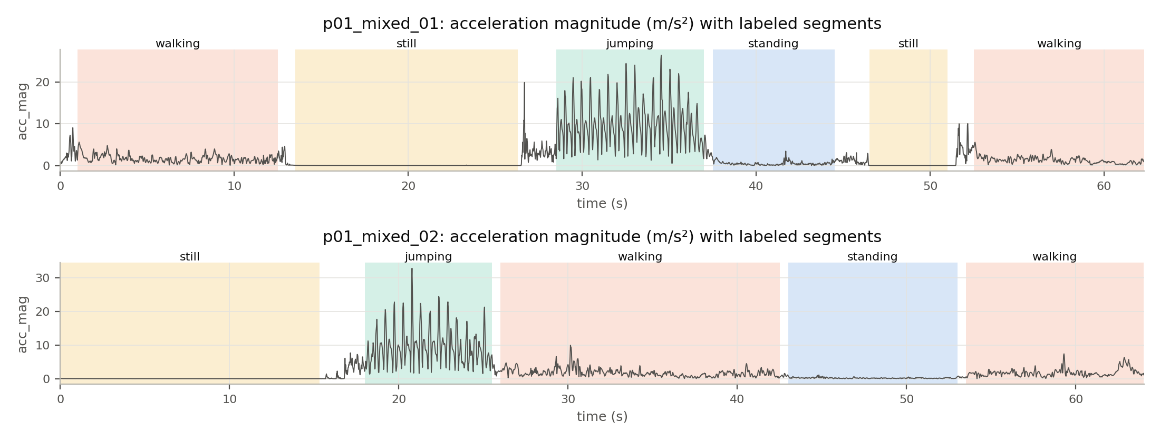
Figure 4. The two unseen test recordings with their labeled activity segments.
State (activity) | Number of samples | Sensitivity | Specificity | Overall accuracy
Standing | 28 | 0.750 | 1.000 | 0.964
Walking | 84 | 0.881 | 0.936 | 0.912
Jumping | 26 | 1.000 | 0.940 | 0.948
Still | 55 | 1.000 | 1.000 | 1.000
All windows | 193 |  |  | 0.912
Table 5. Results on unseen test data (supervised model; samples = 2 s windows; per-activity accuracy is one-vs-rest (TP+TN)/N).
For comparison, 4-fold cross-validation by recording on the training set gives 96.8 % accuracy (supervised) and 97.0 % (with Baum-Welch). On the unseen data the supervised model reaches 91.2 % (89.9 % and 92.3 % for the two files), while the Baum-Welch model drops to 86.0 %.
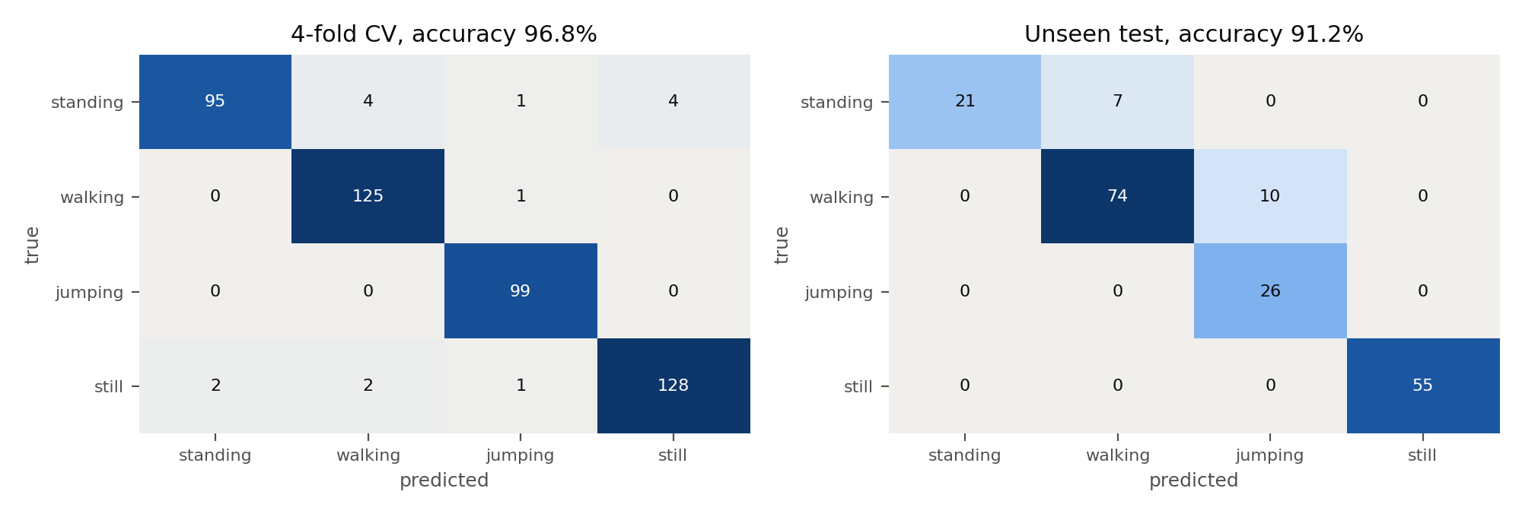
Figure 5. Confusion matrices: cross-validation (left) and unseen test data (right), supervised model.
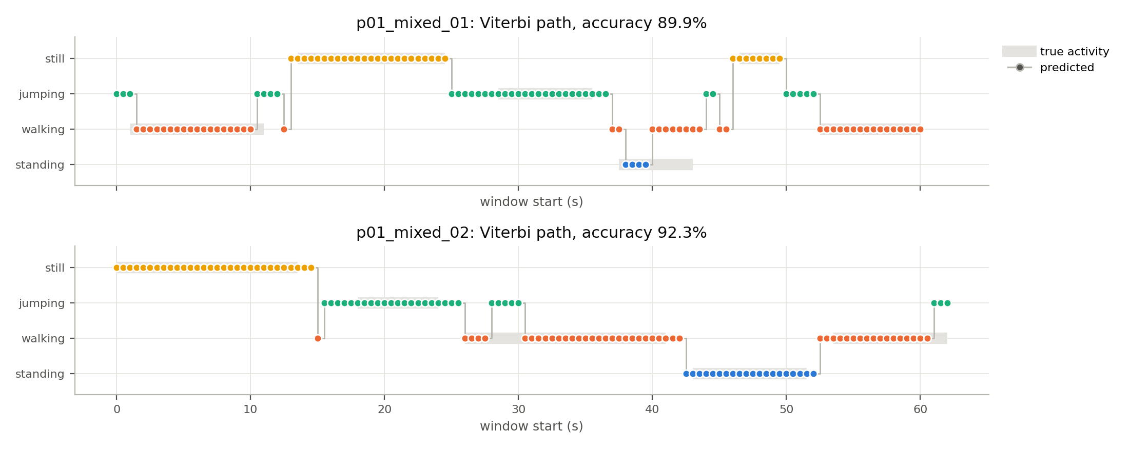
Figure 6. Viterbi-decoded activity sequences on the unseen recordings (gray band = true activity, gaps = transition windows).
Does the model generalize? Mostly yes. Still (55/55) and jumping (26/26) are perfect, and all 9 real activity changes are detected, usually within one or two windows of the labeled boundary, even though the model never saw a real change during training. The 6-point drop from cross-validation comes from two sources. Walking → jumping (10 windows): 5 come from a burst at 28–30 s in p01_mixed_02 where acceleration reaches ~10 m/s² (a turn or stumble), 3 from lifting the phone to stop the recording, and 2 from segment edges. Standing → walking (7 windows): all in p01_mixed_01 around 40–43 s, where a brief hand adjustment is visible in the signal. Windows during handling are mostly decoded as jumping, because short spikes are best explained by the jumping state.
Baum-Welch generalizes worse. It was slightly better in cross-validation but loses most standing windows to walking on the new session. EM re-estimates the variances on the training sessions only, and the median standing variance shrinks from 0.033 to 0.007, so slightly more active standing in a new session no longer fits. We therefore use the supervised model as the final model; the unseen test was essential to see this.

5. Discussion and Conclusion
Easiest and hardest activities. Jumping and still are easiest: they lie at the two extremes of movement intensity and never overlap with other states in the acceleration features (Figure 3). Standing is hardest (sensitivity 0.91 in CV, 0.75 on unseen data). It sits between still and walking, so any disturbance pushes it to one side: a bump or hand adjustment looks like walking, and very quiet standing looks like still. Standing and still are separated mainly by the gyroscope: hand tremor rotates the phone slightly, while a phone on a table does not rotate at all.
Transition probabilities. The diagonal of A is about 0.97 (Figure 2), meaning an expected stay of 1/(1 − 0.97) ≈ 33 windows (≈ 17 s) before switching. That matches realistic behavior, and in our use case exercises do last tens of seconds to minutes. However, since every training recording held one activity, the off-diagonal entries are just the uniform pseudocount (≈ 0.01): the model knows switches are rare, but not which ones are more plausible (e.g. still → walking should be likelier than still → jumping). With 56 features, emissions also dominate: the median log-likelihood gap between the best and second-best state is ~170 nats, against a switch cost of 4.6 nats, so transitions only decide borderline windows, such as the noisy windows near activity changes.
Sensor noise and sampling rate. The 100 Hz recording rate was more than enough; even after resampling to 50 Hz the 1–4 Hz movement rhythms are well captured, so the sampling rate did not limit accuracy. Sensor noise mattered more: for still, the signal is pure noise (~0.005 m/s²), which makes its dominant frequency meaningless (the broad still curve in Figure 3). The largest source of error was human handling at the start and end of recordings and between activities, not the sensors themselves.
Improvements. (1) Train on continuous multi-activity recordings so that A learns real transition patterns; (2) add a fifth "handling" state for picking up and putting down the phone; (3) collect data from more participants and phones and evaluate leave-one-participant-out, since one person and one device make our results optimistic; (4) reduce the 56 partly redundant features (e.g. drop the dominant frequency of low-motion channels, or use PCA), which would let transitions matter more; (5) add gravity-including acceleration for phone orientation and the barometer to detect the height change of a jump.
Conclusion. A from-scratch Gaussian HMM with 56 time- and frequency-domain features recognizes standing, walking, jumping and still with 96.8 % accuracy in cross-validation and 91.2 % on unseen continuous recordings, following every real change of activity. For the rehabilitation use case this is already useful for counting how long each exercise was done and for detecting when the phone was not carried; the main gap, standing being confused with walking during small movements, is the target for the next round of data collection.

