Campus Recruitment

Academic and Employability Factors Influencing Placements

Kapil Rana

19/10/2021

library(tidyverse)

## -- Attaching packages --------------------------------------- tidyverse 1.3.1 --

## v ggplot2 3.3.5 v purrr 0.3.4  
## v tibble 3.1.2 v dplyr 1.0.7  
## v tidyr 1.1.3 v stringr 1.4.0  
## v readr 1.4.0 v forcats 0.5.1

## -- Conflicts ------------------------------------------ tidyverse_conflicts() --  
## x dplyr::filter() masks stats::filter()  
## x dplyr::lag() masks stats::lag()

library(dlookr)

## Imported Liberation Sans Narrow fonts.

##   
## Attaching package: 'dlookr'

## The following object is masked from 'package:tidyr':  
##   
## extract

## The following object is masked from 'package:base':  
##   
## transform

library(ggthemes)  
library(rstatix)

##   
## Attaching package: 'rstatix'

## The following object is masked from 'package:stats':  
##   
## filter

setwd("C:\\Users\\kapil\\Desktop\\(Project)\\R-practice\\Placement Data")  
getwd()

## [1] "C:/Users/kapil/Desktop/(Project)/R-practice/Placement Data"

placement <- readr::read_csv("Placement.csv")

##   
## -- Column specification --------------------------------------------------------  
## cols(  
## sl_no = col_double(),  
## gender = col_character(),  
## ssc_p = col_double(),  
## ssc_b = col_character(),  
## hsc_p = col_double(),  
## hsc_b = col_character(),  
## hsc_s = col_character(),  
## degree_p = col_double(),  
## degree_t = col_character(),  
## workex = col_character(),  
## etest_p = col_double(),  
## specialisation = col_character(),  
## mba_p = col_double(),  
## status = col_character(),  
## salary = col_double()  
## )

View(placement)  
  
placement <- placement %>%   
 rename("serial" = sl_no)

#About Data  
columns <- names(placement)  
  
description <- c(  
"Serial",  
"Gender: Male='M', Female='F'",  
"Secondary Education Percentage (grades 9 and 10) - exam at the end of 10th grade",  
"Board of Education - Central/Others",  
"Higher Secondary Education (grades 11 and 12) - exam at the end of 12th grade",  
"Board of Education - Central/Others",  
"Specialization in Higher Secondary Education",  
"Degree Percentage",  
"Undergraduate (Degree type) - Field of degree education",  
"Work Experience - Yes/No",  
"Employability test Percentage (conducted by college)",  
"Post Graduation (MBA) - Specialization",  
"MBA percentage",  
"Status of placement - Placed/Not placed",  
"Salary offered by corporate to candidates")  
  
dataset_table <-as.data.frame(cbind(columns, description))  
dataset_table

## columns  
## 1 serial  
## 2 gender  
## 3 ssc_p  
## 4 ssc_b  
## 5 hsc_p  
## 6 hsc_b  
## 7 hsc_s  
## 8 degree_p  
## 9 degree_t  
## 10 workex  
## 11 etest_p  
## 12 specialisation  
## 13 mba_p  
## 14 status  
## 15 salary  
## description  
## 1 Serial  
## 2 Gender: Male='M', Female='F'  
## 3 Secondary Education Percentage (grades 9 and 10) - exam at the end of 10th grade  
## 4 Board of Education - Central/Others  
## 5 Higher Secondary Education (grades 11 and 12) - exam at the end of 12th grade  
## 6 Board of Education - Central/Others  
## 7 Specialization in Higher Secondary Education  
## 8 Degree Percentage  
## 9 Undergraduate (Degree type) - Field of degree education  
## 10 Work Experience - Yes/No  
## 11 Employability test Percentage (conducted by college)  
## 12 Post Graduation (MBA) - Specialization  
## 13 MBA percentage  
## 14 Status of placement - Placed/Not placed  
## 15 Salary offered by corporate to candidates

#Check for NA values  
sapply(placement, function(x) sum(is.na(x)))

## serial gender ssc_p ssc_b hsc_p   
## 0 0 0 0 0   
## hsc_b hsc_s degree_p degree_t workex   
## 0 0 0 0 0   
## etest_p specialisation mba_p status salary   
## 0 0 0 0 67

#Only salary column has 67 NA values   
dlookr::plot_na_pareto(placement)

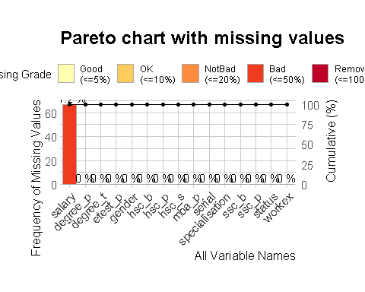

#As 67 students are not placed so we have 67 NA's in Salary Column   
placement %>%   
 count(status, sort = T)

## # A tibble: 2 x 2  
## status n  
## <chr> <int>  
## 1 Placed 148  
## 2 Not Placed 67

#Correlation between numerical variables  
data_cor <- placement %>%   
 select(ssc_p, hsc_p, degree_p, etest_p, mba_p)  
  
my_cols <- c("#00AFBB", "#E7B800")  
pairs(data_cor, pch = 19, cex = 0.5,  
 col = my_cols,  
 lower.panel=NULL)

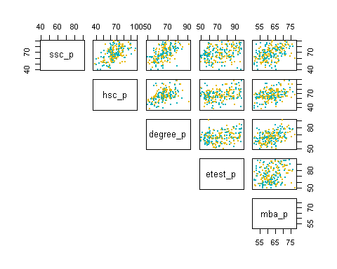

#There is a medium correlation between academic scores it means those who performed well in their secondary education also perform well with higher secondary and bachelor degree but employability test scores only had a low correlation with academic scores.  
data <- as.data.frame(cor(data_cor))  
data

## ssc_p hsc_p degree_p etest_p mba_p  
## ssc_p 1.0000000 0.5114721 0.5384040 0.2619927 0.3884776  
## hsc_p 0.5114721 1.0000000 0.4342058 0.2451129 0.3548226  
## degree_p 0.5384040 0.4342058 1.0000000 0.2244702 0.4023638  
## etest_p 0.2619927 0.2451129 0.2244702 1.0000000 0.2180547  
## mba_p 0.3884776 0.3548226 0.4023638 0.2180547 1.0000000

#Check the Percentage of the students with Status   
#Out of 215 Students only 148 students were placed   
placement %>%   
 mutate(total = (ssc_p + hsc_p + degree_p + mba_p)/4) %>%   
 ggplot(aes(total, fill = status)) +   
 geom_histogram(binwidth = 5, col = "black") +  
 labs(x = "Average Scores across all four levels",   
 y = "Number of Students",   
 title = "Out of 215 students only 67 were not selected")+  
 ggthemes::theme_few()

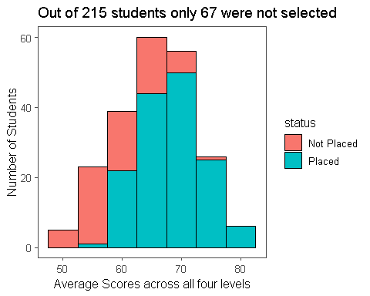

#Most no. of student who get placed are from commerce background  
placement %>%   
 ggplot(aes(degree_t)) +  
 geom_bar(aes(fill = placement$status), col = "black") +  
 coord_flip() +  
 labs(x = "Degree type",   
 y = "Total",  
 fill = guide_legend(title = "Status")) +   
 ggthemes::theme_few()

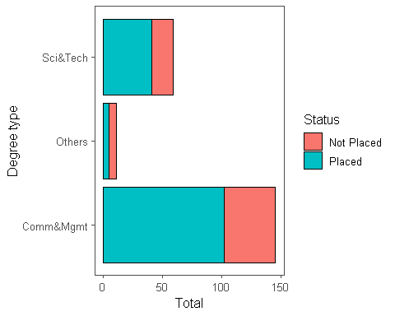

#Lets check the distribution of Scores look like for each level of education Employability test has a different distribution than the others with very wide and almost equal distribution of each bucket   
  
distribution <- function(level, Lev_name) {  
 placement %>%   
 ggplot(aes(level)) +  
 geom_histogram(binwidth = 5, fill = "#ff6600" ,col = "black") +   
 coord_cartesian(xlim = c(30,100),  
 ylim = c(0,70)) +  
 labs(x = "Score",   
 y = "Number of Students",  
 title = Lev_name) +   
 ggthemes::theme_few()  
}  
  
  
distribution(placement$ssc_p, "Senior_Secondary")

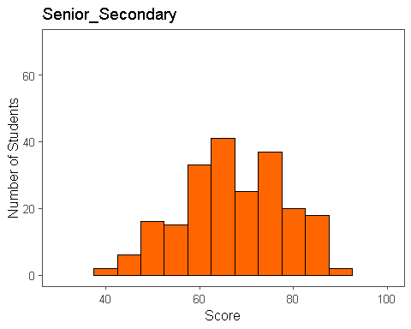

distribution(placement$hsc_p, "Higher_Secondary")

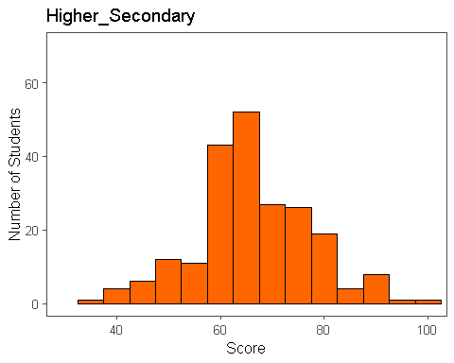

distribution(placement$degree_p, "Unniversity")

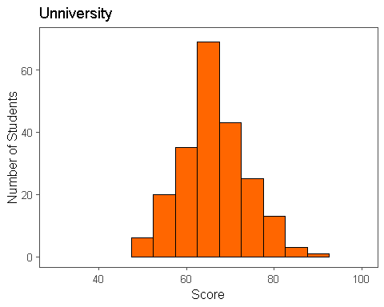

distribution(placement$mba_p, "MBA")

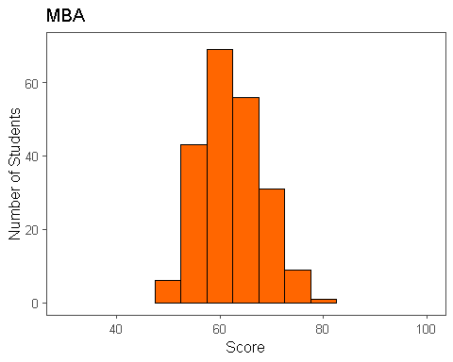

distribution(placement$etest_p, "Employability_Test")

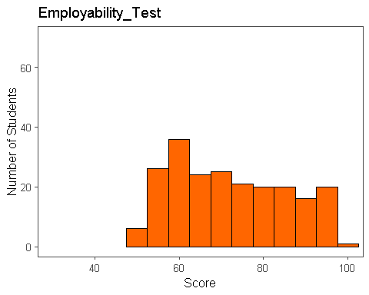

#Is there any significant difference between Genders and their Academic & E.test score?  
#Density plot shows that females score higher than the male but the t.test gave the p.value lower than the alpha(0.05) We have to reject the null hypothesis,It means there is no significant differences in performance ##during University and MBA levels  
  
#Lets Find Out   
  
placement %>%   
 ggplot(aes(degree_p, fill = gender, col = gender)) +  
 geom_density(alpha = 0.3, lwd = 1, show.legend = T) +  
 geom_rug() +  
 labs(x = "Scores",  
 title = "Distribution of Scores at University level between Genders") +  
 ggthemes::theme_few()

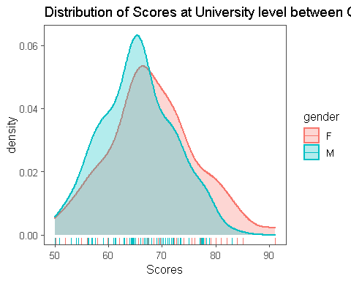

placement %>%   
 ggplot(aes(mba_p, fill = gender, col = gender)) +  
 geom_density(alpha = 0.3, lwd = 1, show.legend = T) +  
 geom_rug() +  
 labs(x = "Scores",  
 title = "Distribution of Scores at MBA level between Genders") +  
 ggthemes::theme_few()

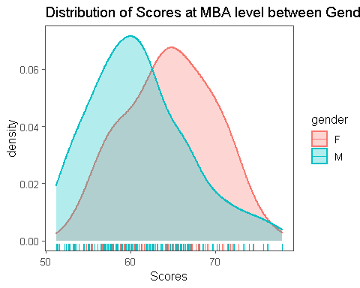

placement %>%   
 ggplot(aes(etest_p, fill = gender, col = gender)) +  
 geom_density(alpha = 0.3, lwd = 1, show.legend = T) +  
 geom_rug() +  
 labs(x = "Scores",  
 title = "Distribution of Scores at E.Test level between Genders") +  
 ggthemes::theme_few()

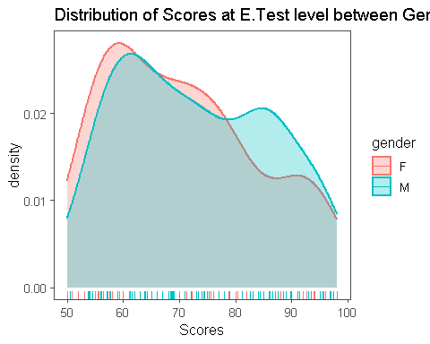

##Now check the significance with a statistical test   
placement %>%   
 t_test(degree_p ~ gender, conf.level = 0.95) %>%   
 add_significance()

## # A tibble: 1 x 9  
## .y. group1 group2 n1 n2 statistic df p p.signif  
## * <chr> <chr> <chr> <int> <int> <dbl> <dbl> <dbl> <chr>   
## 1 degree_p F M 76 139 2.43 132. 0.0164 *

placement %>%   
 t_test(mba_p ~ gender, conf.level = 0.95)

## # A tibble: 1 x 8  
## .y. group1 group2 n1 n2 statistic df p  
## * <chr> <chr> <chr> <int> <int> <dbl> <dbl> <dbl>  
## 1 mba_p F M 76 139 4.73 167. 0.00000486

#As the score became more concentrated around median as the student progressed in their education, we could infer that there was less chance of differentiating themselves based on grade and more based on other factors such as : employability score, work experience, technical skills, soft skills, better interviewing skills, extra-curricular experience  
  
#ANOVA test to check whether Type of Degree(commerce, science & arts) had any significant impact on the avg. MBA marks   
  
#As p.value is more than our critical value 0.05, we can conclude that mean of MBA marks under dufferent degree types are same   
aov(mba_p ~ degree_t, data = placement) %>%   
 summary()

## Df Sum Sq Mean Sq F value Pr(>F)  
## degree_t 2 116 58.13 1.72 0.182  
## Residuals 212 7166 33.80

#Visualize   
placement %>%   
 ggplot(aes(degree_t, mba_p)) +  
 geom_boxplot(fill = "#32a2a8", col = "black") +  
 ggthemes::theme_few()

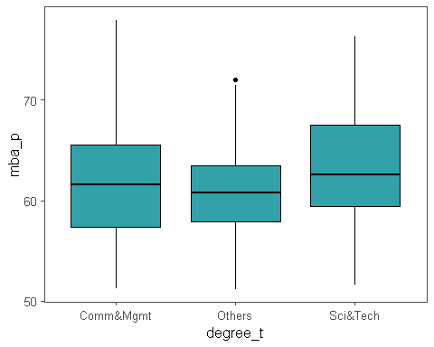

#Bartlett's test to check homegeniety of variance among Types of Degrees with regarding to MBA marks   
#As p.value is more than our critical value 0.05, it suggest that the variance among groups is equal   
bartlett.test(as.numeric(mba_p) ~ as.factor(degree_t), data = placement)

##   
## Bartlett test of homogeneity of variances  
##   
## data: as.numeric(mba_p) by as.factor(degree_t)  
## Bartlett's K-squared = 0.15907, df = 2, p-value = 0.9235

#ANOVA test to check whether Type of Degree(commerce, science & arts) had any significant impact on the Salary   
  
#As p value is more than 0.05, We can conclude that the mean salary under different degree type are same  
aov(salary ~ degree_t, data = placement) %>%   
 summary()

## Df Sum Sq Mean Sq F value Pr(>F)  
## degree_t 2 3.822e+10 1.911e+10 2.224 0.112  
## Residuals 145 1.246e+12 8.591e+09   
## 67 observations deleted due to missingness

#Bartlett's test to check homegeniety of variance among Types of Degrees with regarding Salary   
#As p.value is more than our critical value 0.05, it suggest that the variance among groups is equal   
bartlett.test(as.numeric(salary) ~ as.factor(degree_t), data = placement)

##   
## Bartlett test of homogeneity of variances  
##   
## data: as.numeric(salary) by as.factor(degree_t)  
## Bartlett's K-squared = 2.5268, df = 2, p-value = 0.2827

#Chi-square test to check whether the type of degree has any impact on Status(Placed or not placed), we are using chi2 test as both of our column are factor column   
contigency <- with(placement, table(placement$degree_t, placement$status))  
contigency <- as.matrix(contigency)  
contigency

##   
## Not Placed Placed  
## Comm&Mgmt 43 102  
## Others 6 5  
## Sci&Tech 18 41

#As p.value is more than our critical value 0.05, we conclude that two categorical variables are independent in some population.  
chi.test <- chisq.test(contigency, correct = F)  
chi.test

##   
## Pearson's Chi-squared test  
##   
## data: contigency  
## X-squared = 2.969, df = 2, p-value = 0.2266