**LAB NO: 2**

**Experiment: Do the following Cabling works in a network:a) Cable Crimping b) Standard Cabling c) Cross Cabling d) Testing the crimped cable using a cable tester) share a file between two computers using Ethernet cable**

**Aim:**

To do the following:

1. Cable Crimping
2. Standard Cabling
3. Cross Cabling
4. Testing the crimped cable using a cable tester
5. Share a file between two computers using the Ethernet cable.

**Apparatus/Tools/Equipment/Components:**

* RJ-45 connector
* Crimping Tool
* Twisted pair Cable
* Cable Tester

**Principle:**

**Standard Cabling/Straight Through Cabling:**

Standard Cabling refers to the set of guidelines and specifications used for the design, installation, and maintenance of various types of cables and wiring systems.

Examples: Ethernet Cabling, Coaxial Cabling and Fiber Optic Cabling.

**Ethernet Cabling:**

Ethernet Cabling is used for computer networking and typically follows the standards set by the Institute of Electrical and Electronics Engineers (IEEE) 802.3.

**Coaxial Cabling:**

Coaxial Cabling is used for cable television and broadband Internet and typically follows the standards set by the Society of Cable Telecommunications Engineers (SCTE).

**Fiber Optic Cabling:**

Fiber Optic Cabling is used for high-speed data transmission and typically follows the standards set by the International Electrotechnical Commission (ICE

**Uses:**

1. 10BaseT and 100BaseT are most common mode of LAN

2. A straight cable is used to connect a computer to a hub

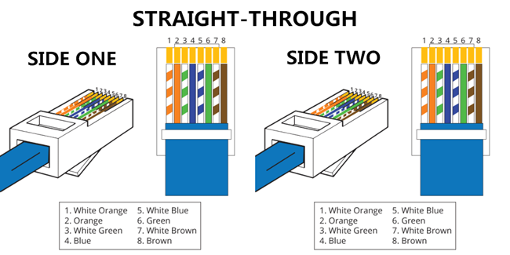

**Cross Cabling:**

Cable crimping is the process of mechanically joining two pieces of a cable or wire by compressing or deforming them with a special tool called a crimping tool. This creates a secure, low-resistance connection between the cable and the connector, which can be used for a variety of purposes such as connecting electrical equipment, telecommunications, or computer networking. A cross cable is used to connect 2 computers directly. It is also used then you connect 2 hubs with a normal port on both hubs.

**Procedure:**

The general steps involved in crimping are:

1. Choose the appropriate crimp connector for the type and size of cable you are using.
2. Strip the insulation off the end of the cable to expose the bare wire.
3. Insert the stripped end of the cable into the connector until it reaches the metal crimp area.
4. Place the connector into the crimping tool, making sure it is positioned correctly.
5. Squeeze the handles of the crimping tool tightly to compress the connector onto the cable. This will create a secure, low-resistance connection between the cable and the connector.
6. Check the crimped connector to ensure that it is tightly attached to the cable and that there are no loose wires or gaps in the connection.
7. Repeat the process for any additional cables that need to be crimped.

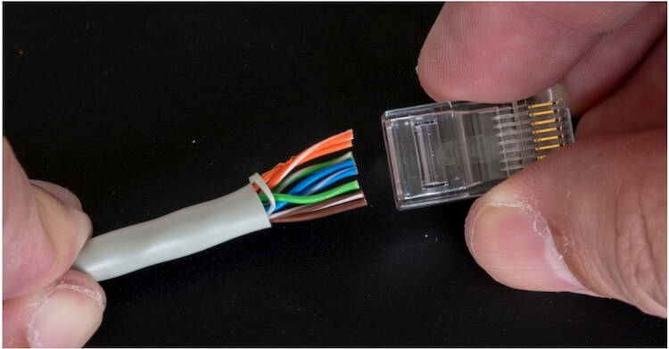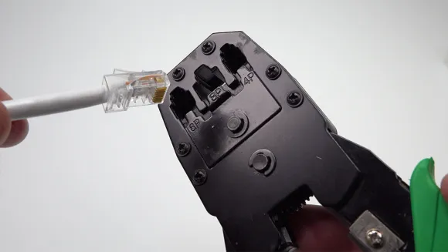

**Testing the crimped cable using a cable tester in points:**

1. Obtain a cable tester that is appropriate for the type of cable you have crimped. Cable testers are typically designed for specific cable types, such as Ethernet or coaxial.
2. Connect the cable to be tested to the cable tester, making sure that it is plugged in securely.
3. Turn on the cable tester and follow the instructions provided by the manufacturer to test the cable.
4. The cable tester will typically display a series of lights or other indicators that show whether the cable is functioning properly. If the cable passes the test, all of the indicators should show that it is working correctly. If the cable fails the test, the indicators may show which part of the cable is not working properly, such as a broken or crossed wire.
5. If the cable fails the test, you may need to re-crimp the connector or troubleshoot other issues with the cable or network.
6. After testing the cable, make sure to unplug it from the tester and label it with any relevant information, such as its intended use or location.

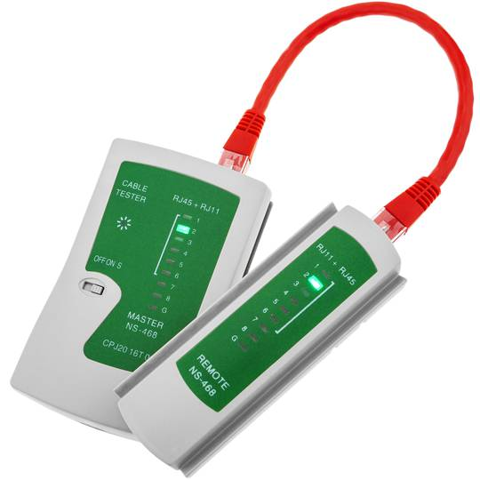

**Data Sharing between two computers using cross cable:**

**Procedure:**

Once connected, follow the steps here :

* Connect both PCs with an Ethernet cable or a LAN cable. Both of them use the same port and do the same thing.
* Right-click the Start button and choose "Control Panel > Network and Sharing Center". You will see the active network or Ethernet.
* . Click "Ethernet > Properties > Internet Protocol Version 4 (TCP/IPv4) > Properties".
* Select "Use the following IP address" and type the IP address and subnet mask as shown in the screenshot below. The IP you enter can be different from the example, as long as they are in the same range.

**Put the following value on 1st PC**

* Ip Address 192.168.1.2
* Subnet mask 225.225.225.0

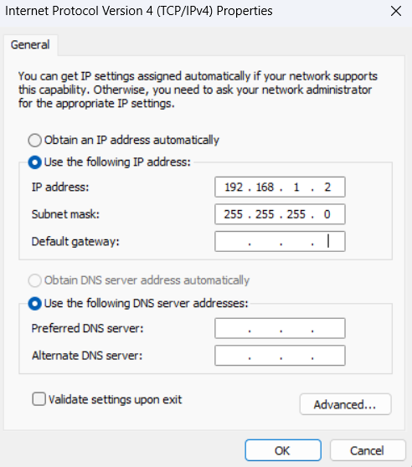

**Put the following value on the 2nd PC**

* Ip Address 192.168.1.3
* Subnet mask 225.225.225.0

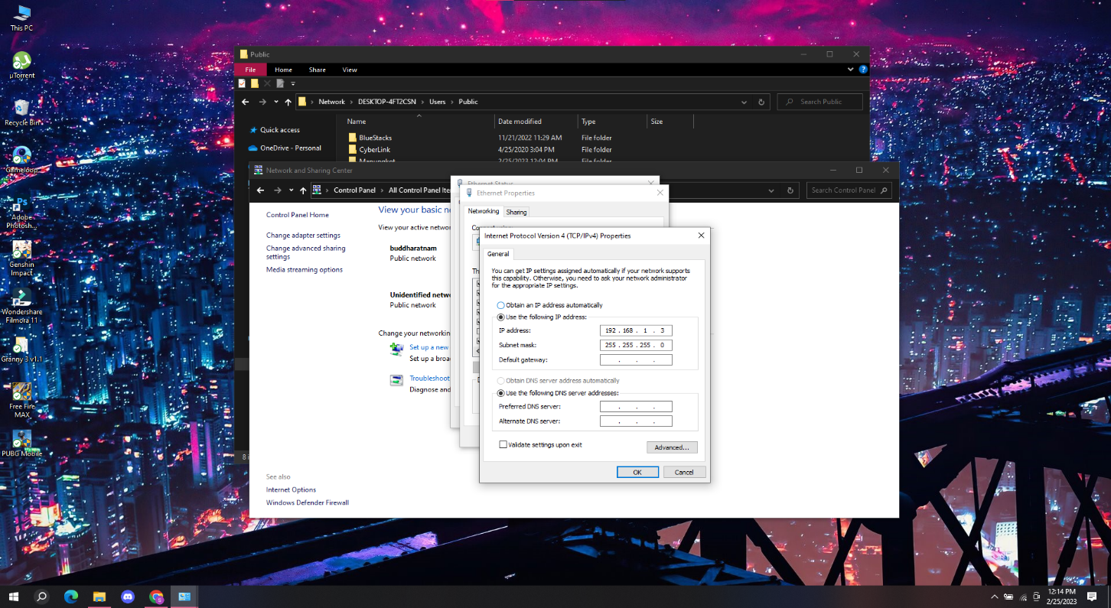

* After assigning the IP addresses successfully, you will see the two computer names in the Networks settings.
* Go to **Control Panel**
* Select the option for **Network and Internet**.
* Then go to the **Network Sharing Center**.
* Pick the option to **Change advanced sharing settings**.
* Choose the option for **Turn on file and printer sharing** under **File and printer sharing**.
* Save your settings, and you are good to go.

****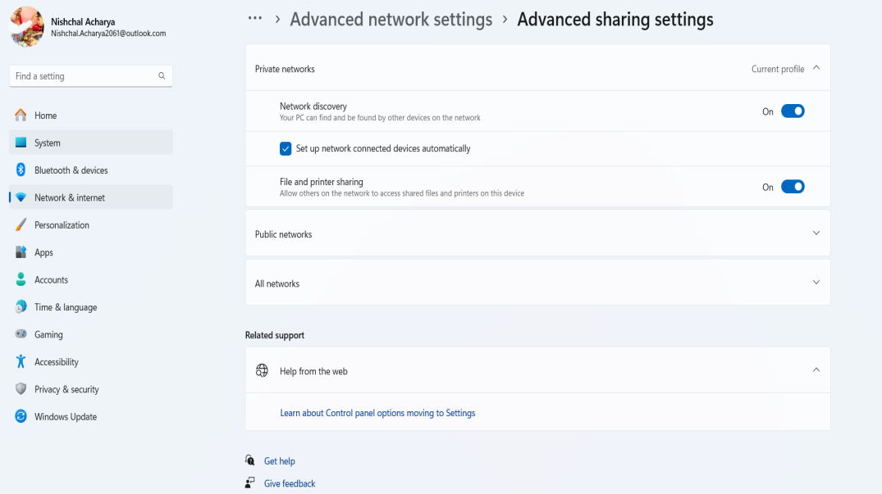

**Data sharing between computer:**

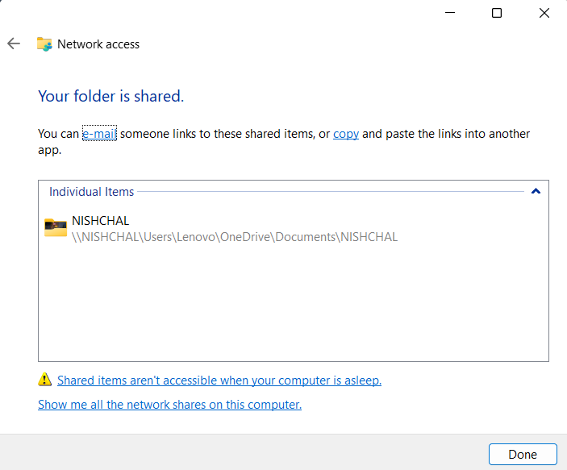

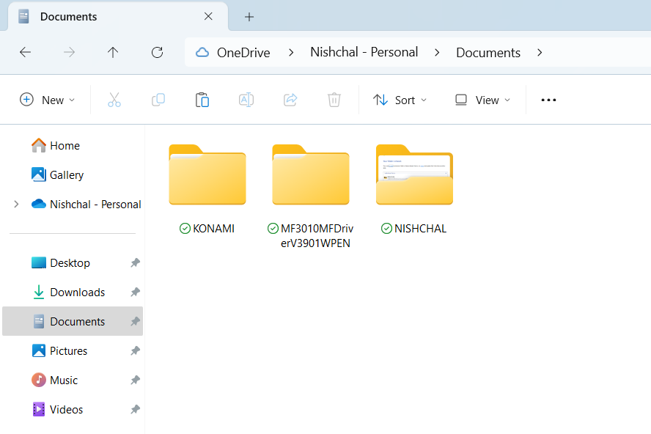**Source PC**





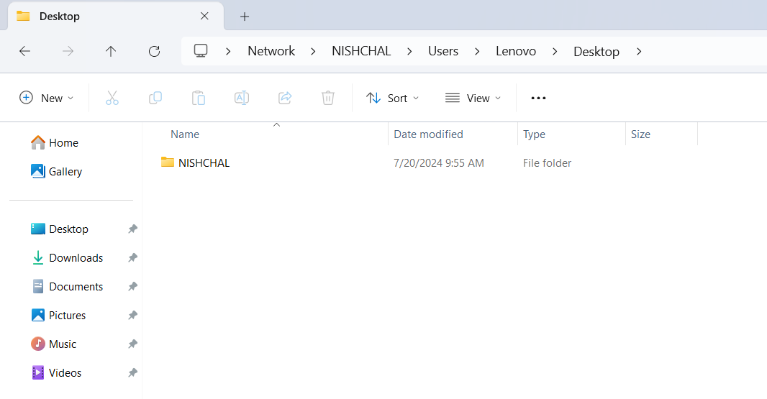**Destination PC**







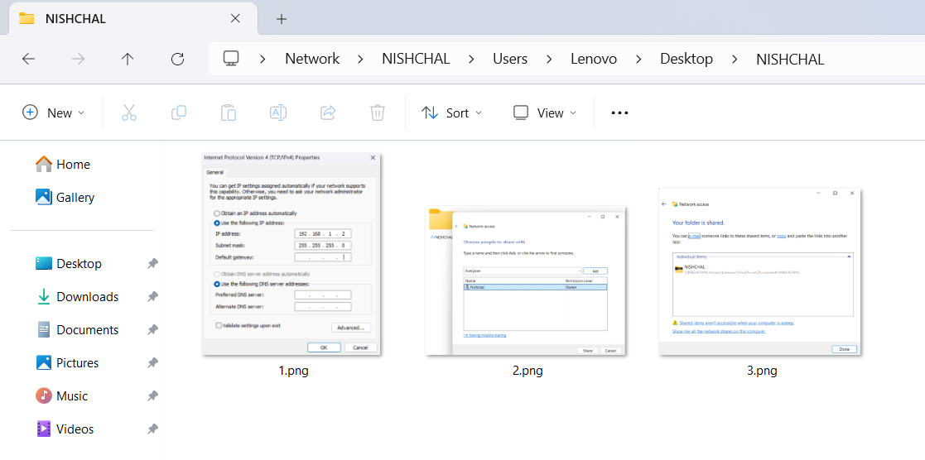

as

**Result:**

Cable Crimping, Standard Cabling and Cross Cabling and testing the crimped cable using a cable tester and file sharing between two computers are done successfully.