# Packet Tracer

Packet Tracer is a cross-platform visual simulation tool designed by Cisco Systems that allows users to create network topologies and imitate modern computer networks. The software allows users to simulate the configuration of Cisco routers and switches using a simulated command line interface. Packet Tracer makes use of a drag and drop user interface, allowing users to add and remove simulated network devices as they see fit.

# PACKET TRACER INTERFACE OVERVIEW

When we open Packet Tracer, by default we will be presented with the following interface:

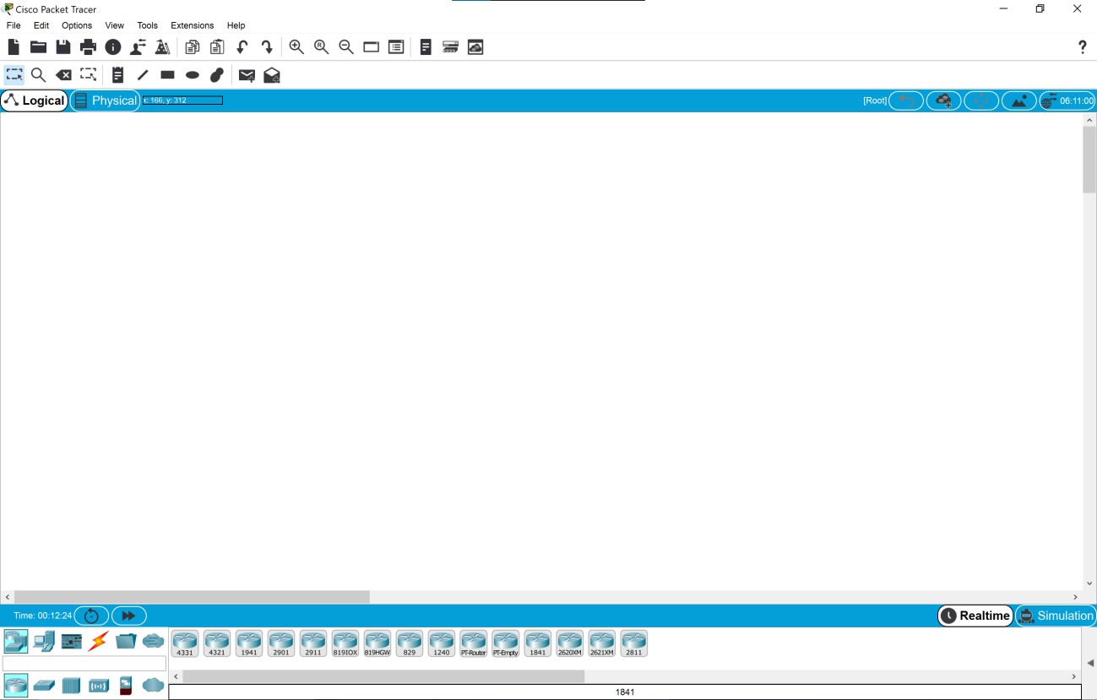

This initial interface contains ten components. If we are unsure of what a particular interface item does, moving our mouse over the item will open a text box that will explain the item.

**1. Menu Bar**



This bar provides the File, Edit, Options, View, Tools, Extensions, and Help menus. We will find basic commands such as Open, Save, Save as Pkz, Print, and Preferences in these menus.

We will also be able to access the Activity Wizard from the Extensions menu.

## 2. Main Tool Bar



This bar provides shortcut icons to the File and Edit menu commands. This bar also provides buttons for Copy, Paste, Undo, Redo, Zoom, the Drawing Palette, and the Custom Devices Dialog. On the right, we will also find the Network Information button, which we can use to enter a description for the current network (or any text we wish to include).

## 3. Common Tools Bar

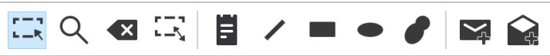

This bar provides access to these commonly used workspace tools: Select, Move Layout, Place Note, Delete, Inspect, Resize Shape, Add Simple PDU, and Add Complex PDU.

## 4. Logical/Physical Workspace and Navigation Bar



We can toggle between the Physical Workspace and the Logical Workspace with the tabs on this bar. In Logical Workspace, this bar also allows us to go back to a previous level in a cluster, create a New Cluster, Move Object, Set Tiled Background, and Viewport. In Physical

Workspace, this bar allows us to navigate through physical locations, create a New City, create

a New Building, create a New Closet, Move Object, apply a Grid to the background, Set Background, and go to the Working Closet.

## 5. Workspace



This area is where we will create our network, watch simulations, and view many kinds of information and statistics.

## 6. Realtime/Simulation Bar



We can toggle between Realtime Mode and Simulation Mode with the tabs on this bar. This bar also provides buttons to Power Cycle Devices and Fast Forward Time as well as the Play Control buttons and the Event List toggle button in Simulation Mode. Also, it contains a clock that displays the relative Time in Realtime Mode and Simulation Mode.

## 7. Network Component Box



This box is where we choose devices and connections to put into the workspace. It contains the Device-Type Selection Box and the Device-Specific Selection Box.

## 8. Device-Type Selection Box

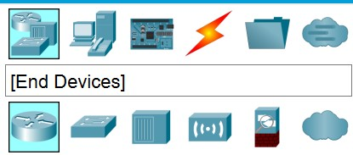

This box contains the type of devices and connections available in Packet Tracer. The DeviceSpecific Selection Box will change depending on which type of device we choose.

## 9. Device-Specific Selection Box



This box is where we choose specifically which devices we want to put in our network and which connections to make.

## 10. User Created Packet Window

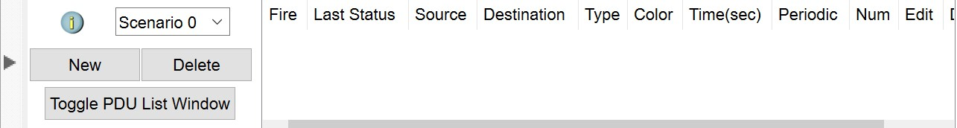

To access this menu, we need click on the arrow icon on the bottom right of the Packet Tracer interface. This window manages the packets we put in the network during simulation scenarios.

# Simulating Star Topology

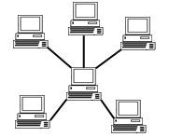Star topology is one of the most common network setups. Every node connects to a central network device in this configuration, like a hub, switch, or computer. The central network device acts as a server, and the peripheral devices act as clients. In a star topology setup, either a coaxial or RJ-45 network cable is used, depending on each computer's type of network card. The image shows how this network setup gets its name, as it is shaped like a star.

There technically is no limit to how many computers can connect in a star topology. However, network performance can decrease as more computers are connected, resulting in slower network speeds.

## Process on Setting up a network in Cisco Packet Tracer

**Step 1: Select a central network device and any type of end-devices. I have chosen a hub and Four PC. Link every device with the hub.**

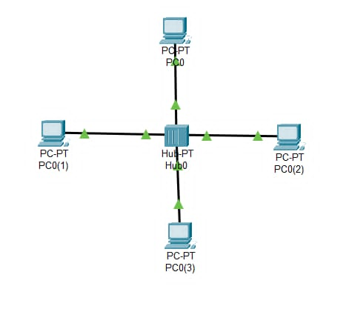

**Step 4: Provide the IP Address to every device. Check whether the connections are correct. I am trying to ping PC0 from PC3.**



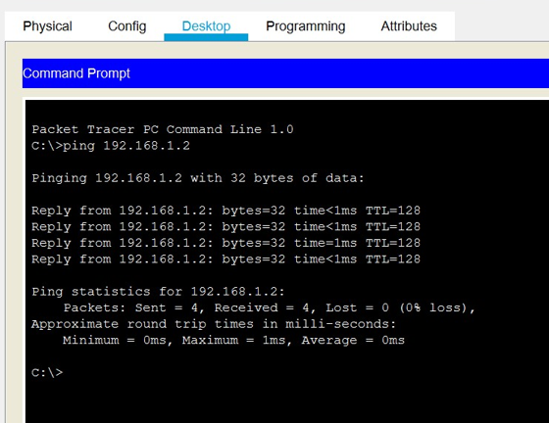

**Step 6: Transfer message from one device to another. Here I am trying to transfer packet from “pc0” to “pc3”.**

First a packet is generated at “pc 0”. Then the packet is sent to “hub0”.

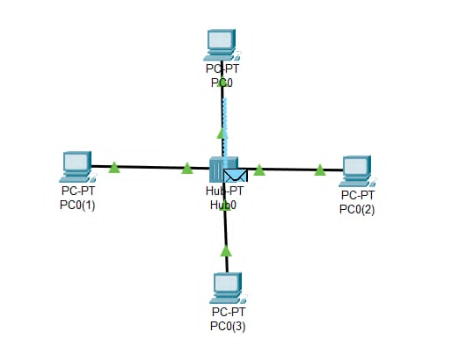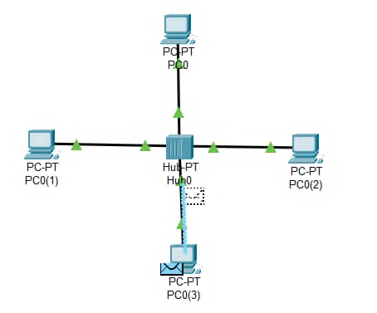

The “hub0” sends the packet to the reviver only i.e. “pc 3”. When the receiver receives the packet it sends acknowledgement message to “hub0”. End devices other than the intended recipient rejects the packet.

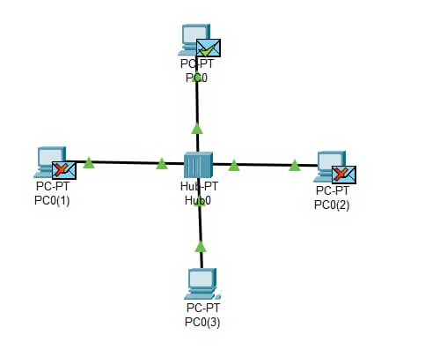 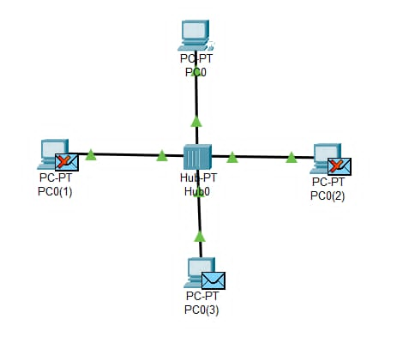

The acknowledgement message is again sent to the sender only ie. “pc 0”.

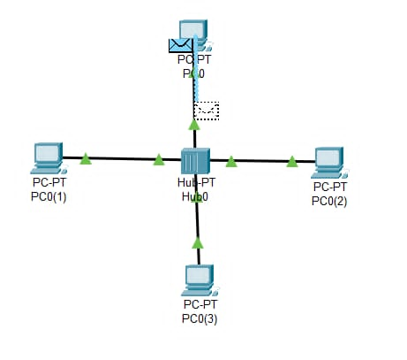 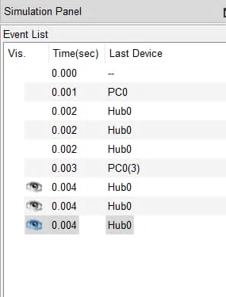

## Star Topology simulation using switch as central network device.

**Step1: Select a central network device and any type of end-devices. I have chosen a switch and four pc. Connect each end device to central network device and configure the IP address of each device.**

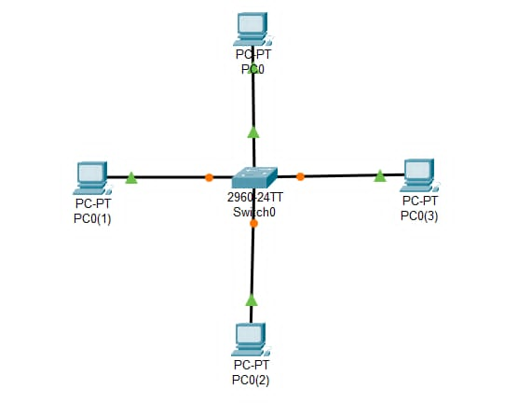

**Step: Check whether the connections are correct. Here I am trying to ping “pc0” form “pc2.**

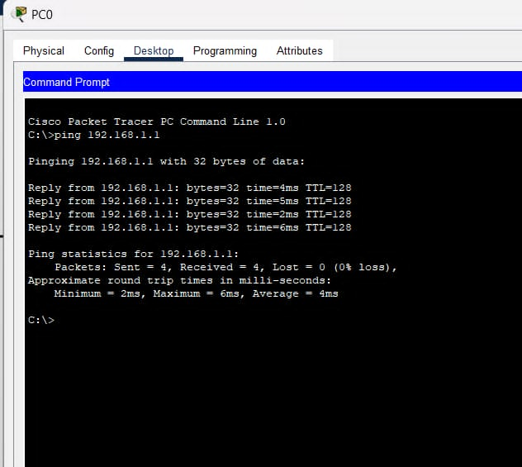

**Transfer message from one device to another. Here I am trying to transfer packet from “Pc0” to “pc2.**

First a packet is generated at “pc0”.

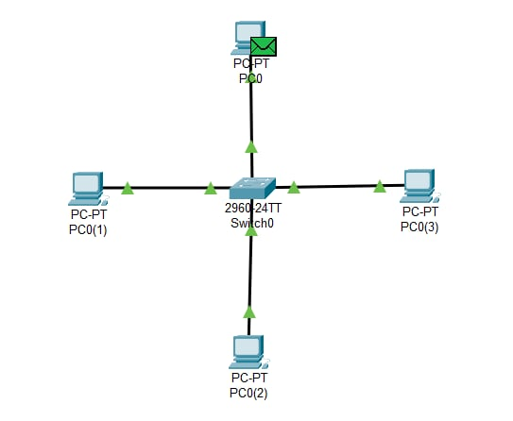

The packet is then sent to the immediate switch i.e. “switch0”

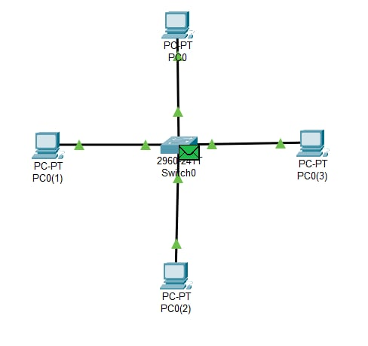

“switch0” sends the packet to all other immediate network devices. If other devices are not the receiving devices, then the packet is rejected.

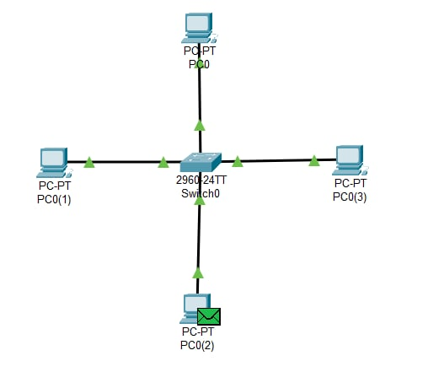

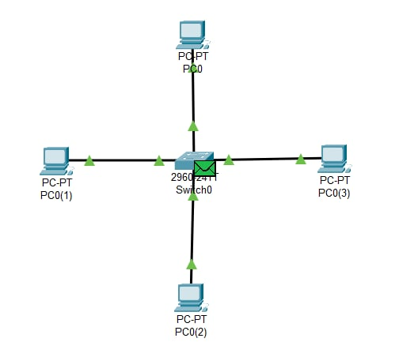

Then “switch0” sends the packet to all its immediate end devices.

The recipient then sends acknowledgement message to its immediate hub i.e. “switch0”.

“switch0” sends acknowledgement message to its immediate network devices.

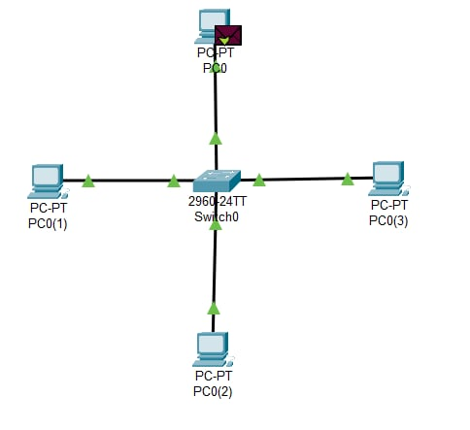

“Hub0” sends the acknowledgement message to its immediate end devices and the message is received by sender only i.e. “Laptop3”.

