**Lab 5: VLAN in CISCO Packet Tracer**

**Objectives:**

The objectives of this exercise is to set up a star topology using a central switch and configure VLANs for end devices in CISCO packet tracer. We will assign VLANs to specific PCs to segment the network for better management and security. The goal is to demonstrate communication within the same VLAN by transferring a messasge form one PC to another within the same VLAN. Additionally, we will illustrate the isolation provided by VLANs by attempting and failing to transfer a message from one PC to another PC on a different VLAN. This exercise will highlight the benefits of VLANs in network segmentation and traffic management. Finally, we will verify the setup by observing successful intra-VLAN communication and the prevention of inter-VLAN communication.

**Aim:**

To do the following:

-Set up star topology using SWITCH.

-Set VLAN for end devices

-Transfer Message from one PC to another PC of same VLAN

Transfer Message from one PC to another PC of Another VLAN

**VLAN:**  
A VLAN is a technology that segments a physical network into multiple logical networks, improving management and security. By isolatin different types of traffic, VLANs help protect sensitive data and reduce the risk of unauthorized access. They also enchance network performance by confining broadcast traffic to specific VLANs, which reduces overall network load. This segmentation proivdes greater flexibility, allowing devices to move between VLANs without changing physical connections. In dynamic environments, VLANs simplify network managemnet by grouping devices with similar network requirements, making it easier to apply policies and troubleshoot issues. Implementing VLANs typically involves using switches that support VLAN tagging, with each VLAN identified by a unique VLAN ID. The IEEE 802.1Q standard is widely used for VLAN tagging, specifying how VLAN tags are added to Ethernet frames and handled by switches.

**Simulating VLAN in CISCO Packet Tracer:**

Step 1:Set up a network with some end devices and a central network device. I have set up 5 PCs and a switch.

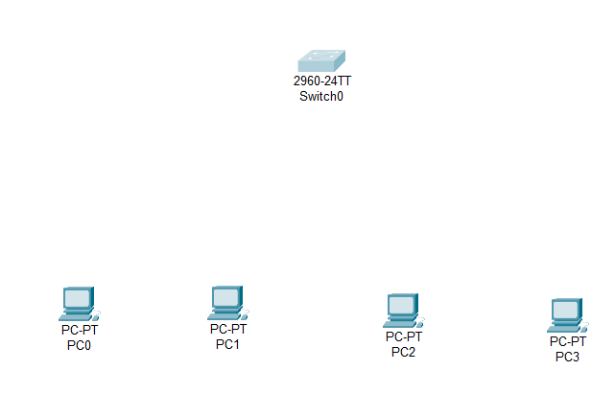

Step 2: Connect the PCs to the Switch.

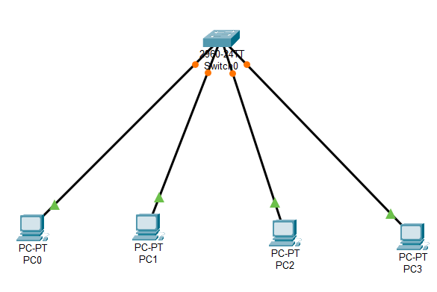

Step 3: Provide an IP address to each PC and divide the network into sections.

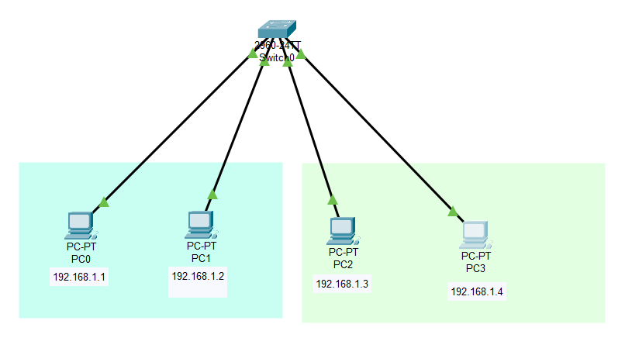

Step 4: Configure the VLAN database and add the required number of virtual LAN. I have added three VLAN as my network is divided into three separate networks.

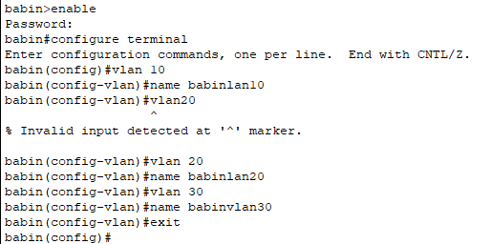

Step 5: configure the “Fast Ethernet” port for the PC in switch and specify the VLAN you want it to be in.

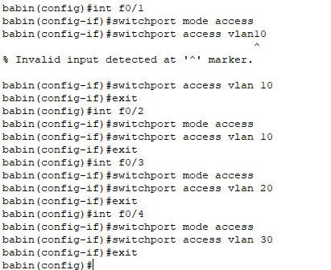

Step 6:Send packets between computer within same VLAn and different VLAN.

Same VLAN:

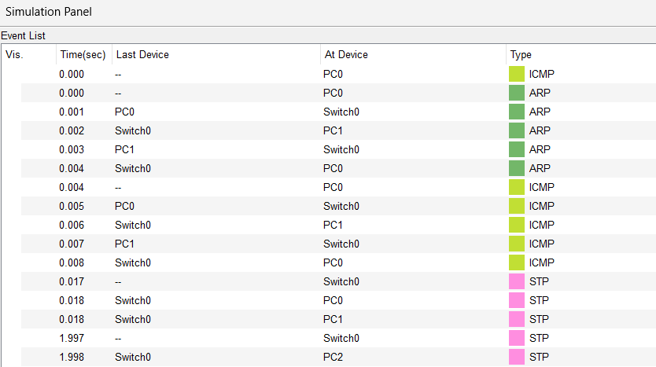

Another VLAN:

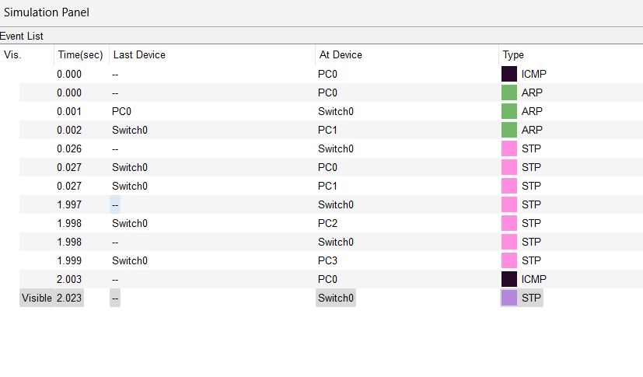

Step 7:Ping between computer within same VLAN and different VLAN.

