**Lab 6**

**Static Routing**

[Static routing](https://www.geeksforgeeks.org/difference-between-static-and-dynamic-routing/" \t "https://www.geeksforgeeks.org/types-of-routing/_blank) is also called as “non-adaptive routing”. In this, routing configuration is done manually by the network administrator. Let’s say for example, we have 5 different routes to transmit data from one node to another, so the network administrator will have to manually enter the routing information by assessing all the routes.

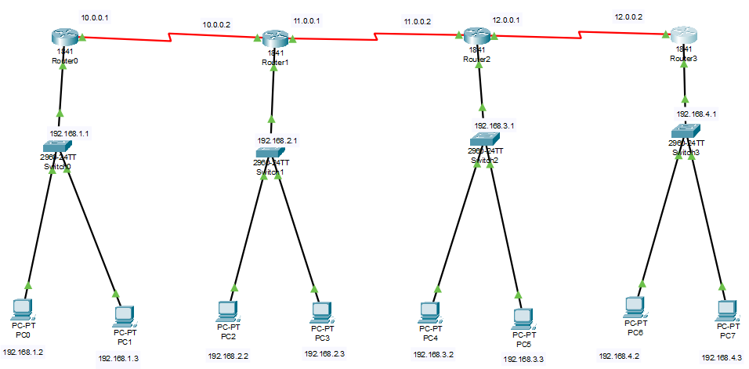

**IP CONFIGS**

Router 0:

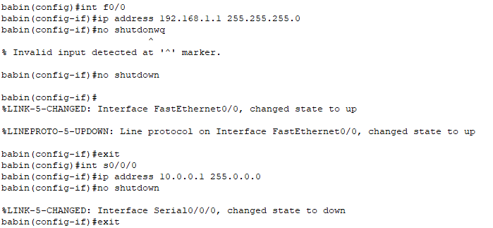

Router 1:

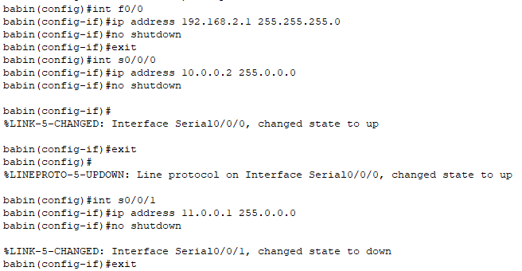

Router 2:

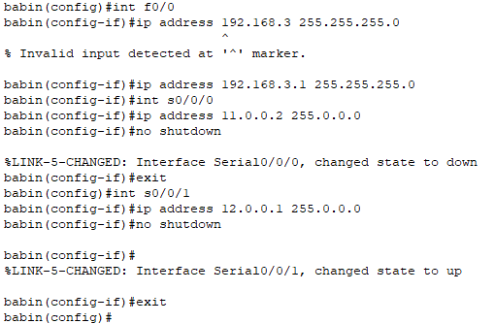

Router 3:

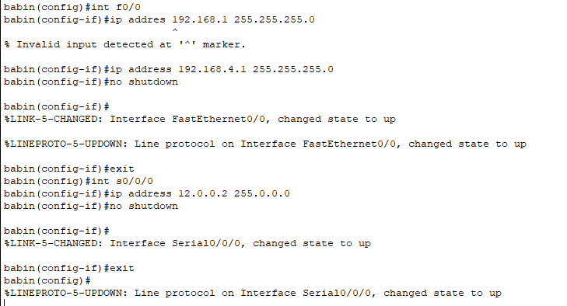

**Now configuring the static routes into the router**

Router 0:

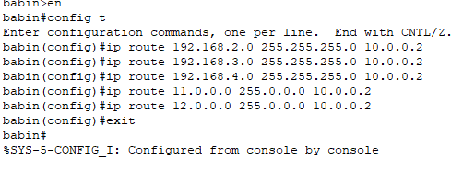

Router 1:

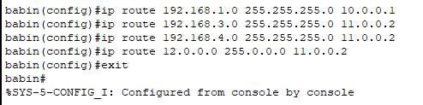

Router 2:

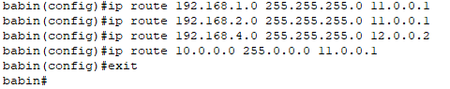

Router 3:

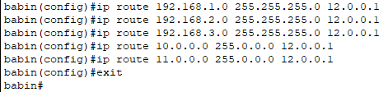

**PING**

