**Babin Rana**

**Lab 7: Dynamic Routing Configuration Using** **Routing Information Protocol (RIP)**

**Objectives:**

The main objective is to understand the fundamentals of dynamic routing and how it operates within a network. It involves learning how to configure RIP on routers to allow automatic updates and the exchange of routing information. Additionally, verifying the functionality of RIP through commands like show ip route is crucial to ensure proper configuration. Analyzing the behavior of RIP under different conditions, such as link failures and route changes, helps deepen understanding of its operation. Finally, the goal is to explore the limitations of RIP, such as the 15-hop limit and slow convergence times, and assess its suitability for different network sizes.

**Dynamic Routing:**

Dynamic routing is a method where routers automatically adjust their routing tables based on changes in the network. It eliminates the need for manual updates by allowing routers to exchange routing information in real-time. This adaptability makes dynamic routing ideal for networks with frequently changing topologies, such as large enterprise environments or WANs. It improves network efficiency by automatically finding the best available path for data transmission. Dynamic routing protocols, like RIP, OSPF, and EIGRP, ensure that the network remains operational even when links go down or new routes are introduced.

**RIP (Routing Information Protocol)**

RIP is one of the simplest dynamic routing protocols, using hop count as a metric to determine the best route to a destination. It broadcasts routing updates every 30 seconds, allowing routers to share their routing tables with neighboring devices. The protocol is easy to configure, making it suitable for smaller networks with fewer hops between routers. However, RIP is limited by its maximum hop count of 15, meaning it cannot scale effectively for larger networks. Despite its limitations, RIP is still useful for small networks where simplicity and low overhead are priorities.

**Simulating Dynamic Routing in Cisco Packet Tracer:**

**Step 1: Set up a network with some end-devices with switches and routers.**

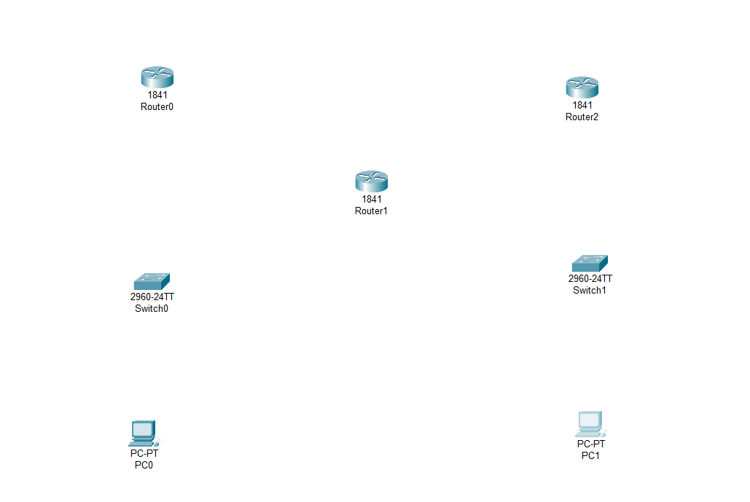

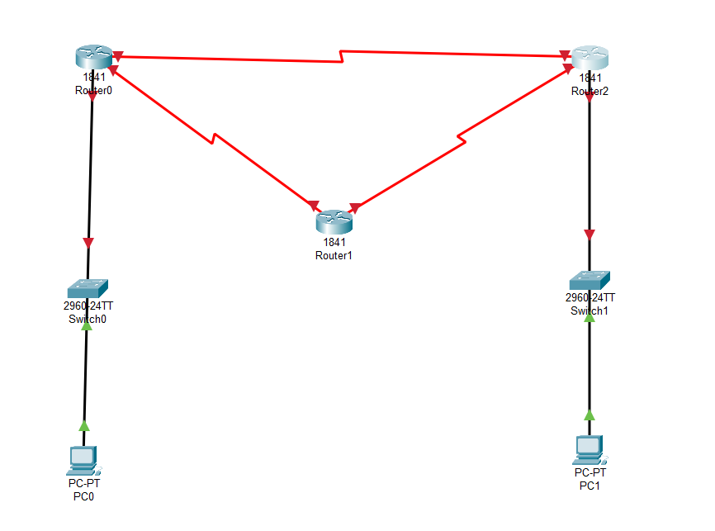**Step 2: Connect the PCs to the switch and connect switch to routers. Before connecting the routers add the serial port WIC-2T to the routers and turn off the router before adding serial port.**

**Step 3: Provide an IP address to each PCs and routers.**

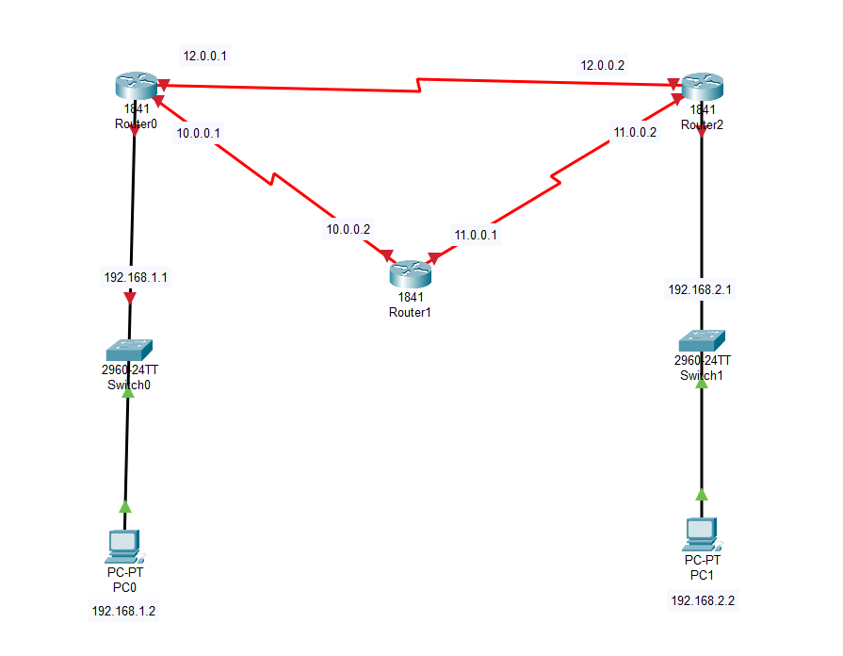

**Step 4: Configure the IP addresses for the routes.**

**Router 0:**

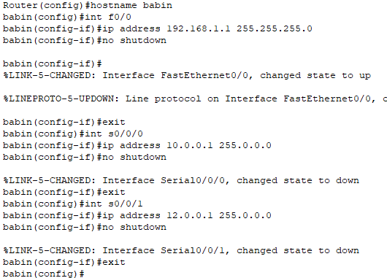

Router 1:

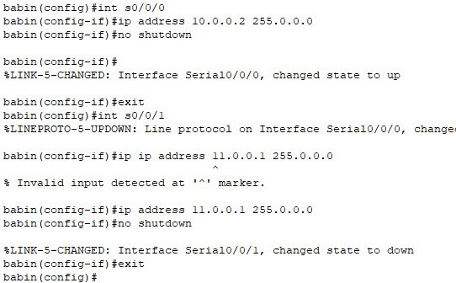

ROuter 2:

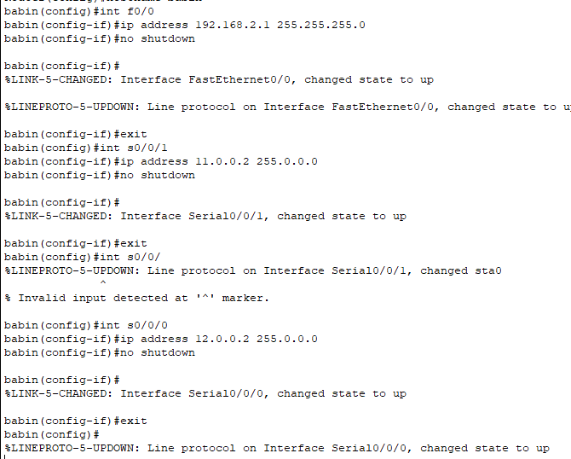

**Step 5: Now configuring the RIP routing into the routers.**

**Router 0:**

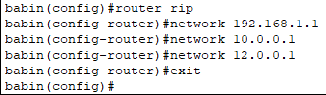

**ROuter 1:**

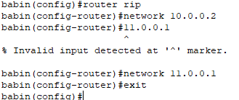

**Router 2:**

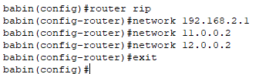

**Ping Test Withing ROuters:**

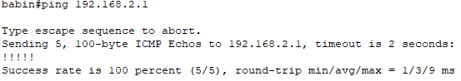

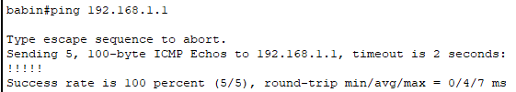

**Ping test between PCs between different networks.**

Ping from PC0(connected to Router 0) to PC1 (connected to Router 2):

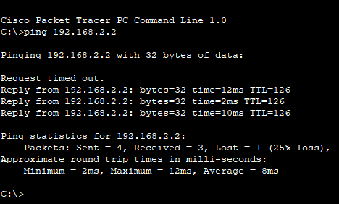

Ping from PC1(connected to Router 3) to PC0 (connected to Router 0):

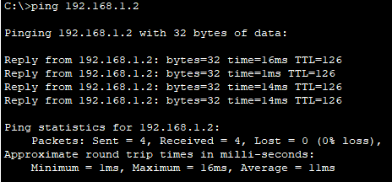

**Conclusion:**

Dynamic routing, particularly using RIP, provides an automated method for routers to exchange routing information and update their paths in response to changes. RIP, though simple and easy to configure, is best suited for smaller networks due to its 15-hop limit and slow convergence speed. While RIP offers ease of use, its limitations become evident in larger or more complex environments. By configuring and verifying RIP, network administrators can see its practical benefits and limitations firsthand. Ultimately, dynamic routing protocols like RIP enable more flexible and adaptive network management, though other protocols may be better suited for larger-scale networks.