**Lab 8: Dynamic Routing Configuration Using**

**Open Shortest Path First (OSPF)**

**Objectives:**

The objective of dynamic routing configuration using Open Shortest Path First (OSPF) is to enable efficient and scalable routing across complex networks. OSPF automatically calculates the best path between routers based on link-state information, ensuring optimal data flow. It aims to minimize manual intervention by dynamically adjusting to changes in network topology, such as link failures or new connections. Additionally, OSPF promotes faster convergence, which reduces downtime during network changes. Its use of hierarchical design also enhances scalability and reduces overhead in large networks.

**Aim:**

**To do the following:**

* To set the hostname of each router to "Babin" and ensure that the labeling on the network configuration is properly done.
* To configure IP addresses on each router interface and establish dynamic routing using OSPF.
* To verify network connectivity using ping tests between all routers.

**Dynamic Routing:**

Dynamic routing is a method where routers automatically adjust their routing tables based on changes in the network. It eliminates the need for manual updates by allowing routers to exchange routing information in real-time. This adaptability makes dynamic routing ideal for networks with frequently changing topologies, such as large enterprise environments or WANs. It improves network efficiency by automatically finding the best available path for data transmission. Dynamic routing protocols, like RIP, OSPF, and EIGRP, ensure that the network remains operational even when links go down or new routes are introduced.

**Open Shortest Path First (OSPF)**

Open Shortest Path First (OSPF) is a link-state routing protocol used in large and complex networks to determine the most efficient path for data transmission. It dynamically adjusts to changes in the network by using a shortest-path algorithm to calculate optimal routes, ensuring reliable communication between routers. OSPF supports hierarchical design through the use of areas, which helps reduce routing overhead and improves scalability. Unlike distance-vector protocols, OSPF quickly converges and minimizes downtime during network changes. It is widely used in enterprise and service provider networks due to its flexibility, speed, and scalability.

**Simulating Dynamic Routing in Cisco Packet Tracer:**

**Step 1: Set up a network with some end-devices with switches and routers.**

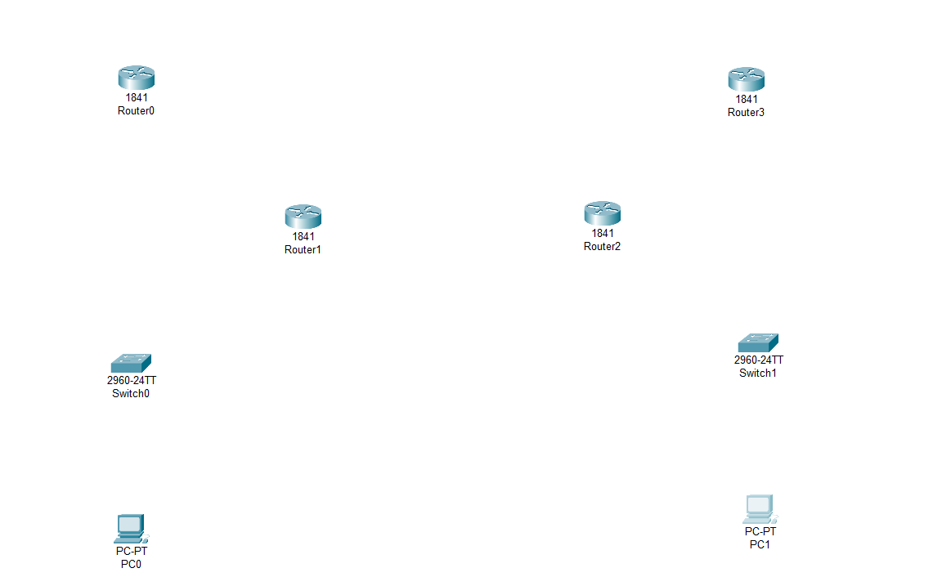

**Step 2: Connect the PCs to the switch and connect switch to routers. Before connecting the routers add the serial port WIC-2T to the routers and turn off the router before adding serial port.**

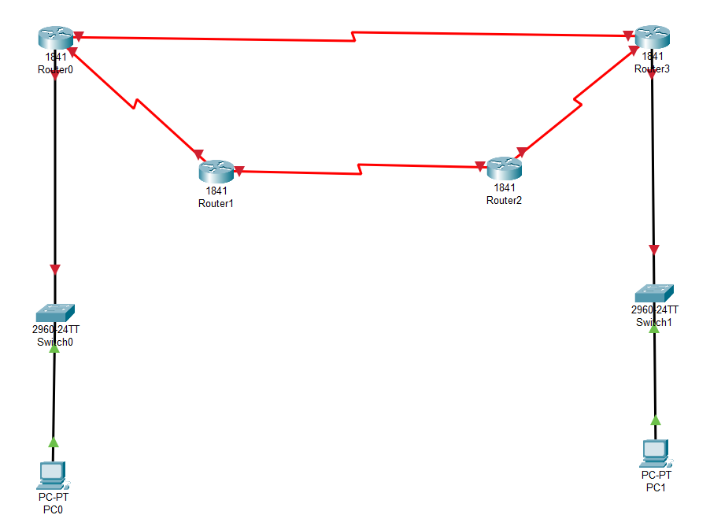

**Step 3: Provide an IP address to each PCs and routers.**

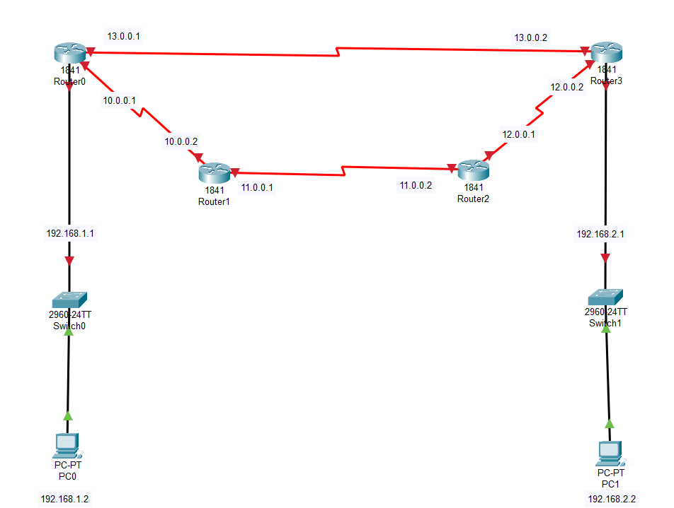

**Step 4: Configure the IP addresses for the routes.**

**Router 0:**

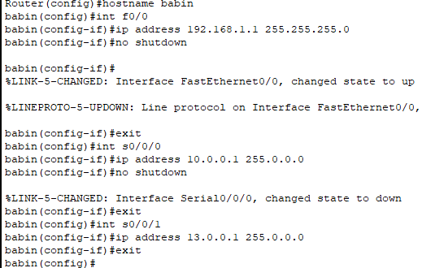

**Router 1:**

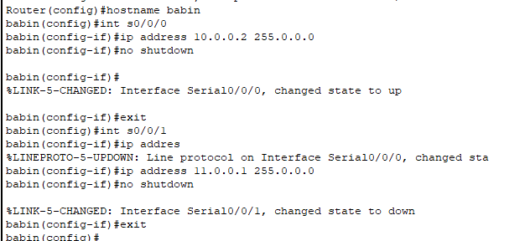

**Router 2:**

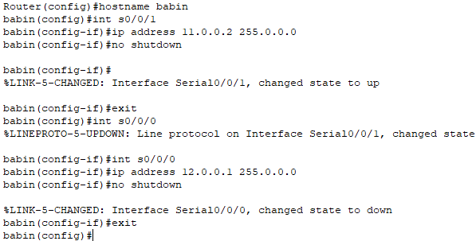

**Router 3:**

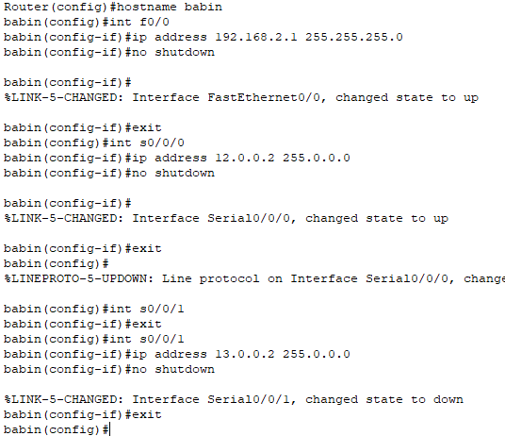

**Step 5: Now configuring the OSPF routing into the routers.**

**Router 0:**

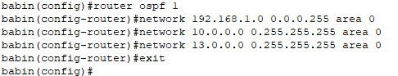

**Router 1:**

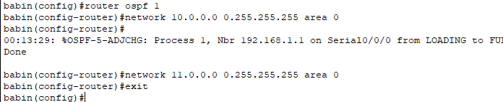

**Router 2:**

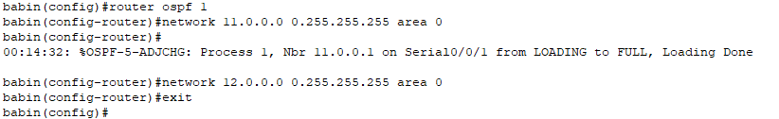

**Router 3:**

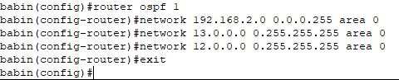

**Step 6: Send packets between computer within different PCs.**

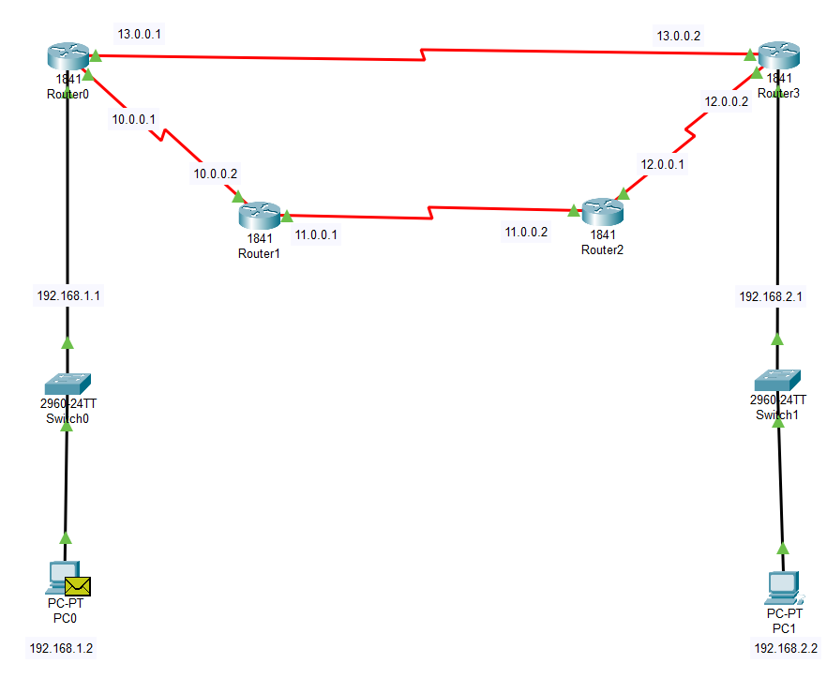

**Step 7: Ping test between PCs between different networks.**

Ping from PC0(connected to Router 0) to PC1 (connected to Router 3):

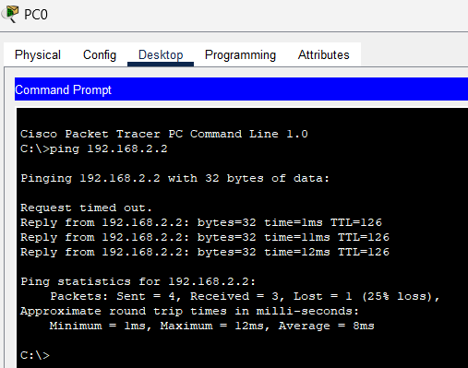

Ping from PC1(connected to Router 3) to PC0 (connected to Router 0):

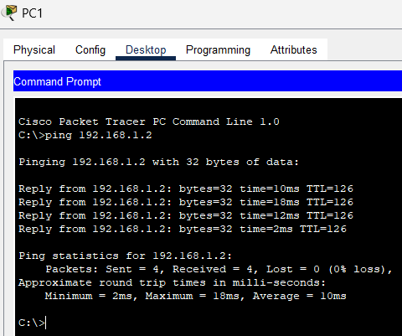

**Conclusion:**

In conclusion, OSPF proves to be an essential protocol for dynamic routing in modern networks due to its adaptability and efficiency. It ensures that data packets take the shortest and most reliable paths, adjusting automatically to network changes. OSPF's quick convergence minimizes disruption, making it ideal for large and evolving network infrastructures. With its support for multiple areas, OSPF helps network administrators manage complexity and enhance performance. Ultimately, OSPF strikes a balance between efficiency, flexibility, and scalability in dynamic routing environments.