**Lab1: Data Definition Language(DDL)**

**Objective**

To study different Data Definition Language queries and implement them in a database.

**Theory**

DDL is a subset of SQL responsible for defining and managing the structure of database and their objects. DDL commands enable you to create, modify, and delete database objects like tables, indexes, constraints, and more. Commonly used DDL in SQL querying are CREATE, ALTER, DROP and TRUNCATE.

**Question**

1. Create a database of your name.

Query:

Output:

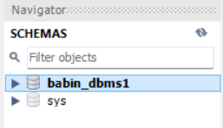

1. **Create Table**
2. **Student(sid(int), name, gender, program):**

Query:

Output:

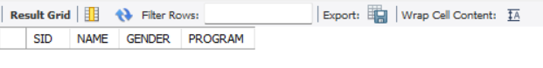

1. **Teacher (id(int), name, address):**

Query:

Output:

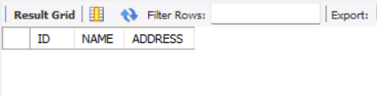

1. **Alter student table (add contactno.varchar(20)):**

Query:

Output:

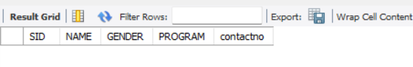

1. **Alter student table column contactno into int:**

Query:

Output: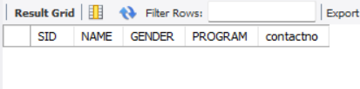

1. **Alter teacher table(add subject varchar(50)):**

Query:

Output:

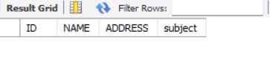

1. **Alter teacher table alter address to int:**

Query:

Output:

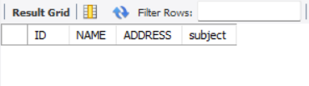

1. **Drop column gender from student table:**

Query:

Output:

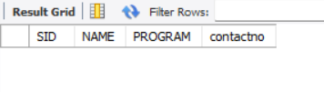

1. **Drop column address from teacher table**

Query:

Output:

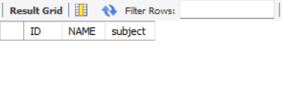

1. **Change student table column name to Studentname:**

Query:

Output:

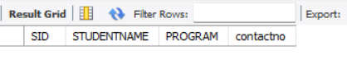

1. **Alter teacher table rename id to tid:**

Query:

Output:

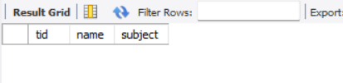

1. **Drop table teacher**

Query:

Output:

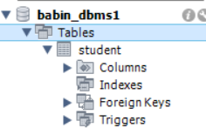

1. **Drop database babin_dbms1;**

Query:

Output:

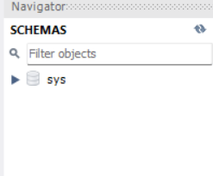

**Conclusion:**

In conclusion, this lab session provided a comprehensive introduction to database schema creation and management through practical exercises with essential DDL commands such as CREATE, ALTER and DROP. The focus was on the importance of defining, and structuring database objects including tables and indexes to ensure data consistency and integrity. We gained hand on experience in creating and modifying database schema, learning best practices for organizing data to optimize performance and support scalability. Overall, this lab session equipped us with foundational skills in data definition, essential for creating robust and efficient database systems.