Lab2: Theory : write about the constraints in SQL

1. **Create a database dbms2**

**Query:**

**Outptut:**



1. **Create table**  
   I. Student (id(int),name,gender, program, contact_number, address)  
   Set NOT NULL constraint on the “id” column for both tables  
   Set UNIQUE constraint on the “id” column  
   II. Teacher (id(int), name, subject, contact_number, address)  
   Set NOT NULL constraint on the “id” column for teacher table  
     
   **Query:**

**Output:**



1. **Set NOT NULL constraint on the “contact_number” column in the existing “Teacher” table**  
   **Query:**

**OUTUPUT:**

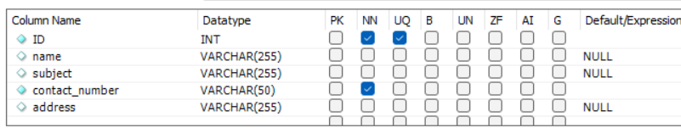

1. Set NOT NULL constraint on the “address” column in the existing “student” table

**Query:**

**Outptut:**

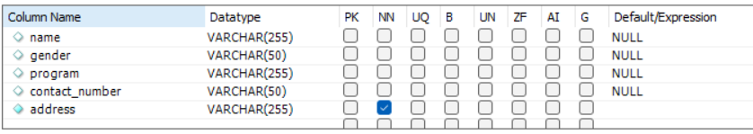

1. Set primary key on the “ID” column on the “teacher” table

**Query:**

**Output:**



1. Set primary key on the “ID” column on the “Student” table

**QUery:**

**Output:**

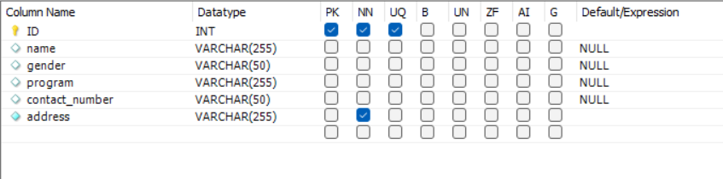

1. Set program “CSIT” in student table

Query:

Output:

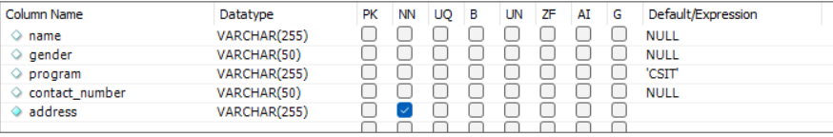

1. Set address “Ekantakuna” in student table

Query:

Output:



1. Delete the constraint primary key on the “ID” column when the “Teacher” table.

Query:

Output:

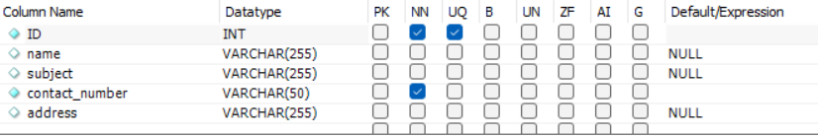

1. Delete NOT NULL constraint on the id column for teacher table.

Query:

Output:

