Lab 3

**A. Data Import**

a. Download northwind-db.sql from classroom link

b. Open MySQL Workbench and Login using root or <name>

c. Create database <name> northwind

**Query:**

create database Babinnorthwind;

**Output**

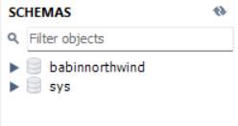

d Import downloaded database in <name> northwind

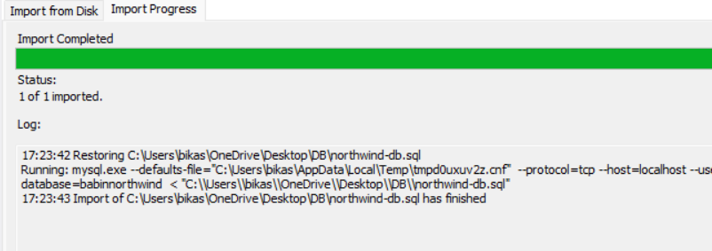

e. Check Total Row Count in each table

**Query:**

select count(*) from categories;

select count(*) from customers;

select count(*) from employees;

select count(*) from orderdetails;

select count(*) from orders;

select count(*) from products;

select count(*) from shippers;

select count(*) from suppliers;

**Output**

Categories

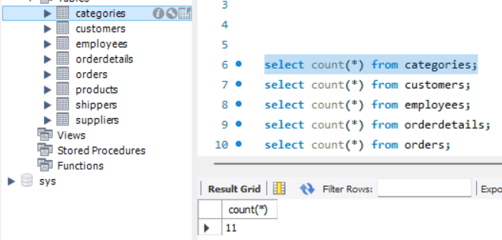

Customers

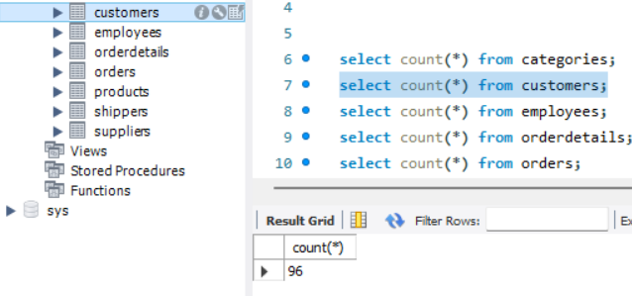

Employees

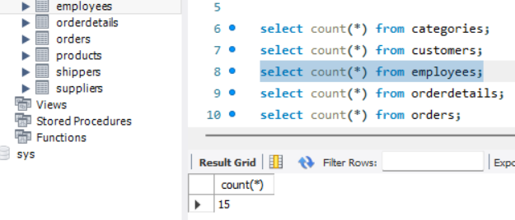

Order Details

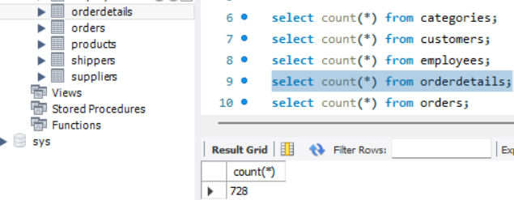

Orders

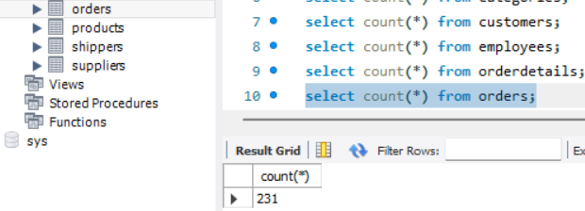

Products

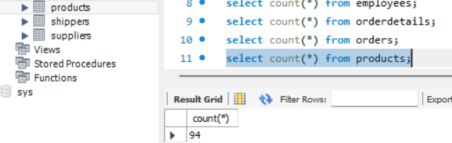

Shippers

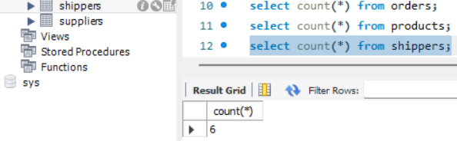

Suppliers

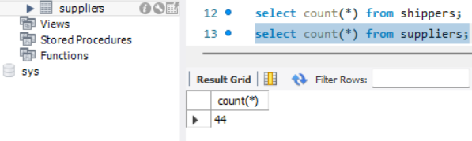

f. Check attributes and constraints in each table

Output:

Categories:

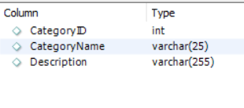

Customers

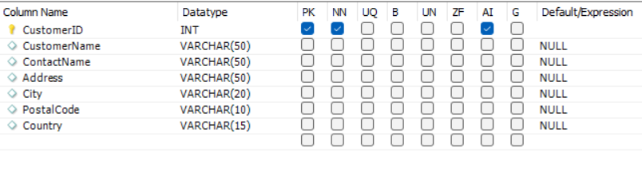

Employees

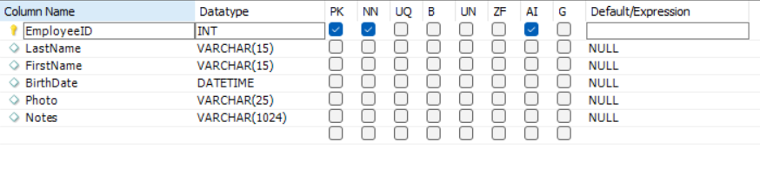

Order Details

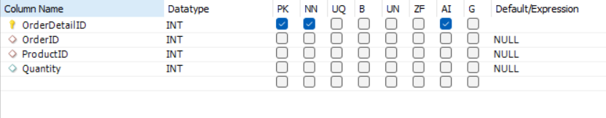

Orders

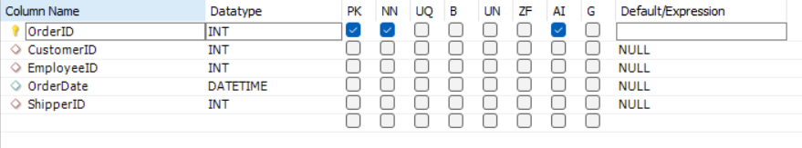

Products

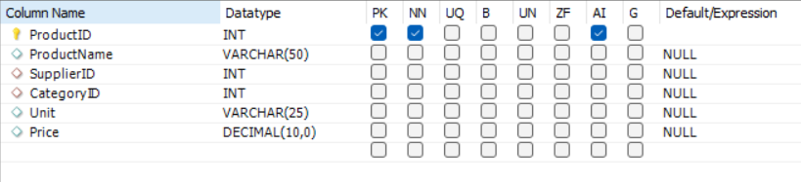

Shippers

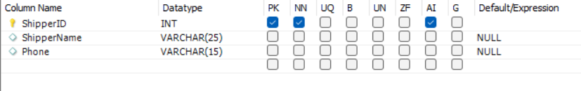

Suppliers

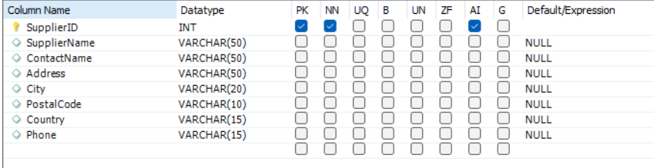

**B. Draw Entity Relationship Diagram**

a. Open any internet browser

b. Open <https://draw.io>

c. Select appropriate storage for your draw.io files (Prefer: Google Drive)

i. Authorize the access

d. Draw ER diagram of northwind database

i. Use appropriate shapes of ER diagram

ii. Use various colors to different Entity and attributes

**Output:**

