**Lab 4**

**DQL**

1. Project categories_name from categories

Query: select categoryName from categories:

Output:

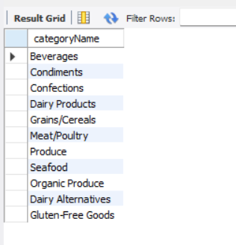

1. Project coutry from customers

Query: select country from customers;

Output:

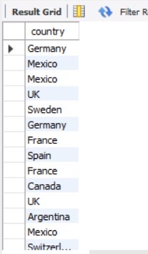

1. Project city , country from customers

Query:select city, country from customers;

Outuput:

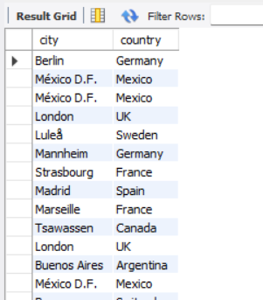

1. Select CustomerName from customers who are form Madrid City

Query:select CustomerName from customers where city='Madrid' ;

Output:

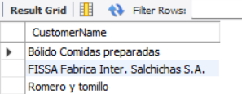

1. SELECT CustomerID from customers who are from Germany

Query:select CustomerID from customers where country='Germany';

Output:

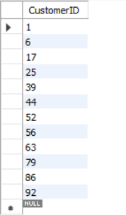

1. SELECT CustomerID, CustomerName from customers who are from Germany or Spain

Query:select CustomerID, CustomerName from customers where country='Germany' or 'Spain';

Output:

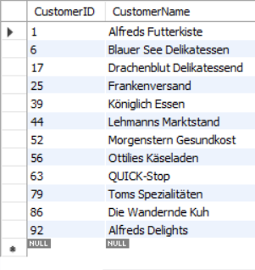

1. SELECT all from customers who are form London or UK

Query:select *from customers where city='London' and country='UK';

Output:

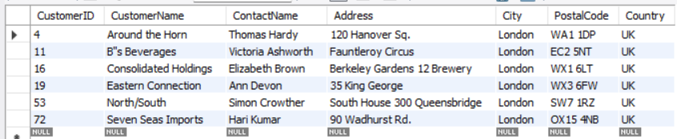

1. SELECT all from customers who are from city having names that start with first letter ofYour Name.

Query:select *from customers where city like 'b%';

Output:

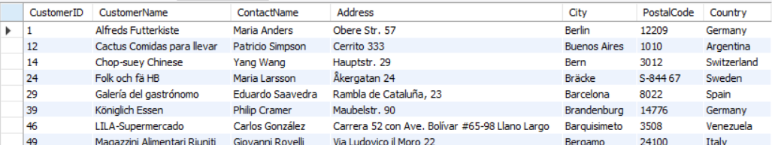

1. SELECT all from customers who are not from Canada and Belgium

Query:select *from customers where country not in ('Canada' ,'Belgium');

Output:

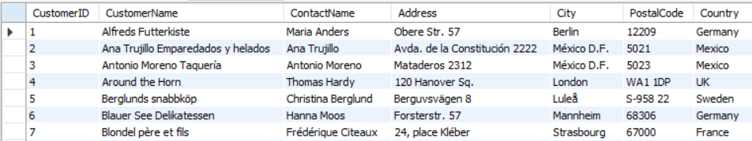

1. SELECT all from customers who are from G7 countries.

Query:select *from customers where country in ('Canada','France' ,'Germany','Italy' ,'Japan','UK','US');

Output:

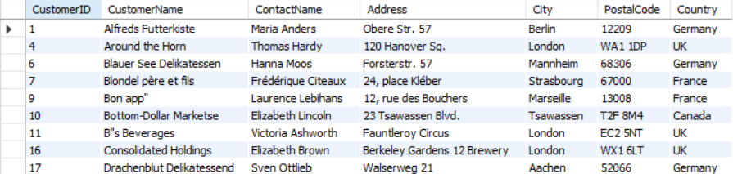

1. SELECT all from customers who have POstalCode containing 31.

Query:select *from customers where PostalCode like '%31%';

Output:

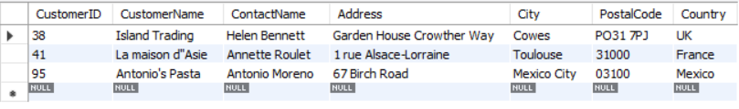

1. SELECT all from customers having PostalCode containing 00 and from Rome or Paris.

Query:select *from customers where PostalCode like '%00%' and city=('Rome' or 'Paris');

Output:

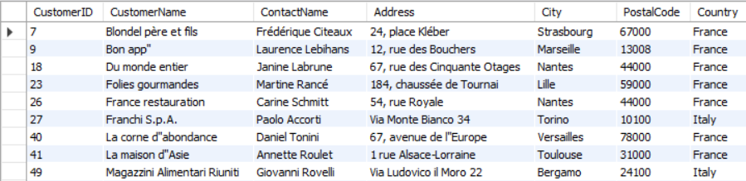

1. SELECT all from customers who are not from Salzburg

Query:select *from customers where country not in ('Salzburg');

Output:

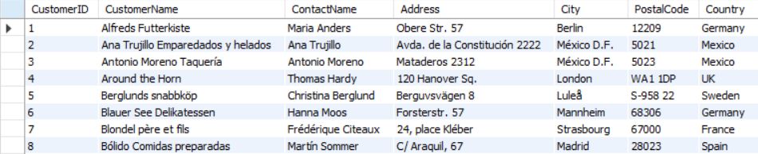

1. SELECT all employees who are born on July.

Query:select *from employees where BirthDate like '%-07-%';

Outptut:

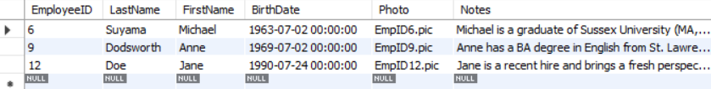

1. SELECT all employees having BA degree in Notes.

Query:select *from employees where Notes like '%BA%';

Output:

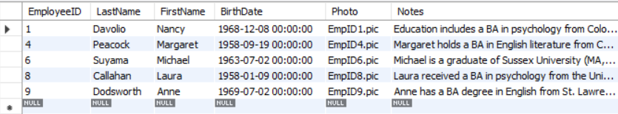

1. SELECT all suppliers from USA and Japan.

Query:select *from suppliers where country in ('USA','Japan');

Output:

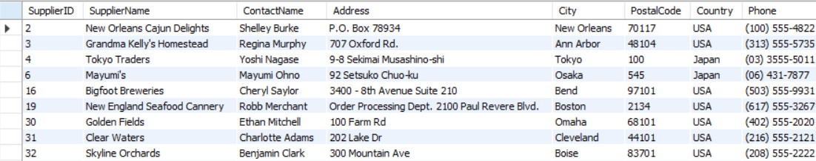17. Find name and count of suppliers from different countries.

Query:select distinct(country),count(*) as supplier_count from suppliers group by country;

Output:

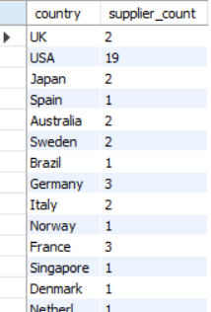

18 Find name and count of customers from different cities.

Query: select distinct(city),count(*) as name_count from customers group by city;

Output:

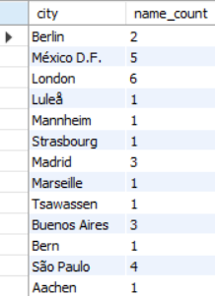

1. Find number of orders made by employee along with employeeID.

Query:select distinct(employeeID),count(*) as order_count from orders group by employeeID;

Output:

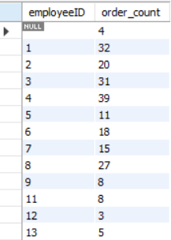

1. Find number of orders made by customers along with customerID.

Query:select distinct(customerID), count(*) as order_count from customers group by customerID;

Output:

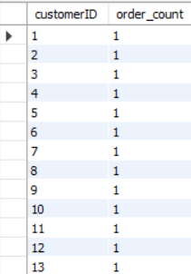

1. Find all order that are shupped by shippers having 1 or 3 shipperID.

Query:select *from orders where shipperID in ('1','3');

Output:

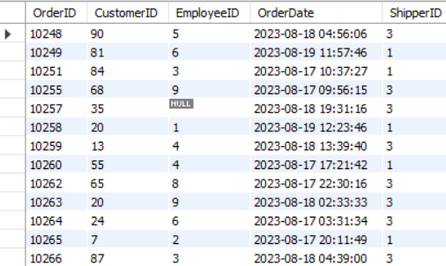

1. SELECT all product having categoriesID 1.

Query:select *from products where categoryID='1';

Output:

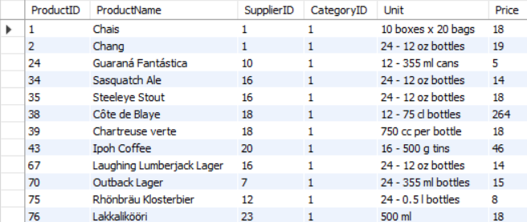

1. SELECT all products having ProductName that starts with First Letter of your name.

Query:select *from products where ProductName like 'b%';

Output:

