**Lab 5**

1. **Add two product categories of your choice**

Query:INSERT INTO categories (CategoryName, Description)

VALUES

('Electronics', 'Electronic devices and gadgets'),

('Books', 'All kinds of books');

select *from Babinnorthwind.categories;

Output:

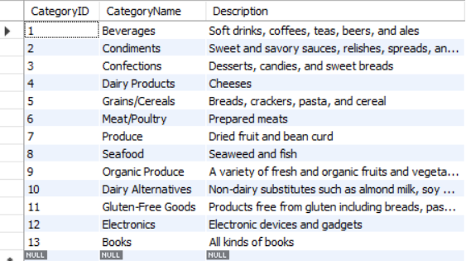

1. **Add 3 new suppliers in suppliers table**

Query:INSERT INTO suppliers (SupplierName, ContactName, Address, City, PostalCode, Country, Phone)

VALUES

('Tech Supplies', 'Alice Johnson', '123 Tech Lane', 'Tech City', '12345', 'USA', '123-456-7890'),

('Book Distributors', 'Bob Smith', '456 Book Blvd', 'Book Town', '67890', 'USA', '098-765-4321'),

('Gadget World', 'Charlie Brown', '789 Gadget Rd', 'Gadget City', '54321', 'Canada', '456-123-7890');

select *from babinnorthwind.suppliers;

Output:

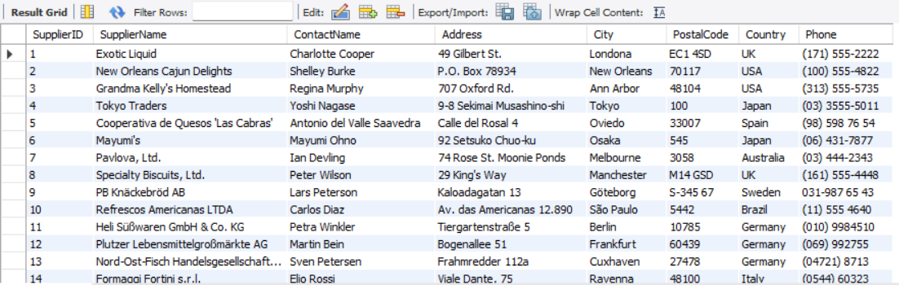

1. **Add 5 new customers in customers table**

Query:INSERT INTO customers (CustomerName, ContactName, Address, City, PostalCode, Country)

VALUES

('John Doe', 'John', '123 Main St', 'New York', '10001', 'USA'),

('Jane Smith', 'Jane', '456 Elm St', 'Los Angeles', '90001', 'USA'),

('Michael Johnson', 'Michael', '789 Oak St', 'Chicago', '60601', 'USA'),

('Emily Davis', 'Emily', '101 Pine St', 'Houston', '77001', 'USA'),

('David Wilson', 'David', '202 Maple St', 'Phoenix', '85001', 'USA');

select *from babinnorthwind.customers;

Output:

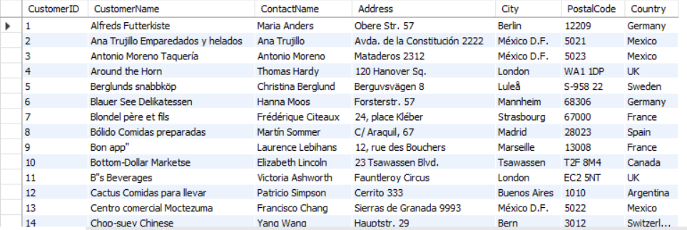

1. **Add 4 products in product table**

Query:INSERT INTO products (ProductName, SupplierID, CategoryID, Unit, Price)

VALUES

('Smartphone', 1, 1, 'Piece', 699),

('Laptop', 1, 1, 'Piece', 999),

('Fiction Book', 2, 2, 'Piece', 20),

('Non-fiction Book', 2, 2, 'Piece', 25);

select *from babinnorthwind.products;

OUtput:

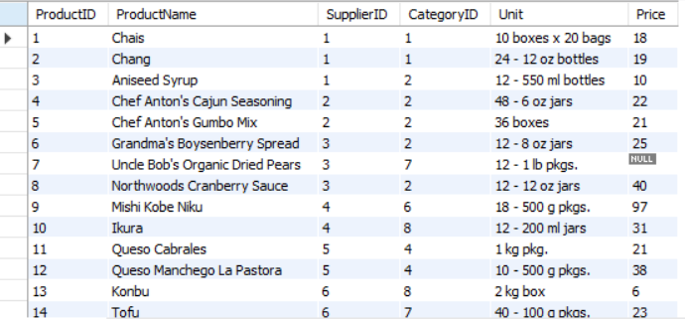

1. **Add 3 new employees**

Query:INSERT INTO employees (LastName, FirstName, BirthDate, Photo, Notes)

VALUES

('Anderson', 'Mark', '1980-05-15', 'mark.jpg', 'Notes about Mark'),

('Taylor', 'Laura', '1985-07-20', 'laura.jpg', 'Notes about Laura'),

('Brown', 'Chris', '1990-08-25', 'chris.jpg', 'Notes about Chris');

select *from babinnorthwind.employees;

Outupt:

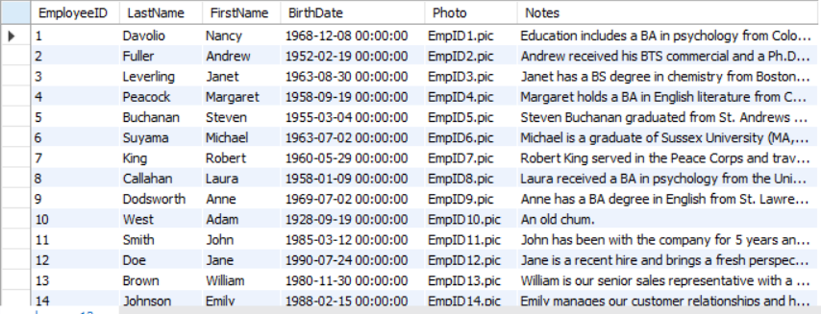

1. **Update all customers from Mexico to Vietnam**

Query:SET SQL_SAFE_UPDATES = 0;

UPDATE customers

SET Country = 'Vietnam'

WHERE Country = 'Mexico';

SET SQL_SAFE_UPDATES = 1; -- Re-enable safe update mode

Select *from babinnorthwind.customers;

OUtput:

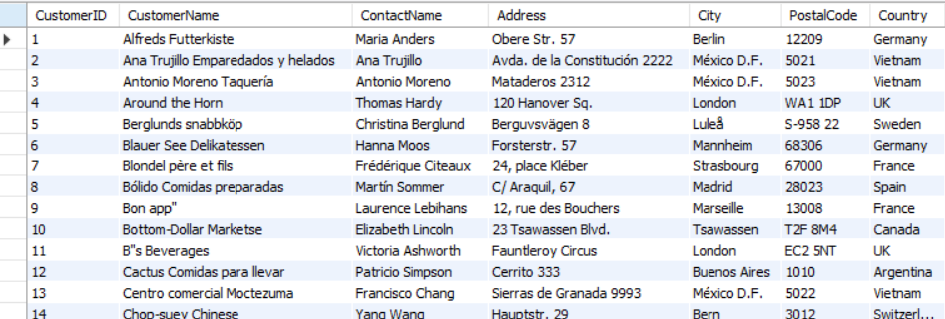

1. **Update customers table changing name of Paris City to Delhi**

Query:UPDATE customers SET City = 'Delhi' WHERE City = 'Paris';

select *from babinnorthwind.customers;

Output:

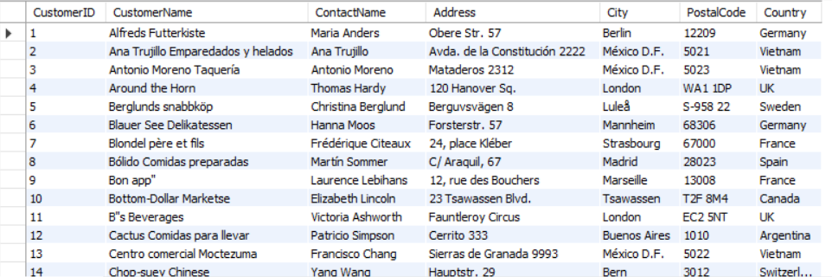

1. **Update all USA customers to Indian customers.**

Query:UPDATE customers SET Country = 'India' WHERE Country = 'USA';

select *from babinnorthwind.customers;

Output:

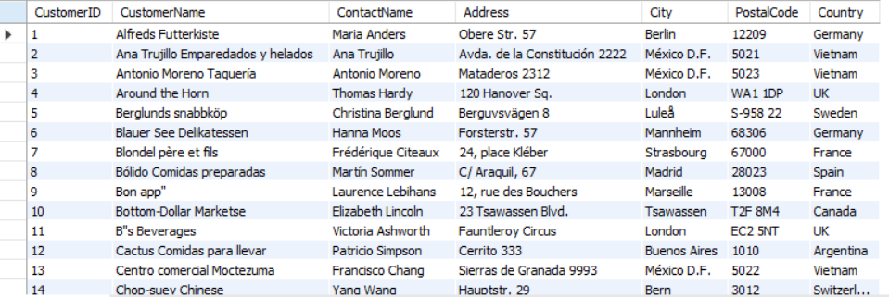

1. **Convert all Brazilian customer to Combodian Customers**

Query:UPDATE customers SET Country = 'Cambodia' WHERE Country = 'Brazil';

select *from babinnorthwind.customers;

Output:

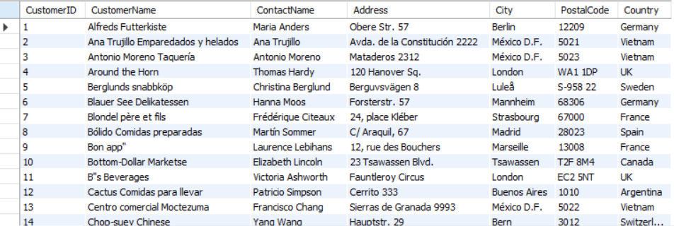

1. **Convert all customers of Madrid to Kathmand customers also change name of country**

Query:UPDATE customers SET City = 'Kathmandu', Country = 'Nepal' WHERE City = 'Madrid';

select *from babinnorthwind.customers;

Output:

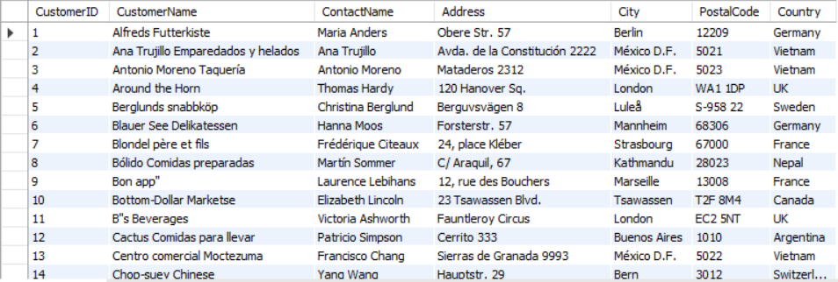

1. **Convert customer from G7 countries to SARCC countries.**

Query:UPDATE customers SET Country = 'SAARC Country' WHERE Country IN ('USA', 'Canada', 'UK', 'France', 'Germany', 'Italy', 'Japan');

select *from babinnorthwind.customers;

Output:

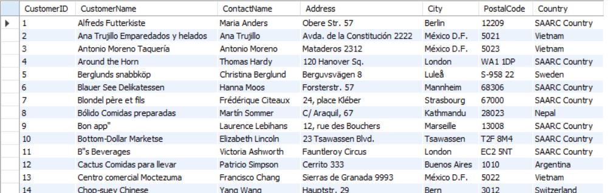

1. **DELETE all from customers who have PostalCode containing 31.**

Query:DELETE FROM orderdetails WHERE OrderID IN (SELECT OrderID FROM orders WHERE CustomerID IN (SELECT CustomerID FROM customers WHERE PostalCode LIKE '%31%'));

DELETE FROM orders WHERE CustomerID IN (SELECT CustomerID FROM customers WHERE PostalCode LIKE '%31%');

DELETE FROM customers

WHERE PostalCode LIKE '%31%';

select *from babinnorthwind.customers;

Output:

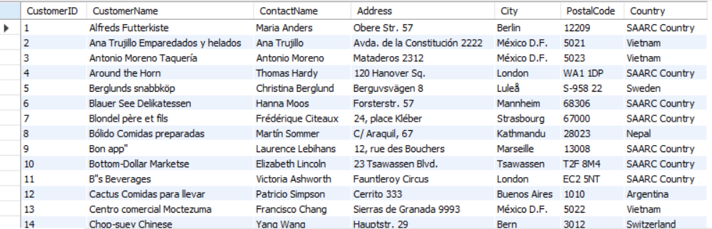

1. **DELETE all from customers having PostalCOde containing 00 and from Rome or Paris**.

Query:DELETE FROM customers WHERE PostalCode LIKE '%00%' AND City IN ('Rome', 'Paris');

select *from babinnorthwind.customers;

Output:

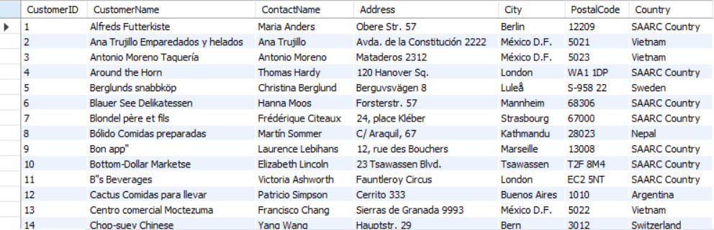

1. **Delete all from customers who are not from Salzburg.**

Query:DELETE FROM customers

WHERE PostalCode LIKE '%31%';

SELECT * FROM babinnorthwind.customers;

DELETE FROM orderdetails

WHERE OrderID IN (SELECT OrderID FROM orders WHERE CustomerID IN

(SELECT CustomerID FROM customers WHERE City != 'Salzburg'));

DELETE FROM orders

WHERE CustomerID IN (SELECT CustomerID FROM customers WHERE City != 'Salzburg');

DELETE FROM customers

WHERE City != 'Salzburg';

Output:

Screenshot 2024-09-10 164352

1. **DELETE all employees who are born on July.**

Query:DELETE FROM employees WHERE MONTH(BirthDate) = 7;

select *from babinnorthwind.employees;

Output:

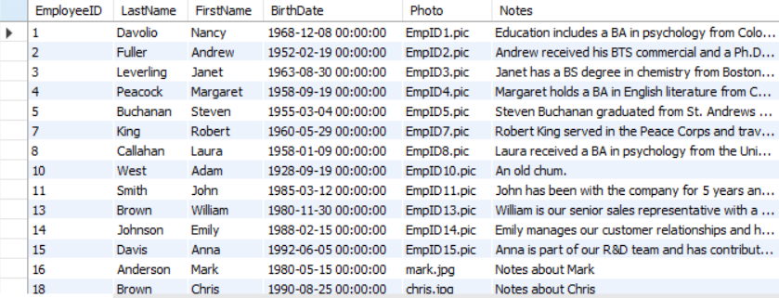

1. **Delete all employees who are born on August**

Query:DELETE FROM employees WHERE MONTH(BirthDate) = 8;

Select *from babinnorthwind.employees;

Output:

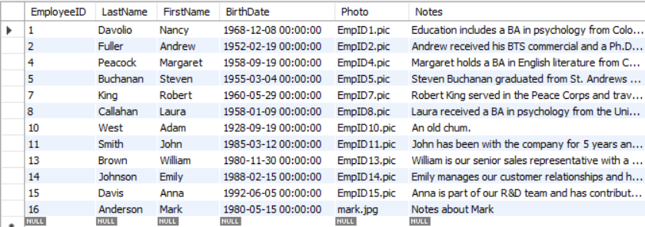

1. **DELETE all suppliers from Singapore and Japan**

QUery:DELETE FROM orderdetails

WHERE ProductID IN (SELECT ProductID FROM products WHERE SupplierID IN

(SELECT SupplierID FROM suppliers WHERE Country IN ('Singapore', 'Japan')));

DELETE FROM products

WHERE SupplierID IN (SELECT SupplierID FROM suppliers WHERE Country IN ('Singapore', 'Japan'));

DELETE FROM suppliers

WHERE Country IN ('Singapore', 'Japan');

select *from babinnorthwind.suppliers;

Output:

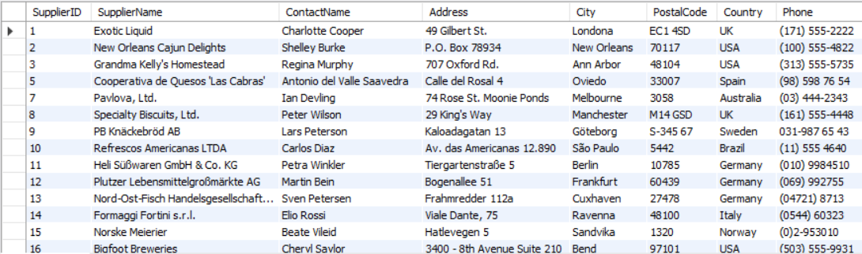

1. **Find name and count of suppliers from different countries**

Query:SELECT Country, COUNT(SupplierID) AS SupplierCount

FROM suppliers GROUP BY Country;

Output:

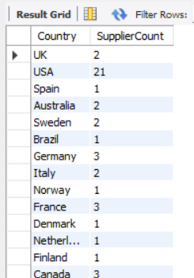

1. **Find name and count of customers from different cities.**

Query:SELECT City, COUNT(CustomerID) AS CustomerCount

FROM customers GROUP BY City;

Output:

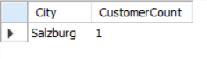

1. **Find number of orders made by employee along with employeeID.**

QUery:SELECT EmployeeID, COUNT(OrderID) AS OrderCount   
FROM orders GROUP BY EmployeeID;

Output:

