**Lab 6**

1. Perform Union of customers and employees relation(ie only matching attributes)

Query:SELECT CustomerID AS ID, CustomerName AS Name, ContactName AS Contact FROM customers

UNION

SELECT EmployeeID AS ID, FirstName + ' ' + LastName AS Name, '' AS Contact FROM employees;

Output:

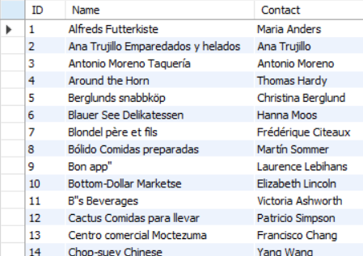

1. Perform UNION ALL of customers.contactname and employee.fullname

Query: SELECT ContactName AS FullName FROM customers

UNION ALL

SELECT FirstName + ' ' + LastName AS FullName FROM employees;

Output:

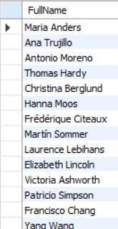

1. List all customers from Mexico and Austria using UNION

Query:select *from customers where COUNTRY='Mexico'

UNION

select *from customers where COUNTRY='Austria';

Output:

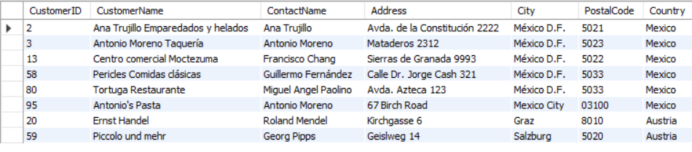

1. List all customers of USA not having same name as of customers from UK.

Query:SELECT * FROM customers

WHERE Country = 'USA'

AND CustomerName NOT IN (SELECT CustomerName FROM customers WHERE Country = 'UK');

Output:

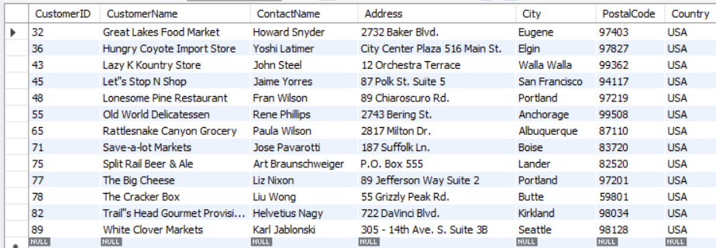

1. Create view cust by selecting only 4 attributes from customers.

Output:

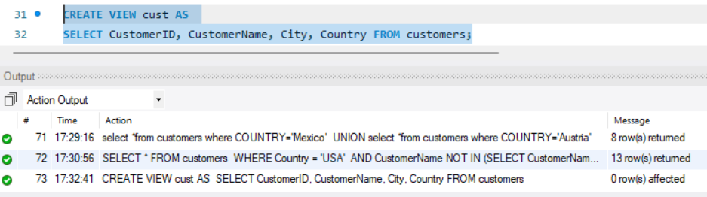

1. Join Products with Categories and Suppliers to create a view named productinfo with productID, Name, Unit ,Price form products and all attributes from categoreis and suppliers.

Output:

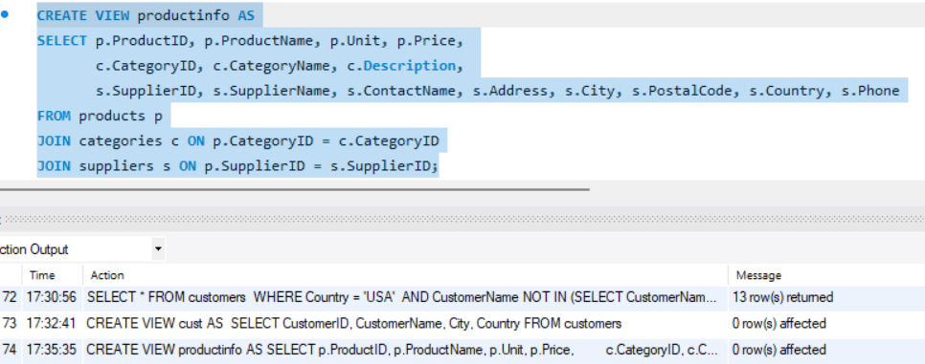

1. Find name and count of Categories from productinfo.

Query:SELECT CategoryName, COUNT(*) AS ProductCount

FROM productinfo

GROUP BY CategoryName;

Output:

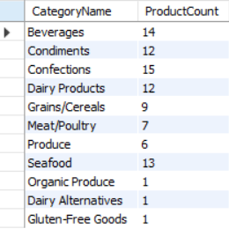

1. Find all products that have suppliers from North America in productinfo.

Query:SELECT * FROM productinfo

WHERE Country IN ('Antigua','Barbuda','Bahamas','Canada'); -- add as much as you want

Output:



1. Find all products that have price lower price than Average price from productinfo.

Query:SELECT * FROM productinfo

WHERE Price < (SELECT AVG(Price) FROM productinfo);

Output:

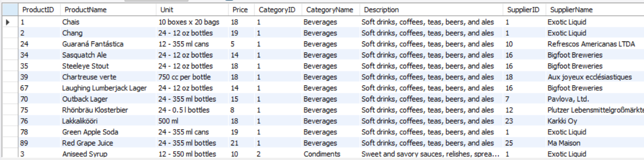

1. Join orders with customers, employees and shippers to create a view as orderinfo

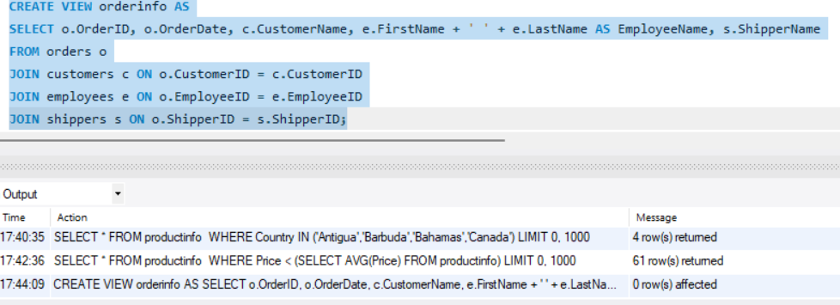

1. List all order shipment provided by United Package and Swift Shipping form orderinfo

Query:SELECT * FROM orderinfo

WHERE ShipperName IN ('United Package', 'Swift Shipping');

Output:

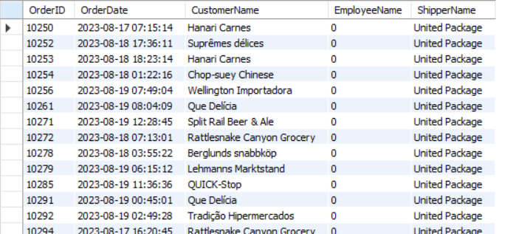

1. List all order processed by employee Janet Leverling and Steven Buchanan from orderinfo.

QUery:SELECT * FROM orderinfo

WHERE EmployeeName IN ('Janet Leverling', 'Steven Buchanan');

OUtput:

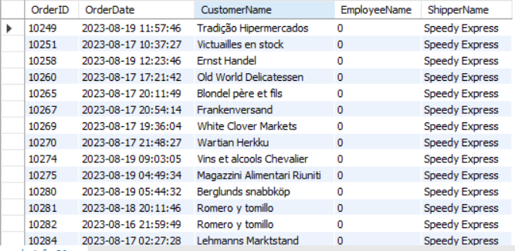

1. LIst all orders shipment provider on date august 18 2023 from orderinfo

Query:SELECT * FROM orderinfo

WHERE OrderDate = '2023-08-18';

Output:

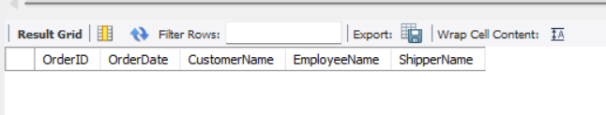

1. List countries of customers that placed order on august 19 2023

Query:SELECT DISTINCT c.Country

FROM orders o

JOIN customers c ON o.CustomerID = c.CustomerID

WHERE o.OrderDate = '2023-08-19';

Output:

