1. Command: ls

Interpretation:List contents of the current working directory.

Output:

Screenshot 2024-06-22 142617

1. Command: dir

Interpretation:List information about the FILES

Output:

Screenshot 2024-06-22 142823

1. Command: ls -a

Interpretation:List contents of the current working directory where option -a is used for displaying all the contents of the directory along with entries starting with .(dot).

Output:

Screenshot 2024-06-22 143024

1. Command: ls -l

Interpretation:List contents of the current working directory where option -l is used for displaying contents of the directory with a long listing format.

Output:

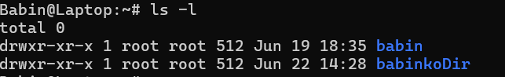

1. Command: ls -lh

Interpretation:

List contents of the current working directory where option -lh is used for displaying contents of the directory with a long listing format with human understandable sizes like 1K 234M etc.

Output:

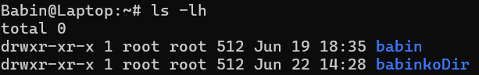

1. Command: ls -F

Interpretation:

The -F option provides additional information about the files and directories in the listing by appending a character to each entry to indicate its type.

Output:

Screenshot 2024-06-22 143813

1. Command: ls -r

Interpretation:

List the contents of directory in the reverse order while sorting.

Ouptut:

Screenshot 2024-06-22 144005

1. Command: ls -R

Interpretation:

List the contents of the current working directory and subdirectories recursively.

Output:

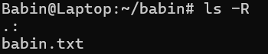

1. Command: ls -ltr

Interpretation:

List the contents of the current working directory where -l displays in long listing format and -t sorts by time, and -r reverse the order while listing. So the content of the directory is listed in long listing format sorted by time.

Output:

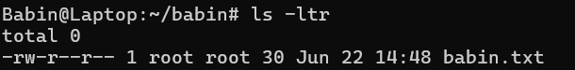

1. Command: ls -i

Interpretation:

List he contents of directory with index numbers.

Output:

Screenshot 2024-06-22 145725

1. Command: ls --version

Interpretation:

Prints the version information the program is.

Ouput:

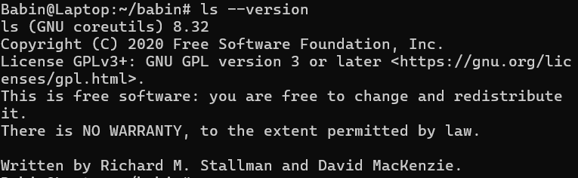

13.Command: ls -n

Interpretation:

Lists the contents of directory with numeric users and group IDs.

Output: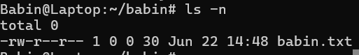

1. Command: clear

Interpretation:Clear the terminal screen.

1. Command: mkdir os

Interpretation:make directories

Output:

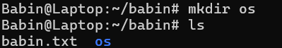

1. Command: cd os

Interpretation: changes directory to os in terminal.

Output:Screenshot 2024-06-22 150838

1. Command: touch linux.txt

Interpretation: create a file name linux.txt.

Output:

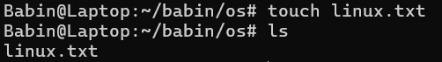

1. Command: nano linux.txt

Interpretatation: Opens the file linux.txt in text editor nano

Output: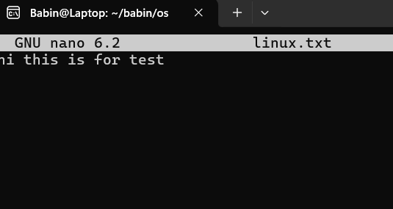

1. Command: cat linux.txt

Interpretation: displays content of linux.txt in the terminal

Ouptut:

Screenshot 2024-06-22 151550

1. Command: touch unix.txt

Interpretation: Create a file named unix.txt

Output:

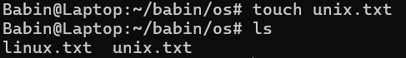

1. Command: cat> linux.txt

Interpretation: allows user to concatenate the text in the file linux.txt and is exited by ctrl+c.

Output:

Screenshot 2024-06-22 152745

1. Command: touch fedora.txt arch.txt debian.txt red_hat.txt

Interpretation: create these files

Ouput:

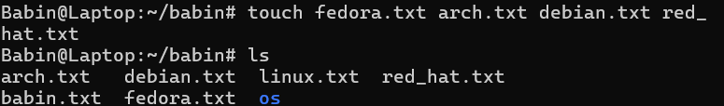

1. Command: cp linux.txt fedora.txt

Interpretation: copy the contents of file linux.txt into file fedora.txt

Output:

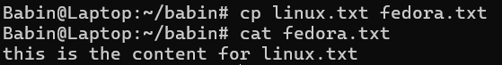

1. Command: cd . .

Interpretation:Change directory to one step back.

Output:

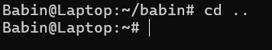

1. Command: pwd

Interpretation:print name of current/working directory

Ouput:

Screenshot 2024-06-22 153808

1. Command:cp /root/fedora.txt /root/ubuntu/

Interpretation:copies the file from directory /root/fedora.txt to directory /root/ubuntu/

1. Command: ls /root/ubuntu/

Interpretation: list the contents of directory /root/ubuntu

Output:



1. Command: cat /root/ubuntu/fedora.txt

Interpretation: read the /root/ubuntu/fedora.txt and displays it in the terminal

Output:

Screenshot 2024-06-22 155905

1. Command: mv /root/babin/debian.txt /root/ubuntu/

Interpretation: move the filemv /root/babin/debian.txt to directory to /root/ubuntu/

1. Command: cd os
2. Command: ls

Output:Screenshot 2024-06-22 160431

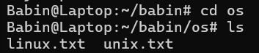

1. Command: rm unix.txt

Interpretation: deletes the file named unix.txt

Output:

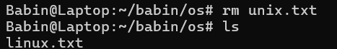

1. Command: rm *.txt

Interpretation: deleted all the files whose name ends with .txt

Output:

Screenshot 2024-06-22 160832

1. Command:rmdir os

Interpretation: deletes the directory named os from current working directory

Output:

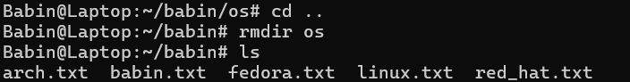

1. Command: rmdir babin

Interpretation: deletes the directory named babin when the specified directory is empty.

Output:

Screenshot 2024-06-22 161235

1. Command: rm -rf babin

Interpretation: deletes the directory babin and it’s content recursively and forcefully.

Output:

