1. Lscpu

Command: display information about the cpu architecture

Output:

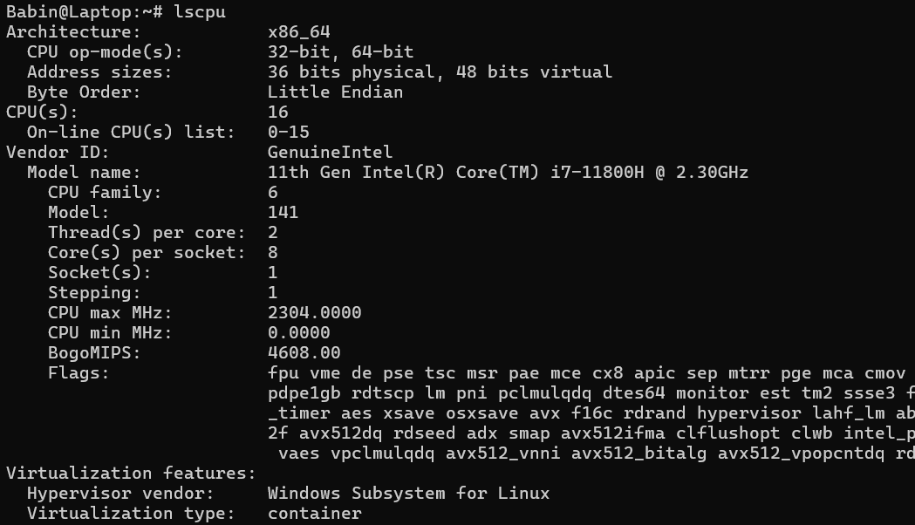

1. Lshw

Command:extract detatiled information on the hardware configuration of the machine.

Output:

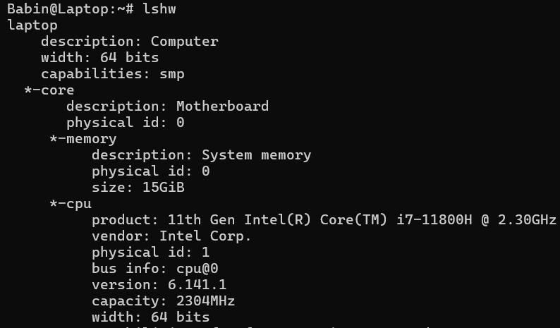

1. Hwinfo

Command: is used to probe for the hardware present in the system. It can be used to generate a system overview log which can be later used for support

Output:

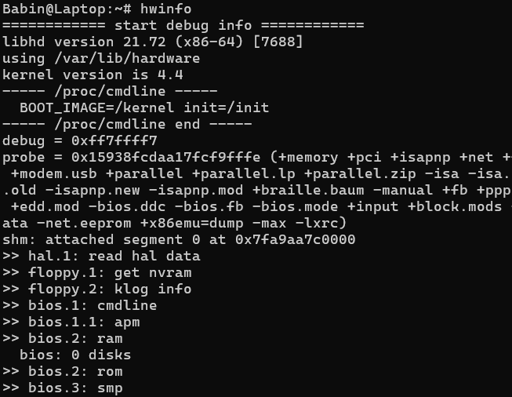

1. Hwinfo --short

Command:shows only a quick summary of hardware present in the system

Output:

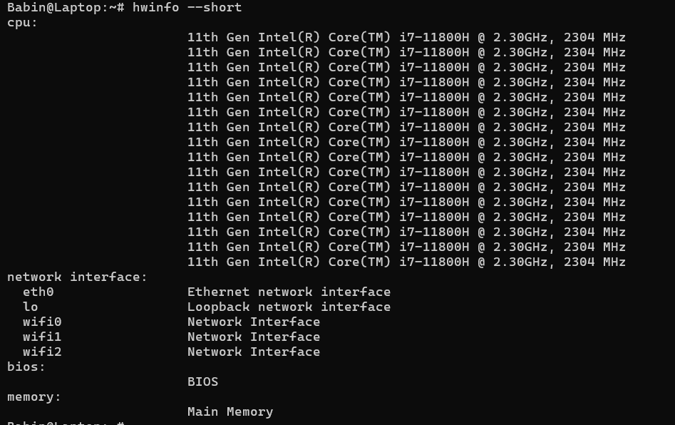

1. Lsspci

Command:list SCSI devices currently attached to the system

Output:

Screenshot 2024-07-03 095217

1. Lsblk

Interpretation: lists info about all available or the specified block devices.

Output:

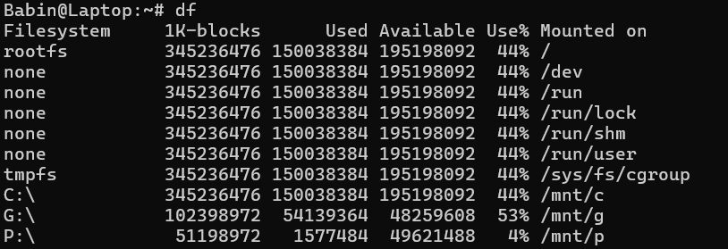

1. Df

Interpretation: displays the amount of space available on the file system containing each file name argument. If no file name is given , the space available on all currently mounted file systems is shown.

Output:

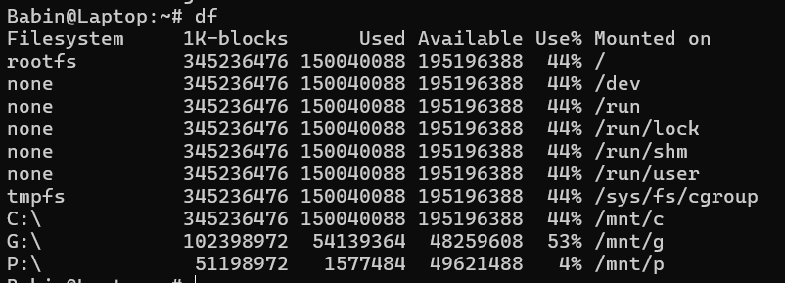

1. Free

Interpretation: display amount of free and used memory in the system.

Output:



1. cat /proc/cpuinfo

Interpretation: read the file /proc/cpuinfo to output the processores info like cpufamily,

Model, microcode, flags, etc.

Output:

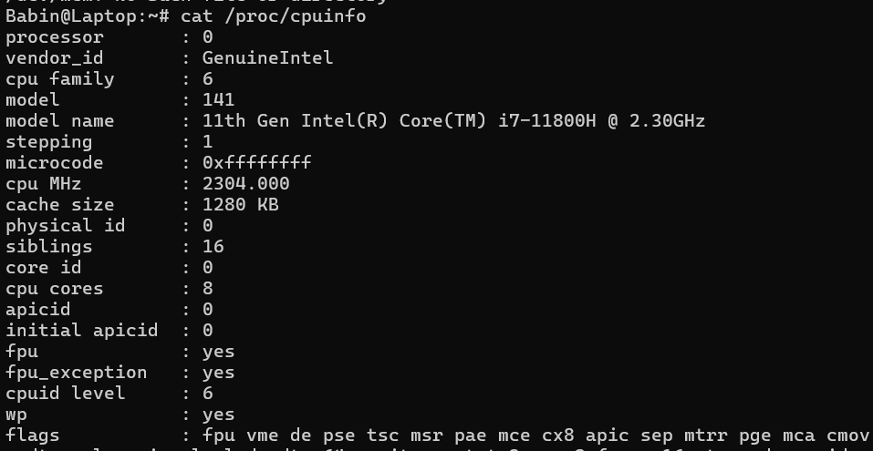

1. Cat /proc/meminfo

Interpretation:reds file /proc/meminfo and output the various info of memory segments of the computer system.

Output:

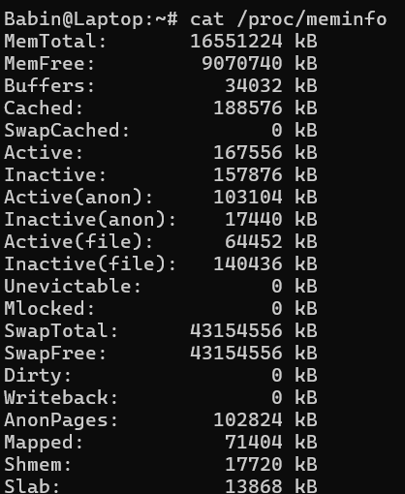

1. Cat /proc/version

Interpretation:displays the system information in quick summary

Output:



1. Linux

Interpretation: prints the system info

Output:

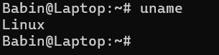

1. Uname -n

Interpretation: prints the network node hostname

Output:

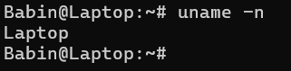

1. Uname -v

Interpretation:print the kernel version

Output:

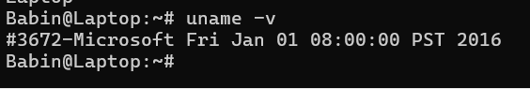

1. Uname -r

Interpretation:print the kernel release

OUtput:

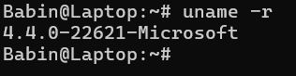

1. uname -m

Interpretation:print the machine hardware name

OUtput:

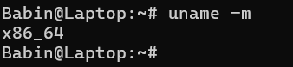

1. uname -a

Interpretation:print all info like kernel, network node hostname,kernel release and version, etc.

OUtput:



1. Factor

Interpretation:print the prime of the given numbers, either given from command line or read from standard input

Output:

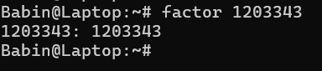

1. echo ‘3*9’| bc

Interpretation:echo displays the string passed and ‘|’ symbol is used to redirect the output of echo to arbitrary precision calculator language bc to produce the product of 3 and 9.

Output:

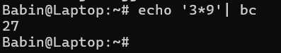

1. Id

Interpretation:print real and effective user and group IDs

Output: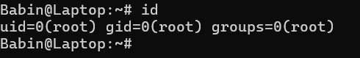

1. Ping -w 3 google.com

Interpretation: send ICMP ECHO_REQUEST to google.com

Output:

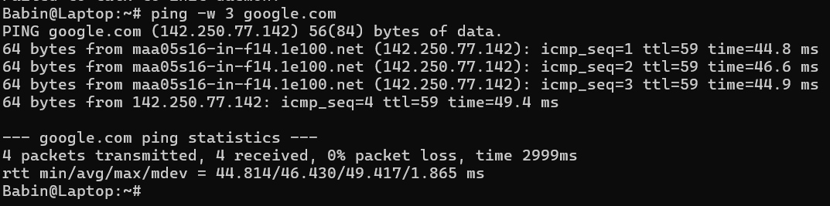

1. Netstat

Interpretation:Print network connections, routing tables, interface statistics, masquerade connections and multicast memberships.

Output:

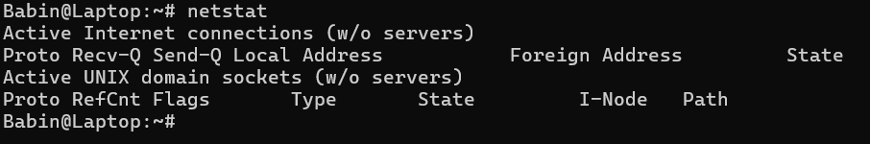

1. Netstat -r

Interpretation:Show the PID and name of the program to which each socket belongs. A hyphen is shown if the socket belong to the kernel.

OUtput:

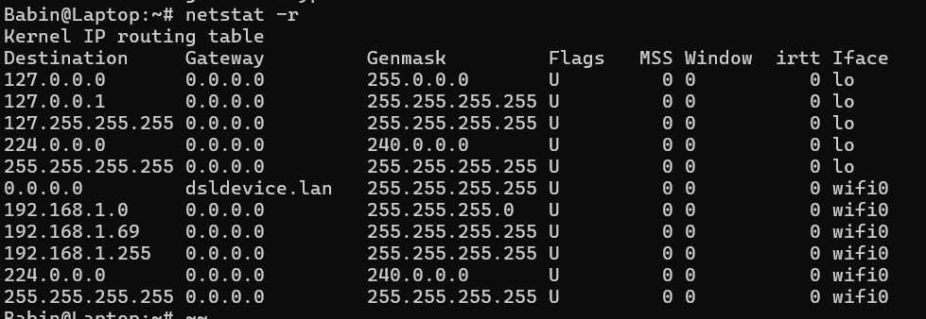

1. Host google.com

Interpretation: performs DNS lookups. It is normally used to convert names to IP iddresses and vice versa.

OUtput:

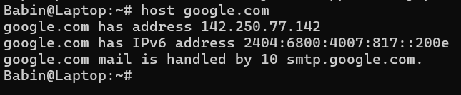

1. Route

Interpretation: show / manipulate the IP routing table

Output:

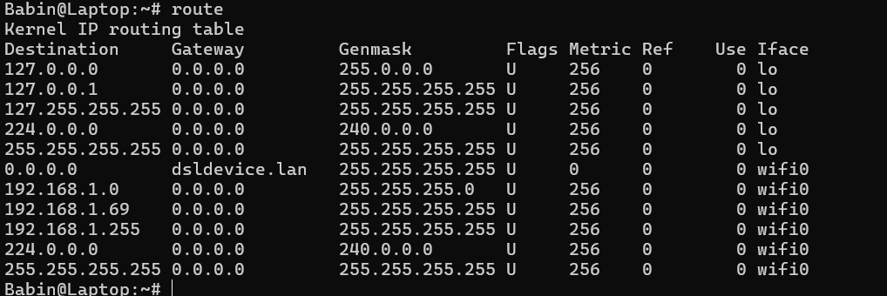

1. Whois brainyquote.com

Interpretation:guess the right server to ask for the specified object. If no guess can be made it will connect to whois.netwroksolutinos.com for NIC handles ro whois.arin.net for IPv4 addresses and network names.

Output:

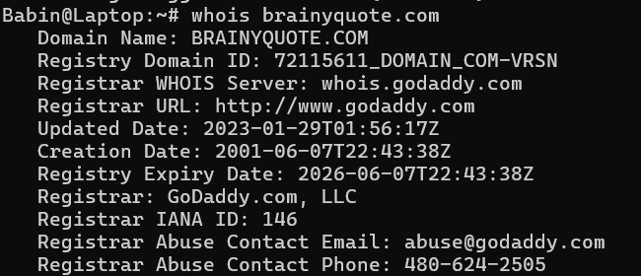

1. Sudo apt-get update

Interpretation: install the newest versions of all packages currently installed on the system from the sources enumerated in /etc/apt/sources.list

Output:

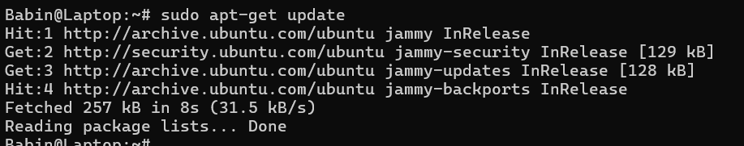

1. Sudo apt-get install sl

Interpretation: install package sl

OUtput:

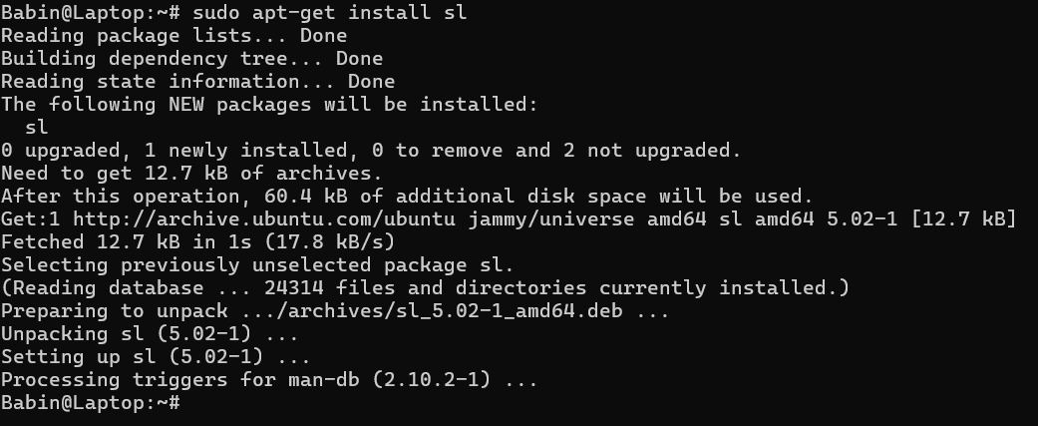

1. Sl

Interpretation:display animations aimed to correct users who accidentally enter sl instead of ls

Output:

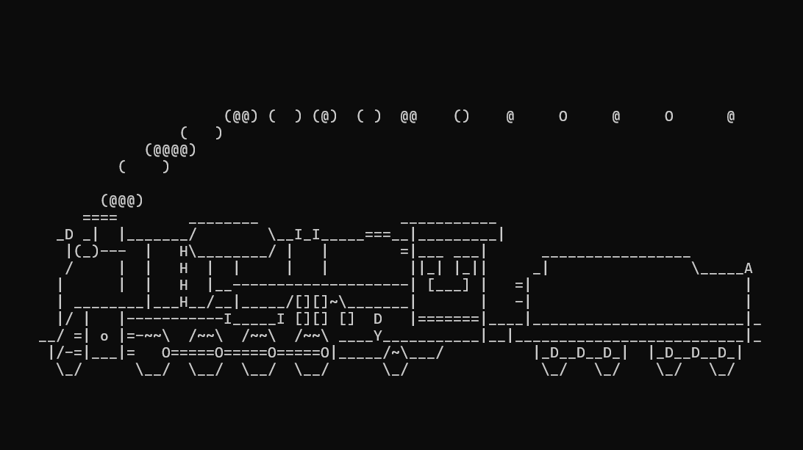

1. Exit

Interpretation: exit the current program