Problems

1. Lack of contracts (gambling specific)
2. Limited Length
3. Token trading (limited to 1e16 size); loses some information about the token itself
4. Unable to currently track token id transfer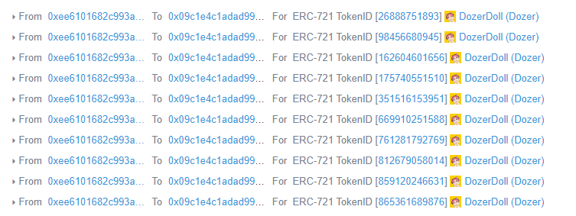
5. Expanded our dataset by using a moving window of 100 transactions for the most recent 1000 transactions.
6. Due to the low amounts of data, the random state of the split can effect the overall accuracy by around 10%.