OPERATING SYSTEM

LAB FILE

NAME: Orussa Firdous
ROLL NO. : 17BCS015

1.PRIORITY QUEUE
#include<stdio.h>
#include<stdlib.h>
void display();
void insert();
void et();
struct pq
{
char process[3];
int priority;
int bursttime;
struct pq *next;
};
struct pq *start=NULL;
int sum=0;
int main()
{
int ch,m=1;
printf("NAME: ORUSSA FIRDOUS\n");
printf("ROLL No.- 17BCS015\n");
while(m==1)
{
printf("enter your choice\n1:add priority node\n2:display\n3:execution time\n4:exit\n");
scanf("%d",&ch);
switch(ch)
{
case 1: insert(); break;
case 2: display(); break;
case 3: et(); break;
case 4: m=0; break;
default : printf("wrong choice"); break;
}
}
}
void display()
{
struct pq *temp=start;
if(start==NULL)
{
printf("nothing to print\n");
return;
}
printf("process name, priority, burst time\n");
while(temp!=NULL)
{
printf("%s\t%d\t%d\n",temp->process,temp->priority,temp->bursttime);
temp=temp->next;
}
}
void insert()
{
int pri,bt;
struct pq *temp,*temp2,*temp1;
temp1=start;
temp=start;
temp=(struct pq *)malloc(sizeof(struct pq));
printf("enter process name,priority and burst time\n");
scanf("%s",temp->process);
scanf("%d%d",&pri,&bt);
temp->priority=pri;
temp->bursttime=bt;
temp->next=NULL;
if(start==NULL)
{
start=temp;
}
else
{
if(start->priority>pri)
{
temp->next=start;
start=temp;
}
else
{
while(temp1->priority<pri)
{
temp2=temp1;
temp1=temp1->next;
if(temp1==NULL)
break;
}
if(temp1==NULL)
{
temp2->next=temp;
}
else
{
temp2->next=temp;
temp->next=temp1;
}
}
}
}
void et()
{
struct pq *temp;
temp=start;
printf("execution time of process%s\n",start->process);
printf("%d\n",sum+start->bursttime);
sum=sum+start->bursttime;
start=start->next;
free(temp);
}

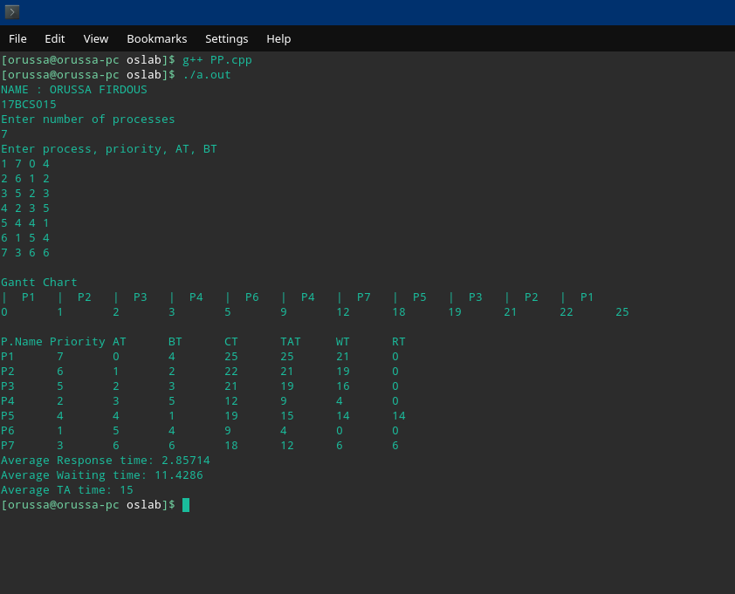

2. FCFS

#include<stdio.h>
#include<stdlib.h>

struct fcfs{

int pid;
int at;
int bt;
int ct;
int tat;
int wt;
int rt;
}process[10];

int main(){

int i,j,t,t1,t2,t3,sct=0,stat=0,swt=0;

printf("NAME: ORUSSA FIRDOUS\n");
printf("ROLL No.- 17BCS015\n");

printf("\nEnter the number of processes you want to have.");
scanf("%d",&t);

printf("\n Enter the process_no. , arrival time and burst time one by one.");

for(i=0;i<t;i++){

scanf("%d%d%d",&process[i].pid,&process[i].at,&process[i].bt);
}

for(i=0;i<(t-1);i++){
for(j=i+1;j<t;j++){

if(process[i].at > process[j].at){
t1=process[i].pid;process[i].pid=process[j].pid;process[j].pid=t1;
t1=process[i].at;process[i].at=process[j].at;process[j].at=t1;
t1=process[i].bt;process[i].bt=process[j].bt;process[j].bt=t1;
}
}
}
process[0].ct=0;
for(i=0;i<t;i++){
if(i == 0){
process[0].rt=0;
}
else
process[i].rt=process[i-1].ct-process[i].at;

sct+=process[i].bt;
process[i].ct+=sct;
process[i].wt=process[i].rt;
process[i].tat=process[i].wt+process[i].bt;
}
printf("\nProcess\t AT \tBT \tCT \tTAT \tWT \tRT\n\n");
for(i=0;i<t;i++){
printf("P%d\t%d\t%d\t%d\t%d\t%d\t%d\n",process[i].pid,process[i].at,process[i].bt,process[i].ct,process[i].tat,process[i].wt,process[i].rt);
}

printf("\n");

for(i=0;i<t;i++){
printf("|--P%d--%d",process[i].pid,process[i].ct);
}

awt=(float)swt/(float)(n);
atat=(float)stat/(float)(n);
printf("\n Average waiting time = %f\n Average Turn Around Time = %f\n",awt,atat);

}

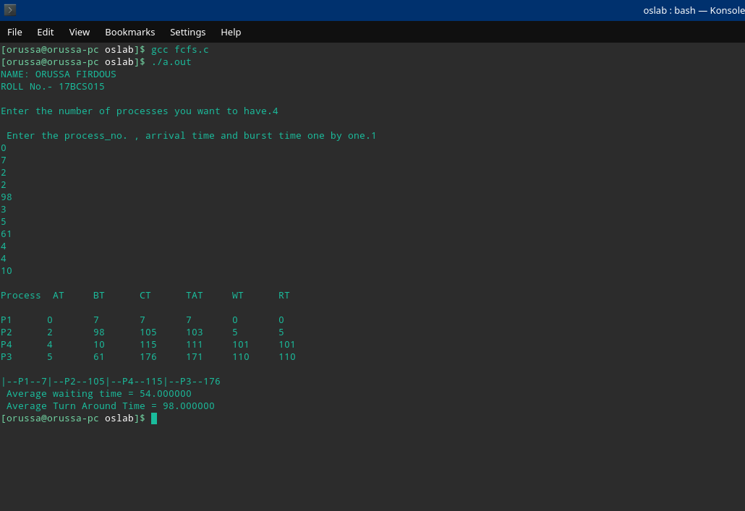

3.SHORTEST REMAINING TIME FIRST.

#include <stdio.h>
#include <stdlib.h>

struct sjf{

int at;int bt; int wt;int ct;int id;int tat;int rt;

}p[50];

int main(){

int i,j,k,t;
int n,smallest,end,swt=0,count =0,stat=0;
float awt,atat;
printf("NAME: ORUSSA FIRDOUS\n");
printf("ROLL No.- 17BCS015\n");
printf("\nEnter the no. of processes you want to have.\n");
scanf("%d",&n);

int arrival[n],burst[n];

printf("\nEnter the c process id ,arrival time and burst time for the process.\n");
for(i=0;i<n;i++){
scanf("%d%d%d",&p[i].id,&p[i].at,&p[i].bt);

arrival[i]=p[i].at;burst[i]=p[i].bt;
}

for(i=0;i<n;i++){
printf("%d\t%d\t%d\n",p[i].id,p[i].at,p[i].bt);

arrival[i]=p[i].at;burst[i]=p[i].bt;
}

p[9].bt=9999;
for(t=0;count !=n;t++){

smallest=9;
for(i=0;i<n;i++){
if(p[i].at <= t && p[i].bt< p[smallest].bt && p[i].bt > 0)
smallest =i;
}p[smallest].bt--;

if(p[smallest].bt == 0){

count++;
end=t+1;
p[smallest].ct=end;p[smallest].wt=end-p[smallest].at-burst[smallest];
p[smallest].tat=end - p[smallest].at;p[smallest].rt=p[smallest].ct-arrival[smallest];
}

}

printf("\nPid \tAT\tBT\tCT\tTAT\tWT\tRT\n");
for(i=0;i<n;i++){

printf(" %d\t %d\t %d\t %d\t %d\t %d\t %d",p[i].id,p[i].at,burst[i],p[i].ct,p[i].tat,p[i].wt,p[i].rt);
swt+=p[i].wt;
stat+=p[i].tat;
printf("\n");
}

awt=(float)swt/(float)(n);
atat=(float)stat/(float)(n);
printf("\n Average waiting time = %f\n Average Turn Around Time = %f\n",awt,atat);

}

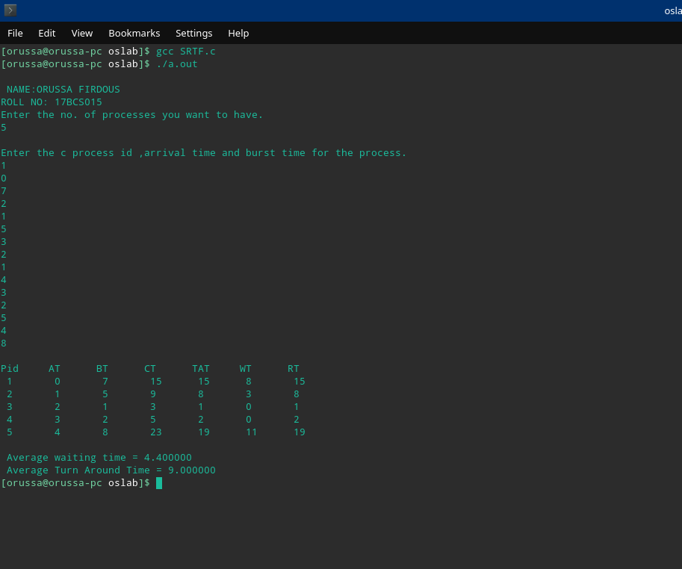

4.ROUND ROBIN
#include<stdio.h>
#include<string.h>
#define max 80
int main()
{
printf("NAME: ORUSSA FIRDOUS\n");
printf("ROLL No.- 17BCS015\n");
char pro[max][max];
int ready[max],ready1[max],bt[max],at[max],ct[max],rt[max],wt[max],tat[max];
int i,j,k,l,m=0,n,t,total=0;
float awt=0,art=0,atat=0;
printf("enter the no of the processes");
scanf("%d",&n);
printf("enter the name of the processes\n");
for(i=0;i<n;i++)
{
scanf("%s",&pro[i]);
}
printf("enter the arrival time for the processes\n");
for(i=0;i<n;i++)
{
scanf("%d",&at[i]);
}
printf("enter the burst time of the processes\n");
for(i=0;i<n;i++)
{
scanf("%d",&bt[i]);
}
printf("enter the quantum time of the processes\n");
scanf("%d",&t);

for(i=0;i<n;i++){
ready[i]=bt[i];
}
for(i=0;i<max;i++){
ready1[i]=0;
}
for(i=0;i<max;i++){
rt[i]=-1;
}
int flag=1;
k=0;
int g=0;
l=0;
printf("|%d",at[0]);
printf("\n\t******GANTT CHART******\n");
while(m<n)
{
if(ready[k]<=t){
if(rt[k]==-1){
rt[k]=total;
}
total+=ready[k];
printf("|%s|%d",pro[k],total);
ready[k]=0;
ct[k]=total;
wt[k]= ct[k]-at[k]-bt[k];
tat[k]=wt[k]+bt[k];
m++;
}
else if(ready[k]>t)
{
ready[k]=ready[k]-t;
if(rt[k]==-1){
rt[k]=total;
}
total+=t;
printf("|%s|%d",pro[k],total);
}
while(at[flag]<=total&&flag<n)
{
ready1[g]=flag;
g++;
flag++;
}
if(ready[k]>0){
ready1[g]=k;
g++;
}
k=ready1[l];
l++;
}
printf("\n");
printf("\n");
printf("pro\tAT\tBT\tRT\tCT\tWT\tTAT\n");
for(i=0;i<n;i++){
printf("%s\t%d\t%d\t%d\t%d\t%d\t%d\n",pro[i],at[i],bt[i],rt[i],ct[i],wt[i],tat[i]);
}
for(i=0;i<n;i++){
art+=rt[i],atat+=tat[i],awt+=wt[i];
}
printf("\nAverage Waiting Time:.3%f",awt/n);
printf("\nAverage Response Time:.3%f",art/n);
printf("\nAverage Turn Around Time:.3%f",atat/n);
return 0;
}

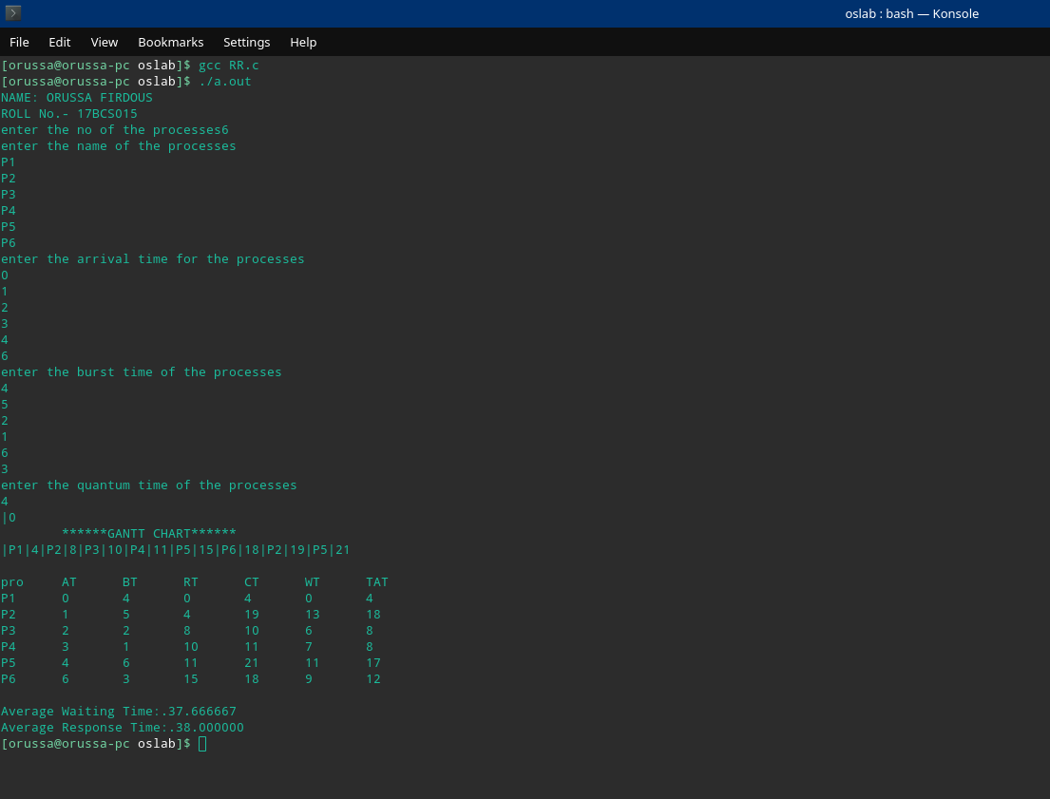
5.HRRN
#include<iostream>
#include<algorithm>
using namespace std;

struct node{
char pname[50];
int btime;
int atime;
int wtime;
float rr=0;
}a[50];

void insert(int n){
int i;
printf("NAME: ORUSSA FIRDOUS\n");
printf("ROLL No.- 17BCS015\n");
for(i=0;i<n;i++){
cin>>a[i].pname;
cin>>a[i].atime;
cin>>a[i].btime;
a[i].rr=0;
a[i].wtime=-a[i].atime;
}
}

bool btimeSort(node a,node b){
return a.btime < b.btime;
}

bool atimeSort(node a,node b){
return a.atime < b.atime;
}

bool rrtimeSort(node a,node b){
return a.rr > b.rr;
}

void disp(int n){
sort(a,a+n,btimeSort);
sort(a,a+n,atimeSort);
int ttime=0,i;
int j,tArray[n];
for(i=0;i<n;i++){
j=i;
while(a[j].atime<=ttime&&j!=n){
j++;
}
// sort(a+i,a+j,btimeSort);

for(int q = i;q<j;q++){

a[q].wtime=ttime-a[q].atime;
a[q].rr=(float)(a[q].wtime+a[q].btime)/(float)a[q].btime;
// cout<<"P"<<a[q].pname<<"->WT "<<a[q].wtime<<"->RR "<<a[q].rr<<" ";
// cout<<" HRRN of P"<<a[q].pname<<" is "<<a[q].rr<<endl;
}
sort(a+i,a+j,rrtimeSort);
for(int q = i;q<j;q++){
cout<<"P"<<a[q].pname<<"->WT "<<a[q].wtime<<"->RR "<<a[q].rr<<" ";
}
tArray[i]=ttime;
cout<<endl;
ttime+=a[i].btime;
}
tArray[i] = ttime;

float averageWaitingTime=0;
float averageResponseTime=0;
float averageTAT=0;
cout<<"\n";
cout<<"P.Name AT\tBT\tCT\tTAT\tWT\tRT\n";
for (i=0; i<n; i++){
cout <<'P'<< a[i].pname << "\t";
cout << a[i].atime << "\t";
cout << a[i].btime << "\t";
cout << tArray[i+1] << "\t";
cout << tArray[i]-a[i].atime+a[i].btime << "\t";
averageTAT+=tArray[i]-a[i].atime+a[i].btime;
cout << a[i].wtime << "\t";
averageWaitingTime+=tArray[i]-a[i].atime;
cout << tArray[i]-a[i].atime << "\t";
averageResponseTime+=tArray[i]-a[i].atime;
cout <<"\n";
}
cout<<"\n";
cout<<"\nGantt Chart\n";
for (i=0; i<n; i++){
cout <<"| P"<< a[i].pname << " ";
}
cout<<"\n";
for (i=0; i<n+1; i++){
cout << tArray[i] << "\t";
}
cout<<"\n";
cout<<"Average Response time: "<<(float)averageResponseTime/(float)n<<endl;
cout<<"Average Waiting time: "<<(float)averageWaitingTime/(float)n<<endl;
cout<<"Average TA time: "<<(float)averageTAT/(float)n<<endl;
}

int main(){
int nop,choice,i;
cout<<"Enter number of processes\n";
cin>>nop;
insert(nop);
disp(nop);
return 0;
}

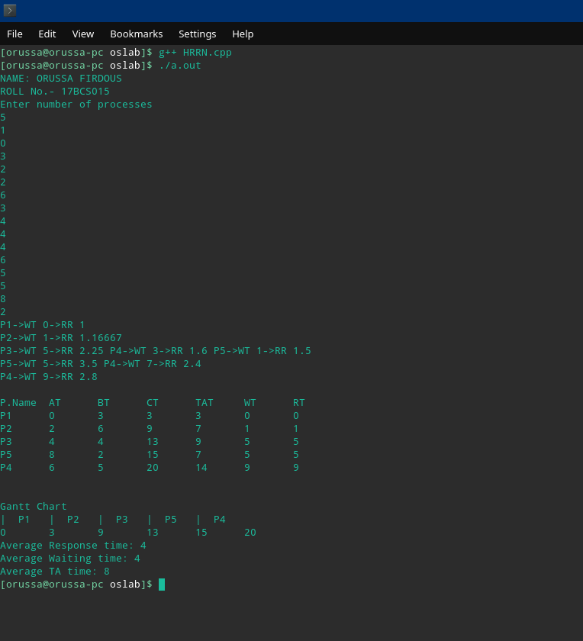

6.WORST FIT
#include<stdio.h>
int main()
{
printf("NAME: ORUSSA FIRDOUS\n");
printf("ROLL No.- 17BCS015\n");
int n,m,i,j,k;
printf("NAME: ORUSSA FIRDOUS\n");
printf("ROLL No.- 17BCS015\n");
printf("enter no. of blocks:\n");
scanf("%d",&n);
int block[n],b[n],IF[n];
printf("enter size of blocks\n");
for(i=0;i<n;i++){
scanf("%d",&block[i]);
b[i]=-1;
IF[i]=-1;
}
printf("enter no. of process:");
scanf("%d",&m);
int process[m];
printf("enter size of processes:\n");
for(i=0;i<m;i++)
{
printf("enter size of process p%d:",i+1);
scanf("%d",&process[i]);
}
int alloc[m],flag;
for(i=0;i<m;i++)
{
flag=-1;
alloc[i]=-1;
for(j=0;j<n;j++)
{
if(block[j]>=process[i] && b[j]==-1)
{
if(flag==-1)
flag=j;
else if(block[flag]<block[j])
flag=j;
}
}
if(flag!=-1)
{
alloc[i]=flag;
IF[flag]=block[flag]-process[i];
b[flag]=i+1;
}
}
printf("\n|");
for(i=0;i<n;i++){
printf("%d\t|",block[i]);
}
printf("\n|");
for(i=0;i<n;i++){
if(b[i]!=-1)
printf("p%d\t|",b[i]);
else
printf(" \t|");
}
printf("\nInternal Fragmentation:\n|");
for(i=0;i<n;i++){
if(IF[i]!=-1)
printf("%d\t|",IF[i]);
else
printf(" \t|");
}
printf("\n");
for(i=0;i<m;i++){
if(alloc[i]==-1)
printf("process p%d is not allocated\n",i+1);
}
return 0;
}

7.BEST FIT

#include<stdio.h>
#include<stdlib.h>
int main(){

int n1;/*Number of memory blocks.*/
int n,i,j,k;/*Number of processes.*/
int lowest=99999,difference;
int ir=0,er=0;
printf("NAME: ORUSSA FIRDOUS\n");
printf("ROLL No.- 17BCS015\n");

printf("\nEnter the number of memory blocks you want to have.");
scanf("%d",&n1);

int *a;
a=(int*)malloc(n1*sizeof(int));

static int *aflag; /*Flag for the memory block*/
aflag=(int*)malloc(n1*sizeof(int));

printf("\n Enter the size of each memory block.");

for(i=0;i<n1;i++){
scanf("%d",&a[i]);aflag[i]=0;
}

printf("\nEnter the number of processes.");
scanf("%d",&n);

int *b; /*for processes*/
b=(int*)malloc(n*sizeof(int));

static int *bflag;/*for processes*/
bflag=(int*)malloc(n*sizeof(int));

int *chart; /* To keep track of the index of the element.*/
chart=(int*)malloc(n1*sizeof(int));

printf("\n Enter the size of each process.");

for(i=0;i<n1;i++){
scanf("%d",&b[i]);
bflag[i]=0;
}

for(i=0;i<n1;i++){

printf("|\t%d\t|",a[i]);
printf("\b");

}printf("|");

printf("\n");

for(i=0;i<n;i++){
for(j=0;j<n1;j++){

difference=a[j]-b[i];
if(difference >=0 && aflag[j] == 0){

if(lowest > difference){
chart[i]=j;bflag[i]=1;
lowest=difference;
}

}
}aflag[chart[i]]=1;lowest=99999;s

}

for(i=0;i<n1;i++){

if(aflag[i] == 1){
printf("|\tP%d=%d\t|",chart[i],b[chart[i]]);ir+=(a[i]-b[chart[i]]);
}

else
{printf("|\tNA\t|");
er+=a[i];}
}printf("\b");

printf("\n");

for(i=0;i<n;i++){
if(bflag[i] == 0)
printf("\n P%d cannot be alloted.",i);

}
printf("\n The internal fragmentation is: %d",ir);

printf("\n The external fragmentation is: %d",er);

return 0;

}

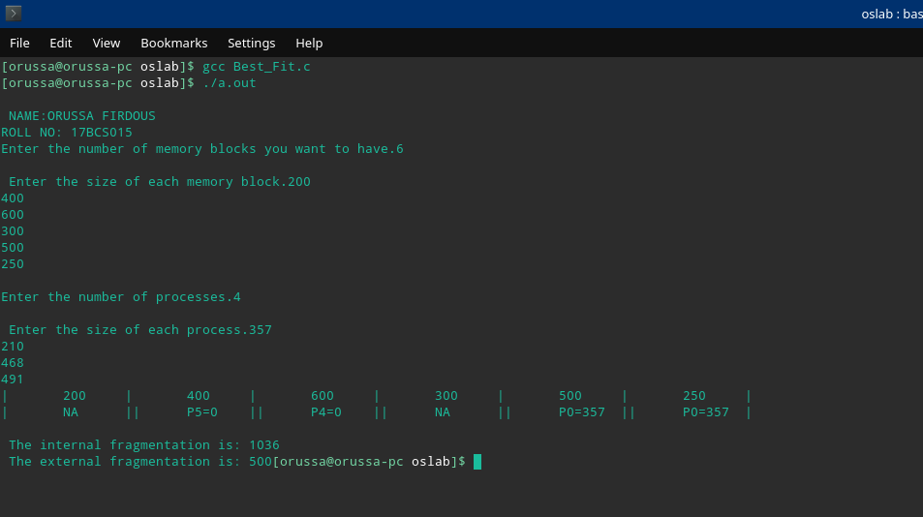

8.NEXT FIT

#include<stdio.h>
#include<stdlib.h>

int main(){

int n1; /*For the number of memory blocks*/
int n,i,j,k; /*For the number of processes.*/
int ir,er;
printf("NAME: ORUSSA FIRDOUS\n");
printf("ROLL No.- 17BCS015\n");
printf("\nEnter the number of memory blocks you want to have.");
scanf("%d",&n1);

int *a;
a=(int*)malloc(n1*sizeof(int));

int *aflag;
aflag=(int*)malloc(n1*sizeof(int)); /*Flags for memrory blocks*/

for(i=0;i<n1;i++){
aflag[i]=0;
}

int *chart; /* To keep track of the index of the element.*/
chart=(int*)malloc(n1*sizeof(int));

printf("\n Enter the size of each block.");
for(i=0;i<n1;i++){

scanf("%d",&a[i]);
}

printf("\n Enter the number of processes.");
scanf("%d",&n);

int *b;
b=(int*)malloc(n*sizeof(int));

int *bflag; /* Flags for the processes.*/
bflag=(int*)malloc(n*sizeof(int));

for(i=0;i<n;i++){
bflag[i]=0;
}

printf("\n Enter the size of each process.");
for(i=0;i<n;i++){

scanf("%d", &b[i]);
}
k=0;ir=0;er=0;
for(i=0;i<n;i++){

for(j=k;j<n1;j++){

if(((a[j]-b[i]) >= 0) && (aflag[j] == 0)){

aflag[j]=1;
chart[j]=i;
bflag[i]=1;
ir+=a[j]-b[i];

if(k==(n1-1))
k=0;
else
k=j+1;
break;
}
}
}

for(i=0;i<n1;i++){

printf("|\t%d\t|",a[i]);
printf("\b");

}printf("|");

printf("\n");

for(i=0;i<n1;i++){

if(aflag[i] == 1){
printf("|\tP%d=%d\t|",chart[i],b[chart[i]]);
}

else
{printf("|\tNA\t|");
er+=a[i];}
}printf("\b");

printf("\n");

for(i=0;i<n;i++){
if(bflag[i] == 0)
printf("\n P%d cannot be alloted.",i);

}
printf("\n The internal fragmentation is: %d",ir);

printf("\n The external fragmentation is: %d",er);

return 0;

}

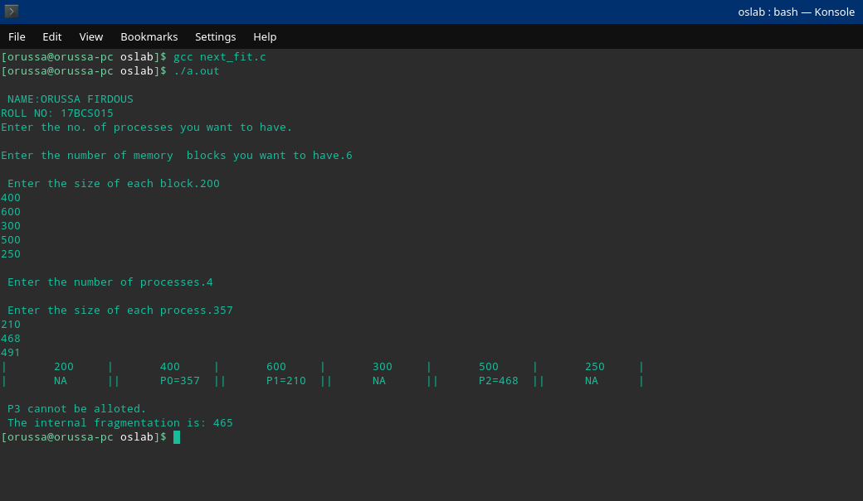

9.FIRST FIT

#include<stdio.h>
#include<stdlib.h>

int main(){

int n1;
int n,i,j,ir=0,er=0,k;
printf("NAME: ORUSSA FIRDOUS\n");
printf("ROLL No.- 17BCS015\n");
printf("\nEnter the number of memory blocks you want to have.");
scanf("%d",&n1);

int *a;
a=(int*)malloc(n1*sizeof(int));

int *aflag;
aflag=(int*)malloc(n1*sizeof(int));

for(i=0;i<n1;i++){
aflag[i]=0;
}

int *chart;
chart=(int*)malloc(n1*sizeof(int));

printf("\n Enter the size of each block.");
for(i=0;i<n1;i++){

scanf("%d",&a[i]);
}

printf("\n Enter the number of processes.");
scanf("%d",&n);

int *b;
b=(int*)malloc(n*sizeof(int));

int *bflag;
bflag=(int*)malloc(n*sizeof(int));

for(i=0;i<n;i++){
bflag[i]=0;
}

printf("\n Enter the size of each process.");
for(i=0;i<n;i++){

scanf("%d", &b[i]);
}

for(i=0;i<n;i++){

for(j=0;j<n1;j++){

if(((a[j]-b[i]) >= 0) && (aflag[j] == 0)){

ir+=(a[j]-b[i]);
aflag[j]=1;
chart[j]=i;
bflag[i]=1;
break;
}
}
}

for(i=0;i<n1;i++){

printf("|\t%d\t|",a[i]);
printf("\b");

}printf("|");

printf("\n");

for(i=0;i<n1;i++){

if(aflag[i] == 1){
printf("|\tP%d=%d\t|",chart[i],b[chart[i]]);
}

else
{
printf("|\tNA\t|");
er+=a[i];}

}printf("\b");

printf("\n");

for(i=0;i<n;i++){
if(bflag[i] == 0)
printf("\n P%d cannot be alloted.",i);
}
printf("\n The internal fragmentation is: %d",ir);

printf("\n The external fragmentation is: %d",er);
return 0;

}

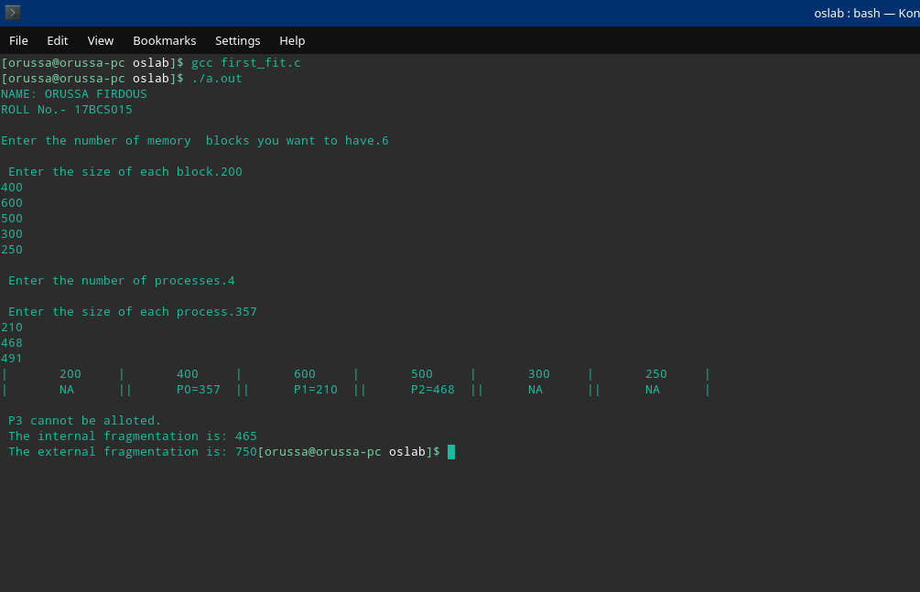

10. LRTF
#include<stdio.h>
int main()
{
printf("NAME: ORUSSA FIRDOUS\n");
printf("ROLL No.- 17BCS015\n");
int gant[40],gant1[40];
int tbt=0,max=-99,pos,l=0,k=0,n=0;
float awt=0,atat=0,art=0;
printf("enter the number of process\n");
scanf("%d",&n);
int bt[n],btc[n],at[n],wt[n],ct[n],tat[n],rt[n];
for (int i = 0; i < n; ++i)
{
printf("enter arrival time arrival of p%d: ",i+1);
scanf("%d",&at[i]);
printf("enter the burst time of p%d: ",i+1);
scanf("%d",&bt[i]);
btc[i]=bt[i];
tbt+=bt[i];
rt[i]=-1;
}
for (int i = 0; i < tbt;)
{
for (int j=0;j<n;j++)
{
if(at[j]<=i&&bt[j]!=0)
{
if(max <bt[j])
{
max=bt[j];
pos=j;
}
}
}
if(rt[pos]==-1){
rt[pos]=i-at[pos];
}
gant1[k++]=i;
gant[l++]=pos;
bt[pos]--;
i++;
if(bt[pos]==0){
ct[pos]=i;
wt[pos]=ct[pos]-(btc[pos]+at[pos]);
tat[pos]=wt[pos]+btc[pos];
}
max=-99;
}
printf("\n\t*****GANTT CHART******\n");
for (int i = 0; i < k; ++i)
{
printf("%d|p%d|",gant1[i],gant[i]+1);
}
printf("%d\n\n",tbt);
printf("pro.\tbt\tat\tct\twt\ttat\trt\n");
for (int i = 0; i < n; i++)
{
awt+=wt[i],art+=rt[i],atat+=tat[i];
printf("p%d\t%d\t%d\t%d\t%d\t%d\t%d\n",i+1,btc[i],at[i],ct[i],wt[i],tat[i],rt[i]);
}
printf("\nAverage Waiting Time: %5.2f",awt/n);
printf("\nAverage Response Time: %5.2f",art/n);
printf("\nAverage Turn Around Time: %5.2f",atat/n);
}

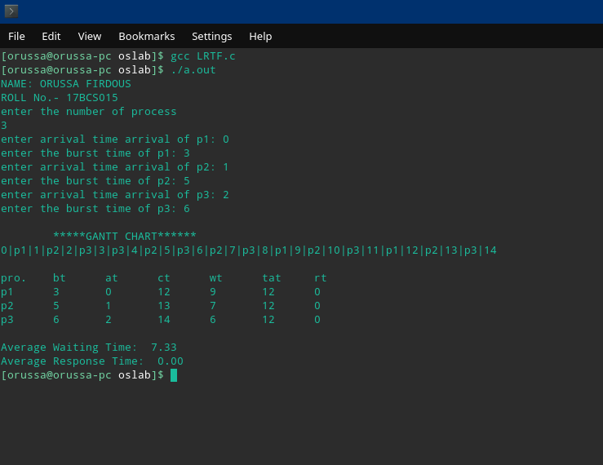
10. FCFS DISK SCHEDULING

#include<stdio.h>

int main(){

int i=0,j,k,n,thm=0,t;
int a[50];
int b[50];

printf("\n NAME: ORUSSA FIRDOUS\n ROLL NO: 17BCS015");
printf("\nEnter the I/O requests.(press -1 to stop).\n");
while(1){
scanf("%d",&n);
if(n>=0 && n<= 199){
a[i]=n;i++;
}
else if(n == -1)
break;

else
printf("\nEnter a valid input.\n");
}

n=i;printf("\n");
printf("\nThe I/O request is:");
for(i=0;i<n;i++)
printf(" %d ",a[i]);
int head;
printf("\nEnter the r/w head.");
scanf("%d",&head);
n=n+1;
b[0]=head;j=0;
for(i=1;i<n;i++){
b[i]=a[j];j++;
}printf("\n");

printf("\n");

for(i=0;i<(n-1);i++){
j=i+1;
t=(b[j]-b[i]);
if(t >= 0){
thm+=t;printf("( %d - %d )+",b[j],b[i]);
}
else{
thm+=(-1)*t;printf("( %d - %d )+",b[i],b[j]);
}

}
printf("\b\nTOTAL HEAD MOVEMENTS = %d\n",thm);

return 0;
}
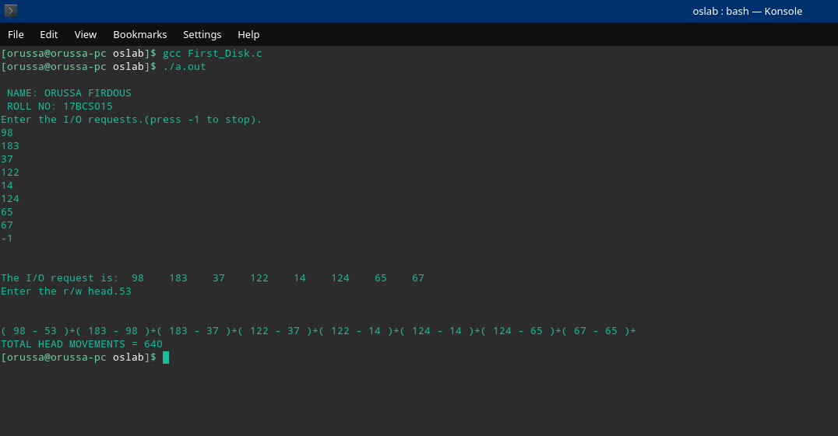

11.SHORTEST SEEK DISK
SCHEDULING

#include<stdio.h>

int main(){

int i=0,j,n,count=0,lowest=99999,diff,t,tbh=0;
int a[50],index;
int b[50],bflag[50];
printf("\n NAME: ORUSSA FIRDOUS\n ROLL NO: 17BCS015");

printf("\nEnter the I/O requests.(press -1 to stop).\n");
while(1){
scanf("%d",&n);
if(n>=0 && n<= 199){
a[i]=n;i++;
}
else if(n == -1)
break;

else
printf("\nEnter a valid input.\n");
}

n=i;printf("\n");
printf("\nThe I/O request is:");
for(i=0;i<n;i++)
printf(" %d ",a[i]);
int head;
printf("\nEnter the r/w head.");
scanf("%d",&head);
n=n+1;
b[0]=head;j=0;bflag[0]=0;
for(i=1;i<n;i++){
b[i]=a[j];j++;bflag[i]=0;
}printf("\n");
index=0;
while(count != n){i=index;
lowest = 99999;
for(j=0;j<n;j++){
if(bflag[j] != 1 && j != i){
diff=b[j]-b[i];
if(diff >= 0)
{diff=diff;}

else
diff=(-1)*diff;

if(lowest > diff){
lowest = diff;index=j;
}
}
}count++;bflag[i]=1;
if(count != n){
t=b[index]-b[i];
if(t>=0){
tbh+=t; printf("( %d - %d )+",b[index],b[i]);

}
else{
tbh+=(-1)*t;printf("( %d - %d )+",b[i],b[index]);
}
}
}printf("\b\b");
printf("\n TOTAL HEAD MOVEMENT = %d ",tbh);

return 0;}

