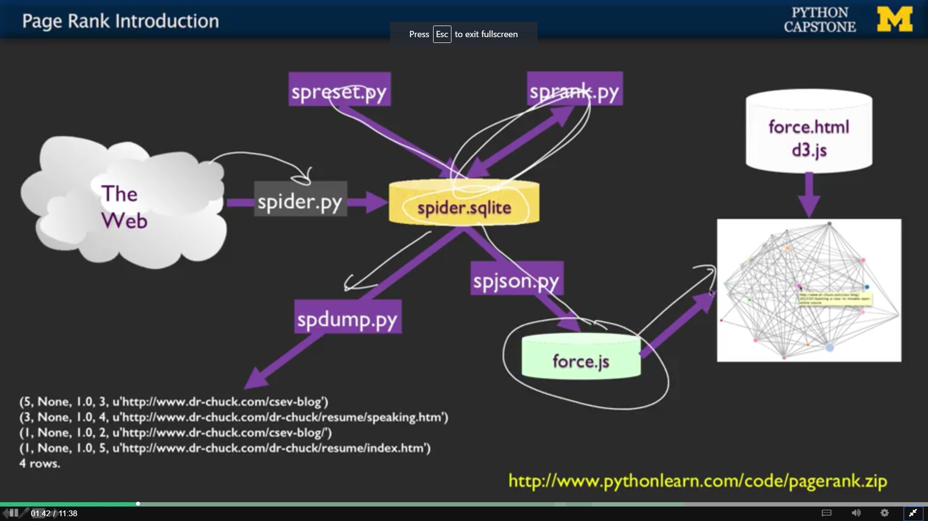

Google Page rank = determine links from good pages

Spider.py = reads pages from web, keep track that have been followed/about to be followed, also restartable

