**CSE-40079**

**UNIX Shell Programming**

**Assignment 1**

1: Given the following files in your current directory: Note: You can create these files by using the touch command:

touch feb96 jan12.02 jan19.02       etc...

$

ls

feb96

jan12.02

jan19.02

jan26.02

jan5.02

jan95

jan96

jan97

jan98

mar98

memo1

memo10

memo2

memo2.sv

$

What would be the output from the following commands?

echo *                                                                                                  echo *[!0-9]

echo m[a-df-z]*                                                                                  echo [A-Z]*

echo jan*                                                                                            echo *.*

echo ?????                                                                                          echo *02

echo jan?? feb?? mar??                                                                      echo [fjm][ae][bnr]*

Output:

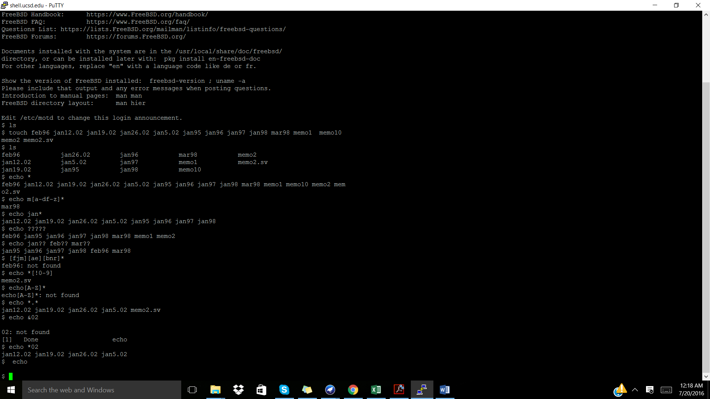



2: What is the effect of the following command sequences?

ls | wc -l                                                                                                  rm ???

who | wc -l                                                                                             mv progs/* /users/steve/backup

ls *.c | wc -l                                                                                             rm *.o

who | sort                                                                                               cd; pwd

cp memo1 ..                                                                                          plotdata 2>errors &

Output:

