**Lab Assignment 1 – First Lab.**

Lab assignment is worth 5 points and is due on Wednesday, Aug 03, 2016. Complete the following labs and skill checks.

Save and submit all the SQL queries for each Lab Workshop and Skill Checks in one MS Word or Worpad and attach them to this assignment. Indicate the Lab Workshop and Skillcheck numbers associated with each query written. Be sure to name the file, f_lastname-week5.doc so I can keep the files straight.

Lab 3.1 Working with NULLS; Skill Checks 1, 2 and 3

Lab Prep: Each lab has one or more Skill Checks. Start with Skill Check 1 and proceed until reaching the Points to Ponder section.

Please run the lab setup script for resetting the database (**SQLQueries2012Vol2Chapter3.1Setup.sql**), please make sure to close all query windows within SSMS.

Skill Check 1: The Employee table in JProCo has a field called ManagerID. Write a query to show all Employees who don’t have a ManagerID.

When you’re done, your result should resemble the figure below.

Skill Check 1 shows all JProCo Employees who have no ManagerID.

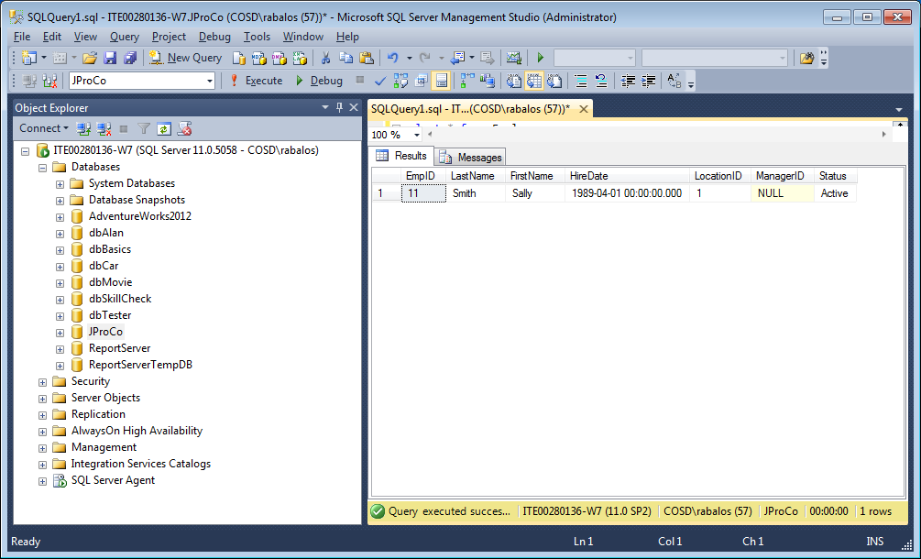

Skill Check 2: Find the two records in the Customer table where there is an existing company name, for each record, as shown in the figure below.

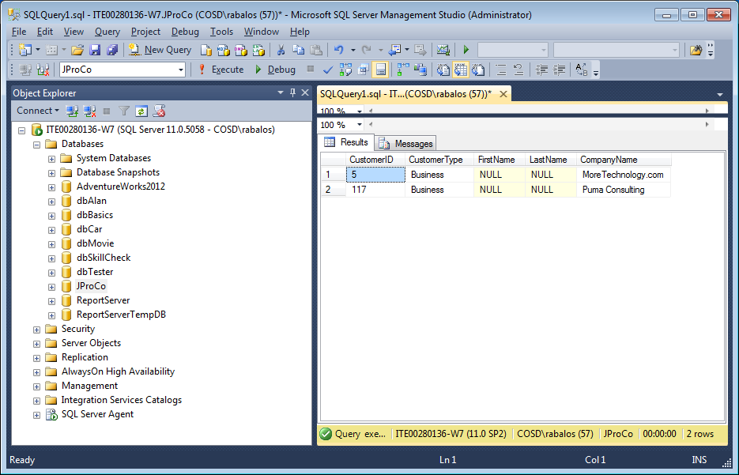

Skill Check 3: Using your result set from Skill Check 2, write a statement to update the CustomerType field of the Customer table to “Consumer”, for each record where the company name is not NULL.

When you are done, query the two records that were updated and you should have two records with the value “Consumer” in the CustomerType field, as shown in the figure below.

Figure in Skill Check 3 changes the CustomerType to “Consumer” if CompanyName is not NULL.

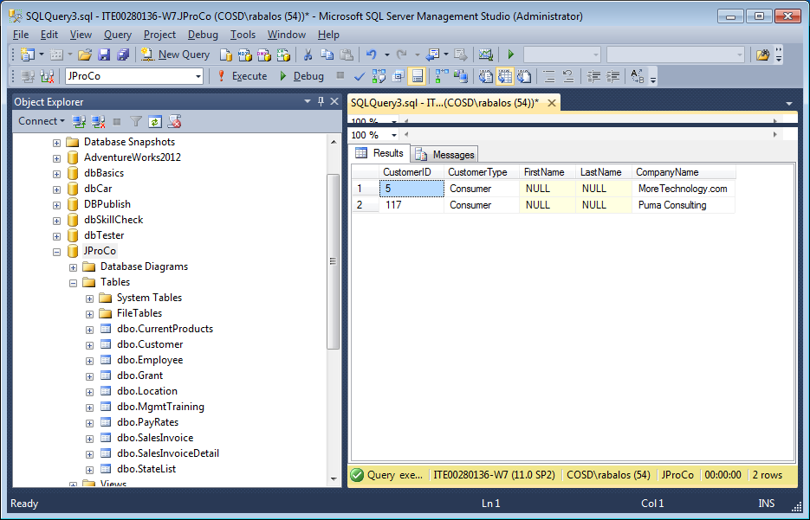

Lab 3.2 Expression Fields; Skill Checks 1, 2, 3 and 4

Lab 3.2: Expression Fields Lab Prep: Each lab has one or more Skill Checks. Start with Skill Check 1.

Please run the lab setup script for resetting the database (**SQLQueries2012Vol2Chapter3.2Setup.sql**), please make sure to close all query windows within SSMS and lastly run the setup script.

Skill Check 1: Using the CurrentProducts table of JProCo, make another field **to express** the price in Canadian currency called CDN $ that is 1.1 times the stated RetailPrice in JProCo’s CurrentProducts table. Then create two additional fields named Aussie $ ( 1.4 times the RetailPrice) and Euro (which is .82 times the RetailPrice). When you’re done your result should resemble the figure below

SELECT ProductName, RetailPrice, --Remaining Code Here

Figure Skill Check 1 with three new currency columns calculated from RetailPrice (US dollars).

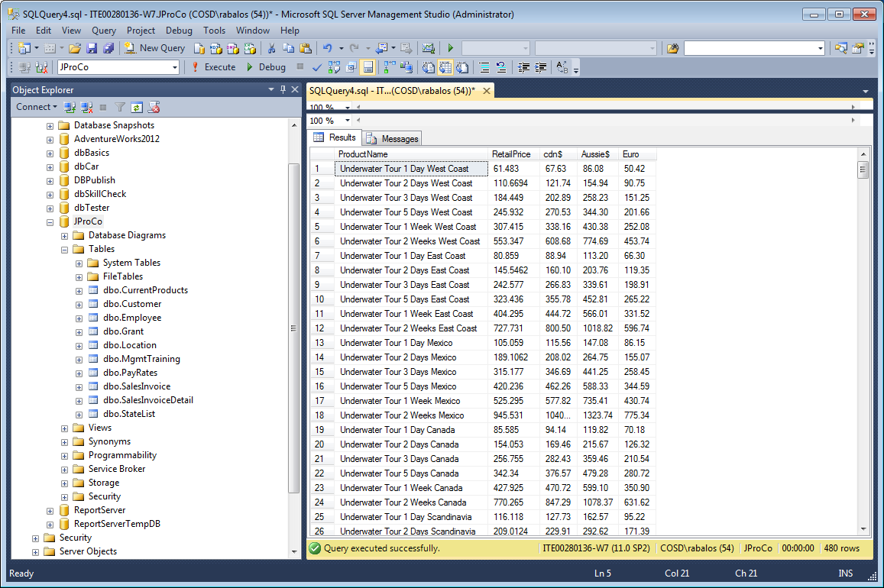

Skill Check 2: In JProCo find the 773 records in your Customer table where the CustomerType is Consumer. Show the CustomerID, CustomerType field and the FullName expression field. Your results should be sorted by the FullName field (Z-A). When you’re done your result should resemble the figure below.

Figure in Skill Check 2 Add the expression field ‘Full Name’.

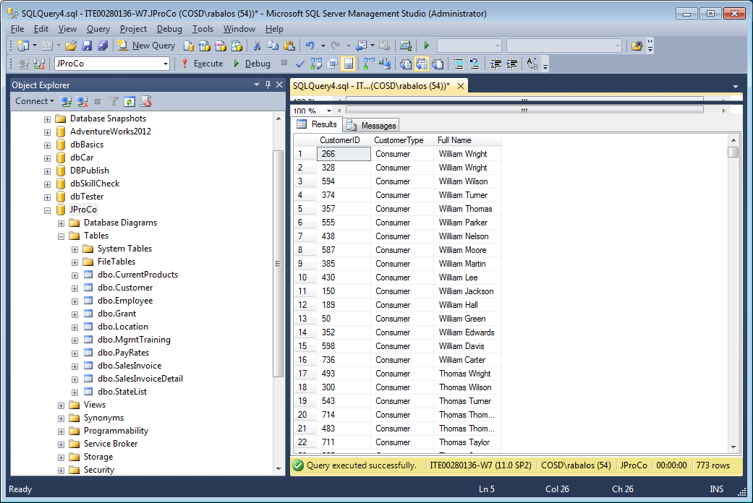

Skill Check 3: Join the SalesInvoiceDetail table to the CurrentProducts table. Show the ProductID, ProductName and RetailPrice from the CurrentProducts table. Show Quantity from the SalesInvoiceDetail table. Create an expression field called SubTotal which multiplies RetailPrice by Quantity. Your result should look like the figure below.

Figure below Skill Check 3 adds dynamic field SubTotal.

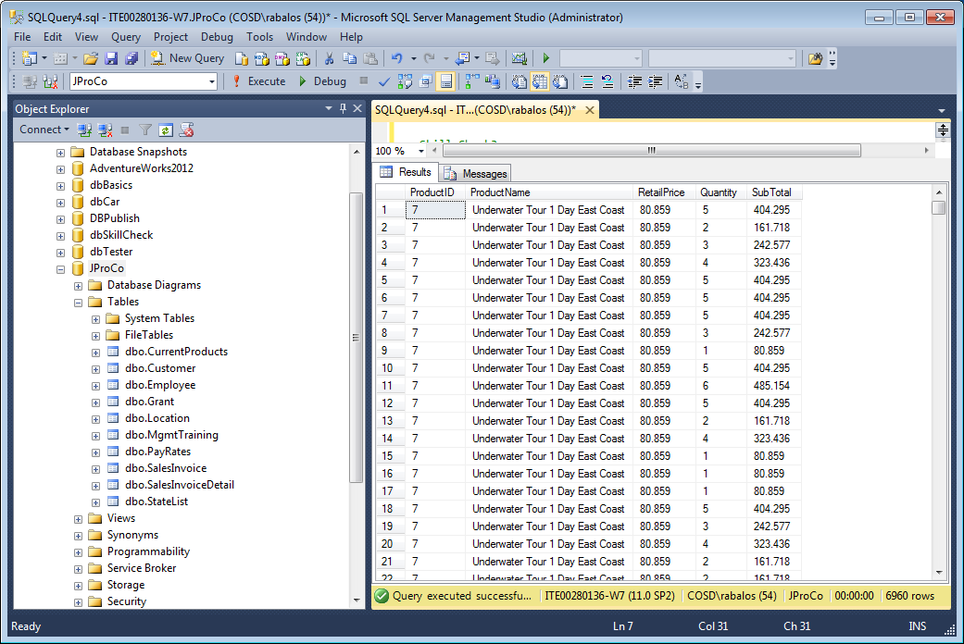

Skill Check 4: Modify your query from Skill Check 3. Using the Round function, show Retail Price and the SubTotal expression field rounded to the nearest penny.

When you’re done, your result will resemble the figure below.

Skill Check 4, Use the ROUND function to display Skill Check 3 results rounded to the nearest penny.

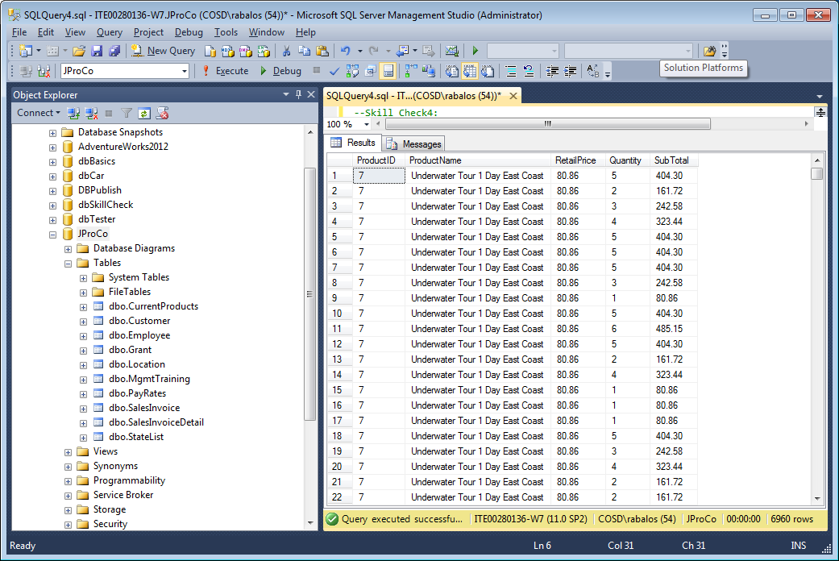

Lab 3.3 Identity Fields; Skill Check 1

Lab 3.3: Identity Fields Lab Prep: Each lab has one or more Skill Checks. Start with Skill Check 1 and proceed until reaching the Points to Ponder section.

Please run the lab setup script for resetting the database (**SQLQueries2012Vol2Chapter3.3Setup.sql**), please make sure to close all query windows within SSMS, and lastly run the setup script.

Skill Check 1: The MgmtTraining table in JProCo has ClassID as an identity field. Previously, this table had many records deleted from it. We want to insert a value of ‘Empowering Others’ in the ClassName field with a ClassID of 4. If we run a simple INSERT statement, the identity counter is already past the number 4. We must set the table’s property for inserting values to allow manually inserting all fields for this record. The ApprovedDate field should be set using the CURRENT_TIMESTAMP property. When done, the results should resemble those shown in Figure below.

Run the following query below to display the result set –

SELECT * FROM MgmtTraining

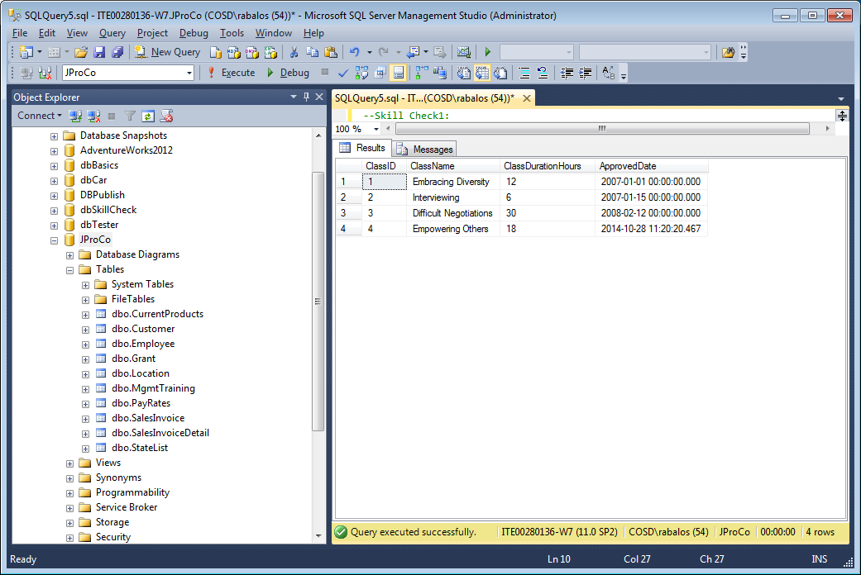

Lab 4.1 Using Group By; Skill Checks 1, 2, 3 and 4

Lab 4.1: Using GROUP BY Lab Prep: Each lab has one or more Skill Checks. Start with Skill Check 1 and proceed until reaching the Points to Ponder section.

Please run the lab setup script for resetting the database (**SQLQueries2012Vol2Chapter4.1Setup.sql**), please make sure to close all query windows within SSMS and lastly run the setup script.

Skill Check 1: Query the Employee table of JProCo to see how many people work for each ManagerID . Select the ManagerID and Count the EmpID field. Alias the field as EmpIDCount.

When you’re done, your result should resemble the figure you see below.

Skill Check 1 displays the count of people associated with each ManagerID.

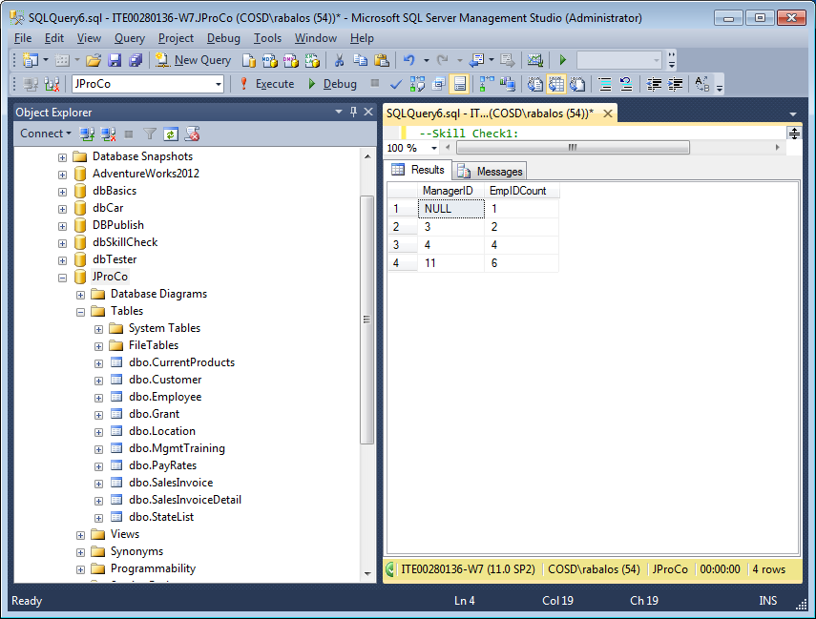

Skill Check 2: Perform a grouping query on the Customer table to get a count of how many consumers versus Business customers you have. Alias the field as CustomerCount. Group on the CustomerType field.

When you’re done your result should resemble the figure you see below.

Skill Check 2 result set displays the Group on CustomerType to show numbers of Consumer vs. Business customers.

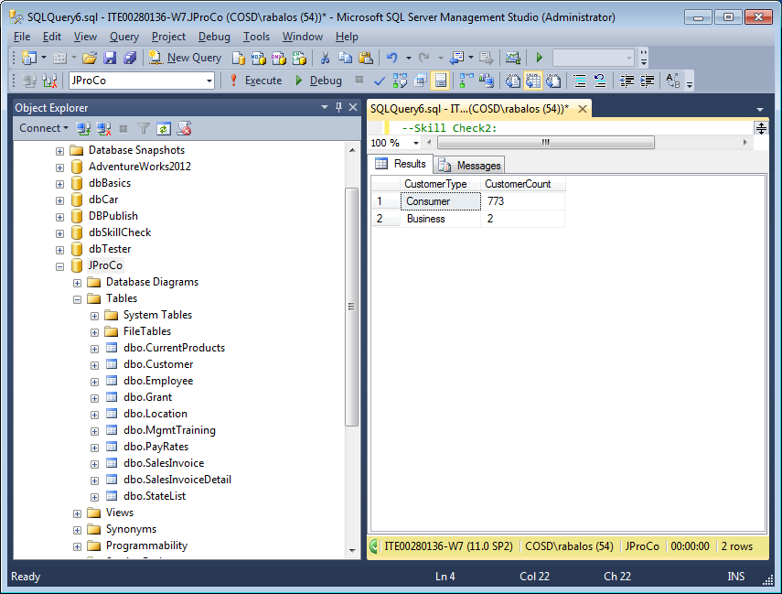

Skill Check 3: Get a list of all Customers and how many Invoice orders each one has placed. You will need to join the Customer and SalesInvoice tables. Alias the aggregated field as InvoiceIDCount. If a Customer has not ordered yet, then you should still see their name with a zero next to it.

Hint: this will require an OUTER JOIN between Customer and SalesInvoice (Figure below). Your results should have 775 records.

Skill Check 3 shows each customer and the COUNT of their invoices.

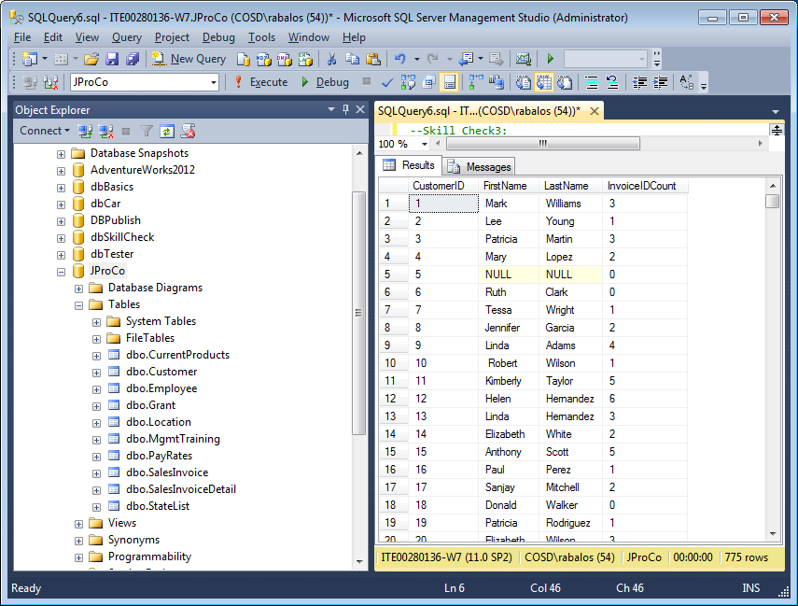

Skill Check 4: Make a slight modification to Skill Check 3 so that only Customers who have placed at least one order appear in the query (Hint: change the type of join). Notice CustomerID 5 does not appear in this result. (Figure below).

Skill Check 4 shows only customers who placed at least one order.

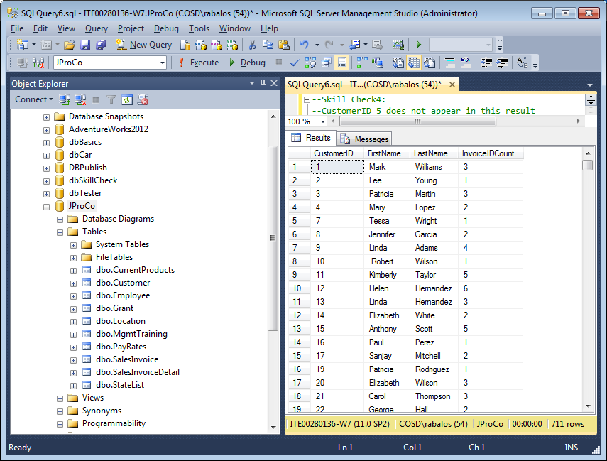

Lab 4.2 Filtering Aggregated Results; Skill Checks 1 and 2

Lab 4.2: Filtering Aggregated Results Lab Prep: Each lab has one or more Skill Checks. Start with Skill Check 1 and proceed until reaching the Points to Ponder section.

Please run the lab setup script for resetting the database (**SQLQueries2012Vol2Chapter4.2Setup.sql)**, please make sure to close all query windows within SSMS and lastly run the setup script.

Skill Check 1: Using the SalesInvoice table, write a query which groups on CustomerID and counts the number of orders (also called invoices) each customer has made. Return only the records where the CustomerID has ordered more than 7 times. Show the aggregated field as OrderCount. When done, the results should resemble the figure below.

Skill Check 1 results show CustomerIDs with more than 7 orders.

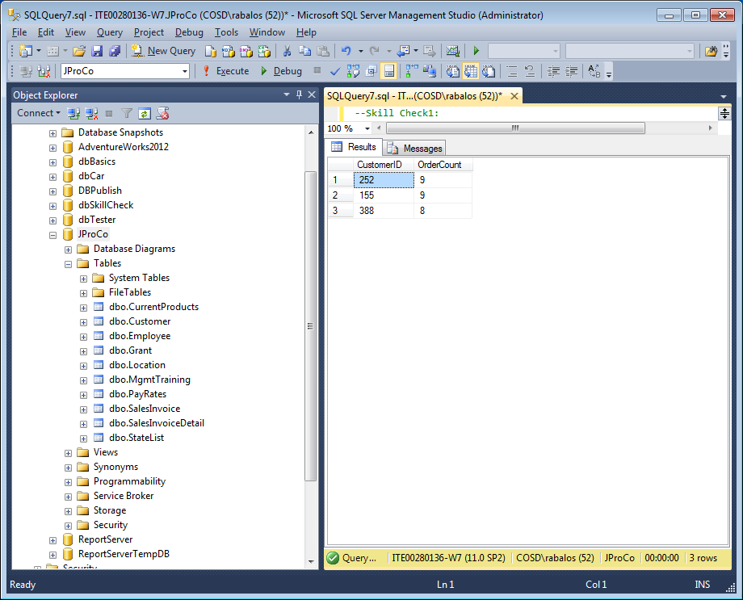

Skill Check 2: Query the SalesInvoiceDetail table and show just the ProductID and InvoiceID fields. Change the query to group on ProductID and count the InvoiceID field. Return only the records where the ProductID has been ordered more than 200 times.

When done the result should resemble the figure below. There is no need to join to the CurrentProducts table since we will be grouping on ProductID which is already in the SalesInvoiceDetail table.

Skill Check 2 looks for products ordered more than 200 times.

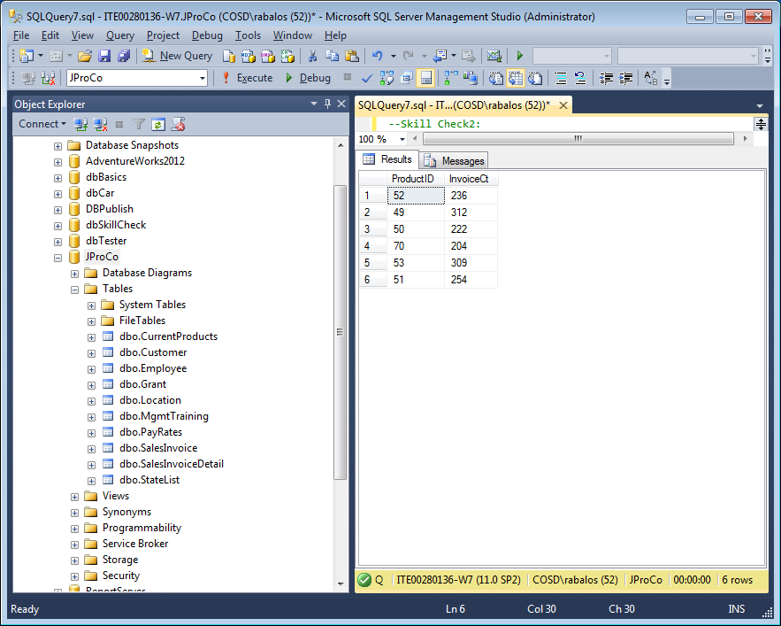

Lab 4.3 Aggregation in Stored Procedures, Skill Check 1

Lab 4.3: Aggregation in Stored Procedures Lab Prep:

Please run the lab setup script for resetting the database (**SQLQueries2012Vol2Chapter4.3Setup.sql**), please make sure to close all query windows within SSMS and lastly run the setup script.

Skill Check 1: Using what you’ve learned, create a stored procedure called GetCategoriesByProductCount. This will join the CurrentProducts and the SalesInvoiceDetail tables and show the total number of orders for each Category.

When done, execute the stored procedure and view the results. The results should resemble those shown in figure below.

EXEC GetCategoriesByProductCount

Skill Check 1 creates the stored procedure GetCategoriesByProductCount.

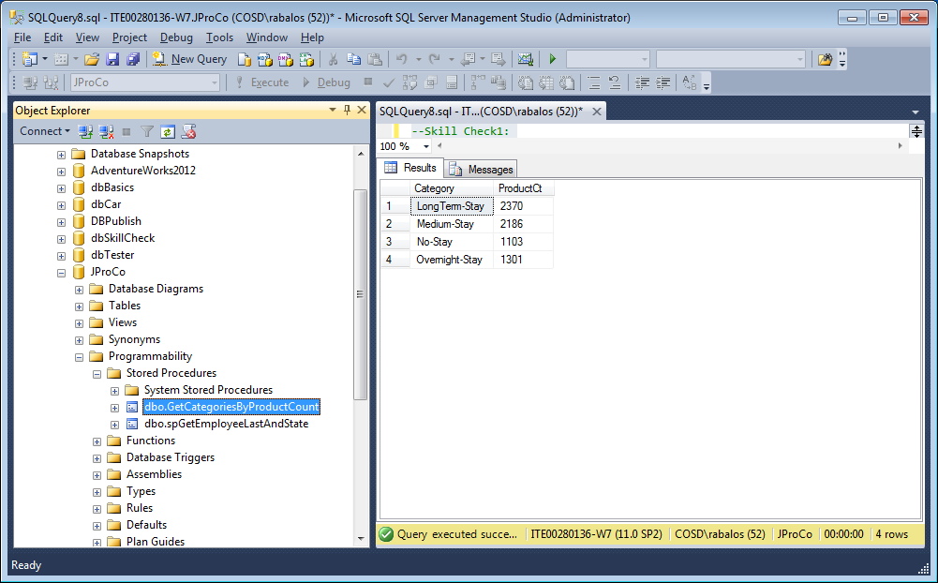

Volume 2: Lab 5.1 Finding Duplicates, Skill Checks 1 and 2;

Lab 5.1: Finding Duplicates Lab Prep: Each lab has one or more Skill Checks. Start with Skill Check 1.

Please run the lab setup script for resetting the database (**SQLQueries2012Vol2Chapter5.1Setup.sql**). Make sure to close all query windows within SSMS and lastly run the setup script.

Skill Check 1: Go to the JProCo database and count all employees having multiple grants listed in the Grant table. Your result should resemble the figure below.

Skill Check 1 looks for employees with multiple entries in the Grant table.

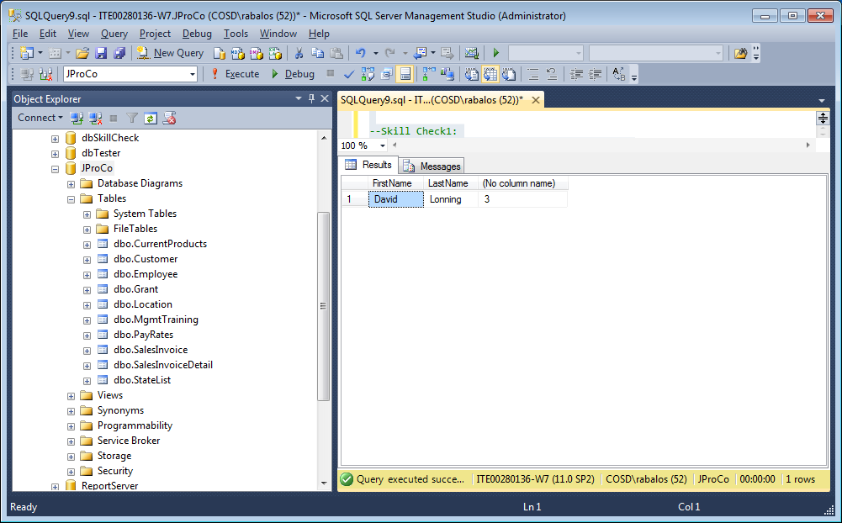

Skill Check 2: Query the StateList table to find any duplicate records . List all duplicated StateID and StateName values you find. Title your aggregated field IDCount.

When you’re done, your result should resemble in the figure below.

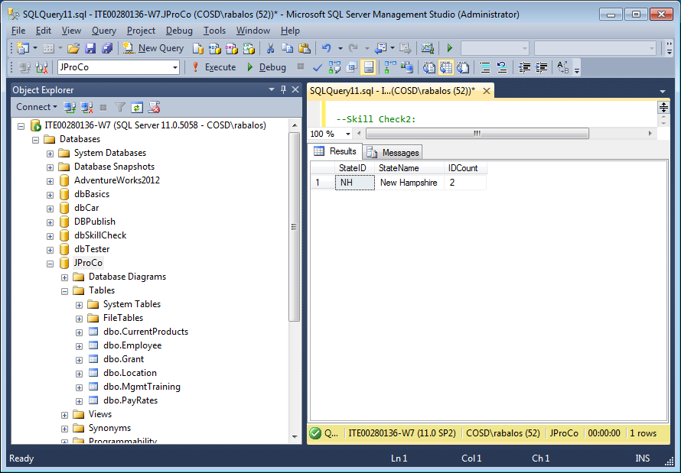

Lab 5.2 The Over the Clause, Skill Checks 1, 2, 3 and 4

Lab 5.2: The OVER Clause Lab Prep: Each lab has one or more Skill Checks. Start with Skill Check 1

Please run the lab setup script for resetting the database (**SQLQueries2012Vol2Chapter5.2Setup.sql**), please make sure to close all query windows within SSMS and lastly run the setup script.

Skill Check 1: Use the JProCo database and query the CurrentProducts table for the fields ProductName, RetailPrice and Category. Create an expression field that combines AVG() with an OVER() clause and call it **AvgPrice**. When you are done, your result should resemble the figure you see below.

Skill Check 1 creates a new expression field combining AVG() with an OVER clause.

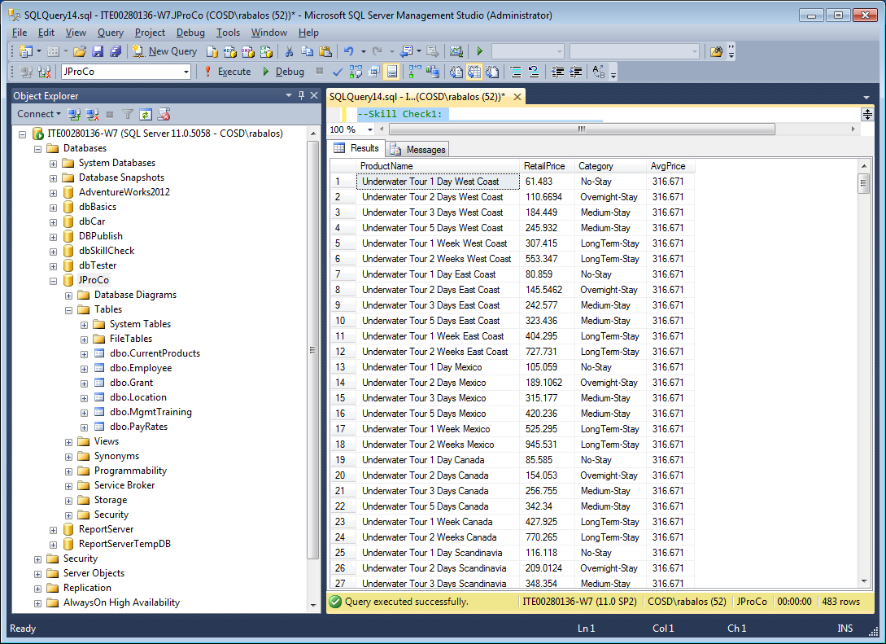

Skill Check 2: Take the query from Skill Check 1 and add another expression field called **AvgCatPrice** that shows the average price for the Category for any given product. When you are done, your result will resemble the figure below.

Skill Check 2 adds a new expression field showing AvgCatPrice.

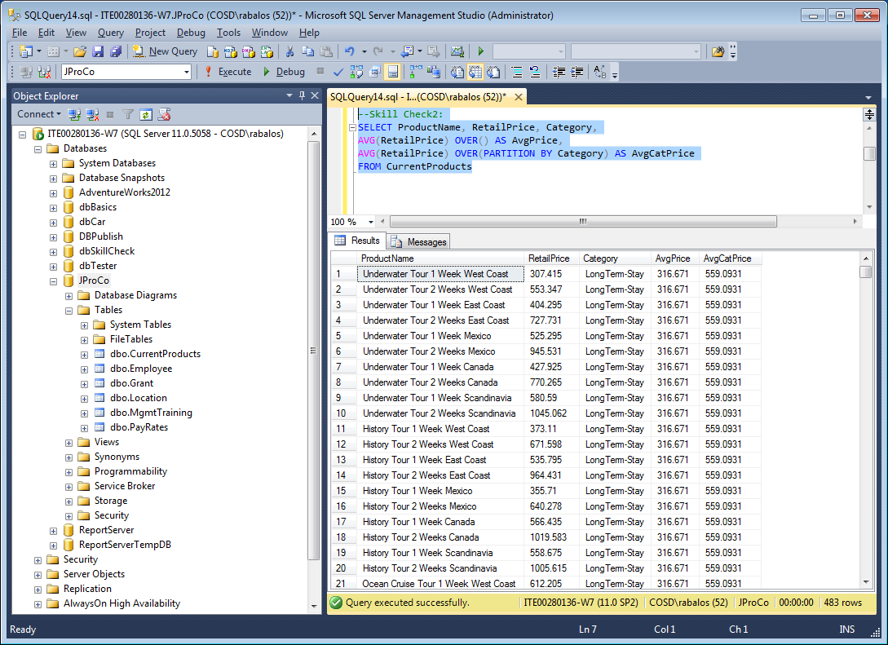

Skill Check 3: Use the JProCo database and query the CurrentProducts table. Show each distinct category and calculate the percentage (with decimals) of products for each Category. Since we have more LongTerm -Stay products, that category will represent the highest percentage of the total (Figure below).

Skill Check 3 calculates the percentage of products in each product Category.

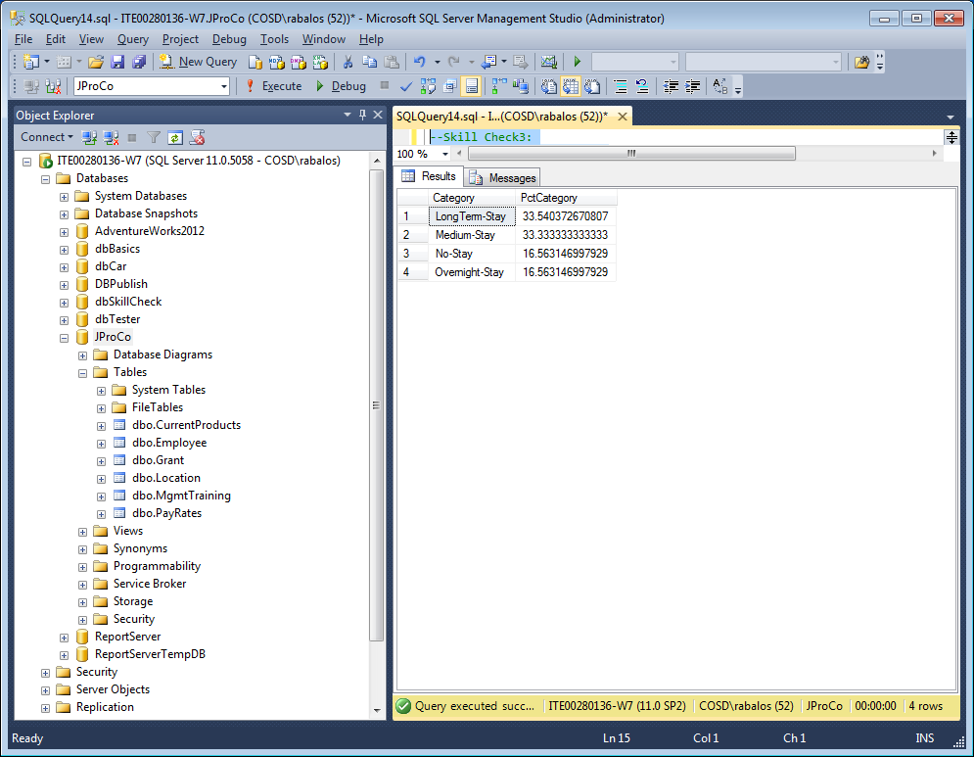

Skill Check 4: Join the Location, Employee and Grant tables and display FirstName, LastName, GrantName, City and Amount. Add an expression field called **CityTotal** that compares each grant to the total amount in the same City (See the expected result in Figure below).

Compare each individual grant to the total grant amounts in the same city (CityTotal).

