**Data Mining III**

**CSE 40977**

**Assignment II**

1 - Apply the SpreadSubsample filter onto the IMAGE_AssignmentII.arff so that there is a uniform distribution of the IMAGE class variable in the selected subsample. Rerun the following models on this subsample and record evaluation scores:

- RepTree

- DecTree (J48)

- Grafting DecTree (J48graft)

- LM Tree

- BF Tree

2 - Load IMAGE_AssignmentII_bothSet.arff. Examine all 19 attributes carefully, as we did with the original dataset (ImageSegmentationData.arff) in Lesson 3. Should any of them be removed? Why?

3 - Load IMAGE_AssignmentII_ready.arff and model it using these three methods: BF Tree, LMTree and ANN. Report your best 10-fold cross validations score.

4 – Now, model the same data using the DT, RepTree, graftingDT, BF, LMT with at least two modified parameter runs each (two runs for each of the five methods) - any better results?

5 - Which tree would you choose to present to the end user, knowing that the model needs to be readable (not a black box)?

**Workflow**

(1) IMAGE_AssignmentII.arff was loaded into Weka. Filters.supervised.instance.SpreadSubsample -M 1.0 -X 0.0 -S 1 was applied to the dataset to allow for uniform distribution for the class attribute, image.

Before filtering:

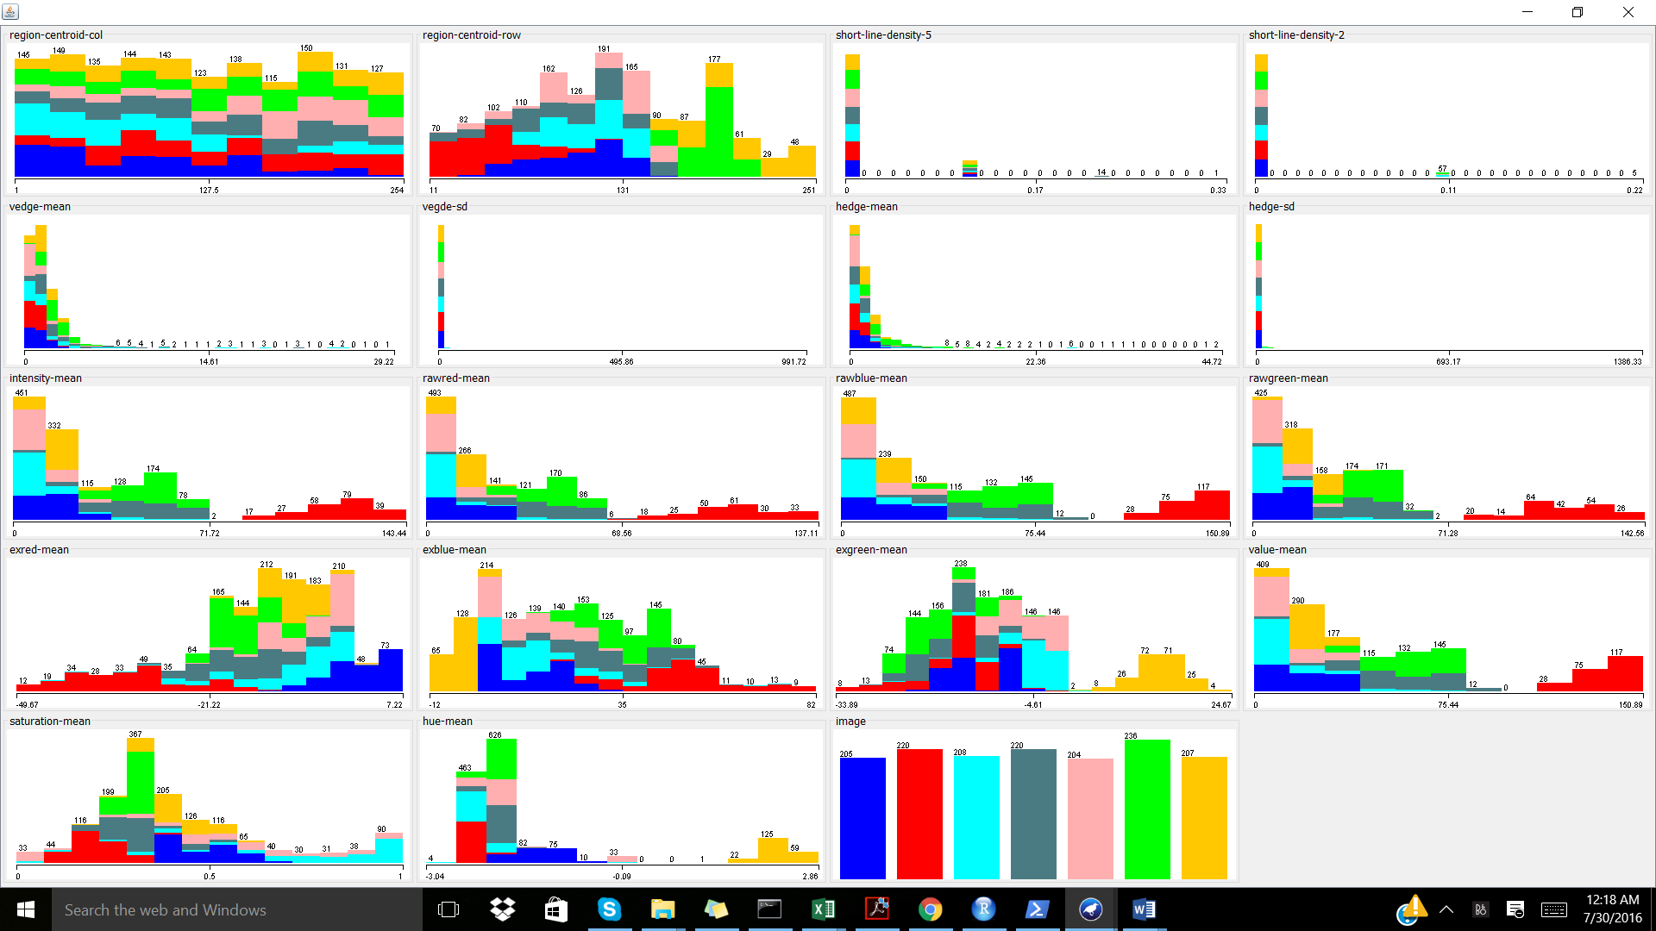

Following filtering:

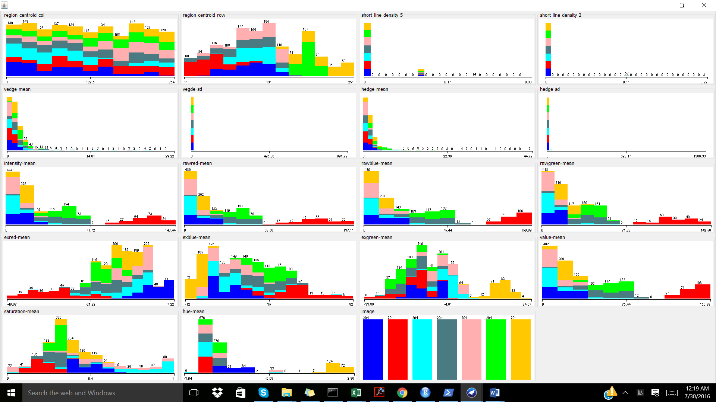

The following classification models were run on the filtered dataset with 10 Folds Cross-validation being implemented. The associated evaluation scores were recorded:

|  |  |  |  |
| --- | --- | --- | --- |
| Classification Model | Correctly classified instances (%) | Mean absolute error | Notes |
| REPTree | 94.1877 | 0.0223 | Size of the tree: 27 |
| J48  Decision Tree | 95.4482 | 0.0145 | Number of Leaves: 31  Size of the tree: 61 |
| J48graft  Grafting Decision Tree | 95.6583 | 0.0141 | Number of Leaves: 106  Size of the tree: 211 |
| LM Tree | 95.8683 | 0.0152 | Number of Leaves: 4  Size of the Tree: 7 |
| BF Tree | 95.2381 | 0.0163 | Size of the Tree: 63  Number of Leaf Nodes: 32 |

(2) The IMAGE_AssignmentII_bothSet.arff file was loaded into Weka. After examination of the dataset, the class attribute, image, had even distribution and no attributes were removed because each of the attribute values provided a gain in information which is necessary for correctly classifying image.

(3) The IMAGE_AssignmentII_ready.arff was loaded into Weka and the following classification models were run with their corresponding 10-fold cross validation scores recorded.

|  |  |  |  |
| --- | --- | --- | --- |
| Classification Model | Correctly classified instances (%) | Mean absolute error | Notes |
| BF Tree | 96.1039 | 0.0139 | Size of the Tree: 91  Number of Leaf Nodes: 46 |
| LM Tree | 95.8442 | 0.015 | Number of Leaves: 5  Size of the Tree: 9 |
| ANN (MultiLayerPerceptron) | 96.1039 | 0.0161 | Number of nodes: 6 |

(4) The IMAGE_AssignmentII_ready.arff file was further use on the following models with slight modification to parameters in order to determine if better results were achieved.

|  |  |  |  |  |
| --- | --- | --- | --- | --- |
| Classification Model | Parameter Modification | Correctly classified instances (%) | Mean absolute error | Notes |
| J48 Decision Tree (Default) | J48 -C 0.25 -M 2 | 96.7965 | 0.011 | Number of Leaves: 39  Size of the tree: 77 |
| J48 Decision Tree | J48 -C 0.5 -M 2  confidenceFactor: 0.5 | 96.7965 | 0.0108 | Number of Leaves: 42  Size of the tree: 83 |
| J48 Decision Tree | J48 -C 0.25 -M 5  minNumObj: 5 | 96.1472 | 0.0143 | Number of Leaves: 30  Size of the tree: 59 |
| REPTree (Default) | REPTree -M 2 -V 0.001 -N 3 -S -L -1 | 95.8009 | 0.0174 | Size of the tree: 53 |
| REPTree | REPTree -M 2 -V 0.01 -N 3 -S -L -1  minVarianceProp: 0.01 | 95.8009 | 0.0174 | Size of the tree: 53 |
| REPTree | REPTree -M 2 -V 0.001 -N 5 -S -L -1  numFolds: 5 | 95.7143 | 0.0172 | Size of the tree: 49 |
| J48 grafting Decision Tree (Default) | J48graft -C 0.25 -M 2 | 96.8398 | 0.0109 | Number of Leaves: 141  Size of the tree: 281 |
| J48 grafting Decision Tree | J48graft -C 0.25 -M 2  confidenceFactor: 0.5 | 96.8398 | 0.0107 | Number of Leaves: 143  Size of the tree: 285 |
| J48 grafting Decision Tree | J48graft -C 0.25 -M 5  minNumObj: 5 | 96.2338 | 0.0142 | Number of Leaves: 122  Size of the tree: 243 |
| BF Tree (Default) | BFTree -S 1 -M 2 -N 5 -C 1.0 -P POSTPRUNED | 96.1039 | 0.0139 | Size of the Tree: 91  Number of Leaf Nodes: 46 |
| BF Tree | BFTree -S 1 -M 5 -N 5 -C 1.0 -P POSTPRUNED  minNumObj: 5 | 94.9351 | 0.02 | Size of the Tree: 53  Number of Leaf Nodes: 27 |
| BF Tree | BFTree -S 1 -M 2 -N 10 -C 1.0 -P POSTPRUNED  numFoldsPruning: 10 | 96.2338 | 0.0133 | Size of the Tree: 95  Number of Leaf Nodes: 48 |
| LM Tree (Default) | LMT -I -1 -M 15 -W 0.0 | 95.8442 | 0.015 | Number of Leaves: 5  Size of the Tree: 9 |
| LM Tree | LMT -B -I -1 -M 15 -W 0.0  convertNominal: True | 95.8442 | 0.015 | Number of Leaves: 5  Size of the Tree: 9 |
| LM Tree | LMT -I -1 -M 20 -W 0.0  minNumInstances: 20 | 95.8442 | 0.015 | Number of Leaves: 5  Size of the Tree: 9 |

(5) From the results above, the best tree to present the end user would be: J48graft -C 0.25 -M 2 or J48 at default which yielded 96.8398% correctly classified instances with a low mean absolute error of 0.0107. Although this is a large tree (Number of Leaves: 141 and Size of the tree: 281), it is the most accurate model which was tested above and thus would be sufficient to present to the end user. Still, if a simpler model is needed (one that does not have as many leaves), the J48 -C 0.25 -M 2 model can be used which yielded 96.7965% correctly classified instances, a mean absolute error of 0.011, and a smaller tree (Number of Leaves: 39 and Size of the tree: 77). Therefore, the final classification model to use will be the J48 -C 0.25 -M 2 model as it is simpler for the end user to use and implement for their own purposes.

J48 -C 0.25 -M 2 Full Model to present to end user:

=== Run information ===

Scheme:weka.classifiers.trees.J48 -C 0.25 -M 2

Relation: segment-weka.filters.unsupervised.attribute.Remove-R3

Instances: 2310

Attributes: 19

region-centroid-col

region-centroid-row

short-line-density-5

short-line-density-2

vedge-mean

vegde-sd

hedge-mean

hedge-sd

intensity-mean

rawred-mean

rawblue-mean

rawgreen-mean

exred-mean

exblue-mean

exgreen-mean

value-mean

saturation-mean

hue-mean

image

Test mode:10-fold cross-validation

=== Classifier model (full training set) ===

J48 pruned tree

------------------

region-centroid-row <= 155

| rawred-mean <= 27.2222

| | hue-mean <= -1.89048

| | | hue-mean <= -2.24632: foliage (160.0/1.0)

| | | hue-mean > -2.24632

| | | | saturation-mean <= 0.772831

| | | | | region-centroid-col <= 110

| | | | | | rawred-mean <= 0.666667

| | | | | | | region-centroid-row <= 150: foliage (14.0/1.0)

| | | | | | | region-centroid-row > 150: window (2.0)

| | | | | | rawred-mean > 0.666667

| | | | | | | exred-mean <= -15.7778: foliage (10.0/2.0)

| | | | | | | exred-mean > -15.7778

| | | | | | | | hue-mean <= -2.03348

| | | | | | | | | rawblue-mean <= 31.6667

| | | | | | | | | | region-centroid-row <= 120: window (27.0)

| | | | | | | | | | region-centroid-row > 120

| | | | | | | | | | | exgreen-mean <= -7.11111: cement (14.0/1.0)

| | | | | | | | | | | exgreen-mean > -7.11111: window (13.0/1.0)

| | | | | | | | | rawblue-mean > 31.6667: cement (3.0)

| | | | | | | | hue-mean > -2.03348

| | | | | | | | | vedge-mean <= 2.44444

| | | | | | | | | | region-centroid-row <= 150: brickface (6.0/1.0)

| | | | | | | | | | region-centroid-row > 150: window (2.0)

| | | | | | | | | vedge-mean > 2.44444: cement (3.0)

| | | | | region-centroid-col > 110

| | | | | | exgreen-mean <= -14.3333: cement (11.0/1.0)

| | | | | | exgreen-mean > -14.3333

| | | | | | | rawred-mean <= 24.7778: window (169.0/8.0)

| | | | | | | rawred-mean > 24.7778

| | | | | | | | vedge-mean <= 1.72223: window (4.0)

| | | | | | | | vedge-mean > 1.72223: cement (7.0)

| | | | saturation-mean > 0.772831

| | | | | hue-mean <= -2.09121

| | | | | | region-centroid-row <= 132: foliage (94.0)

| | | | | | region-centroid-row > 132

| | | | | | | rawred-mean <= 0.444444

| | | | | | | | hedge-mean <= 0.277778

| | | | | | | | | hedge-mean <= 0.166667: window (9.0/1.0)

| | | | | | | | | hedge-mean > 0.166667

| | | | | | | | | | region-centroid-col <= 86: window (3.0)

| | | | | | | | | | region-centroid-col > 86: foliage (4.0)

| | | | | | | | hedge-mean > 0.277778: foliage (18.0/1.0)

| | | | | | | rawred-mean > 0.444444: window (9.0/1.0)

| | | | | hue-mean > -2.09121

| | | | | | region-centroid-col <= 8: foliage (2.0)

| | | | | | region-centroid-col > 8: window (34.0)

| | hue-mean > -1.89048

| | | exgreen-mean <= -5

| | | | vedge-mean <= 2.77778

| | | | | exgreen-mean <= -7: brickface (295.0/2.0)

| | | | | exgreen-mean > -7

| | | | | | vedge-mean <= 0.888891: brickface (26.0)

| | | | | | vedge-mean > 0.888891: window (4.0/1.0)

| | | | vedge-mean > 2.77778

| | | | | region-centroid-row <= 107: brickface (6.0)

| | | | | region-centroid-row > 107: foliage (5.0/1.0)

| | | exgreen-mean > -5

| | | | rawgreen-mean <= 11.7778

| | | | | region-centroid-col <= 115: foliage (7.0/1.0)

| | | | | region-centroid-col > 115: window (58.0)

| | | | rawgreen-mean > 11.7778: grass (6.0)

| rawred-mean > 27.2222

| | rawblue-mean <= 91.4444

| | | hue-mean <= -2.21924: foliage (18.0)

| | | hue-mean > -2.21924: cement (265.0)

| | rawblue-mean > 91.4444: sky (330.0)

region-centroid-row > 155

| exblue-mean <= 9.77778: grass (325.0/1.0)

| exblue-mean > 9.77778

| | saturation-mean <= 0.386456

| | | region-centroid-row <= 159

| | | | hedge-mean <= 8.5: cement (3.0)

| | | | hedge-mean > 8.5: path (3.0)

| | | region-centroid-row > 159: path (327.0)

| | saturation-mean > 0.386456: cement (14.0)

Number of Leaves : 39

Size of the tree : 77

Time taken to build model: 0.06 seconds

=== Stratified cross-validation ===

=== Summary ===

Correctly Classified Instances 2236 96.7965 %

Incorrectly Classified Instances 74 3.2035 %

Kappa statistic 0.9626

Mean absolute error 0.011

Root mean squared error 0.0939

Relative absolute error 4.4987 %

Root relative squared error 26.825 %

Total Number of Instances 2310

=== Detailed Accuracy By Class ===

TP Rate FP Rate Precision Recall F-Measure ROC Area Class

0.979 0.005 0.973 0.979 0.976 0.987 brickface

1 0.001 0.994 1 0.997 0.999 sky

0.93 0.011 0.933 0.93 0.932 0.974 foliage

0.955 0.005 0.972 0.955 0.963 0.978 cement

0.915 0.016 0.907 0.915 0.911 0.958 window

1 0.001 0.997 1 0.998 1 path

0.997 0 1 0.997 0.998 0.998 grass

Weighted Avg. 0.968 0.005 0.968 0.968 0.968 0.985

=== Confusion Matrix ===

a b c d e f g <-- classified as

323 0 3 2 2 0 0 | a = brickface

0 330 0 0 0 0 0 | b = sky

3 1 307 1 18 0 0 | c = foliage

3 1 0 315 11 0 0 | d = cement

3 0 19 6 302 0 0 | e = window

0 0 0 0 0 330 0 | f = path

0 0 0 0 0 1 329 | g = grass

