**Data Mining III**

**CSE 40977**

**Assignment IV**

Access the Forest Fires dataset on the UCI Repository link: http://archive.ics.uci.edu/ml/datasets/Forest+Fires. Download both the data file and the description file (.names and .csv). Carefully read the description of the file. Your task is to model "area" variable -- the burned are of the forest. This task requires a careful data preparation and preprocessing and the web site will provide a hint as to how to prepare the area variable.  You will most likely need to perform several iterations to obtain a model that evaluates to at least 75% correctly classified instances (or approximately 0.75 correlation coefficient).  The output model needs to be fairly user-friendly, i.e. readable. Please include the full model and the all of the evaluation scores.

**Workflow**

The forestfires.csv file was opened in Excel, along with the description file including the attribute descriptions. Examination of the dataset demonstrated that certain data processing was needed in order to clean the data.

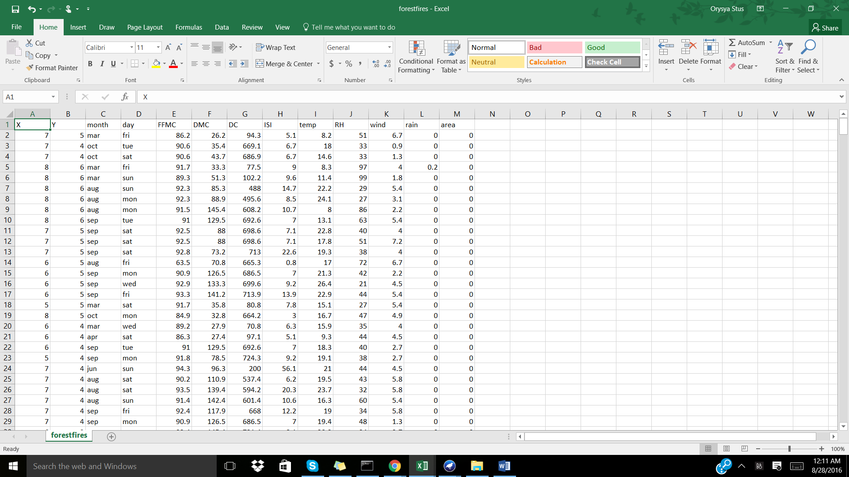

Pre-processing outside of Weka:

Using the categorization data (‘low’, ‘high’, etc.) from <http://cwfis.cfs.nrcan.gc.ca/background/summary/fwi> as well as <http://www.malagaweather.com/fwi-txt.htm> new variables were created for FFMC, DMC, DC, and ISI to allow for numeric attribute to become nominal through specified ranges. The variable newArea was created using a natural log transformation of the area variable in order to decrease the skewness of the data. The variable dewpoint was created using the following formula:

Td = T - ((100 - RH)/5). The binary attribute, newrain, was created from the rain attribute for rain > 0 was ‘yes’ and else was ‘no’. The new attributes were included in the dataset and exported as a .csv file called forestfires_editted.csv. Python libraries, numpy and pandas, were used in order to complete this data processing. Please refer to the ipython notebook: DMII_Assignment4_8.27.2016.ipynb to see all of the specific functions created.

Forestfires_editted.csv (including new variables):

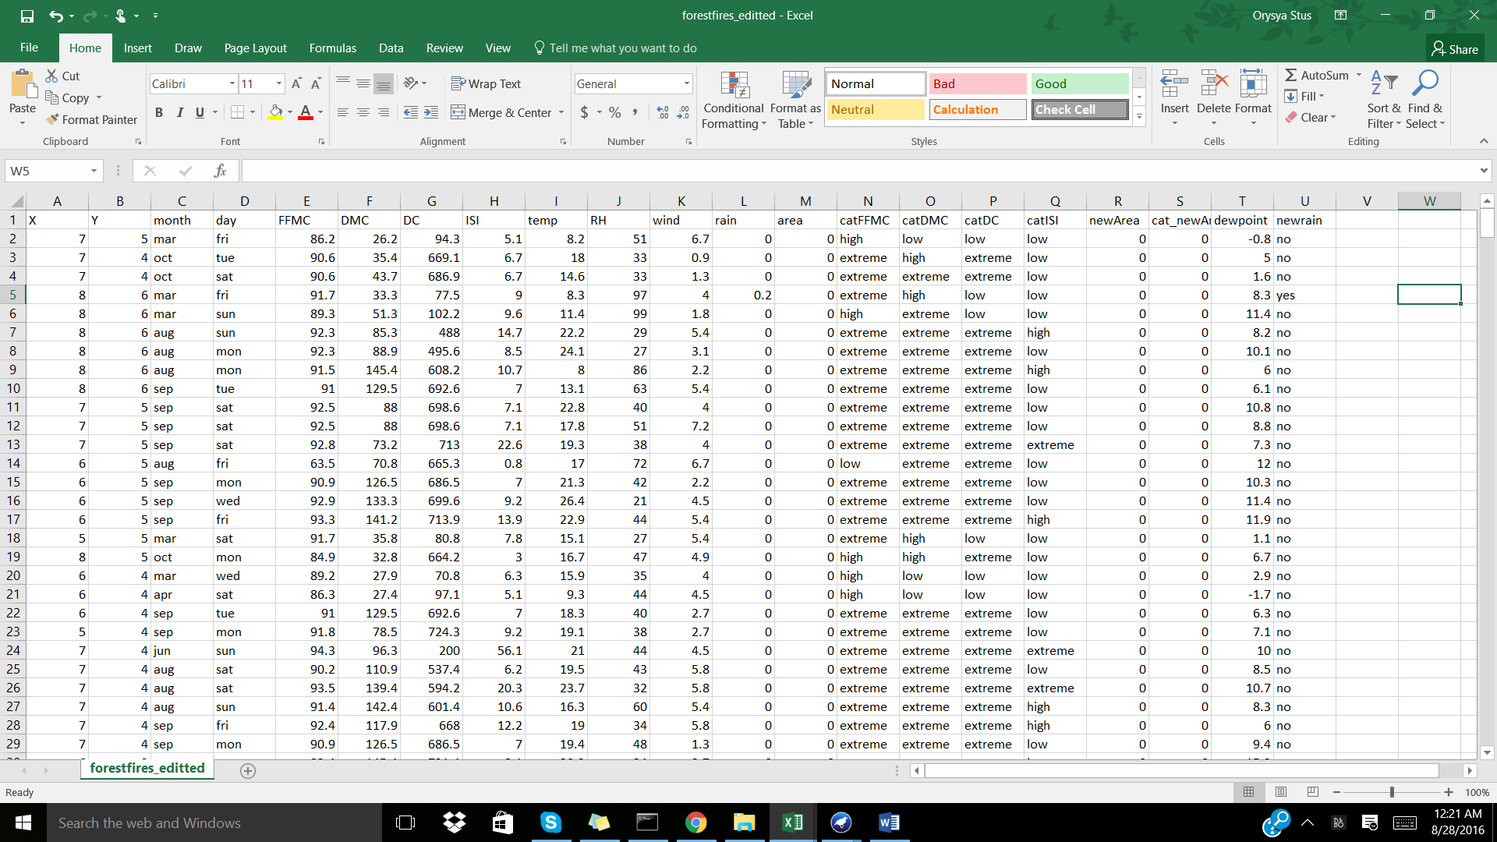

Pre-processing within Weka:

The forestfires_editted.csv file was opened within Weka, in order for the remaining pre-processing steps.

The following variables were removed (due to a duplications of data): FFMC, DMC, DC, ISI, temp, RH, rain, area.

The following variables were discretized using the Discretize -B 10 -M -1.0 -R 1,2,5,10 filter to transform variables X, Y, wind, and dewpoint into nominal values.

The variable cat_newArea was discretized using Discretize -B 10 -M -1.0 -R last filter in order to create a nominal class attribute.

In order to create a more balanced dataset the filter Resample -B 1.0 -S 1 -Z 120.0 was used.

Visualize all shows the instance distribution for all of the instances:

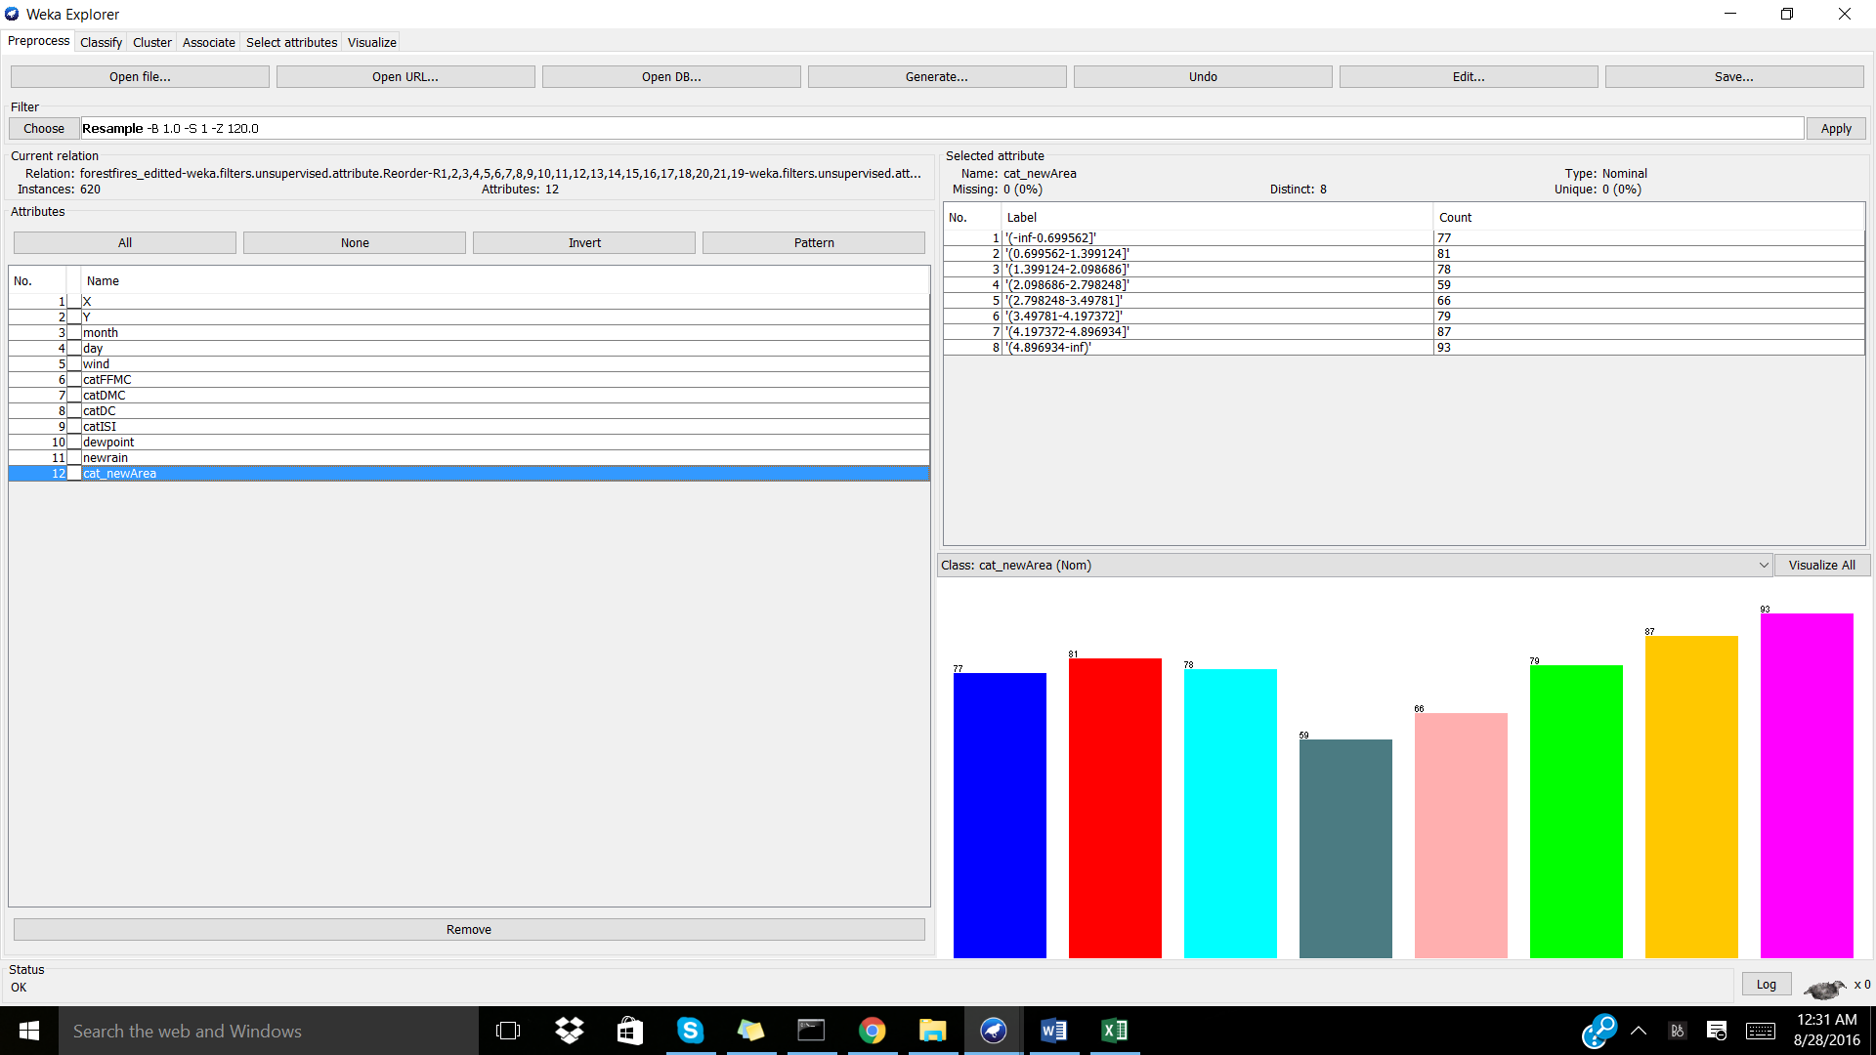

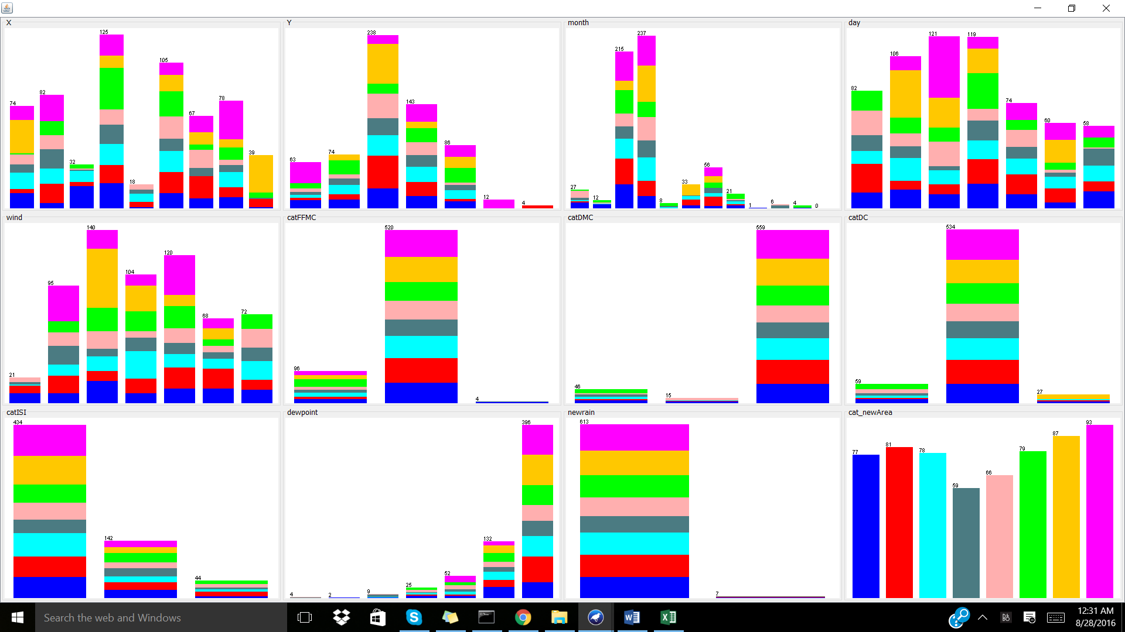

The prepared dataset was saved to the forestfires_resampled_modeled.arff file, for future reference.

Classification:

After testing a variety of user-friendly classifications, it was found that the Id3 tree created the best model with 80.3226% correctly classified instances, a mean absolute error of 0.0353, and the majority of the instances in the main diagonal. Note: 10-fold cross-validation was used.

=== Run information ===

Scheme:weka.classifiers.trees.Id3

Relation: forestfires_editted-weka.filters.unsupervised.attribute.Reorder-R1,2,3,4,5,6,7,8,9,10,11,12,13,14,15,16,17,18,20,21,19-weka.filters.unsupervised.attribute.Remove-R5-10-weka.filters.unsupervised.attribute.Remove-R7-weka.filters.unsupervised.attribute.Remove-R6-weka.filters.unsupervised.attribute.Discretize-O-B10-M-1.0-R5-weka.filters.unsupervised.attribute.NumericToNominal-Rfirst-2-weka.filters.unsupervised.attribute.Discretize-O-B10-M-1.0-Rlast-weka.filters.unsupervised.attribute.Remove-R10-weka.filters.unsupervised.attribute.Discretize-O-B10-M-1.0-R10-weka.filters.supervised.instance.Resample-B1.0-S1-Z120.0

Instances: 620

Attributes: 12

X

Y

month

day

wind

catFFMC

catDMC

catDC

catISI

dewpoint

newrain

cat_newArea

Test mode:10-fold cross-validation

=== Classifier model (full training set) ===

Id3

X = 1

| day = fri

| | Y = 2: '(-inf-0.699562]'

| | Y = 3

| | | wind = '(-inf-1.3]': null

| | | wind = '(1.3-2.2]': '(-inf-0.699562]'

| | | wind = '(2.2-3.1]': null

| | | wind = '(3.1-4]': null

| | | wind = '(4-4.9]': '(3.49781-4.197372]'

| | | wind = '(4.9-5.8]': null

| | | wind = '(5.8-inf)': null

| | Y = 4: '(2.098686-2.798248]'

| | Y = 5: null

| | Y = 6: null

| | Y = 8: null

| | Y = 9: null

| day = tue

| | Y = 2

| | | month = mar: null

| | | month = oct: null

| | | month = aug: '(-inf-0.699562]'

| | | month = sep: '(4.896934-inf)'

| | | month = apr: null

| | | month = jun: null

| | | month = jul: null

| | | month = feb: null

| | | month = jan: null

| | | month = dec: null

| | | month = may: null

| | | month = nov: null

| | Y = 3: null

| | Y = 4: '(-inf-0.699562]'

| | Y = 5: '(2.098686-2.798248]'

| | Y = 6: null

| | Y = 8: null

| | Y = 9: null

| day = sat

| | Y = 2: '(-inf-0.699562]'

| | Y = 3: '(1.399124-2.098686]'

| | Y = 4: '(1.399124-2.098686]'

| | Y = 5: '(0.699562-1.399124]'

| | Y = 6: null

| | Y = 8: null

| | Y = 9: null

| day = sun

| | Y = 2: '(-inf-0.699562]'

| | Y = 3

| | | wind = '(-inf-1.3]': null

| | | wind = '(1.3-2.2]': null

| | | wind = '(2.2-3.1]': null

| | | wind = '(3.1-4]': '(4.197372-4.896934]'

| | | wind = '(4-4.9]': null

| | | wind = '(4.9-5.8]': null

| | | wind = '(5.8-inf)': '(1.399124-2.098686]'

| | Y = 4: '(1.399124-2.098686]'

| | Y = 5: '(4.197372-4.896934]'

| | Y = 6: null

| | Y = 8: null

| | Y = 9: null

| day = mon

| | wind = '(-inf-1.3]': null

| | wind = '(1.3-2.2]': '(2.798248-3.49781]'

| | wind = '(2.2-3.1]': '(0.699562-1.399124]'

| | wind = '(3.1-4]': null

| | wind = '(4-4.9]': null

| | wind = '(4.9-5.8]': null

| | wind = '(5.8-inf)': '(2.798248-3.49781]'

| day = wed

| | Y = 2: '(-inf-0.699562]'

| | Y = 3: null

| | Y = 4: '(4.197372-4.896934]'

| | Y = 5: null

| | Y = 6: null

| | Y = 8: null

| | Y = 9: null

| day = thu

| | month = mar: null

| | month = oct: null

| | month = aug: '(1.399124-2.098686]'

| | month = sep

| | | Y = 2: '(-inf-0.699562]'

| | | Y = 3: null

| | | Y = 4: '(2.098686-2.798248]'

| | | Y = 5: null

| | | Y = 6: null

| | | Y = 8: null

| | | Y = 9: null

| | month = apr: null

| | month = jun: null

| | month = jul: null

| | month = feb: null

| | month = jan: null

| | month = dec: null

| | month = may: null

| | month = nov: null

X = 2

| day = fri

| | Y = 2: '(3.49781-4.197372]'

| | Y = 3: null

| | Y = 4: '(1.399124-2.098686]'

| | Y = 5: '(2.098686-2.798248]'

| | Y = 6: null

| | Y = 8: null

| | Y = 9: null

| day = tue

| | wind = '(-inf-1.3]': null

| | wind = '(1.3-2.2]': null

| | wind = '(2.2-3.1]': '(1.399124-2.098686]'

| | wind = '(3.1-4]': '(1.399124-2.098686]'

| | wind = '(4-4.9]': '(2.098686-2.798248]'

| | wind = '(4.9-5.8]': null

| | wind = '(5.8-inf)': '(0.699562-1.399124]'

| day = sat

| | wind = '(-inf-1.3]': '(1.399124-2.098686]'

| | wind = '(1.3-2.2]': '(4.896934-inf)'

| | wind = '(2.2-3.1]': null

| | wind = '(3.1-4]': null

| | wind = '(4-4.9]': null

| | wind = '(4.9-5.8]': null

| | wind = '(5.8-inf)': '(2.798248-3.49781]'

| day = sun

| | wind = '(-inf-1.3]': null

| | wind = '(1.3-2.2]': '(2.798248-3.49781]'

| | wind = '(2.2-3.1]': '(-inf-0.699562]'

| | wind = '(3.1-4]'

| | | Y = 2: null

| | | Y = 3: null

| | | Y = 4: '(2.098686-2.798248]'

| | | Y = 5

| | | | catISI = low: '(0.699562-1.399124]'

| | | | catISI = high: '(2.798248-3.49781]'

| | | | catISI = extreme: null

| | | Y = 6: null

| | | Y = 8: null

| | | Y = 9: null

| | wind = '(4-4.9]': '(2.098686-2.798248]'

| | wind = '(4.9-5.8]'

| | | catFFMC = high

| | | | Y = 2: '(-inf-0.699562]'

| | | | Y = 3: null

| | | | Y = 4: '(3.49781-4.197372]'

| | | | Y = 5: null

| | | | Y = 6: null

| | | | Y = 8: null

| | | | Y = 9: null

| | | catFFMC = extreme: '(0.699562-1.399124]'

| | | catFFMC = low: null

| | wind = '(5.8-inf)': '(0.699562-1.399124]'

| day = mon

| | wind = '(-inf-1.3]': null

| | wind = '(1.3-2.2]': '(0.699562-1.399124]'

| | wind = '(2.2-3.1]': '(1.399124-2.098686]'

| | wind = '(3.1-4]'

| | | catISI = low: '(2.098686-2.798248]'

| | | catISI = high: '(2.098686-2.798248]'

| | | catISI = extreme: '(0.699562-1.399124]'

| | wind = '(4-4.9]': null

| | wind = '(4.9-5.8]': null

| | wind = '(5.8-inf)': null

| day = wed

| | Y = 2: '(0.699562-1.399124]'

| | Y = 3: null

| | Y = 4: '(0.699562-1.399124]'

| | Y = 5: '(1.399124-2.098686]'

| | Y = 6: null

| | Y = 8: null

| | Y = 9: null

| day = thu

| | wind = '(-inf-1.3]': null

| | wind = '(1.3-2.2]': null

| | wind = '(2.2-3.1]': '(2.098686-2.798248]'

| | wind = '(3.1-4]': '(-inf-0.699562]'

| | wind = '(4-4.9]': '(-inf-0.699562]'

| | wind = '(4.9-5.8]': null

| | wind = '(5.8-inf)': '(1.399124-2.098686]'

X = 3

| wind = '(-inf-1.3]': '(0.699562-1.399124]'

| wind = '(1.3-2.2]'

| | month = mar: null

| | month = oct: null

| | month = aug: '(-inf-0.699562]'

| | month = sep: null

| | month = apr: null

| | month = jun: null

| | month = jul: '(0.699562-1.399124]'

| | month = feb: null

| | month = jan: null

| | month = dec: null

| | month = may: null

| | month = nov: null

| wind = '(2.2-3.1]': '(-inf-0.699562]'

| wind = '(3.1-4]'

| | day = fri: '(3.49781-4.197372]'

| | day = tue: null

| | day = sat: null

| | day = sun: '(1.399124-2.098686]'

| | day = mon: null

| | day = wed: null

| | day = thu: '(1.399124-2.098686]'

| wind = '(4-4.9]': '(-inf-0.699562]'

| wind = '(4.9-5.8]'

| | dewpoint = '(-inf--7.33]': null

| | dewpoint = '(-7.33--4.26]': null

| | dewpoint = '(-4.26--1.19]': null

| | dewpoint = '(-1.19-1.88]': '(1.399124-2.098686]'

| | dewpoint = '(1.88-4.95]': '(-inf-0.699562]'

| | dewpoint = '(4.95-8.02]': '(-inf-0.699562]'

| | dewpoint = '(8.02-inf)'

| | | month = mar: null

| | | month = oct: null

| | | month = aug: '(0.699562-1.399124]'

| | | month = sep

| | | | day = fri: '(-inf-0.699562]'

| | | | day = tue: null

| | | | day = sat: null

| | | | day = sun: '(2.798248-3.49781]'

| | | | day = mon: null

| | | | day = wed: null

| | | | day = thu: null

| | | month = apr: null

| | | month = jun: null

| | | month = jul: null

| | | month = feb: null

| | | month = jan: null

| | | month = dec: null

| | | month = may: null

| | | month = nov: null

| wind = '(5.8-inf)'

| | day = fri: '(1.399124-2.098686]'

| | day = tue

| | | month = mar: '(-inf-0.699562]'

| | | month = oct: null

| | | month = aug: null

| | | month = sep: '(2.098686-2.798248]'

| | | month = apr: null

| | | month = jun: null

| | | month = jul: null

| | | month = feb: null

| | | month = jan: null

| | | month = dec: null

| | | month = may: null

| | | month = nov: null

| | day = sat: '(-inf-0.699562]'

| | day = sun: '(-inf-0.699562]'

| | day = mon: null

| | day = wed: null

| | day = thu: null

X = 4

| day = fri

| | wind = '(-inf-1.3]': '(0.699562-1.399124]'

| | wind = '(1.3-2.2]': null

| | wind = '(2.2-3.1]': null

| | wind = '(3.1-4]'

| | | month = mar: null

| | | month = oct: null

| | | month = aug: null

| | | month = sep: '(1.399124-2.098686]'

| | | month = apr: null

| | | month = jun: null

| | | month = jul: null

| | | month = feb: null

| | | month = jan: null

| | | month = dec: null

| | | month = may: '(3.49781-4.197372]'

| | | month = nov: null

| | wind = '(4-4.9]'

| | | Y = 2: null

| | | Y = 3: null

| | | Y = 4: '(0.699562-1.399124]'

| | | Y = 5: '(-inf-0.699562]'

| | | Y = 6: null

| | | Y = 8: null

| | | Y = 9: null

| | wind = '(4.9-5.8]': null

| | wind = '(5.8-inf)'

| | | Y = 2: null

| | | Y = 3: null

| | | Y = 4: '(2.098686-2.798248]'

| | | Y = 5: '(-inf-0.699562]'

| | | Y = 6: null

| | | Y = 8: null

| | | Y = 9: null

| day = tue

| | wind = '(-inf-1.3]': null

| | wind = '(1.3-2.2]': '(0.699562-1.399124]'

| | wind = '(2.2-3.1]'

| | | month = mar: null

| | | month = oct: null

| | | month = aug: '(1.399124-2.098686]'

| | | month = sep: null

| | | month = apr: null

| | | month = jun: null

| | | month = jul: '(-inf-0.699562]'

| | | month = feb: null

| | | month = jan: null

| | | month = dec: null

| | | month = may: null

| | | month = nov: null

| | wind = '(3.1-4]': null

| | wind = '(4-4.9]': null

| | wind = '(4.9-5.8]'

| | | Y = 2: null

| | | Y = 3: null

| | | Y = 4: '(-inf-0.699562]'

| | | Y = 5: '(0.699562-1.399124]'

| | | Y = 6: null

| | | Y = 8: null

| | | Y = 9: null

| | wind = '(5.8-inf)': '(3.49781-4.197372]'

| day = sat

| | Y = 2: null

| | Y = 3

| | | month = mar: null

| | | month = oct: null

| | | month = aug: '(-inf-0.699562]'

| | | month = sep: '(1.399124-2.098686]'

| | | month = apr: null

| | | month = jun: null

| | | month = jul: null

| | | month = feb: null

| | | month = jan: null

| | | month = dec: null

| | | month = may: null

| | | month = nov: null

| | Y = 4

| | | dewpoint = '(-inf--7.33]': null

| | | dewpoint = '(-7.33--4.26]': null

| | | dewpoint = '(-4.26--1.19]': null

| | | dewpoint = '(-1.19-1.88]': null

| | | dewpoint = '(1.88-4.95]': '(2.798248-3.49781]'

| | | dewpoint = '(4.95-8.02]': '(2.098686-2.798248]'

| | | dewpoint = '(8.02-inf)': '(-inf-0.699562]'

| | Y = 5: '(4.896934-inf)'

| | Y = 6: '(-inf-0.699562]'

| | Y = 8: null

| | Y = 9: null

| day = sun

| | wind = '(-inf-1.3]'

| | | catFFMC = high: '(-inf-0.699562]'

| | | catFFMC = extreme: '(2.798248-3.49781]'

| | | catFFMC = low: '(-inf-0.699562]'

| | wind = '(1.3-2.2]': '(3.49781-4.197372]'

| | wind = '(2.2-3.1]'

| | | Y = 2: null

| | | Y = 3: '(-inf-0.699562]'

| | | Y = 4: null

| | | Y = 5: '(-inf-0.699562]'

| | | Y = 6: '(3.49781-4.197372]'

| | | Y = 8: null

| | | Y = 9: null

| | wind = '(3.1-4]': '(2.098686-2.798248]'

| | wind = '(4-4.9]'

| | | Y = 2: null

| | | Y = 3: '(1.399124-2.098686]'

| | | Y = 4: '(3.49781-4.197372]'

| | | Y = 5: null

| | | Y = 6: null

| | | Y = 8: null

| | | Y = 9: null

| | wind = '(4.9-5.8]': null

| | wind = '(5.8-inf)': '(2.098686-2.798248]'

| day = mon

| | Y = 2: null

| | Y = 3: '(3.49781-4.197372]'

| | Y = 4

| | | month = mar: '(-inf-0.699562]'

| | | month = oct: null

| | | month = aug: null

| | | month = sep: null

| | | month = apr: null

| | | month = jun: null

| | | month = jul: null

| | | month = feb: null

| | | month = jan: null

| | | month = dec: '(2.098686-2.798248]'

| | | month = may: null

| | | month = nov: null

| | Y = 5: '(0.699562-1.399124]'

| | Y = 6: null

| | Y = 8: null

| | Y = 9: null

| day = wed

| | wind = '(-inf-1.3]'

| | | Y = 2: null

| | | Y = 3: null

| | | Y = 4: '(-inf-0.699562]'

| | | Y = 5: '(2.798248-3.49781]'

| | | Y = 6: null

| | | Y = 8: null

| | | Y = 9: null

| | wind = '(1.3-2.2]': '(0.699562-1.399124]'

| | wind = '(2.2-3.1]': null

| | wind = '(3.1-4]': null

| | wind = '(4-4.9]'

| | | Y = 2: null

| | | Y = 3: '(3.49781-4.197372]'

| | | Y = 4: '(4.197372-4.896934]'

| | | Y = 5: null

| | | Y = 6: null

| | | Y = 8: null

| | | Y = 9: null

| | wind = '(4.9-5.8]': '(1.399124-2.098686]'

| | wind = '(5.8-inf)': null

| day = thu

| | wind = '(-inf-1.3]'

| | | Y = 2: null

| | | Y = 3: '(0.699562-1.399124]'

| | | Y = 4: '(-inf-0.699562]'

| | | Y = 5: '(2.098686-2.798248]'

| | | Y = 6: null

| | | Y = 8: null

| | | Y = 9: null

| | wind = '(1.3-2.2]'

| | | Y = 2: null

| | | Y = 3: '(-inf-0.699562]'

| | | Y = 4: null

| | | Y = 5: '(2.098686-2.798248]'

| | | Y = 6: null

| | | Y = 8: null

| | | Y = 9: null

| | wind = '(2.2-3.1]'

| | | Y = 2: null

| | | Y = 3: '(2.098686-2.798248]'

| | | Y = 4: null

| | | Y = 5: '(-inf-0.699562]'

| | | Y = 6: null

| | | Y = 8: null

| | | Y = 9: null

| | wind = '(3.1-4]': '(-inf-0.699562]'

| | wind = '(4-4.9]': '(1.399124-2.098686]'

| | wind = '(4.9-5.8]': null

| | wind = '(5.8-inf)': null

X = 5

| day = fri

| | dewpoint = '(-inf--7.33]': null

| | dewpoint = '(-7.33--4.26]': null

| | dewpoint = '(-4.26--1.19]': '(2.798248-3.49781]'

| | dewpoint = '(-1.19-1.88]': null

| | dewpoint = '(1.88-4.95]': null

| | dewpoint = '(4.95-8.02]': '(1.399124-2.098686]'

| | dewpoint = '(8.02-inf)': '(0.699562-1.399124]'

| day = tue: '(2.798248-3.49781]'

| day = sat: null

| day = sun: '(1.399124-2.098686]'

| day = mon: null

| day = wed: '(2.098686-2.798248]'

| day = thu

| | Y = 2: null

| | Y = 3: null

| | Y = 4: '(1.399124-2.098686]'

| | Y = 5: '(-inf-0.699562]'

| | Y = 6: null

| | Y = 8: null

| | Y = 9: null

X = 6

| day = fri

| | wind = '(-inf-1.3]': null

| | wind = '(1.3-2.2]': '(0.699562-1.399124]'

| | wind = '(2.2-3.1]': '(2.798248-3.49781]'

| | wind = '(3.1-4]'

| | | month = mar: '(2.098686-2.798248]'

| | | month = oct: null

| | | month = aug: '(0.699562-1.399124]'

| | | month = sep: '(2.798248-3.49781]'

| | | month = apr: null

| | | month = jun: null

| | | month = jul: null

| | | month = feb: null

| | | month = jan: null

| | | month = dec: null

| | | month = may: null

| | | month = nov: null

| | wind = '(4-4.9]': null

| | wind = '(4.9-5.8]'

| | | month = mar: null

| | | month = oct: null

| | | month = aug: '(-inf-0.699562]'

| | | month = sep: null

| | | month = apr: null

| | | month = jun: '(0.699562-1.399124]'

| | | month = jul: null

| | | month = feb: null

| | | month = jan: null

| | | month = dec: null

| | | month = may: null

| | | month = nov: null

| | wind = '(5.8-inf)': '(2.798248-3.49781]'

| day = tue

| | month = mar: null

| | month = oct: '(-inf-0.699562]'

| | month = aug

| | | wind = '(-inf-1.3]': null

| | | wind = '(1.3-2.2]': null

| | | wind = '(2.2-3.1]': '(3.49781-4.197372]'

| | | wind = '(3.1-4]': '(-inf-0.699562]'

| | | wind = '(4-4.9]': null

| | | wind = '(4.9-5.8]': null

| | | wind = '(5.8-inf)': null

| | month = sep

| | | Y = 2: null

| | | Y = 3: null

| | | Y = 4: '(4.197372-4.896934]'

| | | Y = 5: '(2.798248-3.49781]'

| | | Y = 6: null

| | | Y = 8: null

| | | Y = 9: null

| | month = apr: null

| | month = jun: null

| | month = jul: '(1.399124-2.098686]'

| | month = feb

| | | Y = 2: null

| | | Y = 3: null

| | | Y = 4: '(0.699562-1.399124]'

| | | Y = 5: '(1.399124-2.098686]'

| | | Y = 6: null

| | | Y = 8: null

| | | Y = 9: null

| | month = jan: null

| | month = dec: '(2.798248-3.49781]'

| | month = may: null

| | month = nov: null

| day = sat

| | wind = '(-inf-1.3]': null

| | wind = '(1.3-2.2]': null

| | wind = '(2.2-3.1]': null

| | wind = '(3.1-4]': '(4.896934-inf)'

| | wind = '(4-4.9]'

| | | dewpoint = '(-inf--7.33]': null

| | | dewpoint = '(-7.33--4.26]': null

| | | dewpoint = '(-4.26--1.19]': null

| | | dewpoint = '(-1.19-1.88]': null

| | | dewpoint = '(1.88-4.95]': null

| | | dewpoint = '(4.95-8.02]': '(3.49781-4.197372]'

| | | dewpoint = '(8.02-inf)'

| | | | month = mar: null

| | | | month = oct: null

| | | | month = aug: null

| | | | month = sep: '(1.399124-2.098686]'

| | | | month = apr: null

| | | | month = jun: null

| | | | month = jul: null

| | | | month = feb: null

| | | | month = jan: null

| | | | month = dec: null

| | | | month = may: '(-inf-0.699562]'

| | | | month = nov: null

| | wind = '(4.9-5.8]': null

| | wind = '(5.8-inf)': null

| day = sun

| | month = mar: null

| | month = oct: null

| | month = aug: null

| | month = sep: '(2.098686-2.798248]'

| | month = apr: '(3.49781-4.197372]'

| | month = jun: null

| | month = jul: null

| | month = feb: '(-inf-0.699562]'

| | month = jan: null

| | month = dec: null

| | month = may: null

| | month = nov: null

| day = mon

| | dewpoint = '(-inf--7.33]': null

| | dewpoint = '(-7.33--4.26]': null

| | dewpoint = '(-4.26--1.19]': null

| | dewpoint = '(-1.19-1.88]'

| | | wind = '(-inf-1.3]': null

| | | wind = '(1.3-2.2]': '(-inf-0.699562]'

| | | wind = '(2.2-3.1]': '(2.798248-3.49781]'

| | | wind = '(3.1-4]': null

| | | wind = '(4-4.9]': null

| | | wind = '(4.9-5.8]': '(1.399124-2.098686]'

| | | wind = '(5.8-inf)': null

| | dewpoint = '(1.88-4.95]': '(1.399124-2.098686]'

| | dewpoint = '(4.95-8.02]'

| | | wind = '(-inf-1.3]': null

| | | wind = '(1.3-2.2]': null

| | | wind = '(2.2-3.1]': null

| | | wind = '(3.1-4]': null

| | | wind = '(4-4.9]'

| | | | Y = 2: null

| | | | Y = 3: '(1.399124-2.098686]'

| | | | Y = 4: null

| | | | Y = 5: '(-inf-0.699562]'

| | | | Y = 6: null

| | | | Y = 8: null

| | | | Y = 9: null

| | | wind = '(4.9-5.8]': '(1.399124-2.098686]'

| | | wind = '(5.8-inf)': null

| | dewpoint = '(8.02-inf)'

| | | wind = '(-inf-1.3]': null

| | | wind = '(1.3-2.2]': '(3.49781-4.197372]'

| | | wind = '(2.2-3.1]': '(-inf-0.699562]'

| | | wind = '(3.1-4]': null

| | | wind = '(4-4.9]': null

| | | wind = '(4.9-5.8]': null

| | | wind = '(5.8-inf)': null

| day = wed: '(0.699562-1.399124]'

| day = thu

| | wind = '(-inf-1.3]': null

| | wind = '(1.3-2.2]': null

| | wind = '(2.2-3.1]': '(2.098686-2.798248]'

| | wind = '(3.1-4]'

| | | Y = 2: null

| | | Y = 3: null

| | | Y = 4: '(0.699562-1.399124]'

| | | Y = 5: '(-inf-0.699562]'

| | | Y = 6: null

| | | Y = 8: null

| | | Y = 9: null

| | wind = '(4-4.9]': '(0.699562-1.399124]'

| | wind = '(4.9-5.8]': '(2.098686-2.798248]'

| | wind = '(5.8-inf)': '(3.49781-4.197372]'

X = 7

| month = mar

| | wind = '(-inf-1.3]': null

| | wind = '(1.3-2.2]': null

| | wind = '(2.2-3.1]': '(0.699562-1.399124]'

| | wind = '(3.1-4]': '(2.098686-2.798248]'

| | wind = '(4-4.9]': null

| | wind = '(4.9-5.8]': '(2.798248-3.49781]'

| | wind = '(5.8-inf)': null

| month = oct

| | Y = 2: null

| | Y = 3: null

| | Y = 4: '(-inf-0.699562]'

| | Y = 5: '(3.49781-4.197372]'

| | Y = 6: null

| | Y = 8: null

| | Y = 9: null

| month = aug

| | wind = '(-inf-1.3]': '(0.699562-1.399124]'

| | wind = '(1.3-2.2]': '(0.699562-1.399124]'

| | wind = '(2.2-3.1]'

| | | day = fri: '(-inf-0.699562]'

| | | day = tue: null

| | | day = sat: null

| | | day = sun: null

| | | day = mon: null

| | | day = wed: null

| | | day = thu: '(0.699562-1.399124]'

| | wind = '(3.1-4]': '(-inf-0.699562]'

| | wind = '(4-4.9]': '(2.098686-2.798248]'

| | wind = '(4.9-5.8]'

| | | day = fri: null

| | | day = tue: null

| | | day = sat: '(2.798248-3.49781]'

| | | day = sun: '(0.699562-1.399124]'

| | | day = mon: null

| | | day = wed: null

| | | day = thu: null

| | wind = '(5.8-inf)'

| | | day = fri: null

| | | day = tue: null

| | | day = sat: '(0.699562-1.399124]'

| | | day = sun: '(-inf-0.699562]'

| | | day = mon: null

| | | day = wed: null

| | | day = thu: null

| month = sep

| | wind = '(-inf-1.3]': '(-inf-0.699562]'

| | wind = '(1.3-2.2]': '(2.798248-3.49781]'

| | wind = '(2.2-3.1]'

| | | day = fri: '(0.699562-1.399124]'

| | | day = tue: null

| | | day = sat: null

| | | day = sun: '(-inf-0.699562]'

| | | day = mon: null

| | | day = wed: null

| | | day = thu: null

| | wind = '(3.1-4]': null

| | wind = '(4-4.9]'

| | | day = fri: '(2.798248-3.49781]'

| | | day = tue: null

| | | day = sat: '(2.798248-3.49781]'

| | | day = sun: null

| | | day = mon: null

| | | day = wed: '(3.49781-4.197372]'

| | | day = thu: null

| | wind = '(4.9-5.8]': '(0.699562-1.399124]'

| | wind = '(5.8-inf)'

| | | Y = 2: null

| | | Y = 3: null

| | | Y = 4: '(2.098686-2.798248]'

| | | Y = 5: '(-inf-0.699562]'

| | | Y = 6: null

| | | Y = 8: null

| | | Y = 9: null

| month = apr: null

| month = jun: null

| month = jul

| | day = fri: null

| | day = tue: '(4.197372-4.896934]'

| | day = sat: null

| | day = sun: '(0.699562-1.399124]'

| | day = mon: '(4.896934-inf)'

| | day = wed: null

| | day = thu: null

| month = feb: '(2.098686-2.798248]'

| month = jan: null

| month = dec: null

| month = may: null

| month = nov: null

X = 8

| day = fri

| | month = mar: null

| | month = oct: null

| | month = aug: '(1.399124-2.098686]'

| | month = sep: '(2.798248-3.49781]'

| | month = apr: null

| | month = jun: null

| | month = jul: null

| | month = feb: null

| | month = jan: null

| | month = dec: null

| | month = may: null

| | month = nov: null

| day = tue

| | month = mar: null

| | month = oct: null

| | month = aug: '(-inf-0.699562]'

| | month = sep: '(-inf-0.699562]'

| | month = apr: null

| | month = jun: null

| | month = jul: '(1.399124-2.098686]'

| | month = feb: null

| | month = jan: null

| | month = dec: null

| | month = may: null

| | month = nov: null

| day = sat

| | wind = '(-inf-1.3]': null

| | wind = '(1.3-2.2]': null

| | wind = '(2.2-3.1]': '(-inf-0.699562]'

| | wind = '(3.1-4]'

| | | catISI = low: '(1.399124-2.098686]'

| | | catISI = high: '(4.197372-4.896934]'

| | | catISI = extreme: null

| | wind = '(4-4.9]'

| | | catISI = low: '(1.399124-2.098686]'

| | | catISI = high: '(3.49781-4.197372]'

| | | catISI = extreme: null

| | wind = '(4.9-5.8]': null

| | wind = '(5.8-inf)': null

| day = sun

| | wind = '(-inf-1.3]': null

| | wind = '(1.3-2.2]': '(0.699562-1.399124]'

| | wind = '(2.2-3.1]': '(3.49781-4.197372]'

| | wind = '(3.1-4]': '(1.399124-2.098686]'

| | wind = '(4-4.9]': null

| | wind = '(4.9-5.8]'

| | | month = mar: '(2.098686-2.798248]'

| | | month = oct: null

| | | month = aug: '(4.896934-inf)'

| | | month = sep: null

| | | month = apr: null

| | | month = jun: null

| | | month = jul: null

| | | month = feb: null

| | | month = jan: null

| | | month = dec: null

| | | month = may: null

| | | month = nov: null

| | wind = '(5.8-inf)': null

| day = mon

| | month = mar: null

| | month = oct

| | | Y = 2: null

| | | Y = 3: null

| | | Y = 4: null

| | | Y = 5: '(-inf-0.699562]'

| | | Y = 6: '(1.399124-2.098686]'

| | | Y = 8: null

| | | Y = 9: null

| | month = aug: '(0.699562-1.399124]'

| | month = sep

| | | dewpoint = '(-inf--7.33]': null

| | | dewpoint = '(-7.33--4.26]': null

| | | dewpoint = '(-4.26--1.19]': null

| | | dewpoint = '(-1.19-1.88]': null

| | | dewpoint = '(1.88-4.95]': null

| | | dewpoint = '(4.95-8.02]'

| | | | wind = '(-inf-1.3]': null

| | | | wind = '(1.3-2.2]': '(-inf-0.699562]'

| | | | wind = '(2.2-3.1]': null

| | | | wind = '(3.1-4]': null

| | | | wind = '(4-4.9]': '(0.699562-1.399124]'

| | | | wind = '(4.9-5.8]': null

| | | | wind = '(5.8-inf)': null

| | | dewpoint = '(8.02-inf)': '(2.098686-2.798248]'

| | month = apr: null

| | month = jun: '(0.699562-1.399124]'

| | month = jul: null

| | month = feb: null

| | month = jan: null

| | month = dec: null

| | month = may: null

| | month = nov: null

| day = wed

| | Y = 2: null

| | Y = 3: null

| | Y = 4: null

| | Y = 5: null

| | Y = 6: '(1.399124-2.098686]'

| | Y = 8: '(4.896934-inf)'

| | Y = 9: null

| day = thu

| | month = mar: null

| | month = oct: null

| | month = aug

| | | wind = '(-inf-1.3]': null

| | | wind = '(1.3-2.2]': null

| | | wind = '(2.2-3.1]': null

| | | wind = '(3.1-4]': null

| | | wind = '(4-4.9]': '(4.896934-inf)'

| | | wind = '(4.9-5.8]': null

| | | wind = '(5.8-inf)': '(-inf-0.699562]'

| | month = sep

| | | Y = 2: null

| | | Y = 3: '(2.798248-3.49781]'

| | | Y = 4: null

| | | Y = 5: null

| | | Y = 6: '(0.699562-1.399124]'

| | | Y = 8: null

| | | Y = 9: null

| | month = apr: null

| | month = jun: null

| | month = jul: null

| | month = feb: null

| | month = jan: null

| | month = dec: null

| | month = may: null

| | month = nov: null

X = 9

| day = fri: null

| day = tue: '(4.197372-4.896934]'

| day = sat

| | month = mar: null

| | month = oct: null

| | month = aug: null

| | month = sep: null

| | month = apr: null

| | month = jun: '(4.197372-4.896934]'

| | month = jul: '(2.098686-2.798248]'

| | month = feb: null

| | month = jan: null

| | month = dec: null

| | month = may: null

| | month = nov: null

| day = sun: '(0.699562-1.399124]'

| day = mon: '(0.699562-1.399124]'

| day = wed: '(-inf-0.699562]'

| day = thu

| | Y = 2: null

| | Y = 3: null

| | Y = 4: null

| | Y = 5: null

| | Y = 6: '(3.49781-4.197372]'

| | Y = 8: null

| | Y = 9: '(0.699562-1.399124]'

Time taken to build model: 0.03 seconds

=== Stratified cross-validation ===

=== Summary ===

Correctly Classified Instances 498 80.3226 %

Incorrectly Classified Instances 81 13.0645 %

Kappa statistic 0.8392

Mean absolute error 0.0353

Root mean squared error 0.1854

Relative absolute error 17.3339 %

Root relative squared error 58.089 %

UnClassified Instances 41 6.6129 %

Total Number of Instances 620

=== Detailed Accuracy By Class ===

TP Rate FP Rate Precision Recall F-Measure ROC Area Class

0.397 0.025 0.639 0.397 0.489 0.632 '(-inf-0.699562]'

0.808 0.026 0.819 0.808 0.814 0.852 '(0.699562-1.399124]'

0.853 0.031 0.784 0.853 0.817 0.858 '(1.399124-2.098686]'

0.745 0.023 0.774 0.745 0.759 0.836 '(2.098686-2.798248]'

0.909 0.021 0.845 0.909 0.876 0.959 '(2.798248-3.49781]'

0.975 0.016 0.906 0.975 0.939 0.981 '(3.49781-4.197372]'

1 0.006 0.967 1 0.983 0.997 '(4.197372-4.896934]'

1 0.01 0.949 1 0.974 0.996 '(4.896934-inf)'

Weighted Avg. 0.86 0.019 0.85 0.86 0.852 0.904

=== Confusion Matrix ===

a b c d e f g h <-- classified as

23 8 11 7 2 4 1 2 | a = '(-inf-0.699562]'

4 59 1 4 3 1 0 1 | b = '(0.699562-1.399124]'

2 2 58 0 3 2 1 0 | c = '(1.399124-2.098686]'

5 2 2 41 2 1 1 1 | d = '(2.098686-2.798248]'

1 1 2 1 60 0 0 1 | e = '(2.798248-3.49781]'

1 0 0 0 1 77 0 0 | f = '(3.49781-4.197372]'

0 0 0 0 0 0 87 0 | g = '(4.197372-4.896934]'

0 0 0 0 0 0 0 93 | h = '(4.896934-inf)'