**Regular SAS Software vs SAS Enterprise Guide**

If you are using the regular SAS software (any version) for this course, there is no need to read these notes because you can test all the code and complete all the assignments for this course without any technical issues. However, if you don’t have regular SAS software, you need to read this document and test the code below.

Since you don’t have regular SAS software, you will need to register for SAS® OnDemand for Academics and then access SAS Enterprise Guide for Academics by following the instruction below:

1. please register for SAS OnDemand for Academics first. To register, visit the following site: <https://odamid.oda.sas.com/SASODARegistration/>
2. After you have registered, please click the following course enrollment link to enroll in my course:  
   <https://odamid.oda.sas.com/SASODAControlCenter/enroll.html?enroll=2d685a80-7598-4275-9d3b-93aa94bcffa5>
3. A step-by-step registration instruction can be found in EnterpriseGuideStudent.pdf file (in the syllabus folder)

You might have downloaded the SAS Enterprise Guide (EG) when you took the last SAS course. However, **you probably still need to register for this class; otherwise, you might not be able to access the file.** To run the EG software, you need to reside in North America and have internet access. We have heard that some people have experienced difficulties running the EG when they travel outside North America.

Almost all the SAS codes in this course can be executed correctly by using the EG, with a few exceptions. For example, the biggest drawback in using the EG software is that you won’t be able to save the permanent SAS data file on your local computer by using the LIBNAME statement. However, you can access the SAS data sets or text files that I will be providing. These files are located in the following folder, which is our course folder on the SAS server:

“/courses/d93a3ee5ba27fe300/c_8666"

For example, I uploaded a SAS data set named NOISE.SAS7BDAT in our course folder. To copy this file, you need to specify the following LIBNAME statement. The ACCESS=READONLY option prevents you from modifying the data. Please test the following code to make sure it works.

libname saslib '/courses/d93a3ee5ba27fe300/c_8666' access=readonly;

**data** noise1;

set saslib.noise;

**run**;

I also uploaded a text file, HEARING.TXT, in the course folder. You also need to test the following code to ensure that you will be able to read this text file correctly.

**data** hearing;

infile "/courses/d93a3ee5ba27fe300/c_8666/hearing.txt";

input id $ **1**-**4** race $ **6** smoke $ **8**-**14** Age **16**-**17** Preg **19**

Hearing $ **21**-**23** Income **25**-**30**;

**run**;

**How to Save SAS Data Sets on your computer?**

The SAS codes above created two SAS data sets, named NOISE1 and HEARING in your WORK library. These files will be deleted once you close EG. Remember that you won’t be able to save these two files to your computer by using the LIBNAME statement. However, you can save these files on your computer by using the following alternative method:

Click on Tasks 🡪 Data 🡪 Download Data Files to PC…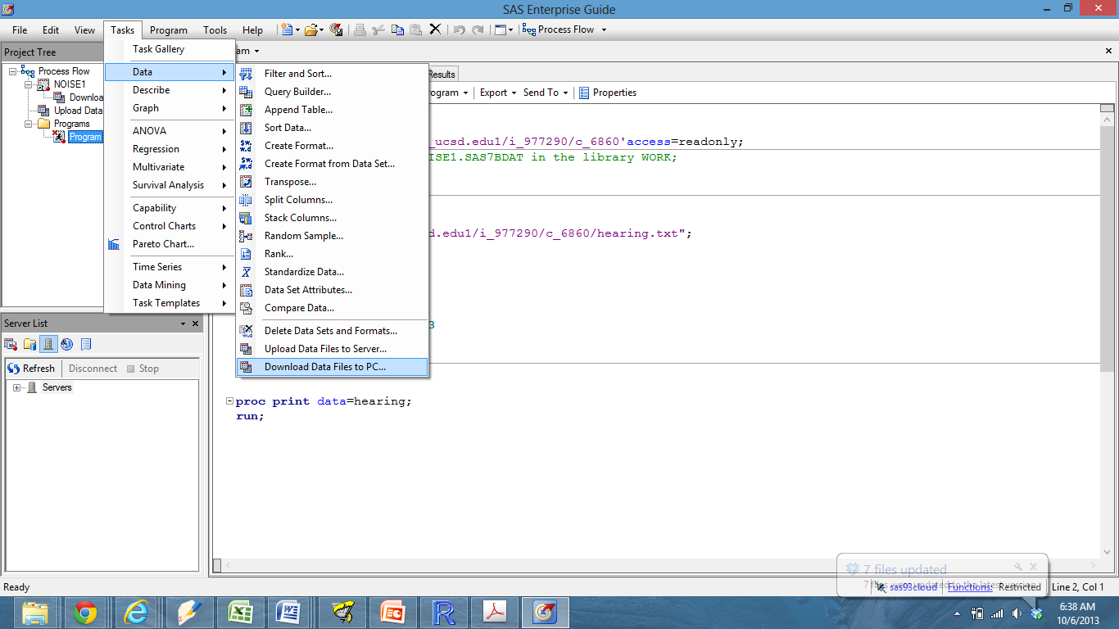

Then it will bring you the following window: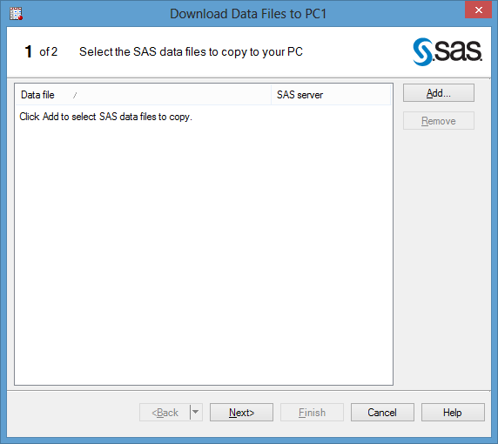

Next, Click on Add…

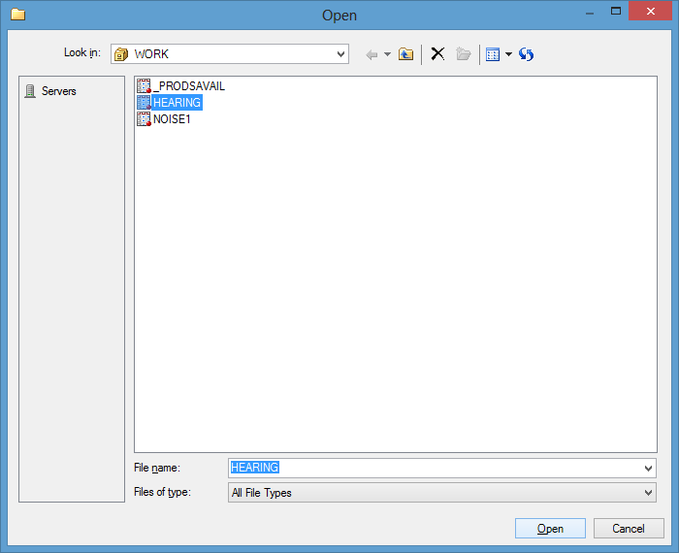

Choose the file that you want to save and click on Open.

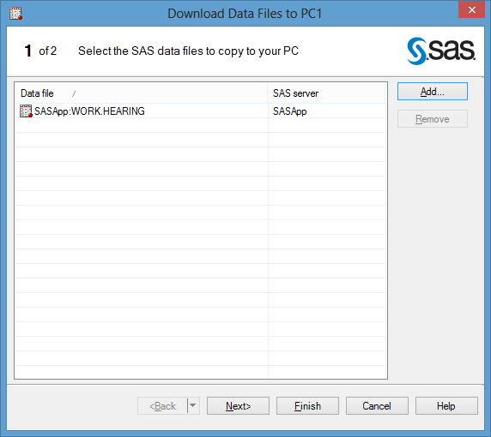

Click on the Next> button

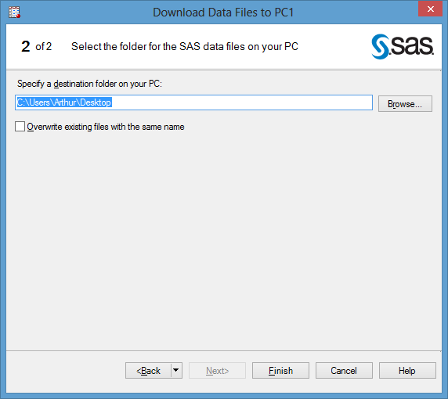

Click on the Browse… button to select the location where you want to save your data. Then click on the Finish button.

**How to Upload a SAS Data Set to the WORK Library?**

Suppose that you would like to upload a SAS data set, “GRADE.SAS7BDAT” to the WORK library.

1. Download “grade.sas7bdat” on your computer.

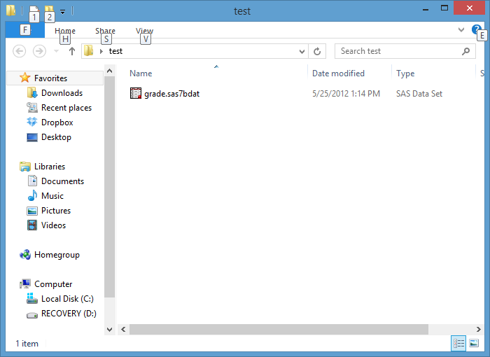

2. Open SAS Enterprise Guide

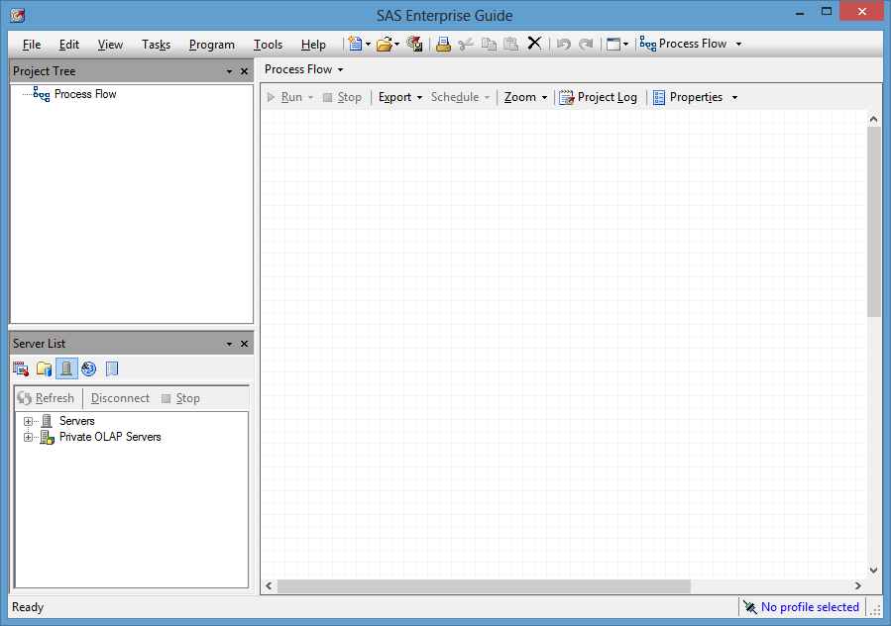

3. Click on Task 🡪Data 🡪 Upload Data Files to Server…

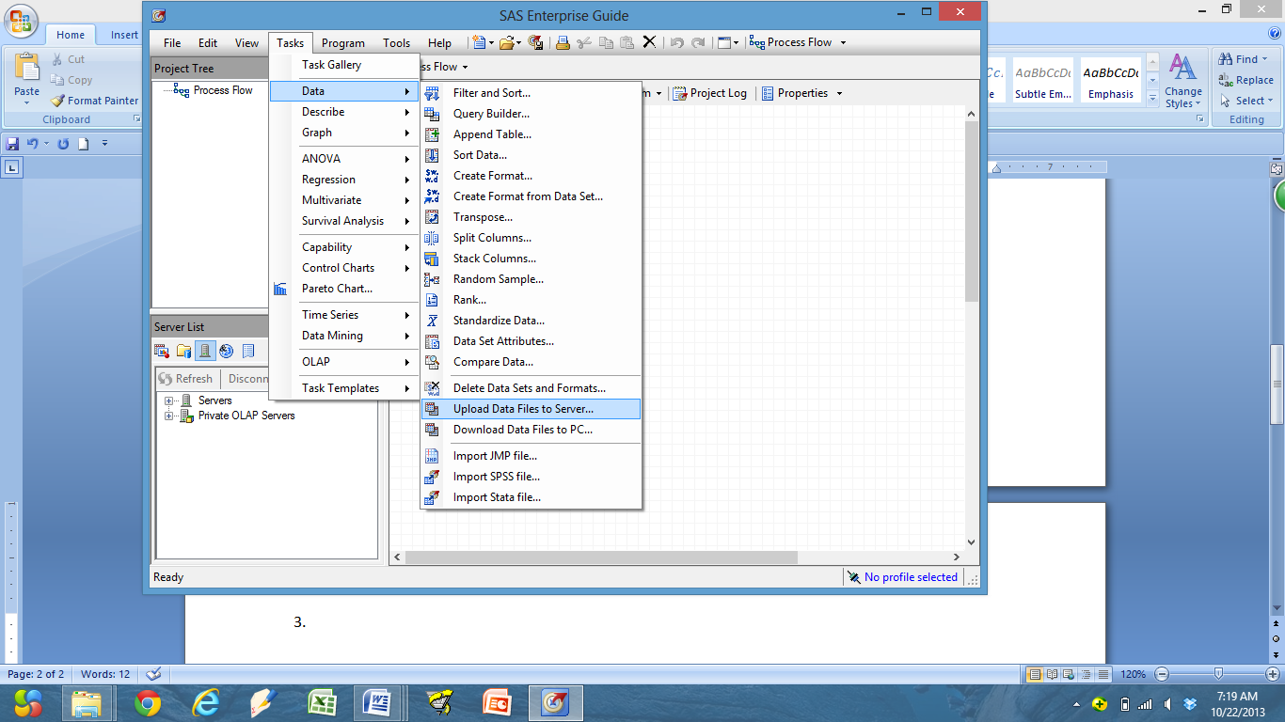

4. Then you will see this window:

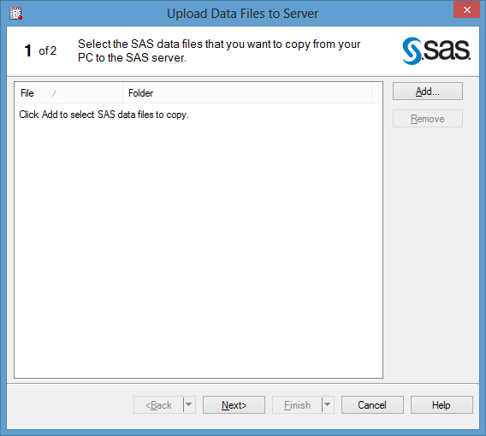

5. Click on “Add…”, then you will see a window that is similar to the one below:

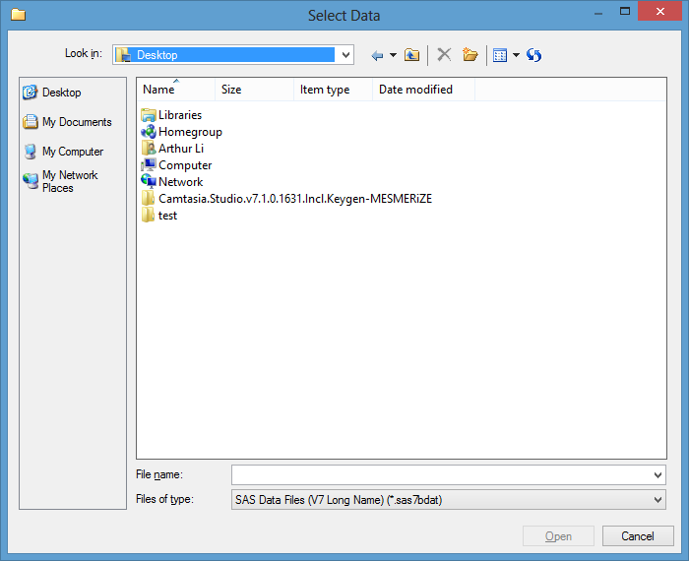

6. Locate the folder where you store “grade.sas7bdat”

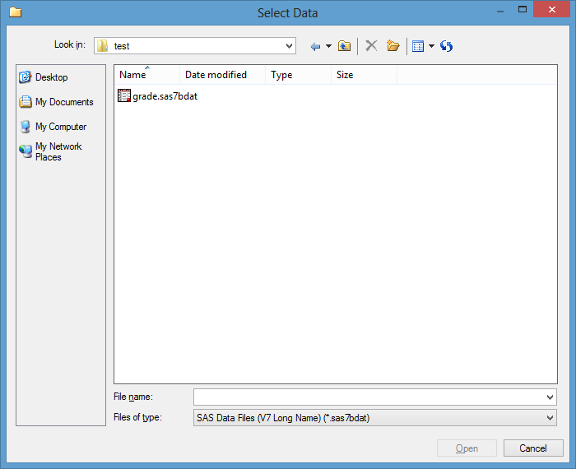

7. Double click “grade.sas7bdat” file. Then you will see the following window:

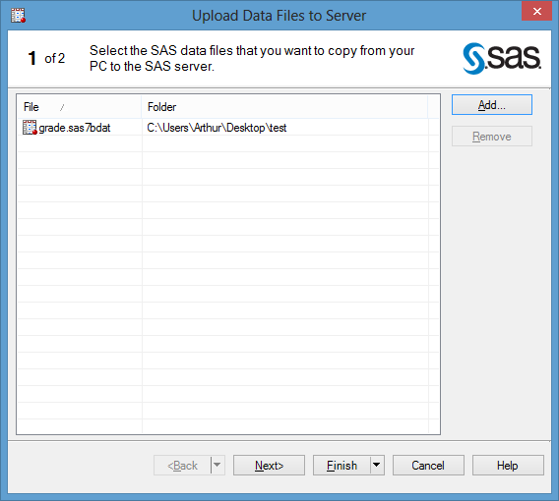

8. Click on the “Finish” button. Then you will see the following window:

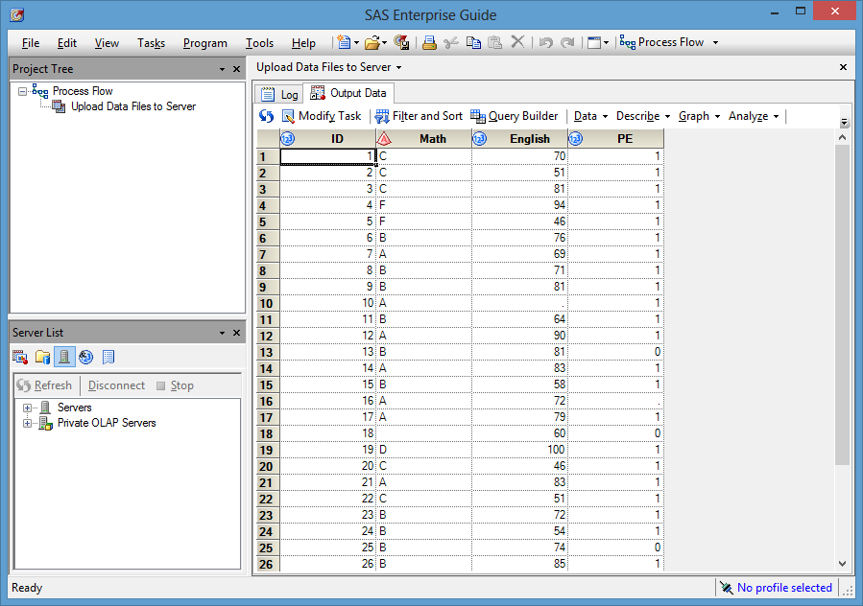

9. Now, the “grade.sas7bdat” file is in your work library.