UC San Diego Extension

Advanced Web Analytics:

Harnessing the Predictive Power

Winter 2016

Homework#4

**Linear Regression**

1.

Via computation:

Via Excel:

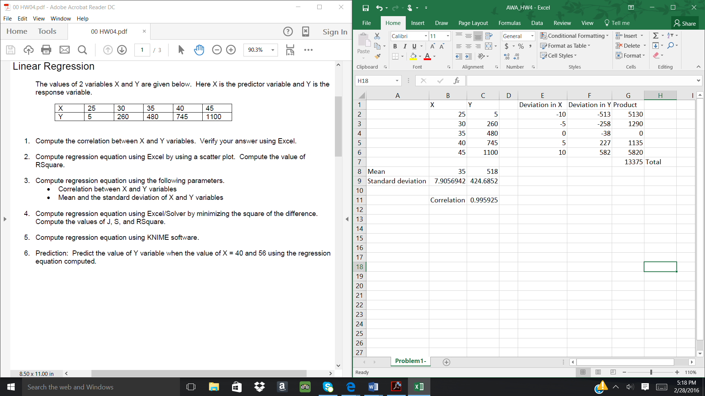

2.

3.

Via computation:

y = bx + a

y = 53.45x -1353.92

4.

Finding regression equation using Excel/Solver:

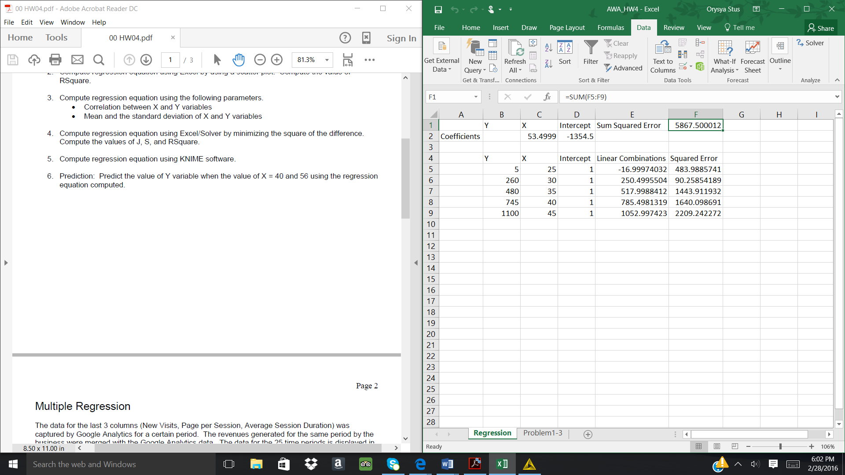

5.

Finding regression equation using KNIME software:

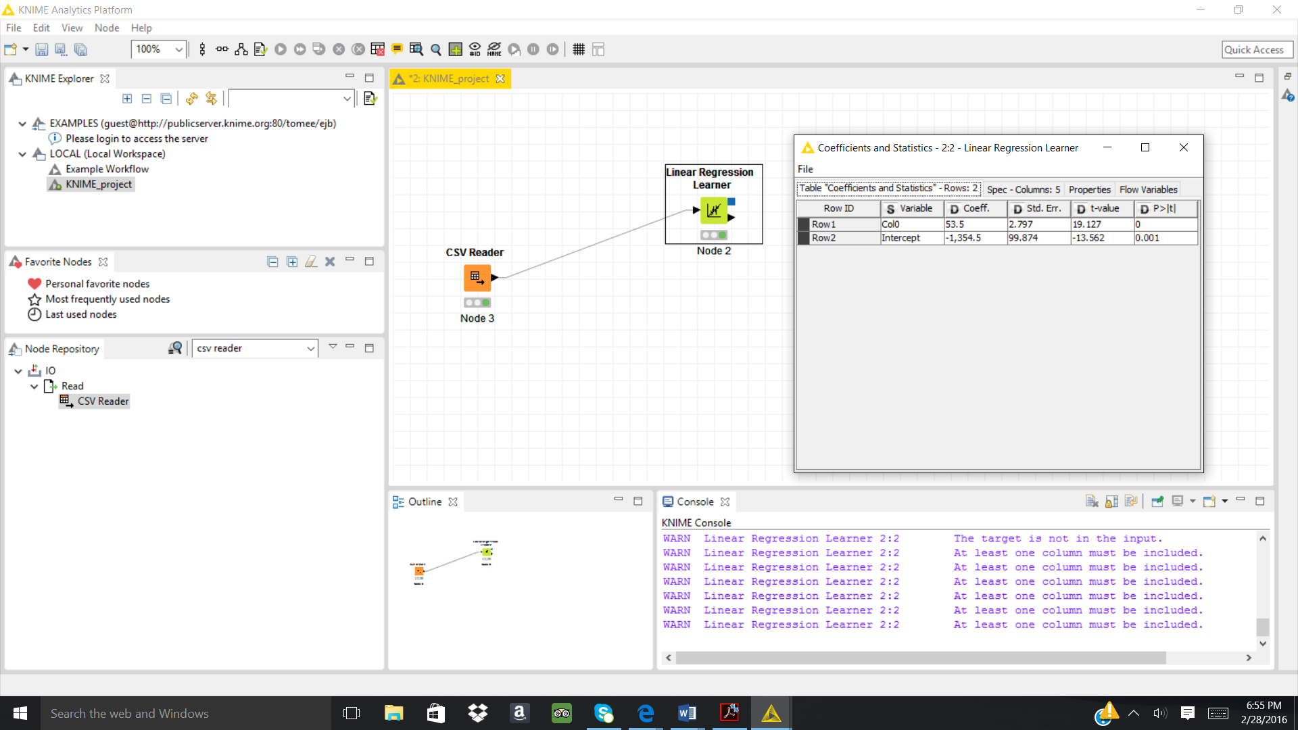

6. Using the equation: y = 53.5x – 1354.5, then plug & chug:

X = 40 y = 785.5

X = 56 y = 1641.5

**Multiple Regression**

7.

Finding regression equation using Excel/Solver:

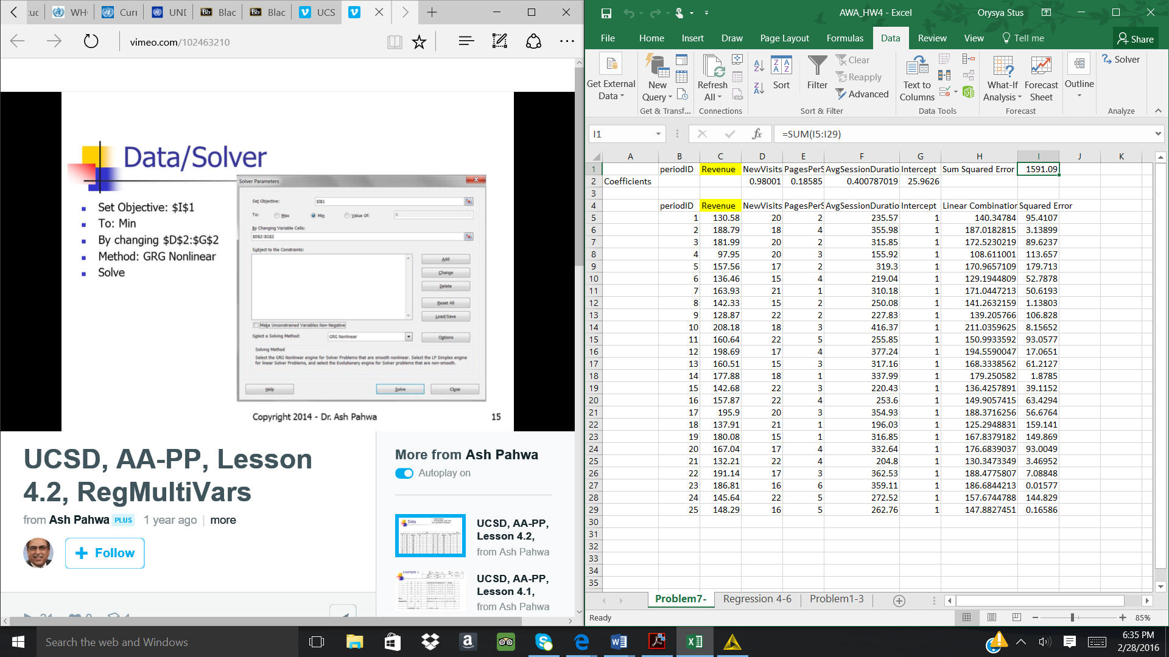

Y = 0.98001*NewVisits + 0.18585*Pages/Session + 0.40078*AvgPageLoadTime +25.9679

RSquare = 0.9083

8.

Finding regression equation using KNIME:

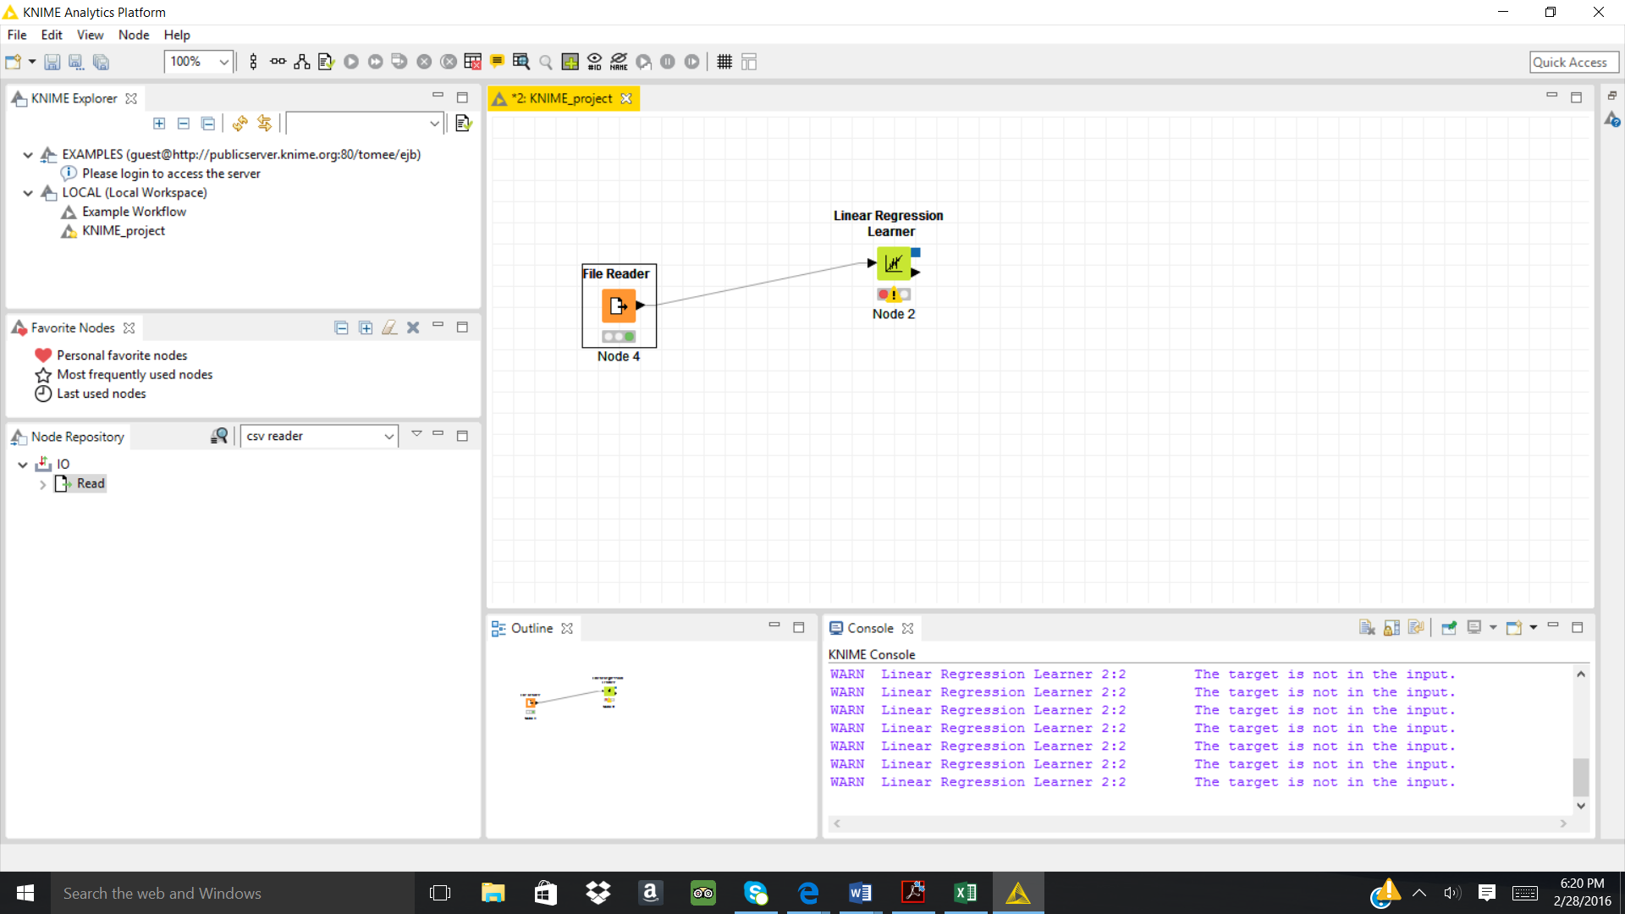

9. Using the equation, then plug & chug:

y = 0.98001*NewVisits + 0.18585*Pages/Session + 0.40078*AvgPageLoadTime +25.9679

New Visits = 32, Page/session = 7, AvgPageDuration = 457 then Revenue:

Revenue = y = 0.98001*(32) + 0.18585*(7) + 0.40078*(457) +25.9679 = $241,788