**UC San Diego Extension**

**Advanced Web Analytics:**

**Harnessing the Predictive Power**

**Winter 2016**

**Homework #5**

1. Probability of getting a 7 as the sum:

Pair of dices each have 6 potential outcomes -> Total outcomes = 6*6 = 36

Combinations to get sum of 7:

1+6, 2+5, 3+4, 4+3, 5+2, 6+1 -> 6 total outcomes

Therefore, probability of getting a 7 as the sum = 6/36 or 1/6

Odds of favor of getting a 7 as the sum:

2.

The eTerm was calculated and dragged down from E2:E21.

 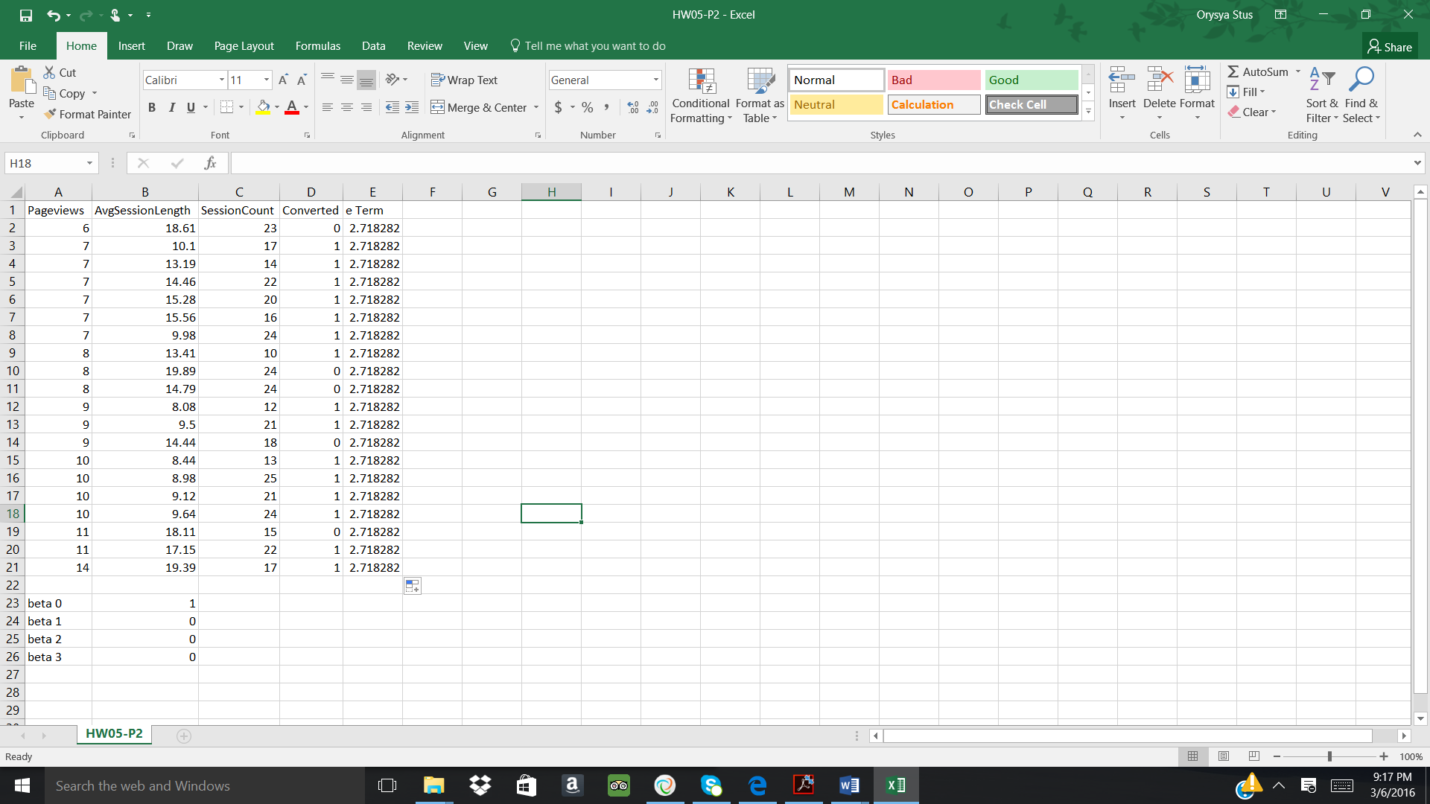

The probability was calculated and dragged down from F2:F21.

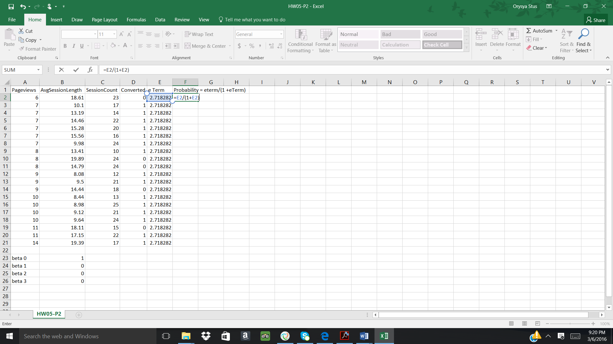 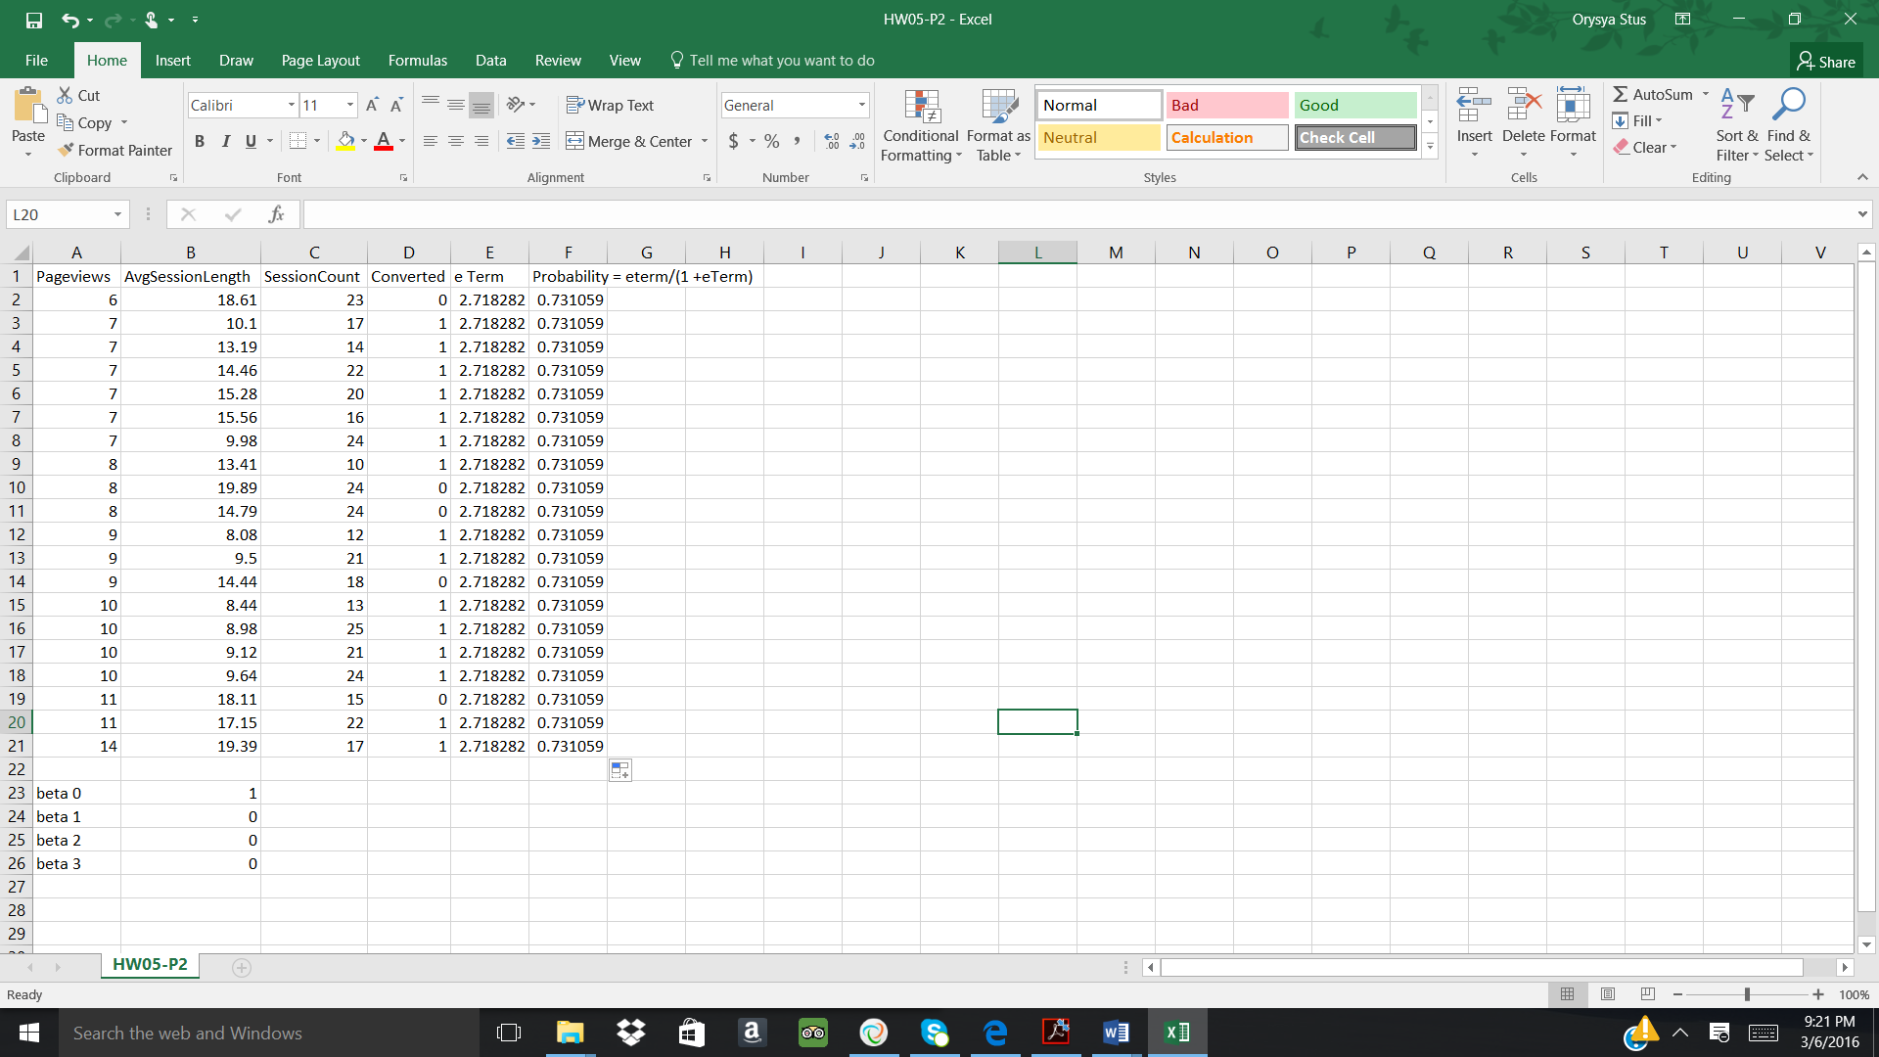

The likelihood term was calculated and dragged down from G2:G21.

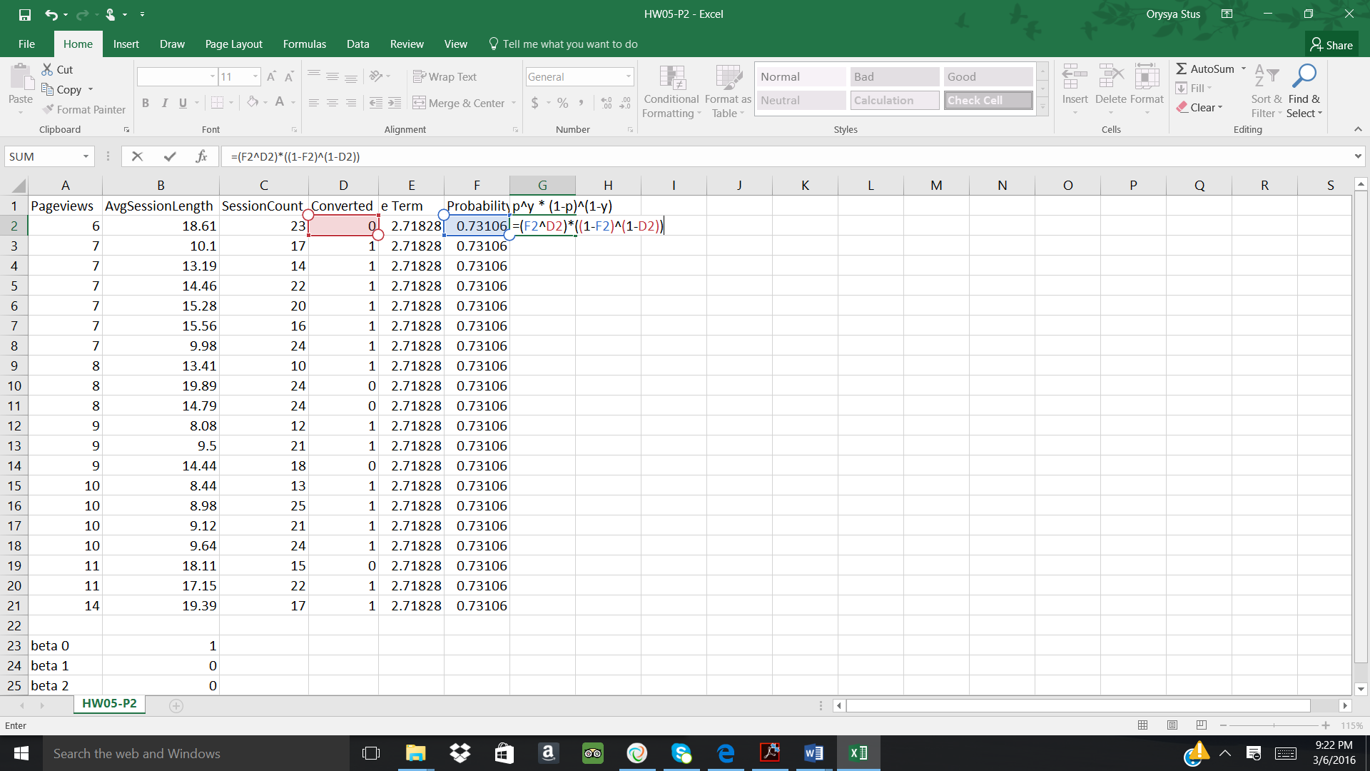 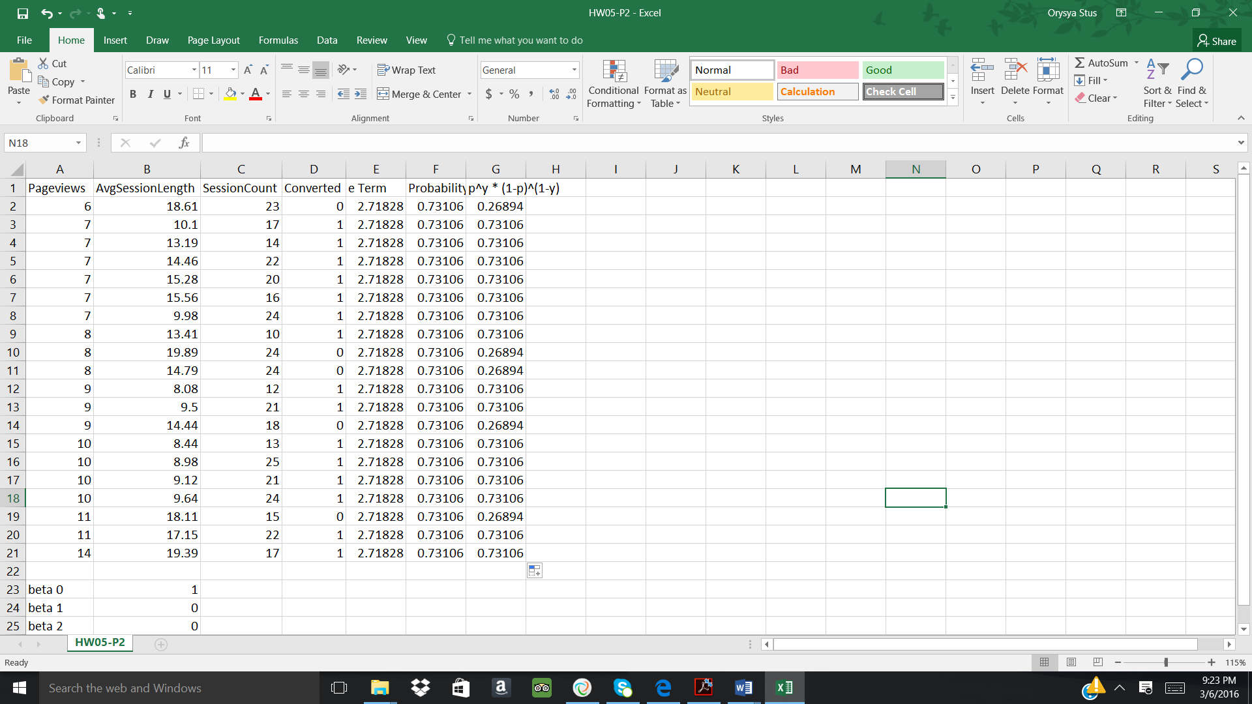

The product of the probabilities was computed in G23.

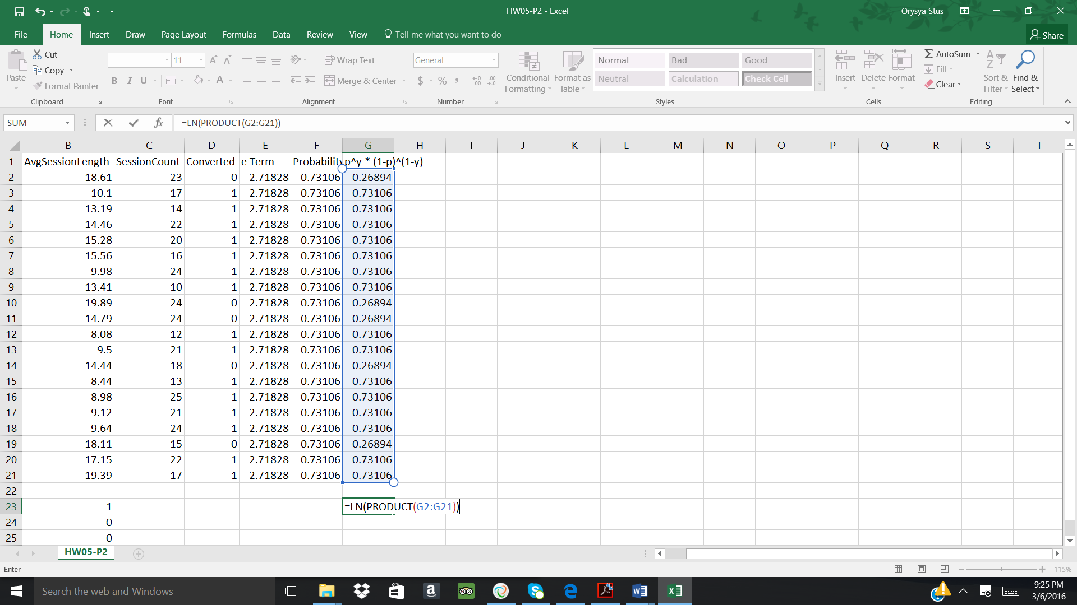 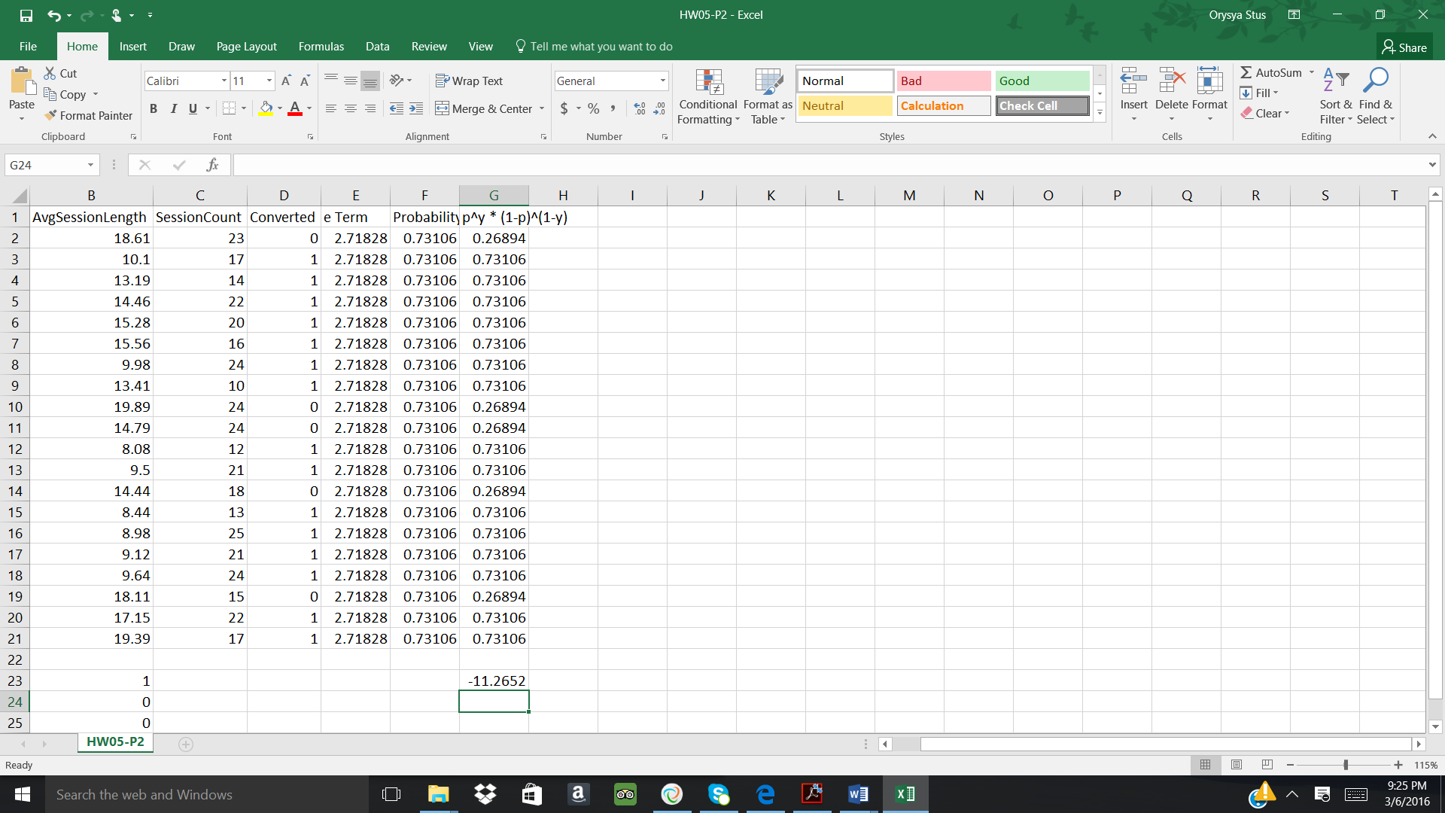

Using Solver, the following parameters were set in order to determine the beta values.

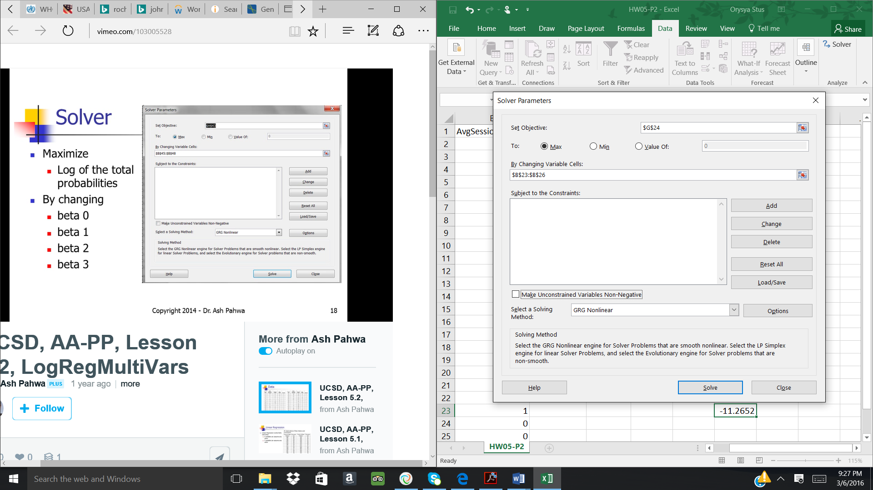 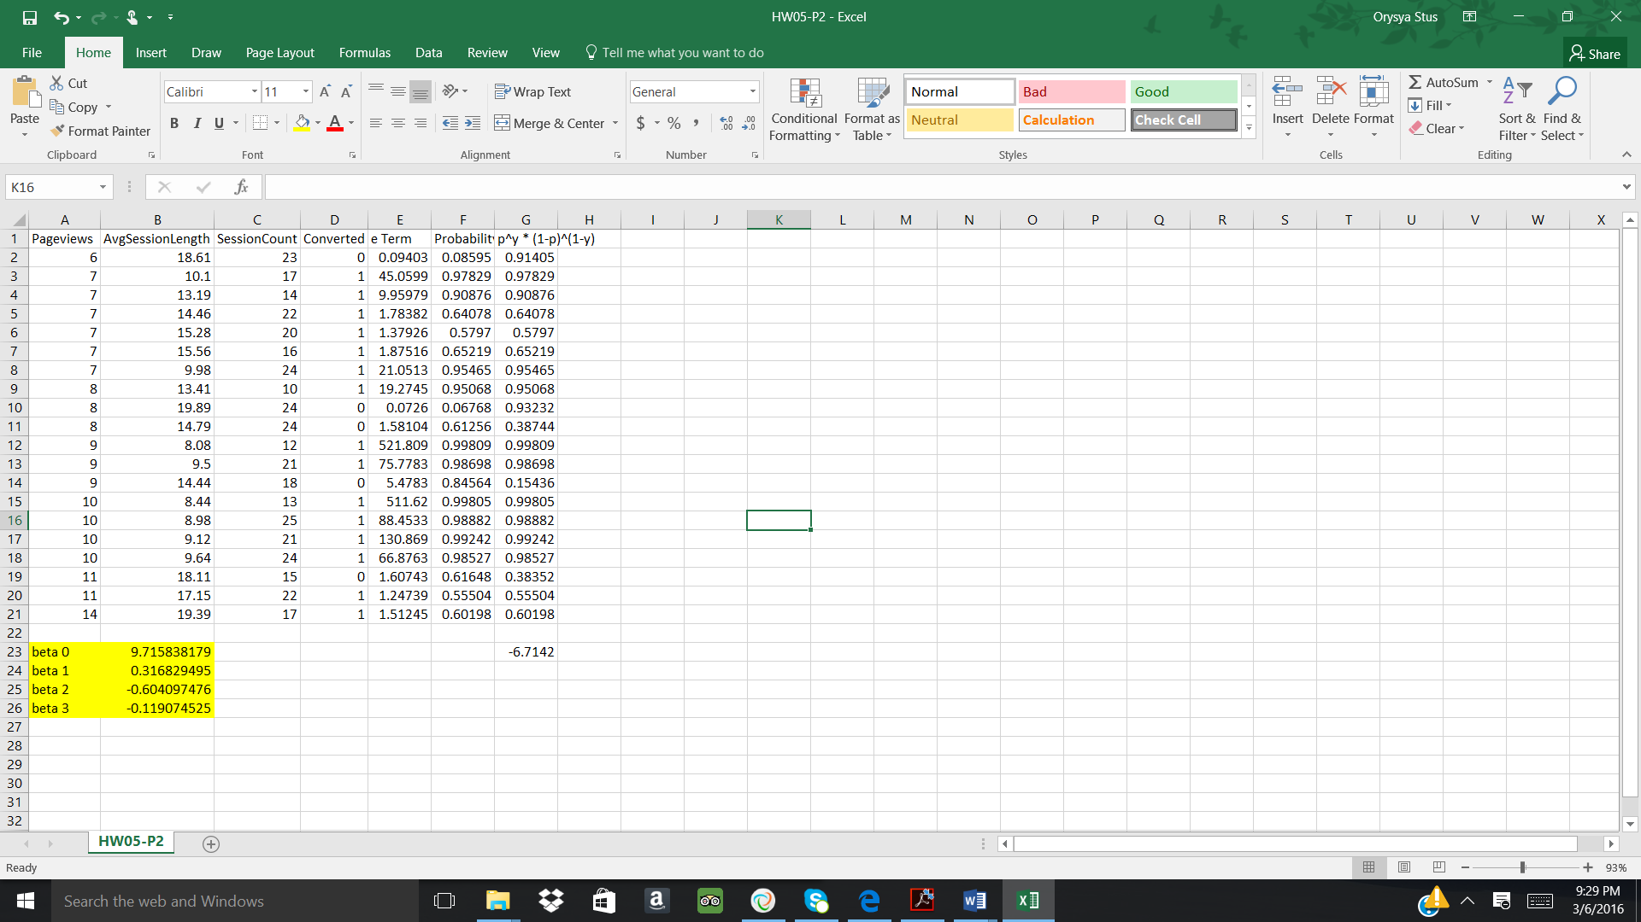

**Prediction:**

The e Term and probability term were calculated for the prediction values. The below logical statement was used in order to determine whether or not a revisit would occur.

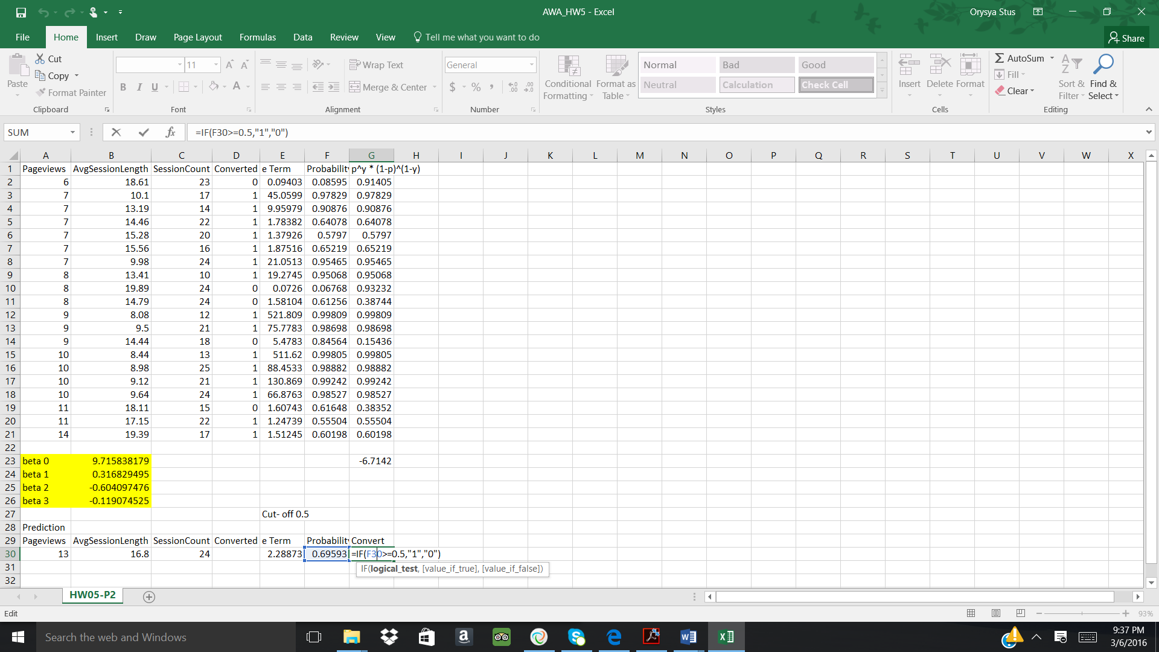 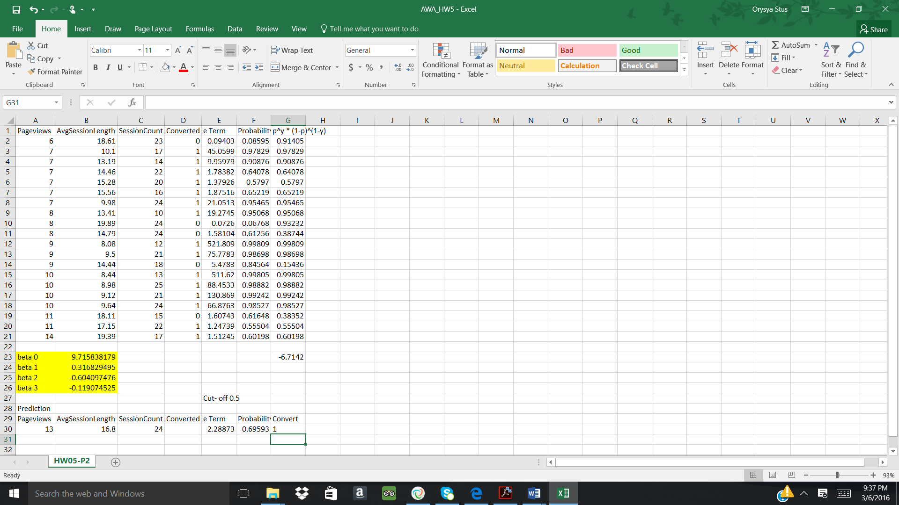

Validation using KNIME:

