Data Mining II: Advanced Methods and Techniques

Final Laboratory Assignment: (30pts)

Create and train a back-prop Neural Network that will accurately predict either a subject of your choice, or you can expand on the vegetable dataset below. Create a training datasest based on a series of input parameters. The dataset needs to contain a comprehensive description of attributes(inputs) for the given class values (outputs). Please have at least 5-6 attributes and 150 instances. You can either reuse existing code, and annotate it to show your understanding, or generating your own code from scratch.

Your report needs to include dataset description, please attach dataset (.csv or .arff) separately, annotation/comments the code(for both reusing or generating code from scratch), and written discussion evaluating your model.

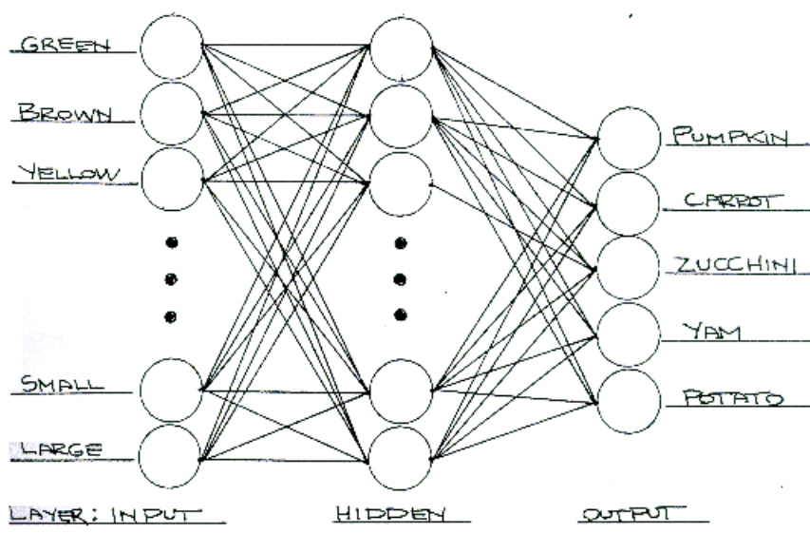

Final Report

The Australian AIDS Survival Data from https://vincentarelbundock.github.io/Rdatasets/datasets.html is used as the foundation for my dataset. The Aids2 dataset contains 7 attributes: state, sex, diag (date of Aids diagnosis), death (date of death, or date of last observation if alive), status (dead or alive), T.categ (type of transmission), and age; this dataset contains 2843 instances.


This dataset was editted into Aids2_editted.csv to classify the binary output (dead = 0, alive = 1) for each Aids patient dependent on the following 5 attributes: state (NSW, Other, VIC, QLD), sex (M, F), days_diagtofinalobservation (integer value, new variable created by death-diag from above), age (integer value), and the class attribute, status (dead = 0, alive = 1); the Aids2_editted dataset contains 2843 instances. See attached.

The csv file was imported into Weka.
Filters.unsupervised.attribute.NumerictoNominal was applied on the class attribute, status.
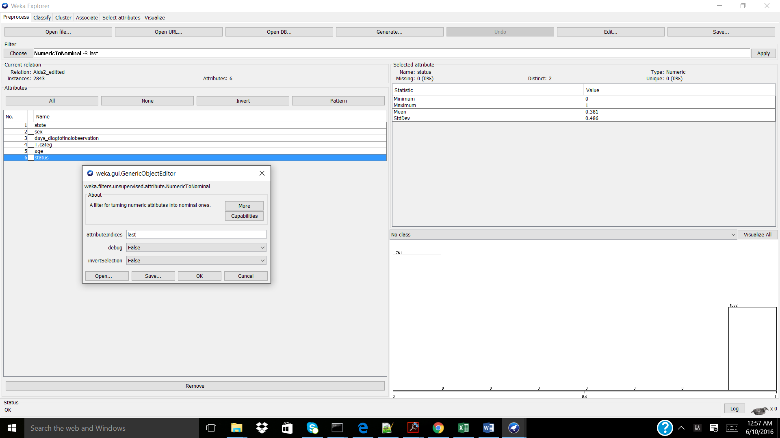

The numeric attributes, days_diagtofinalobservation and age were discretized using:
Filters.unsupervised.attribute.Discretize as shown below.
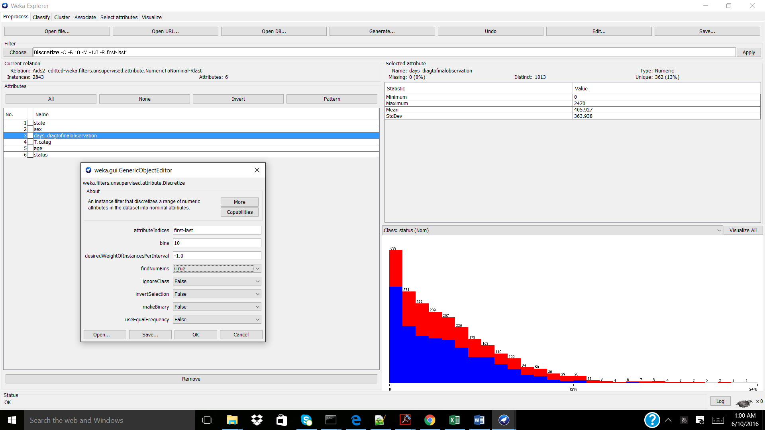

“Visualize all” demonstrated that the status classes held good distributions.
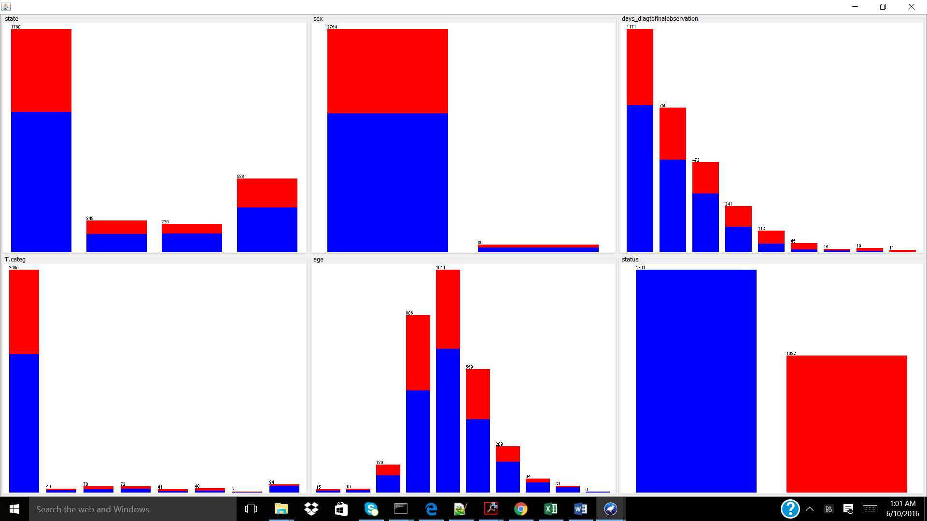

Classifier.functions.MultiLayerPerceptron was used with the below parameters, in order to create a neural network with backpropagation on with a percentage split of 80% train and 20% test. The parameters below were found following iterative testing and generated the best model, in that it had the highest (over 50%) TP rates for status = 0 and status = 1.
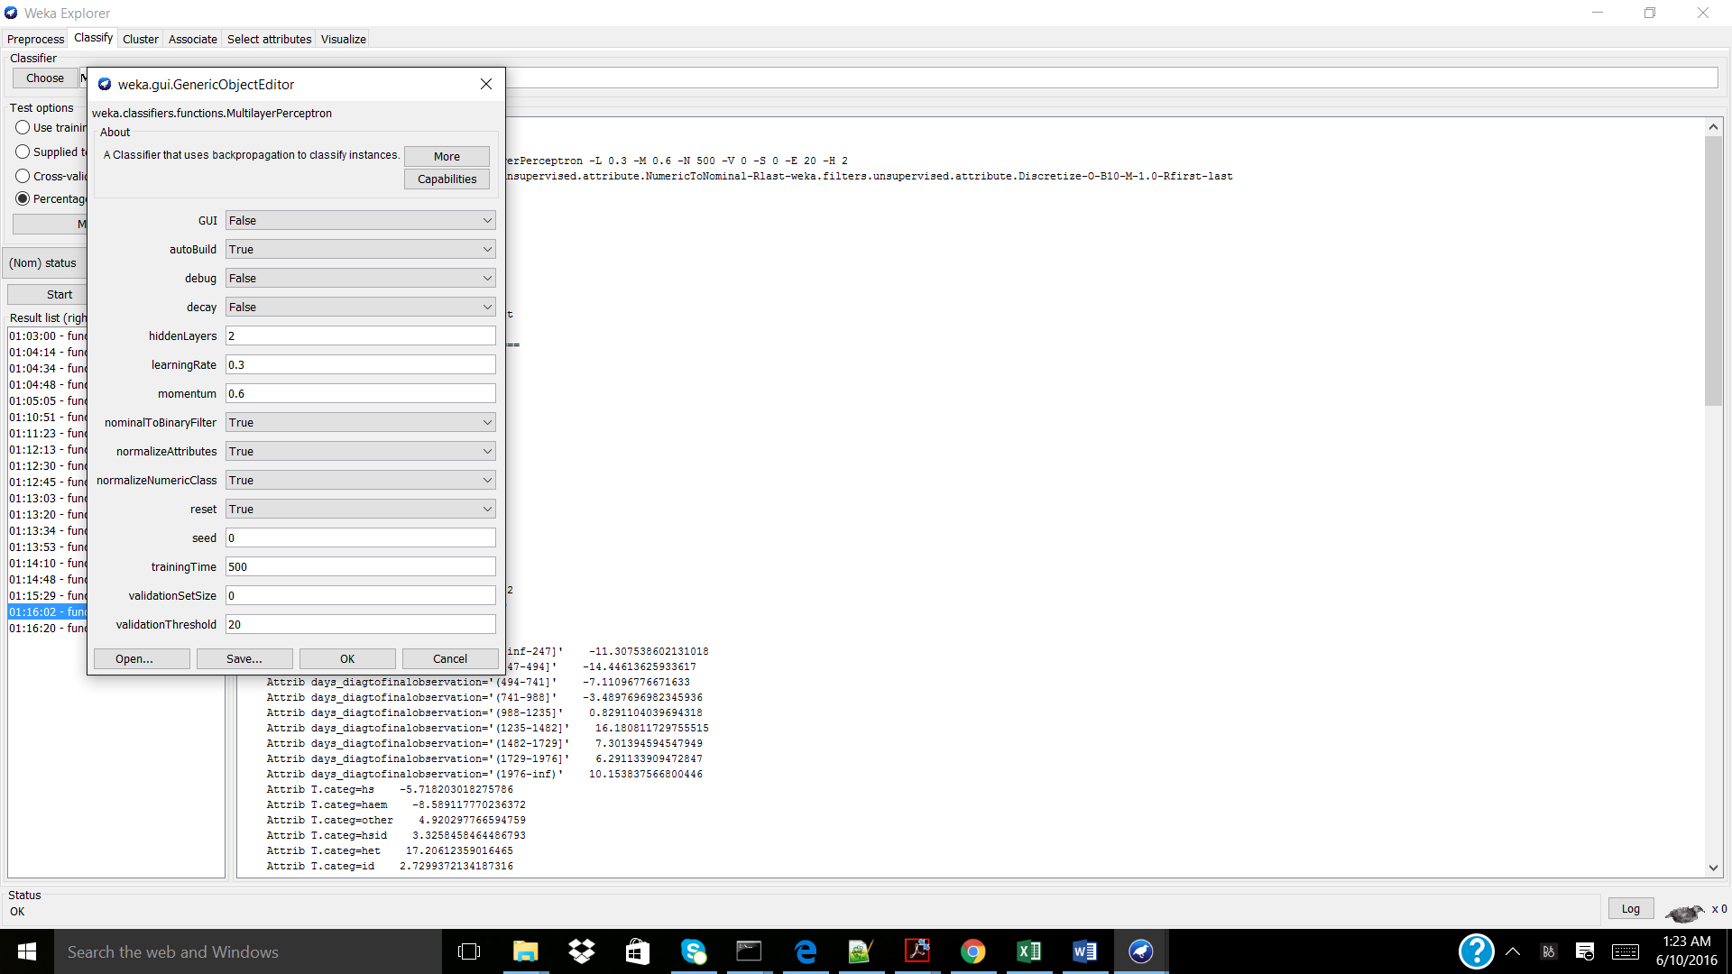

The following model was generated:
=== Run information ===

Scheme:weka.classifiers.functions.MultilayerPerceptron -L 0.3 -M 0.6 -N 500 -V 0 -S 0 -E 20 -H 2
Relation: Aids2_editted-weka.filters.unsupervised.attribute.NumericToNominal-Rlast-weka.filters.unsupervised.attribute.Discretize-O-B10-M-1.0-Rfirst-last
Instances: 2843
Attributes: 6
state
sex
days_diagtofinalobservation
T.categ
age
status
Test mode:split 80.0% train, remainder test

=== Classifier model (full training set) ===

Sigmoid Node 0
Inputs Weights
Threshold 0.4027580160093764
Node 2 -2.0784396224967616
Node 3 -2.1795241666059706
Sigmoid Node 1
Inputs Weights
Threshold -0.40275801600937644
Node 2 2.0784396224967616
Node 3 2.17952416660597
Sigmoid Node 2
Inputs Weights
Threshold -0.6116103791298871
Attrib state=NSW 9.761705321396853
Attrib state=Other 5.461408752859742
Attrib state=QLD -15.40617026593369
Attrib state=VIC 1.4205159445778197
Attrib sex 7.77381097579913
Attrib days_diagtofinalobservation='(-inf-247]' -11.307538602131018
Attrib days_diagtofinalobservation='(247-494]' -14.44613625933617
Attrib days_diagtofinalobservation='(494-741]' -7.11096776671633
Attrib days_diagtofinalobservation='(741-988]' -3.4897696982345936
Attrib days_diagtofinalobservation='(988-1235]' 0.8291104039694318
Attrib days_diagtofinalobservation='(1235-1482]' 16.180811729755515
Attrib days_diagtofinalobservation='(1482-1729]' 7.301394594547949
Attrib days_diagtofinalobservation='(1729-1976]' 6.291133909472847
Attrib days_diagtofinalobservation='(1976-inf)' 10.153837566800446
Attrib T.categ=hs -5.718203018275786
Attrib T.categ=haem -8.589117770236372
Attrib T.categ=other 4.920297766594759
Attrib T.categ=hsid 3.3258458464486793
Attrib T.categ=het 17.20612359016465
Attrib T.categ=id 2.7299372134187316
Attrib T.categ=mother -0.8806902295678779
Attrib T.categ=blood -9.242560582181287
Attrib age='(-inf-8.2]' -2.5042313687941613
Attrib age='(8.2-16.4]' 2.2455149211867087
Attrib age='(16.4-24.6]' 8.523827483827754
Attrib age='(24.6-32.8]' 4.130687289108886
Attrib age='(32.8-41]' 2.113710493292087
Attrib age='(41-49.2]' -12.955193783465454
Attrib age='(49.2-57.4]' 9.022890597745553
Attrib age='(57.4-65.6]' -2.921513422640614
Attrib age='(65.6-73.8]' 3.8761472139188515
Attrib age='(73.8-inf)' -6.270809376036443
Sigmoid Node 3
Inputs Weights
Threshold -1.6662654536532528
Attrib state=NSW 3.4768744427571407
Attrib state=Other 8.779766475860091
Attrib state=QLD 0.3087138643354367
Attrib state=VIC -9.062987970668933
Attrib sex -12.150556266472814
Attrib days_diagtofinalobservation='(-inf-247]' -3.6094715529972787
Attrib days_diagtofinalobservation='(247-494]' -10.165382255587938
Attrib days_diagtofinalobservation='(494-741]' -1.7563275750832326
Attrib days_diagtofinalobservation='(741-988]' -3.021421500637929
Attrib days_diagtofinalobservation='(988-1235]' 10.721673582738028
Attrib days_diagtofinalobservation='(1235-1482]' -1.7672965298796048
Attrib days_diagtofinalobservation='(1482-1729]' -6.28413460912831
Attrib days_diagtofinalobservation='(1729-1976]' 15.51336078089208
Attrib days_diagtofinalobservation='(1976-inf)' 12.197642779236736
Attrib T.categ=hs 1.5336659582759105
Attrib T.categ=haem -4.011383979032481
Attrib T.categ=other -2.312578626008816
Attrib T.categ=hsid -7.424922687568426
Attrib T.categ=het 4.576505993387023
Attrib T.categ=id 6.762700954690612
Attrib T.categ=mother 6.985408451302525
Attrib T.categ=blood 4.107000832959694
Attrib age='(-inf-8.2]' 10.928252200369746
Attrib age='(8.2-16.4]' 1.855951364194595
Attrib age='(16.4-24.6]' 1.175031337019227
Attrib age='(24.6-32.8]' 3.255731245527811
Attrib age='(32.8-41]' -3.8019855976962456
Attrib age='(41-49.2]' 8.939820204773572
Attrib age='(49.2-57.4]' -0.05537540789214315
Attrib age='(57.4-65.6]' -3.6647815243427853
Attrib age='(65.6-73.8]' -5.585228946724402
Attrib age='(73.8-inf)' 0.6998205348529303
Class 0
Input
Node 0
Class 1
Input
Node 1

Time taken to build model: 2.69 seconds

=== Evaluation on test split ===
=== Summary ===

Correctly Classified Instances 320 56.239 %
Incorrectly Classified Instances 249 43.761 %
Kappa statistic 0.1421
Mean absolute error 0.4604
Root mean squared error 0.4846
Relative absolute error 97.7403 %
Root relative squared error 99.9423 %
Total Number of Instances 569

=== Detailed Accuracy By Class ===

TP Rate FP Rate Precision Recall F-Measure ROC Area Class
0.517 0.363 0.701 0.517 0.595 0.605 0
0.637 0.483 0.445 0.637 0.524 0.605 1
Weighted Avg. 0.562 0.408 0.604 0.562 0.568 0.605

=== Confusion Matrix ===

a b <-- classified as
183 171 | a = 0
78 137 | b = 1

Discussion
The model generated above modeled the dataset with TP rate of larger than 50%, a mean absolute error of 0.4604. Improvements to this model could have been attributed if the sampling of patient information also included whether or not the individual was on some type of medicine, treatment, or new lifestyle which potentially hindered or progressed the progression of Aids and thus death. Supplementary data would provide more insight as to the outcome of the patient as well as predict whether the patients they were still alive would be predicted to die within a given amount of time.

Python generated code to divide the dataset, as was completed in Weka.

train_test_extract.py : http://localhost:8888/notebooks/train_test_extract.ipynb
#takes the input of a .csv file and divides the data into a training a testing dataset, based on parameters inputted.

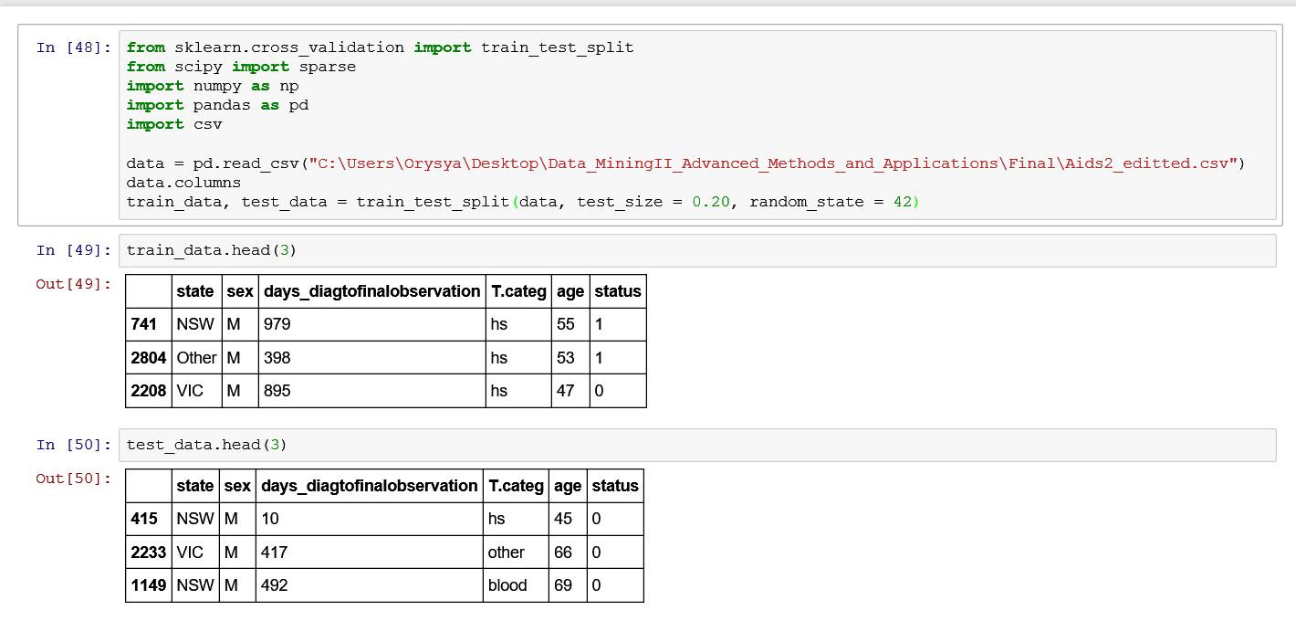

Backprop.py : http://localhost:8888/notebooks/Backprop.ipynb
#runs a neural network backprop on the dataset

#
# Imports
#
import numpy as np

class BackPropagationNetwork:
"""A back-propagation network"""
#
# Class members
#
layerCount = 0
shape = None
weights = []

#
# Class methods
#
def __init__(self, layerSize):
"""Initialize the network"""

# Layer info
self.layerCount = len(layerSize) - 1
self.shape = layerSize

# Input/Output data from the last Run
self._layerInput = []
self._layerOutput = []

# Create the weight arrays
for (l1,l2) in zip(layerSize[:-1], layerSize[1:]):
self.weights.append(np.random.normal(scale=0.1, size = (l2, l1+1)))
#
# Run method
#
def Run(self, input):
"""Run the network based on the input data"""

lnCases = input.shape[0]

# Clear out the previous intermediate value lists
self._layerInput = []
self._layerOutput = []

# Run it
for index in range(self.layerCount):
#Determine layer input
if index == 0:
layerInput = self.weights[0].dot(np.vstack([input.T, np.ones([1, lnCases])]))
else:
layerInput = self.weights[index].dot(np.vstack([self._layerOutput[-1], np.ones([1, lnCases])]))

self._layerInput.append(layerInput)
self._layerOutput.append(self.sgm(layerInput))
return self._layerOutput[-1].T

#
# TrainEpoch method
#
def TrainEpoch(self, input, target, trainingRate = 0.2):
"""This method trains the network for one epoch"""

delta = []
lnCases = input.shape[0]

# First run the network
self.Run(input)

# Calculate our deltas
for index in reversed(range(self.layerCount)):
if index == self.layerCount - 1:
# Compare to the target values
output_delta = self._layerOutput[index] - target.T
error = np.sum(output_delta**2)
delta.append(output_delta * self.sgm(self._layerInput[index], True))
else:
# Compare to the following layer's delta
delta_pullback = self.weights[index + 1].T.dot(delta[-1])
delta.append(delta_pullback[:-1, :1]* self.sgm(self._layerInput[index], True))

# Compute weight deltas
for index in range(self.layerCount):
delta_index = self.layerCount - 1 - index

if index == 0:
layerOutput = np.vstack([input.T, np.ones([1, lnCases])])
else:
layerOutput = np.vstack([self._layerOutput[index - 1], np.ones([1, self._layerOutput[index - 1].shape[1]])])

weightDelta = np.sum(\
layerOutput[None,:,:].transpose(2,0,1)*delta[delta_index][None,:,:].transpose(2,1,0)\
, axis = 0)
self.weights[index] -= trainingRate*weightDelta
return error

# Transfer functions
def sgm(self, x, Derivative=False):
if not Derivative:
return 1.0 / (1.0 + np.exp(-x))
else:
out = self.sgm(x)
return out*(1-out)

#in
# If run as a script, create a test object
#
if __name__ == "__main__":
bpn = BackPropagationNetwork((2,2,1))
print(bpn.shape)
print(bpn.weights)

lvInput = np.array([[0,0], [1,1], [0,1], [1,0]])
lvTarget = np.array([[0.05], [0.05], [0.95], [0.95]])

lnMax = 100000
lnErr = 1e-5
for i in range(lnMax+1):
err = bpn.TrainEpoch(lvInput, lvTarget)
if i % 2500 == 0:
print("Iteration {0}\tError: {1:0.6f}".format(i, err))
if err <= lnErr:
print("Minimum error reached at iteration {0}".format(i))
break

# Display output
lvOutput = bpn.Run(lvInput)
print("Input: {0}\nOutput: {1}".format(lvInput, lvOutput))

