UCSD Computing & Networking Technologies

Data Mining II: Advanced Methods and Techniques

Laboratory Assignment III:

- What is a ‘support vector’?
In support vector machines (SVMs), the instances closest to the maximum margin hyperplane are called the support vectors. The support vectors define the maximum margin hyperplane, where all instances can be deleted without changing the position and orientation of the hyperplane.
- Write down the Bayes rule:
P(A|B) = [P(B|A)P(A)] / P(B)
The likelihood of a future event occurring is based on the past probability that it occurred.
- Analyze the weather.arff data using Weka’s Support Vector Machine method (classifier.SMO).
- The weather.arff file was opened in Weka and no further preprocessing was done on the data. Note: the data file is small, having 5 attributes and 14 instances. Furthermore, “Visualize all” was selected to view the instances distributions for each attribute.
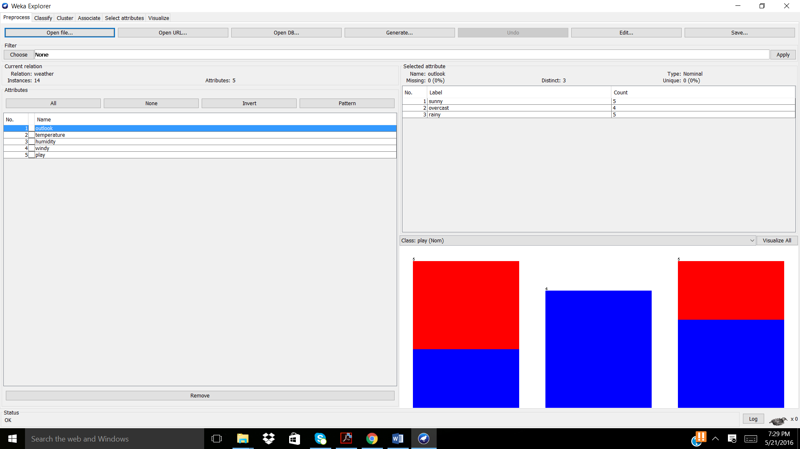
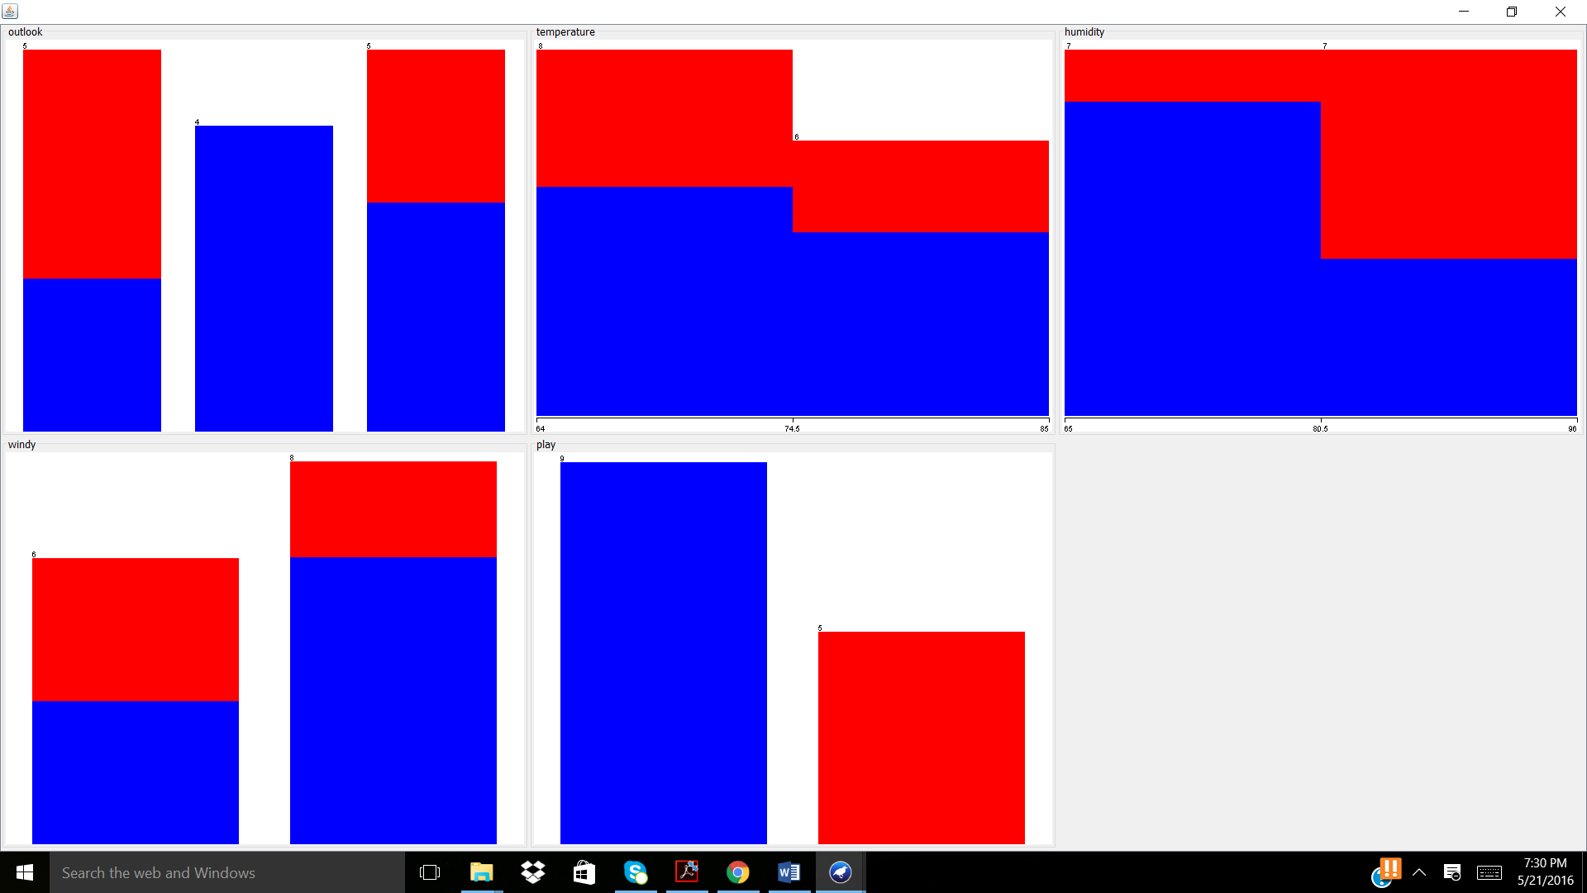
Note: Expect 9 classes of “Yes” and 5 classes of “No” for class attribute of “play”.
  - How many support vectors were created? Would you say the produced model is acceptable? Was it able to successfully learn both outcomes of the ‘play’ class attribute?
A. To complete the SMO classifier method: Classify > Functions > SMO was selected. Utilizing the default settings for the classifier and Cross-Validation 10 Fold the following was generated.
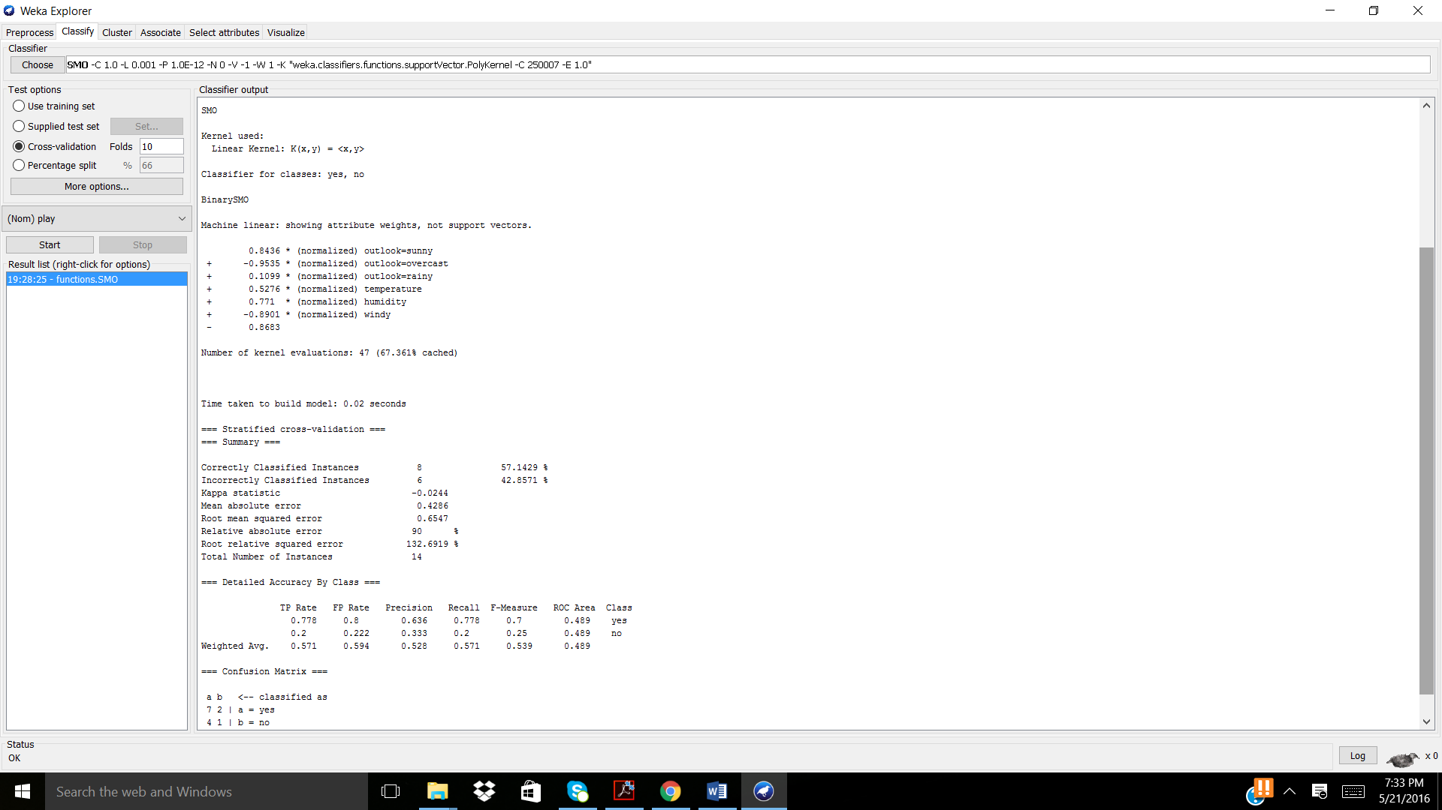
In total there were 6 support vectors and 47 kernel evaluations generated when E = 1. The produced model needs further optimization as it was able to classify only 8/14 instances correctly with a mean absolute error of 0.4286. Viewing the confusion matric, the class play “Yes” was classified more correctly than “No”, with 7/9 correct “Yes” and 1/5 correct “No” for class attribute “play”.
  - Change the parameter ‘-E’ to 2.0. What has changed in the output? How many support vectors? Was the learning successful? Were both outcomes of ‘play’ successfully learned?
A. Parameter -E was changed to 2.0. And the SMO classifier was run again.
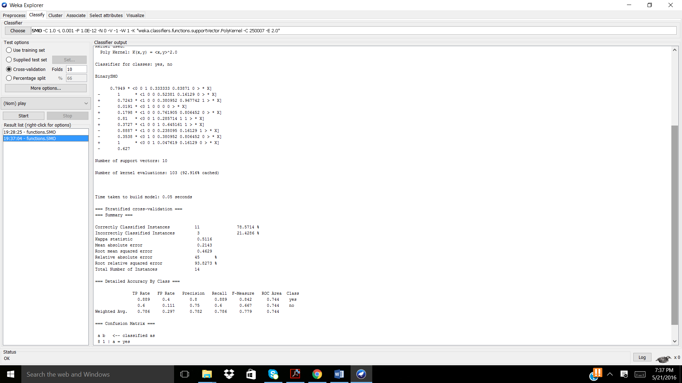
When the parameter -E = 1.0 the output generated is a machine linear where the attributes were considered to be combinations of weights like a simple Neutral Network, when the parameter -E = 2.0 the output generated is a binary SMO. Compared to the first order SMO, the second order SMO perfromed better. There were 10 support vectors and 103 kernal evaluations completed. Here, 11/14 instances were correctly classified with a mean absolute error of 0.2143. The learning was more successful with -E = 2.0 then when the parameter -E = 1.0. Viewing the confusion matrix, 8/9 “Yes” and 3/5 “No” were correctly classified for class attribute “play”.
  - Change the parameter ‘-E’ to 3.0. Describe and explain the output? How many support vectors were created? Why was the number of kernel evaluations increased? Was the learning successful? Were both outcomes of ‘play’ successfully learned?

A. Parameter -E was changed to 3.0. And the SMO classifier was run again.
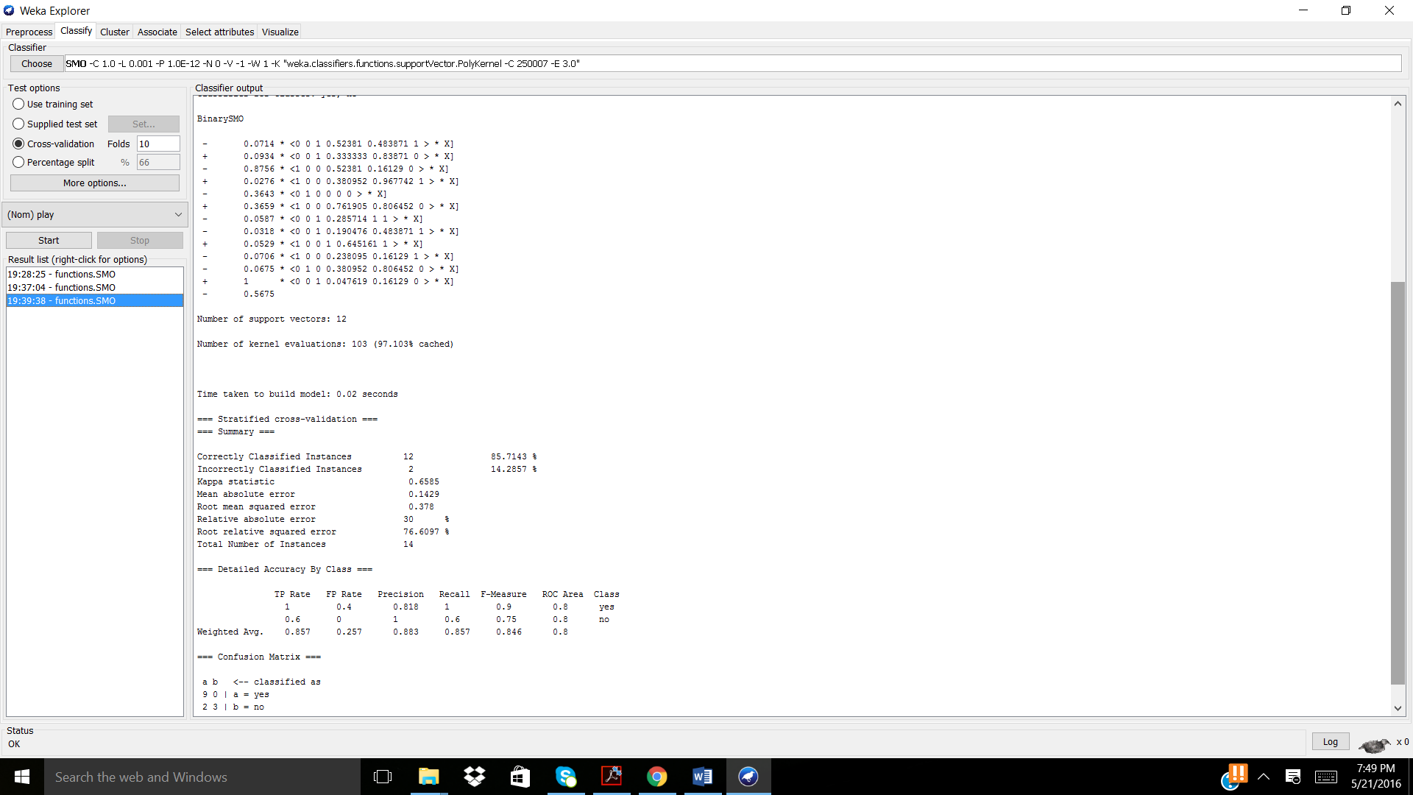
Utilizing a third order SMO classifier, produced 12 support vectors and 103 kernels evaluated, 12/14 correctly classified attributes, and a mean absolute error of 0.1429 showing that is performs the best, when compared to previous evaluations. Viewing the confusion matrix, there were 9/9 correctly classified “Yes” and 3/5 correctly classified “No” for the class attribute “play”, showing that the SMO had more difficulty in learning and classifying instances correctly as “No”.
  - Which of the three models would you choose? Why?
The model created in part c, utilizing the parameter -E = 3.0, since this allows for the most accurate model and the lowest mean absolute error and largest amount of attributes correctly classified.

