Data Mining II: Advanced Methods and Techniques

Laboratory Assignment I:

Questions
1. What is the basic structure of a biological neuron and how does it relate to the McCulloch-Pitts neuron?

A biological neuron retrieves input signals (from nervous system or other neurons) through the dendrites which are collected and processed in the cell body, following processing the axon which is covered by a myelinated sheath (to increase the speed of signal transmission) transports the processed signal as the output towards the synaptic terminals (which only becomes transmitted through a synaptic space once a threshold activation is reached), and the synaptic terminals are connected to other neurons (dendrites from neurons) for signal transduction of neural signals.
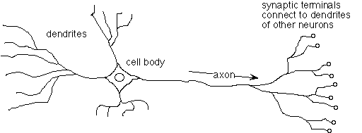
Similarly, in a McCulloch-Pitts neuron, the inputs and associated weights are brought into a processing unit, along connections, where a perceptron calculates the weighted sum of the input values. Next, a non-linear activation function is applied on the weighted sum which produces an output (y) which can be outputted/used in a further neural network, like a feedforward neural network.
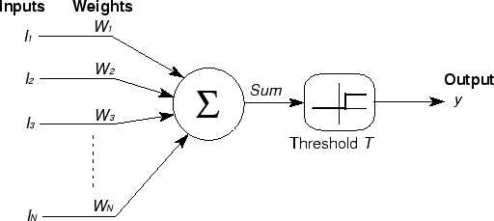

2. Design networks of McCuloogh-Pitts neurons that implement logical NOT and logical AND gate. Draw each network and label the weight and threshold value. In what way would XOR be more difficult to implement?

McCulloch-Pitts neuron, logical NOT gate:
x1
{0,1}
w1 = -1
In | Out
0 | 1
1 | 0
Sgn(x1) = {1 if ∑w1x1 > -0.5
{0 if ∑w1x1 ≤ -0.5
With threshold = -0.5

McCulloch-Pitts neuron, logical AND gate:
x1
{0,1}
w1 = 1
In1 | In2 | Out
0 | 0 | 0
0 | 1 | 0
1 | 0 | 0
1 | 1 | 1
Sgn(x1, x2) =
{1 if ∑wixi > 1.5
{0 if ∑wixi ≤ 1.5
With threshold = 1.5

x2
{0,1}
w2 = 1

McCulloch-Pitts neuron, XOR:
A XOR operator is not linearly separated, like the logical functions above, therefore it cannot be achieved by using a single perceptron. This problem is overcome by using more than 1 perceptron arranged in a feedforward network.

3. Read a short tutorial at: http://lcn.epfl.ch/tutorial/english/index.html. What is the main difference between McCulloch-Pitts neuron and general artificial neuron?
The main difference between this model and the Artificial Neuron model is the use of absolute inhibitory input. This neuron is able to implement nonmonotonic logic functions.
The inputs and outputs are binary (exclusively ones or zeros); the nodes produce only binary results. There are no weights, and the activation function is always the unit step function.
4. Which of the 2-input binary logical functions can be computed with a McCulloch-Pitts
• neuron? AND, OR, NOT, NAND, NOR
• network? XOR, XNOR

5. Using the unit step activation function for the artificial neuron, determine a set of weights (and threshold value) that will produce the following classification:

x1 x2 output
-0.2 0.5 0
0.2 -0.5 0
0.8 -0.8 1
0.8 0.8 1
Using iteration in excel:

-0.8x1 – 0.1y ≥ -0.5
Where w1 = -0.8, w2 = -0.1, and unit threshold = -0.5
Following iterative error finding and recalculating the weights and unit threshold were found.

Confirmed using:
https://www.desmos.com/calculator/jw5hjem6xy

As well as:


Try to do this by hand first, and then check your answer with the applet. You can use any applet available on the Internet (please include the link to the applet used

