Data Mining II: Advanced Methods and Techniques

Laboratory Assignment II:

Questions – Part A:
- Create a truth table for the XOR problem. Proceed with the following:
  - Demonstrate the backpropagation algorithm for learning the XOR function, using the following weights as initial random weights:
output

z
2.2
2.5
y
x
5
4.6
-4.9
-5.1
b
a

inputs

Show each neuron output value in the forward direction, and the weight change in the backward direction, using the backpropagation algorithm, for each row of the truth table. Assume that the threshold function for the neuron is 0.01, which means that if the sum of the inputs is less than 0.01, the neuron will output a 0. Moreover, if the sum of inputs >= 0.01, the neuron will output a 1.
A. Utilizing the hint posted on Ted:
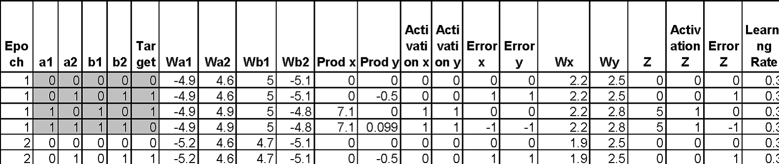
The following truth table or the file Prob1_TruthTable.csv was created:

  - Using the truth table, produce an .arff file to be entered into the Weka Neural Network classifier. Preprocess the data. You will be using this dataset to conduct different neural network experiments by modifying the neural network topology, the learning rate, the number of epochs to train, etc.
A. The Prob1_TruthTable.csv file was inputted into Weka. It was seen that the attribute values were numeric, in order to correctly work with this data set numerictonominal filtering method was applied (numerictobinary filtering method was first attempted, but there were issues in making the class attribute, Z, binary).
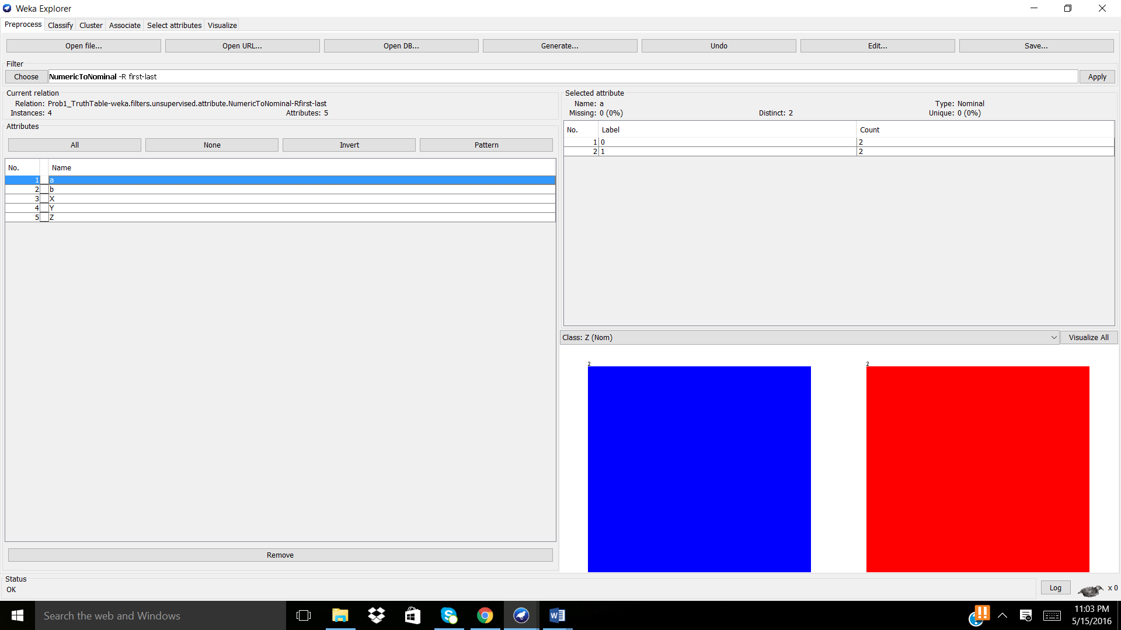
“Visualize all” demonstrated the instance distribution for the nominal attributes.
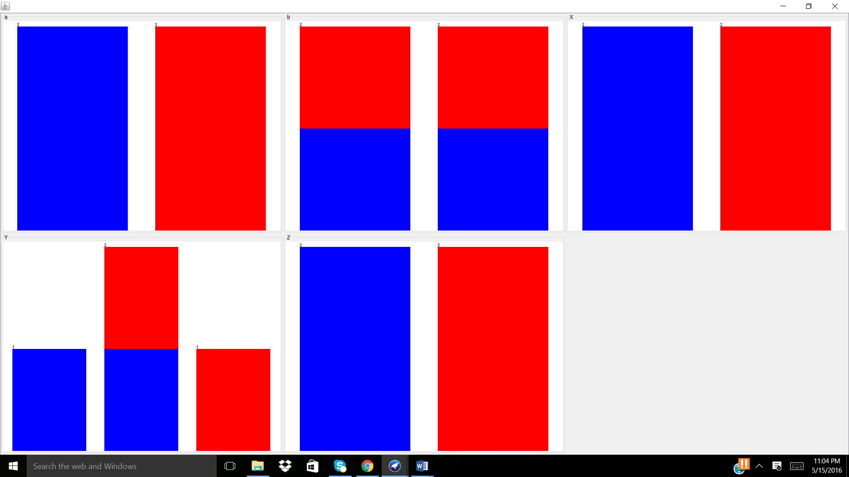
  - Build the most accurate neural network for predicting the XOR function value using Weka’s neural network classifier. Experiment with two different configurations, two different learning rate values per each configuration, as well as two different numbers of training epochs. Describe all six of your experiments in enough detail that they can be reproduced.

A. Next, Weka’s neural network classifier, MultiLayerPerceptron, was applied, since it uses backpropagation to classify instances into the class, a nominal class. Parameters such as learning rate and number of training epochs (training time) were fluctuated, as seen in the table below. Note: “Use the training set” was used in order to train the entire data set, as it only contains 4 instances.
Learning rate | Training time | Correctly classified instances (#/4) | Mean absolute error
0.5 | 300 | 4 | 0.0314
0.6 | 300 | 4 | 0.0282
1.0 | 300 | 4 | 0.0211
1.0 | 400 | 4 | 0.018
1.0 | 500 | 4 | 0.0159
1.0 | 600 | 4 | 0.0144
From the table produced above, it can be seen that the most accurate model is when:
Learning rate = 1.0 Training time = 600 (or higher)
All instances were correctly classified Mean absolute error = 0.0144
Using iterative processing it was seen that learning rates > 1.0 do not change the statistics of the model thus learning rate = 1.0 is valid enough for modeling. Also, with increasing training time the mean absolute error approached 0, thus also validating that the model, through gradient descent and backpropagation, has reached a global minima.
Parameters: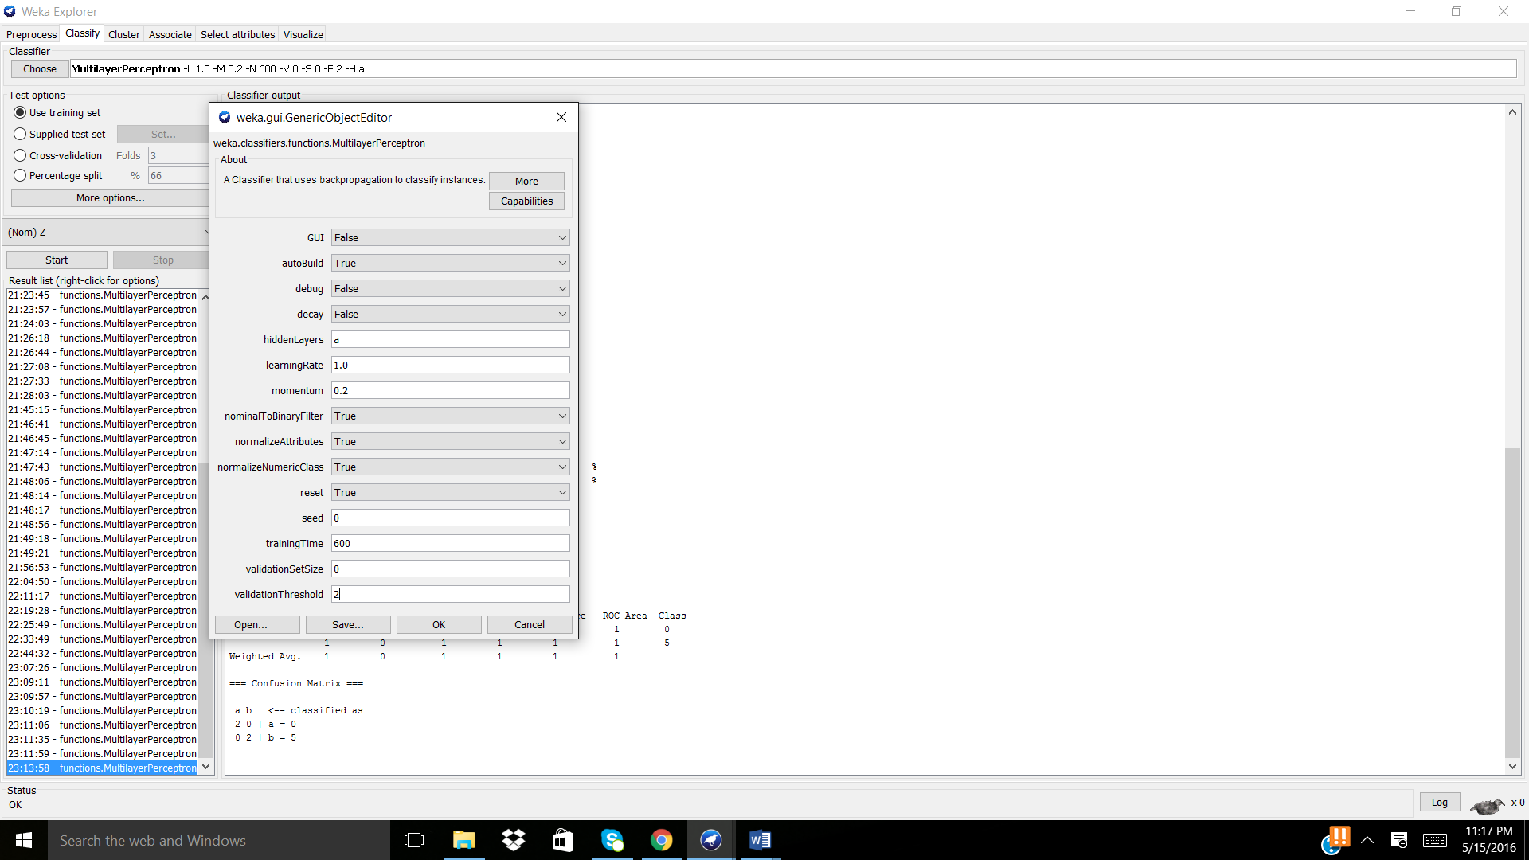
Model produced:
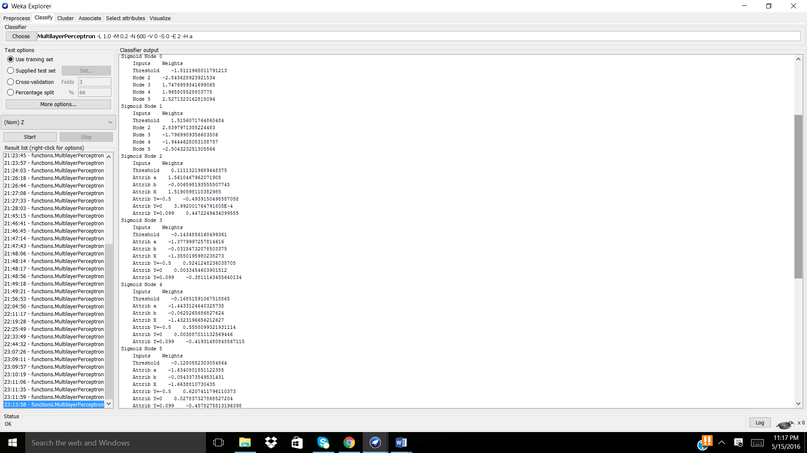
- Create a truth table for the following function: p = (x OR ~y) AND (x OR ~z). Proceed with the following:
  - Using the truth table, produce an .arff file to be entered into the Weka Neural Network classifier. Preprocess the data. You will be using this dataset to conduct different neural network experiments by modifying the neural network topology, the learning rate, the number of epochs to train, etc.

A. Utilizing the following link for confirmation: http://turner.faculty.swau.edu/mathematics/materialslibrary/truth/, the following truth table was created and saved as Prob2_TruthTable.csv for processing in Weka:


Also, note that an .arff could have been used but this was more visually appealing for me.

B. The Prob2_TruthTable.csv was opened in Weka, and it was seen that the attribute values were numeric, in order to correctly work with this data set numerictonominal filtering method was applied (numerictobinary filtering method was first attempted, but there were issues in making the class attribute, p, binary).
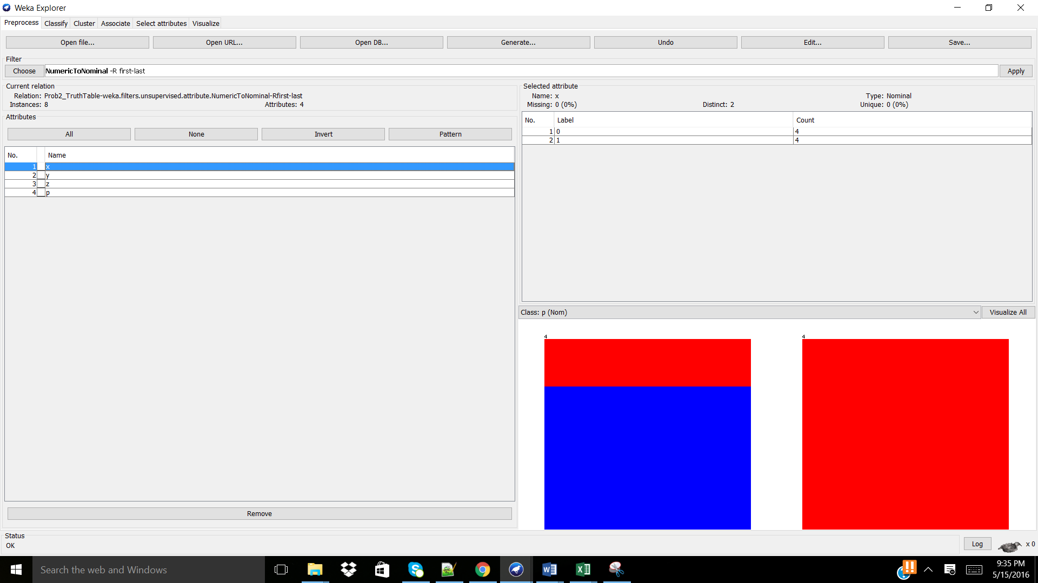

“Visualize all” demonstrated the instance distribution for the nominal attributes.
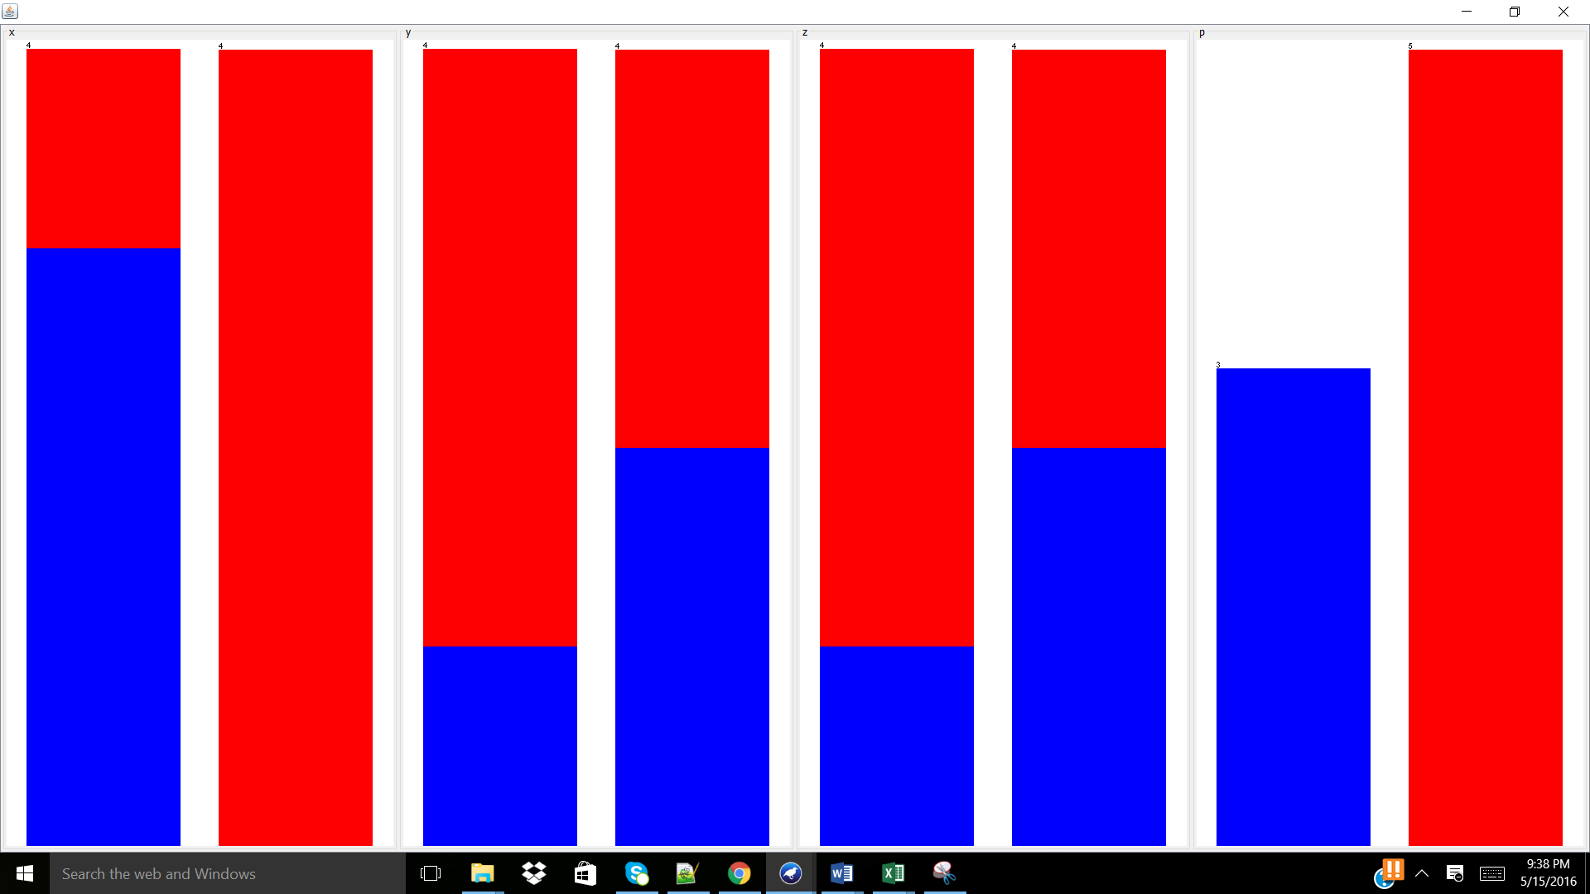

  - Build the most accurate neural network for predicting this function value using Weka’s neural network classifier. Experiment with three different configurations, varying the learning rate and number of training epochs of your choice. Describe all three of your experiments in enough detail that they can be reproduced.
A. Next, Weka’s neural network classifier, MultiLayerPerceptron, was applied, since it uses backpropagation to classify instances into the class, a nominal class. Parameters such as learning rate and number of training epochs (training time) were fluctuated, as seen in the table below. Note: “Use the training set” was used in order to train the entire data set, as it only contains 8 instances.
Learning rate | Training time | Correctly classified instances (#/8) | Mean absolute error
0.5 | 300 | 8 | 0.0369
0.6 | 300 | 8 | 0.0326
0.7 | 300 | 8 | 0.0295
1.0 | 300 | 8 | 0.0236
1.0 | 400 | 8 | 0.02
1.0 | 500 | 8 | 0.0176
As shown above, it can be seen that with increasing the learning rate and the training time, the mean absolute error approaches zero. Above, the most accurate neural network for predicting the function is when:
Learning rate = 1.0 (or higher) training time = 500 (or higher)
All instances correctly classified Mean absolute error = 0.0176 (or can be even lower)
Parameters applied:
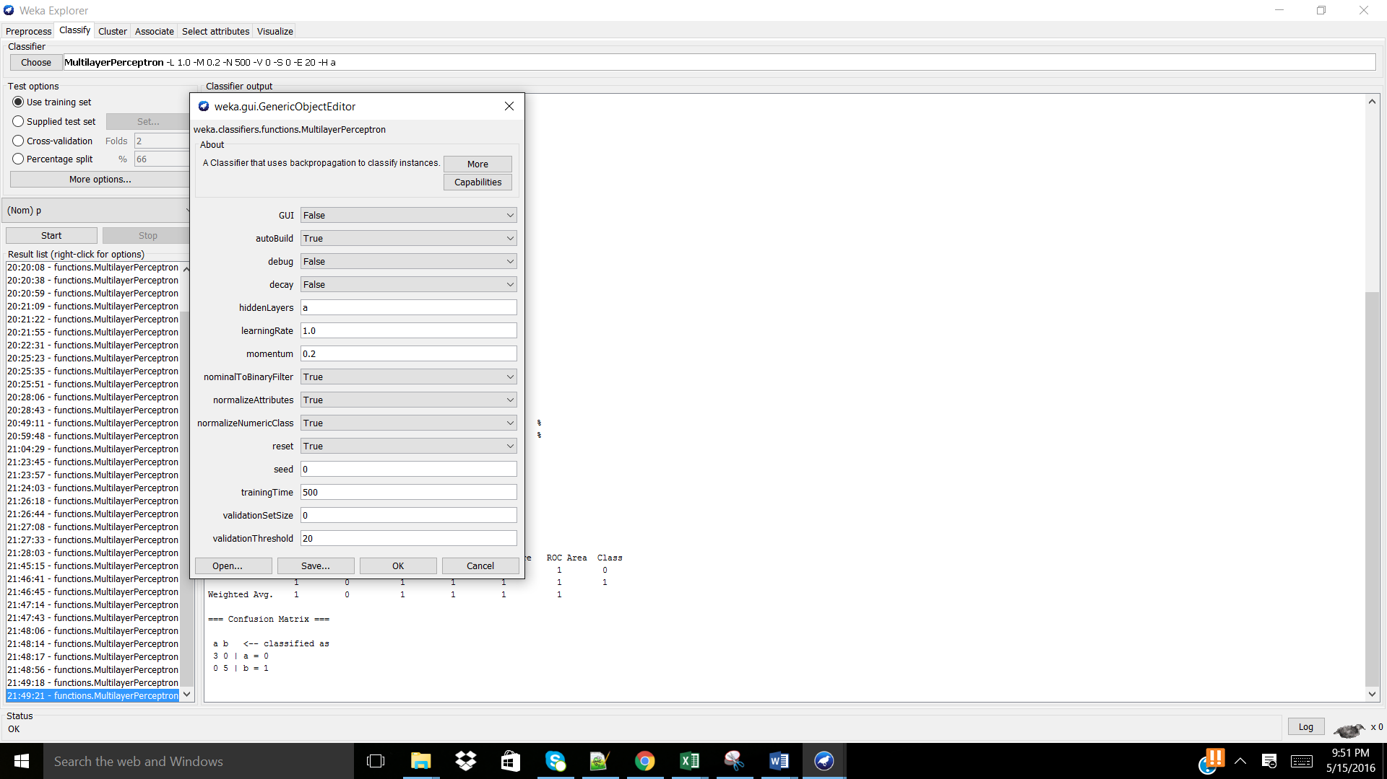
NN produced:
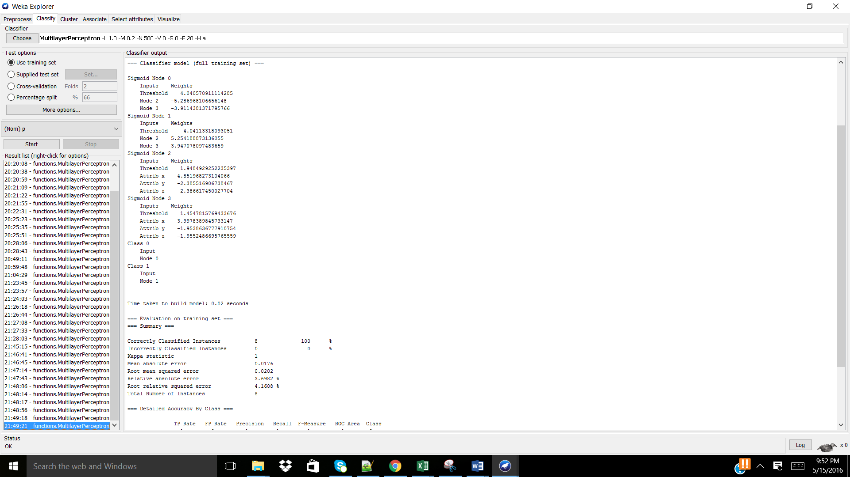

Questions – Part B:
- Use either the CPU dataset or the Iris dataset. These .arff files are usually found in the data directory when you start Weka. Preprocess the data. Build a neural network model of this dataset by testing several configurations, the learning rate values and training time. Report the most accurate neural network you built in enough detail that it can be reproduced.
A. The iris.arff was uploaded into Weka, there was no need to further filter the data during the “Preprocess” phase. Note: 5 attributes exist in this data set.
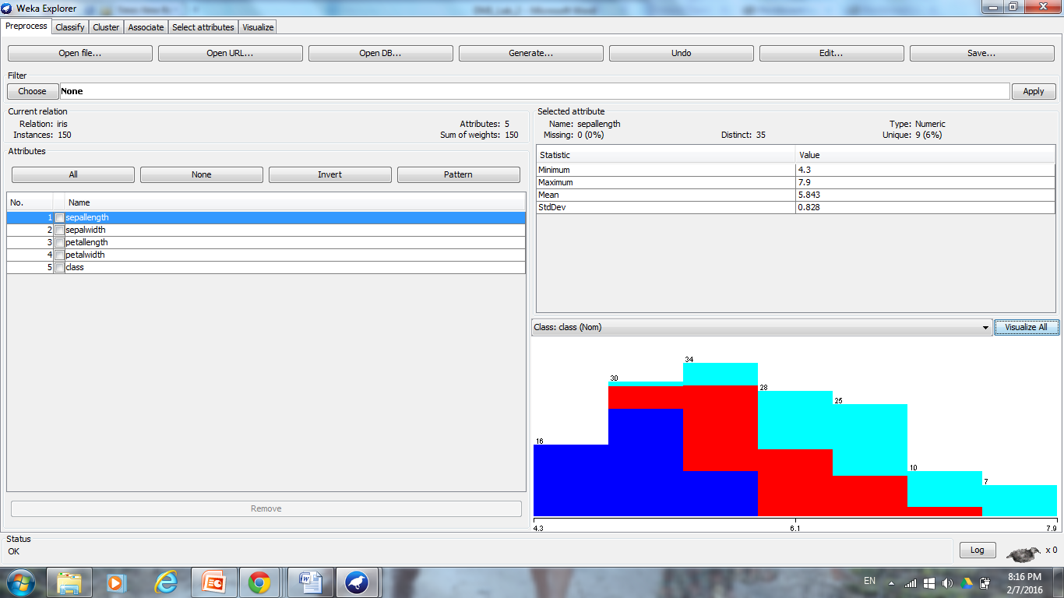

B. “Visualize all” was used to visual the distributions for each class. Where, attributes “sepalength” and “sepalwidth” follow positive skewed Gaussian distributions, the attributes “petallength” and “petalwidth” follow no concrete distribution, and the “class” attribute distributions are equal.
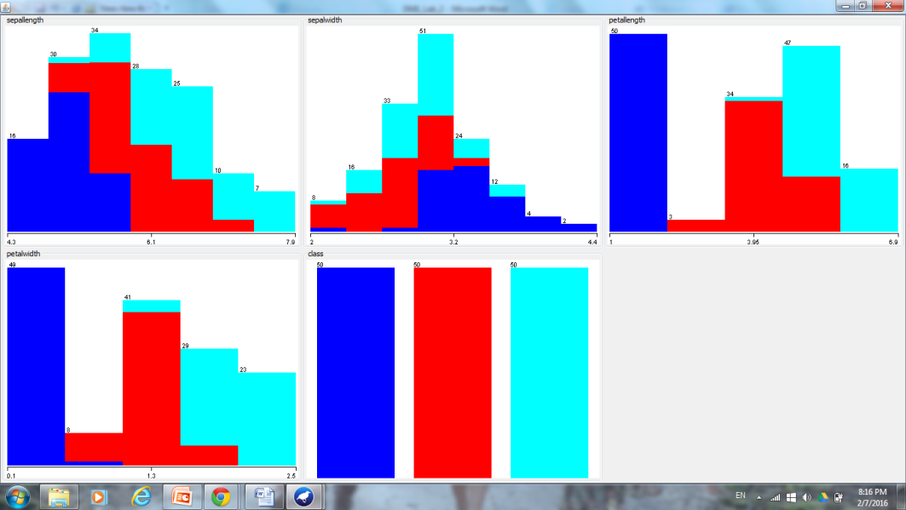
C. Next, Weka’s neural network classifier, MultiLayerPerceptron, was applied, since it uses backpropagation to classify instances into the class, a nominal class (Iris-setosa, Iris-versicolor, or Iris-virginica). Some of the parameters were specified, in order to reach the most accurate NN:
At default using 10-fold cross-validation, the learningRate = 0.3, and training time = 500.
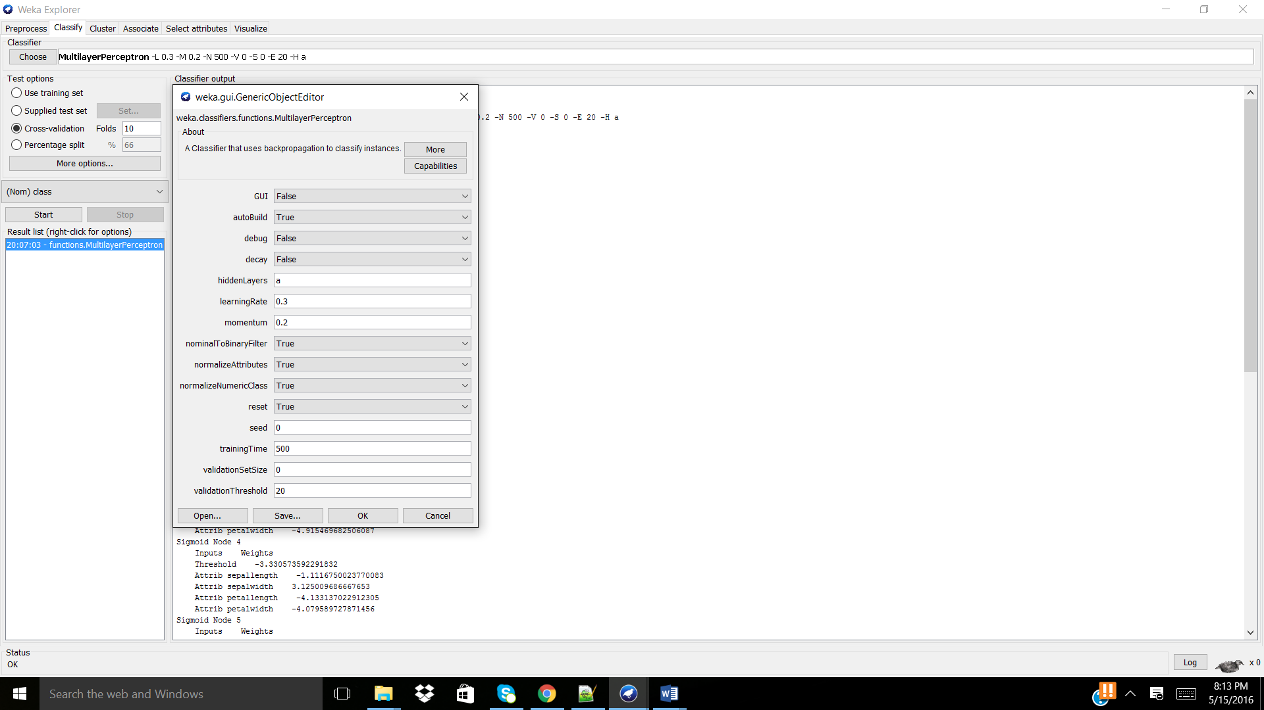
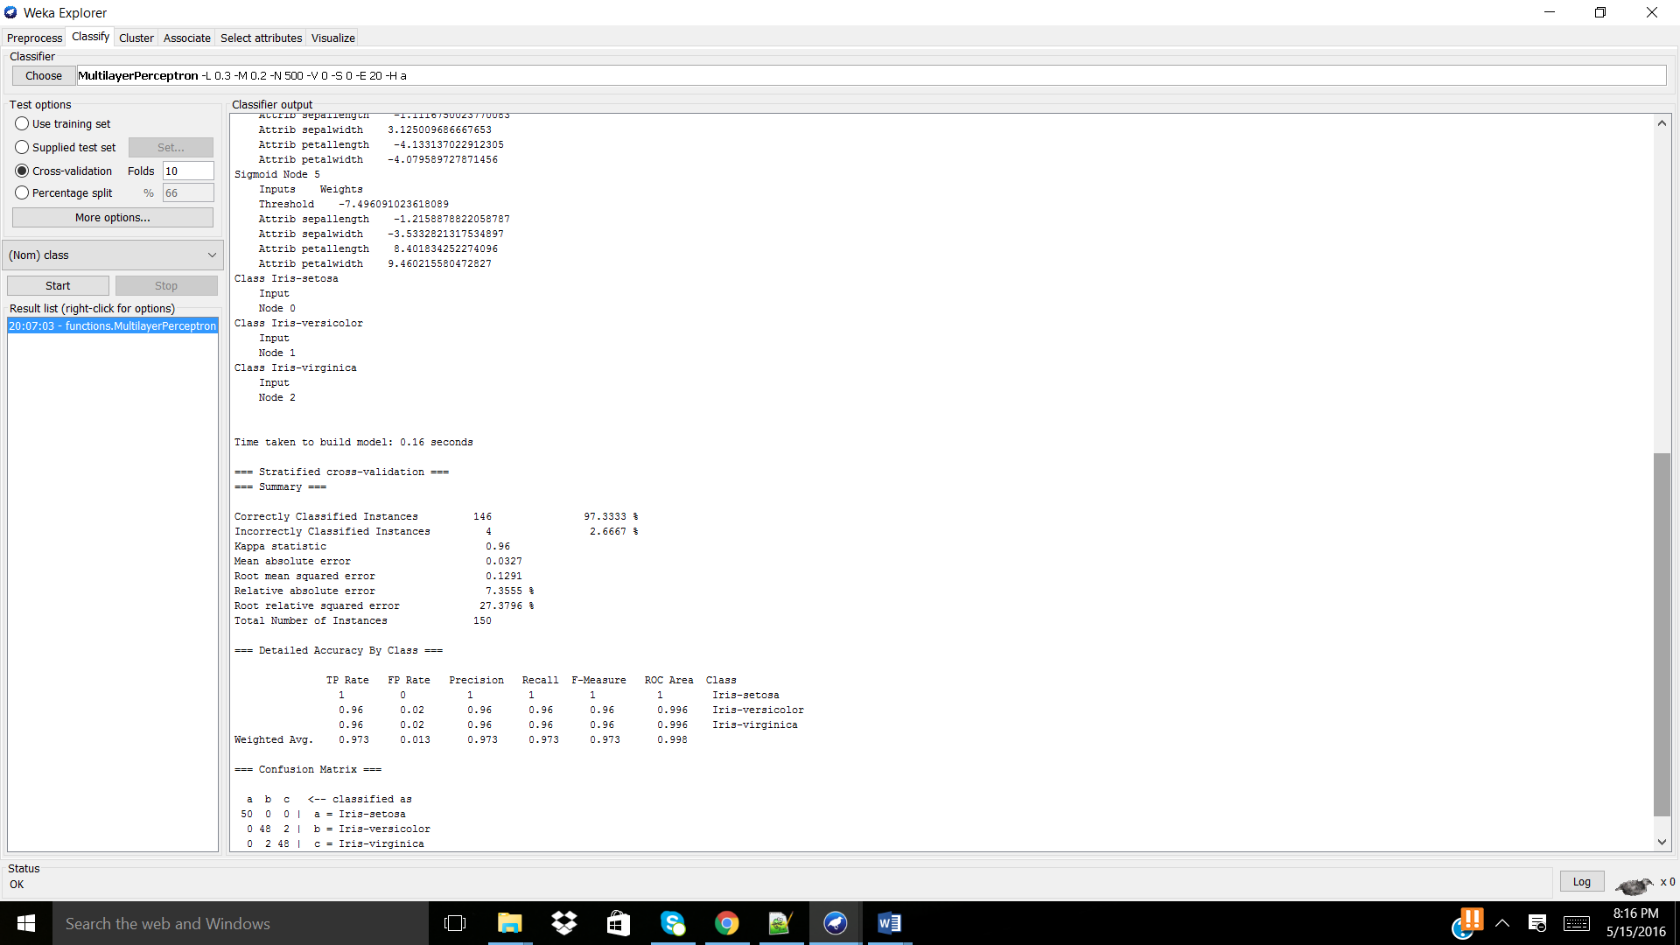
The model correctly classified 146/150 instances with a mean absolute error of 0.0327.
Next, the learning rate and training rate were fluctuated in order to determine the effect on the NN’s accuracy:
Learning rate | Training rate | Correctly classified instances (#/150) | Mean absolute error
0.3 | 500 | 146 | 0.0327
0.4 | 500 | 146 | 0.0315
0.5 | 500 | 146 | 0.0304
0.7 | 500 | 146 | 0.0301
0.7 | 400 | 145 | 0.0311
0.7 | 600 | 145 | 0.298
0.7 | 700 | 146 | 0.0296
0.7 | 1000 | 146 | 0.027
0.7 | 2000 | 146 | 0.0223
From iterative processing, it was found that in this data set the parameters which allowed for the lowest mean absolute error while preserving the highest accuracy of the system was when:
learning rate = 0.7 training rate = 2000 (or higher, since the mean absolute error is nearing the absolute minima)
correctly classified instances were = 146/150 mean absolute error = 0.0223
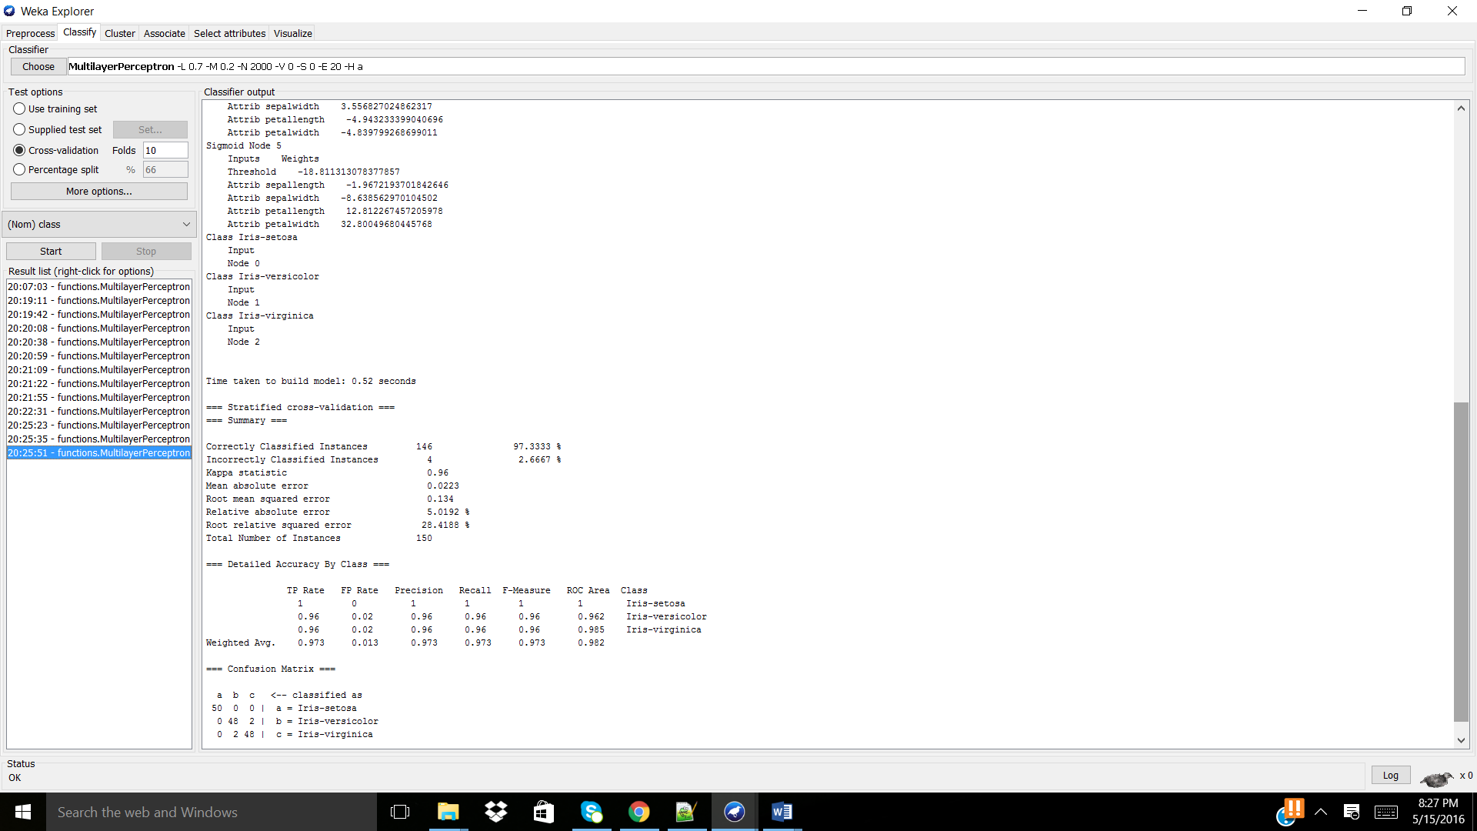
- Built the most accurate neural network from a dataset available via UCI KDD archive: http://kdd.ics.uci.edu/summary.data.alphabetical.html. Describe how you came to the model you decided to keep. Report your findings in enough detail that they can be reproduced.
A. From https://archive.ics.uci.edu/ml/machine-learning-databases/adult/adult.data , the adult.data file was downloaded and uploaded into Excel (comma-delimiter applied). The attribute values were found from: https://archive.ics.uci.edu/ml/machine-learning-databases/adult/old.adult.names and filled into the Excel file. The file was saved as a CSV file and was uploaded into Weka.

B. The adult.data.csv data set was uploaded into Weka. There are 15 attributes (with a variety of data types – numeric or nominal) for 32561 instances. Considering that this data set is large, only the first 5000 instances will be used for further calculations. No further preprocessing was necessary as the MultiLayerPerceptron can take both nominal and attribute values. Furthermore, it should be noted that 7% of the values are missing in the entire data set. Note: the class was to predict is the salary is greater or less than 50,000.
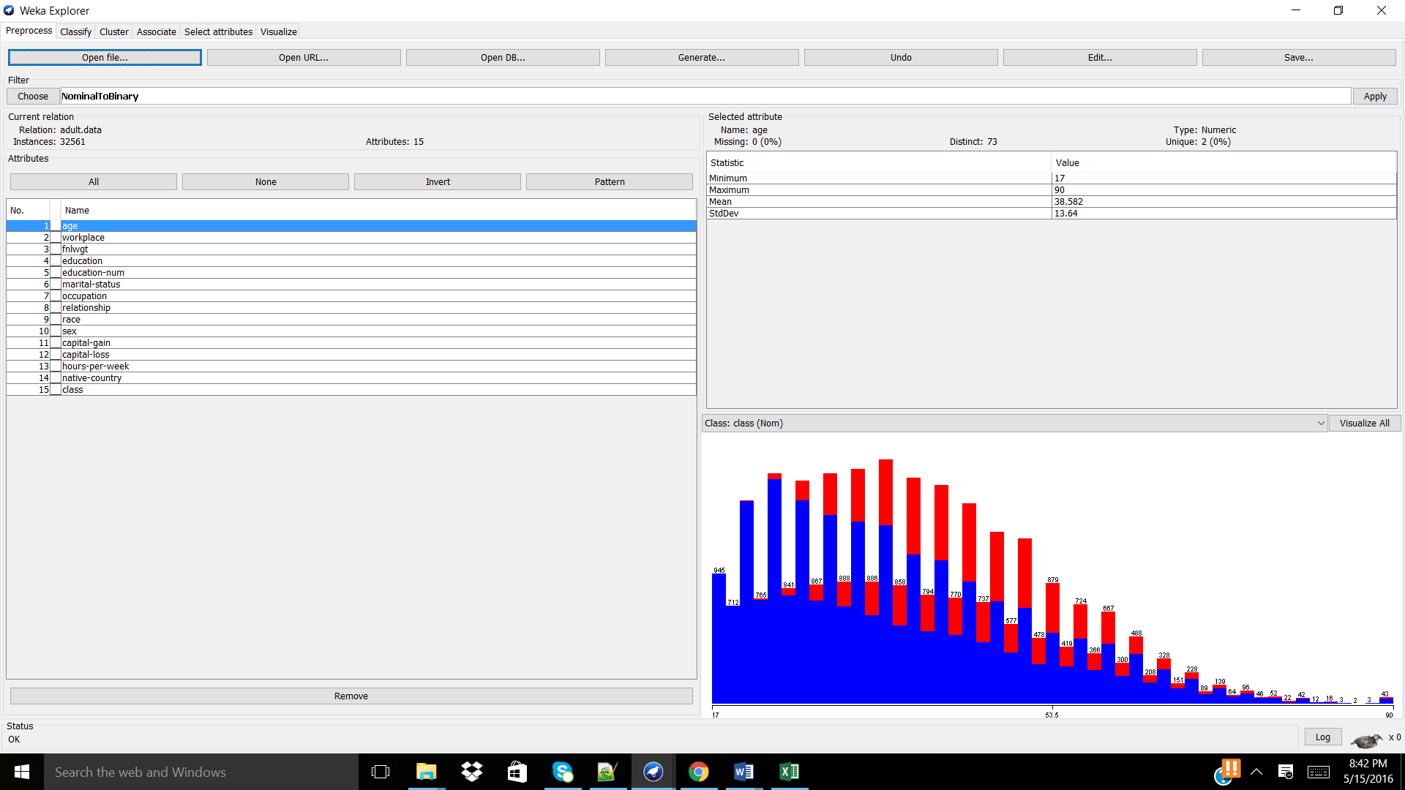
C. “Visualize all” was used in order to understand the instance distributions.
For all 32561 instances.
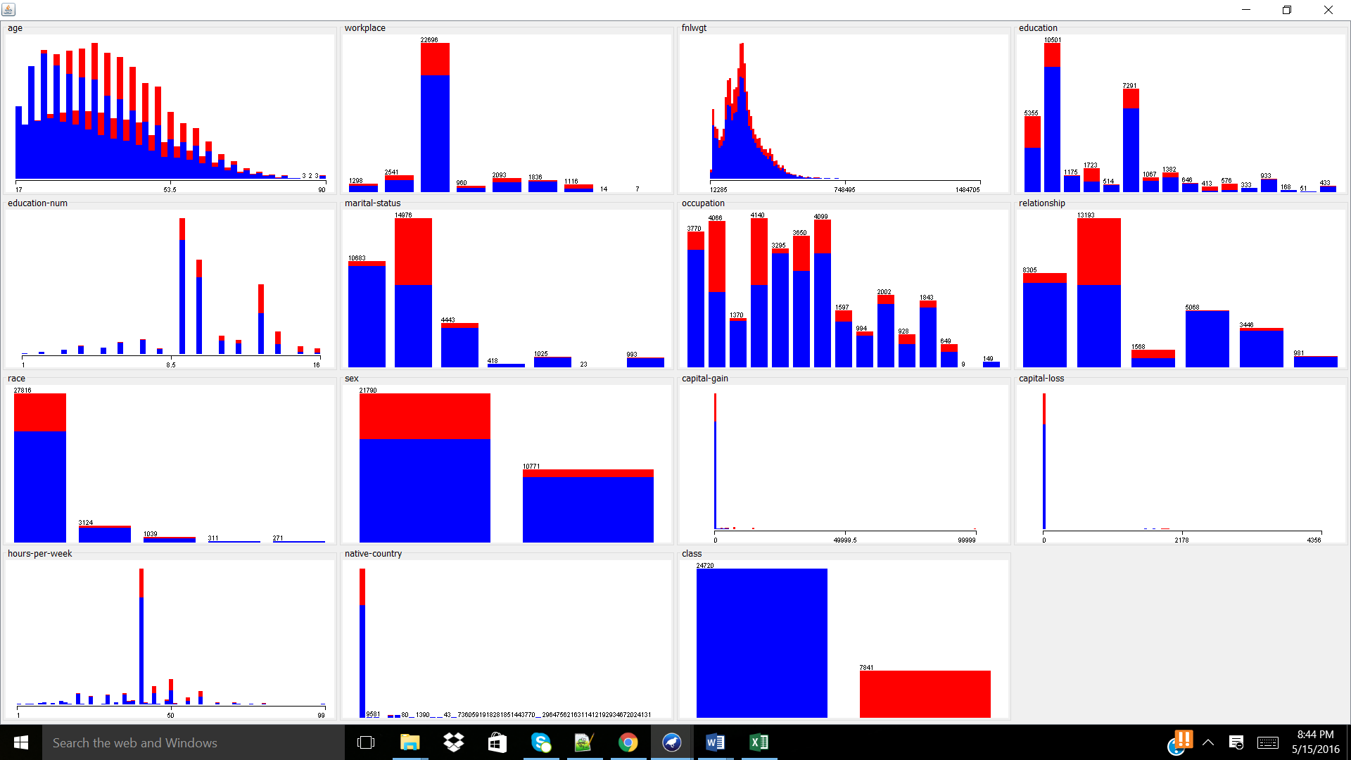
For 5000 instances.
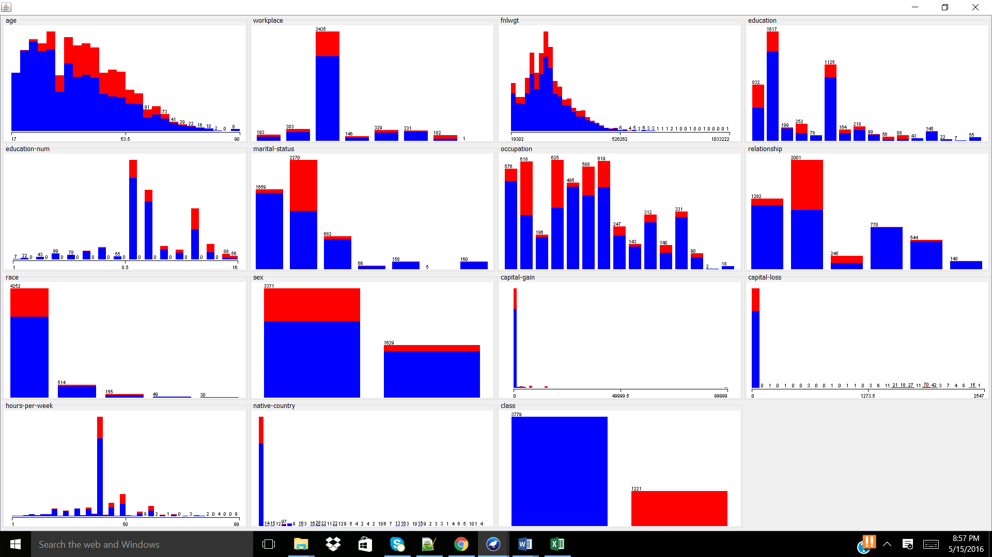
It should be noted, that the instance distributions are similar therefore applicable to further data mining applications to use 5000 attributes. Also, not as much computation time or energy must be utilized with this smaller data set.
D. Next, Weka’s neural network classifier, MultiLayerPerceptron, was applied, since it uses backpropagation to classify instances into the class attribute. Note: Cross-validation Folds 3 was used in order to decrease computational power.
The learning rate and training time were varied, similarly to how it was done above, in order to determine the most accurate NN model:
Learning rate | Training rate | Correctly classified instances (#/5000) | Mean absolute error
0.5 | 100 | 4067 | 0.1963
0.6 | 100 | 3968 | 0.2121
0.4 | 100 | 4067 | 0.1922
0.3 | 100 | 3975 | 0.2037
0.4 | 200 | 4085 | 0.1883
0.4 | 300 | 4134 | 0.1783
From iterative processing, it was found that in this data set the parameters which allowed for the lowest mean absolute error while preserving the highest accuracy of the system was when:
learning rate = 0.4 training rate = 300(or higher)
correctly classified instances were = 4234 mean absolute error = 0.1783
Parameters set:
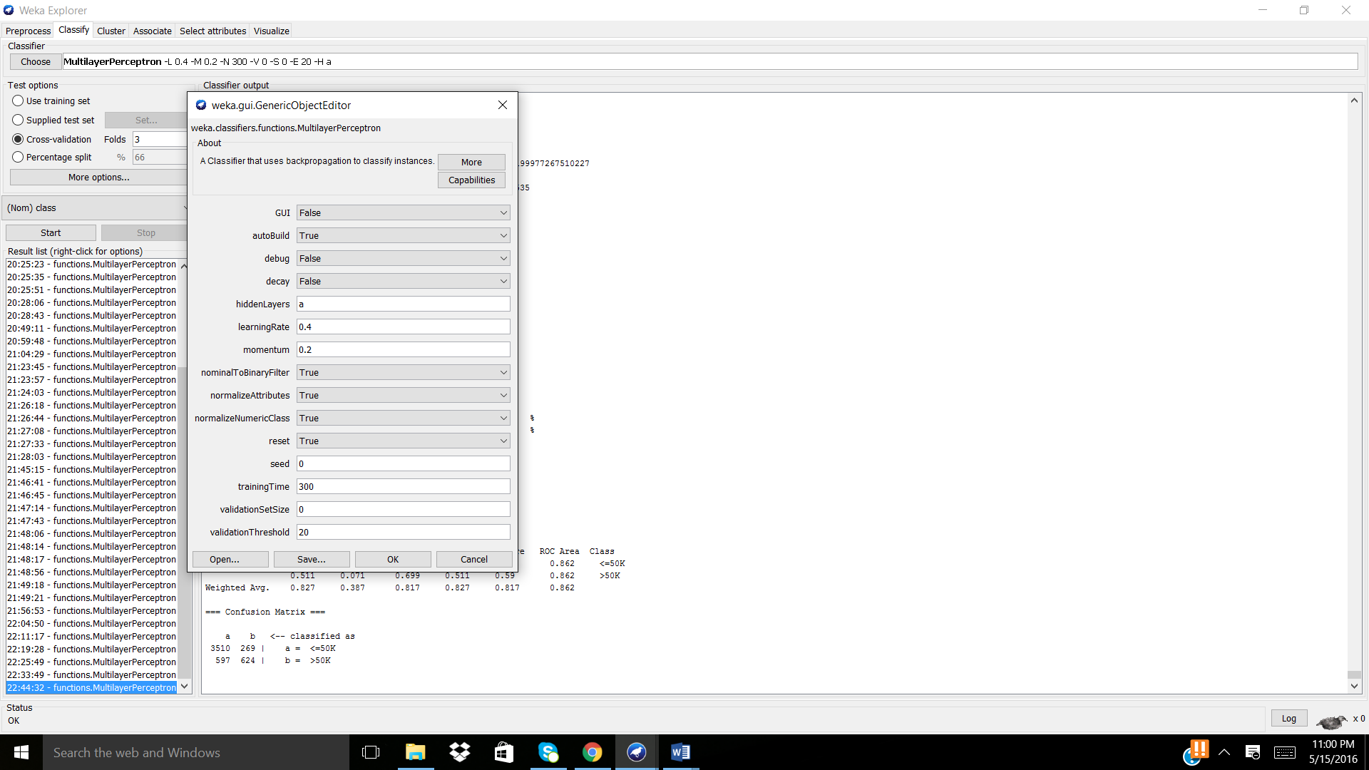

Model Produced:
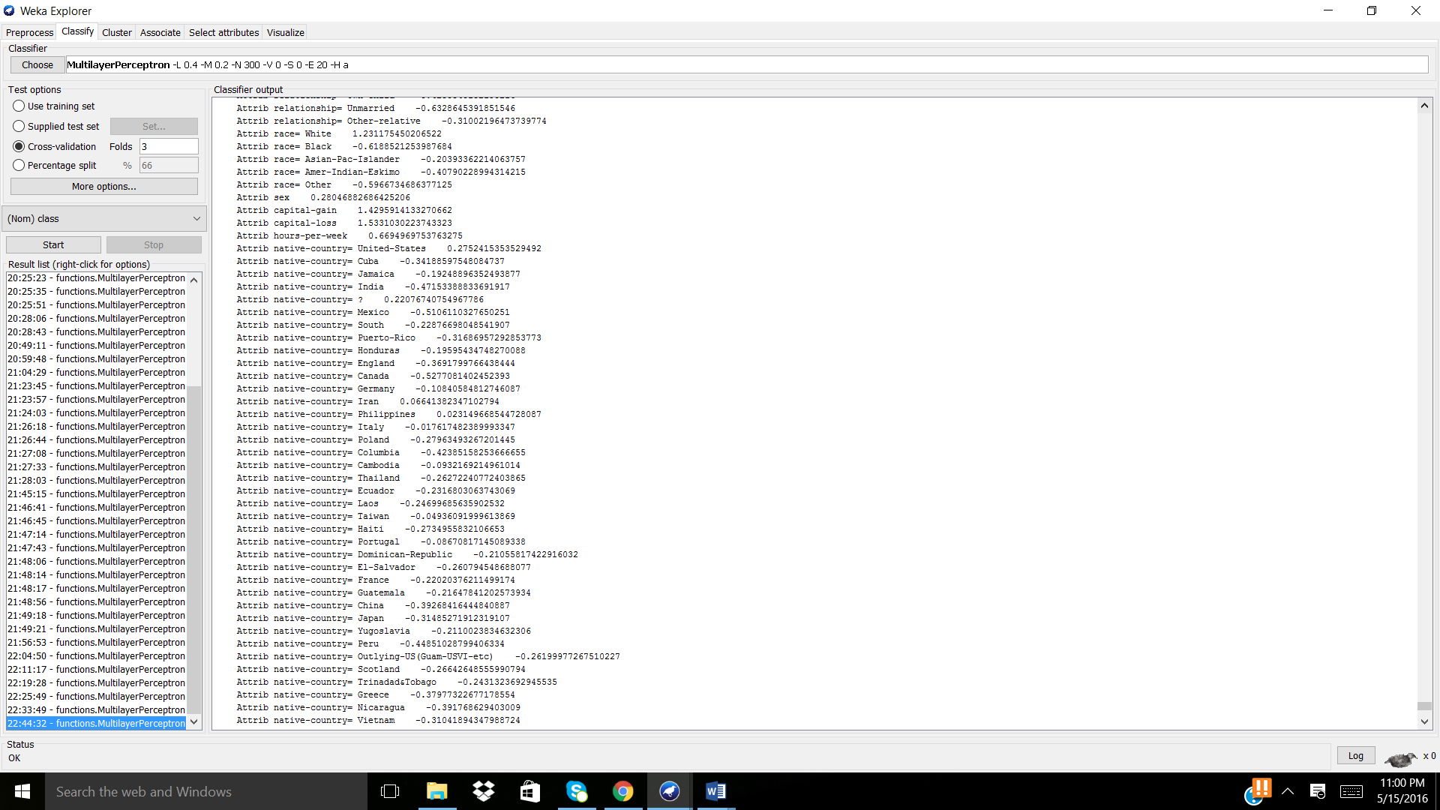

Note: This is a large data set, thus in order to get an even more accurate answer more computation power and time is necessary. Yet the model produced would be able to perform with some degree of accuracy for the entire data set.

