
University of Asia Pacific

Department of Computer Science & Engineering

Course Title : Microprocessors and Microcontrollers Lab
Course Code : CSE 316
Report No : 03
Report Title : Touch Sensor Door Lock System
Date : 26 - 04 - 2026
c

Submitted By : Submitted To :
Name : Md. Osman Goni Khadiza Sultana Sayma
Reg. No : 23101012 Lecturer, Department of CSE
Section : A1 University Of Asia Pacific.
- Experiment Name
Touch Sensor Door Lock System

2. Objective
To design and implement a touch/push-button based door lock system using Arduino, where a servo motor locks/unlocks the door and a buzzer provides different sound indications for each action.

3. Apparatus / Hardware & Software Requirements
- Hardware
- Arduino Uno
- Push button / Touch sensor ( digital input )
- Servo motor
- Buzzer
- Breadboard
- Jumper wires
- USB cable / 5V supply
Software
- Arduino IDE
- Arduino Servo library (#include <Servo.h>)

4. Circuit Diagram / Schematic
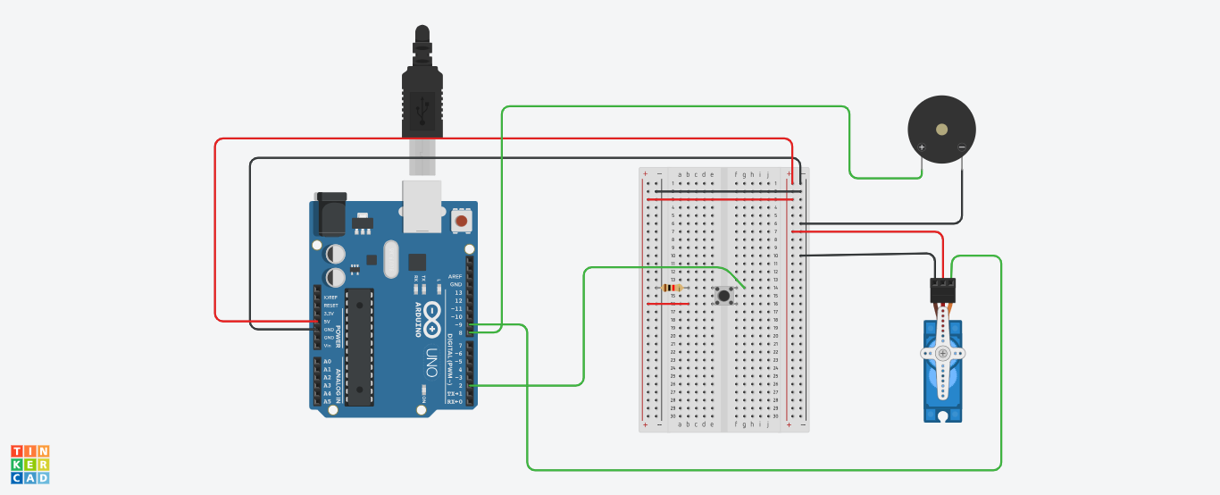
5. Code / Assembly Program

#include <Servo.h>
Servo myServo;
const int PushPin = 2;
const int buzzerPin = 8;
const int servoPin = 9;
bool doorLocked = true;
void setup() {
pinMode(PushPin, INPUT);
pinMode(buzzerPin, OUTPUT);
myServo.attach(servoPin);
myServo.write(0); // Initially locked position
}
void loop() {
int touchState = digitalRead(PushPin);
if (touchState == HIGH) {
if (doorLocked) {
// Unlock door
myServo.write(90);
tone(buzzerPin, 200, 500000);
delay(200);
noTone(buzzerPin);
doorLocked = false;
} else {
// Lock door
myServo.write(0);
tone(buzzerPin, 500, 400000);
delay(400);
noTone(buzzerPin);
doorLocked = true;
}
delay(1000);
}
}

6. Output / Observations
- The system starts in locked position (servo at 0°).
- When the touch/push input is detected HIGH, the Arduino toggles the door state:
  - If locked → it unlocks and gives a buzzer tone.
  - If unlocked → it locks and gives a different buzzer tone.
- The system waits briefly (delay(1000)) to avoid rapid repeated toggling.

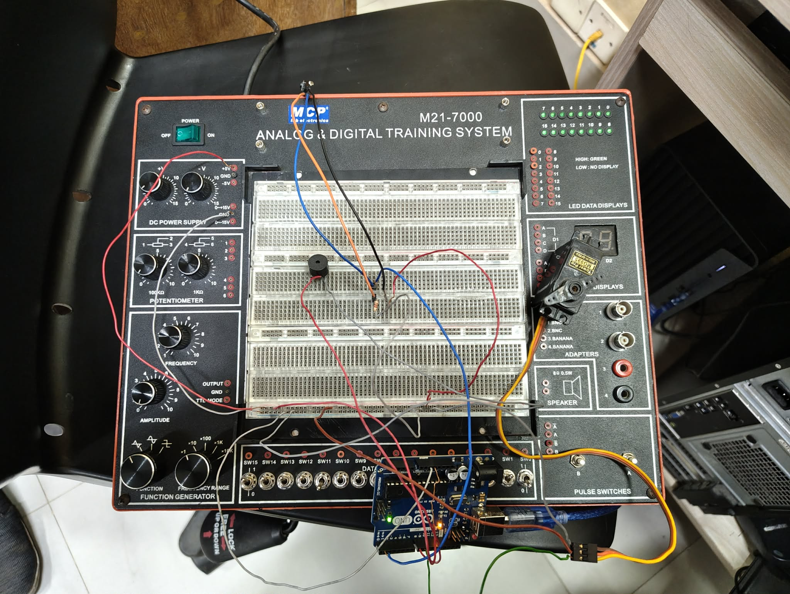

7. Result
After implementing and testing the system, the following observations were recorded:
Unlock Action (when doorLocked = true):
When the button was pressed while the door was locked, the servo rotated to 90° (unlock position). The buzzer produced a low-frequency tone (200 Hz), indicating successful unlocking. The door state changed to unlocked and the system responded correctly.
Lock Action (when doorLocked = false):
When the button was pressed again while the door was unlocked, the servo rotated back to 0° (lock position). The buzzer produced a higher-frequency tone (500 Hz), indicating successful locking. The door state changed back to locked and the cycle repeated properly.

8. Conclusion
This project provided practical experience in building a simple access-control system using Arduino. It strengthened understanding of digital input reading, controlling a servo motor for mechanical movement, and using a buzzer for audio feedback. The experiment also improved skills in implementing toggle logic using a state variable (doorLocked) and coordinating multiple outputs reliably.
Overall, the touch sensor door lock system worked as expected: each press alternated between lock and unlock states with clear visual/mechanical action from the servo and distinct sound feedback from the buzzer. This setup offers a strong foundation for future enhancements such as adding RFID, keypad security, password control, or wireless access features.

