
University of Asia Pacific

Department of Computer Science & Engineering

Course Title : Microprocessors and Microcontrollers Lab
Course Code : CSE 316
Report No : 04
Report Title : Wireless Theft Detection
Date : 03 - 05 - 2026
c

Submitted By : Submitted To :
Name : Md. Osman Goni Khadiza Sultana Sayma
Reg. No : 23101012 Lecturer, Department of CSE
Section : A1 University Of Asia Pacific.
- Experiment Name

Wireless Theft Detection

2. Objective
To design and implement a touch/push-button based door lock system using Arduino, where a servo motor locks/unlocks the door and a buzzer provides different sound indications for each action.

3. Apparatus / Hardware & Software Requirements
Hardware
- Arduino Uno (or compatible)
- PIR motion sensor (e.g., HC-SR501)
- Servo motor (e.g., SG90)
- Buzzer
- LED + current-limiting resistor (220Ω–330Ω)
- Push button
- Breadboard and jumper wires
- USB cable / 5V supply
Software
- Arduino IDE
- Arduino Servo library (#include <Servo.h>)

4. Circuit Diagram / Schematic

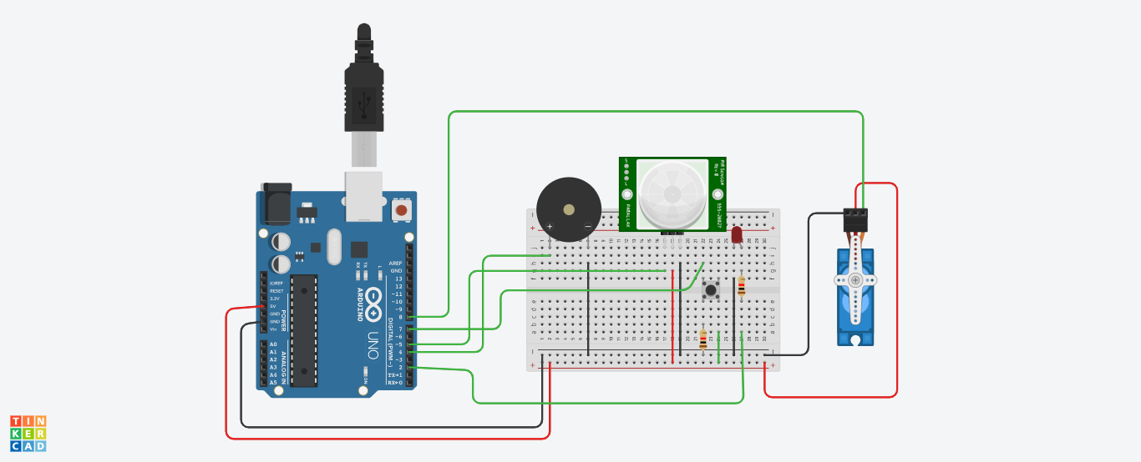

#include <Servo.h>
5. Code / Assembly Program

// Pin setup

int pirPin = 5; // PIR sensor

int buzzerPin = 4; // Buzzer

int ledPin = 2; // LED

int servoPin = 8; // Servo

int buttonPin = 7; // Push button

int motionState = LOW;

bool systemOn = false; // Mode OFF initially

Servo myServo;

void setup() {

pinMode(pirPin, INPUT);

pinMode(buzzerPin, OUTPUT);

pinMode(ledPin, OUTPUT);

pinMode(buttonPin, INPUT_PULLUP); // Button

myServo.attach(servoPin);

myServo.write(0); // Initial position

}

void loop() {

static bool lastButtonState = HIGH;

bool currentButtonState = digitalRead(buttonPin);

if (lastButtonState == HIGH && currentButtonState == LOW) {

systemOn = !systemOn; // Toggle mode

delay(300);

}

lastButtonState = currentButtonState;

if (!systemOn) {

motionState = digitalRead(pirPin);

if (motionState == HIGH) {

// Motion detected

digitalWrite(ledPin, HIGH);

digitalWrite(buzzerPin, HIGH);

myServo.write(0); // Rotate servo

tone(buzzerPin, 200, 500000);

delay(200);

noTone(buzzerPin);

Serial.println("Motion Detected!");

} else {

// No motion

digitalWrite(ledPin, LOW);

digitalWrite(buzzerPin, LOW);

noTone(buzzerPin);

myServo.write(0); // Back to normal

}

}

else {

motionState = digitalRead(pirPin);

if (motionState == HIGH) {

// Motion detected

digitalWrite(ledPin, HIGH);

myServo.write(90); // Rotate servo

} else {

// No motion

digitalWrite(ledPin, LOW);

digitalWrite(buzzerPin, LOW);

myServo.write(0);

}

}

delay(200);

}

6. Output / Observations
- The system has two modes controlled by the push button:
  - Mode 1 (systemOn = false): Alarm mode (LED + buzzer tone + message)
  - Mode 2 (systemOn = true): Silent mode (LED + servo movement only)
- Pressing the button toggles the mode; a small delay is used for basic debounce.
- When motion is detected, the PIR sensor output becomes HIGH, and the system responds according to the selected mode.

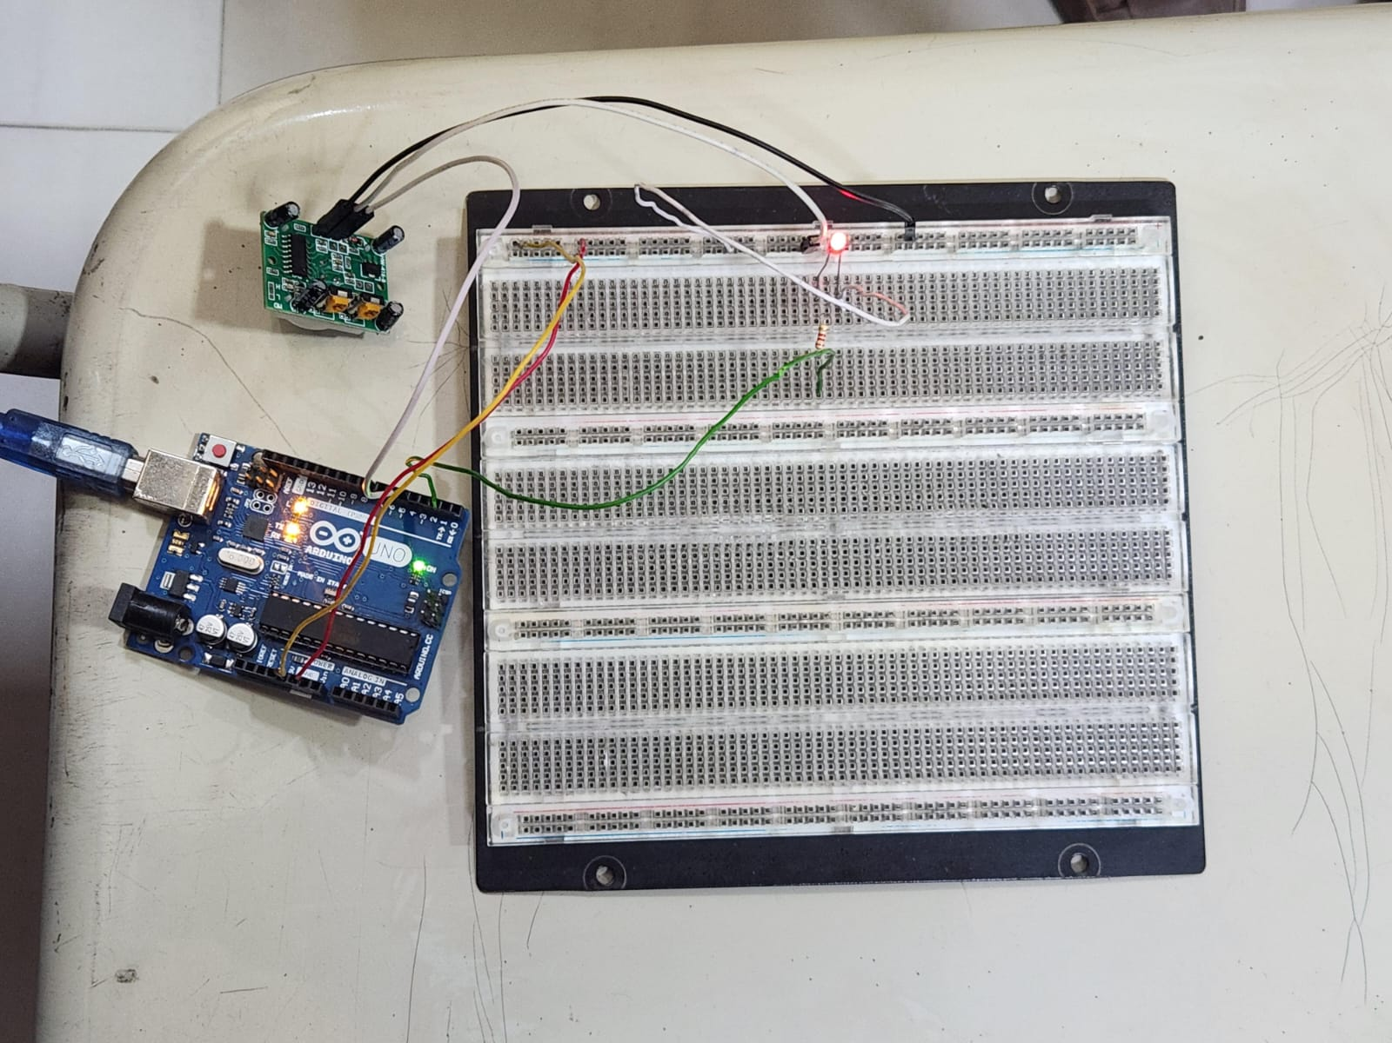

7. Result
After implementing and testing the system, the following observations were recorded:
Alarm Mode (systemOn = false):
When motion was detected, the LED turned ON and the system triggered the buzzer tone (200 Hz), indicating an alert condition. The Serial Monitor (after adding Serial.begin) displayed “Motion Detected!”. When no motion was present, the LED and buzzer turned OFF, and the system returned to standby.
Silent Mode (systemOn = true):
When motion was detected, the LED turned ON and the servo rotated to 90°, indicating a motion-triggered action without sound. When motion was not detected, the LED turned OFF and the servo returned to 0°, keeping the system in a normal idle state.

8. Conclusion
This experiment provided practical understanding of sensor-based automation using Arduino and improved skills in reading a PIR sensor’s digital output to control multiple actuators. It strengthened concepts such as mode selection using a push button (INPUT_PULLUP), conditional logic for different system behaviors, and coordinating outputs like LEDs, buzzer alerts, and servo positioning.
Overall, the system successfully detected motion and produced correct responses in both modes—an audible alarm mode and a silent servo-based mode. This project forms a strong foundation for future smart security and automation applications such as intrusion alarms, automatic doors, and motion-triggered access control systems.

