
University of Asia Pacific

Department of Computer Science & Engineering

Course Title : Microprocessors and Microcontrollers Lab
Course Code : CSE 316
Report No : 06
Report Title : Remote AC Bulb Control
Date : 25 - 05 - 2026
c

Submitted By : Submitted To :
Name : Md. Osman Goni Khadiza Sultana Sayma
Reg. No : 23101012 Lecturer, Department of CSE
Section : A1 University Of Asia Pacific.

- Experiment Name
Remote AC Bulb Control

Objective
To control an AC bulb wirelessly using an IR remote, Arduino, a relay module, and an IR receiver, so the bulb can be switched ON or OFF at a distance.

Apparatus / Hardware & Software Requirements
Hardware:
- Arduino UNO board
- IR Receiver sensor
- IR Remote (as shown, standard NEC protocol remote)
- Relay Module (suitable for AC voltage)
- AC Bulb with holder and wiring
- 9V Battery for relay/bulb
- Breadboard and connecting wires
- USB Cable for Arduino
Software:
- Arduino IDE
- IRremote library for Arduino (#include <IRremote.hpp>)

4. Circuit Diagram / Schematic
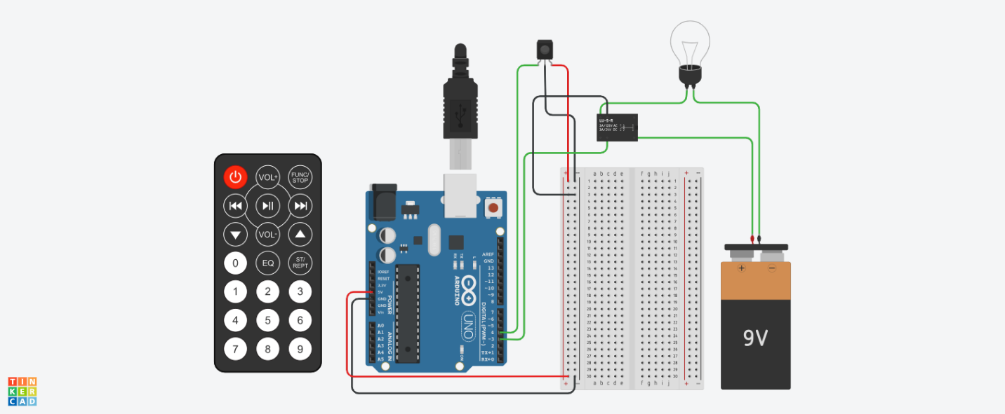

- Code / Assembly Program
#include <IRremote.hpp>
const int relayPin = 3;
const int rcvPin = 4;
void setup() {
pinMode(relayPin, OUTPUT);
digitalWrite(relayPin, LOW);
Serial.begin(9600);
IrReceiver.begin(rcvPin, ENABLE_LED_FEEDBACK);
Serial.println("IR receiver ready...");
}
void loop() {
if (IrReceiver.decode()) {
unsigned long value = IrReceiver.decodedIRData.decodedRawData;
Serial.print("IR code: ");
Serial.println(value);
switch (value) {
// ON button (replace with your remote code)
case 4010852096:
Serial.println("Bulb ON");
digitalWrite(relayPin, HIGH);
break;
// OFF button
case 4077698816:
Serial.println("Bulb OFF");
digitalWrite(relayPin, LOW);
break;
default:
Serial.println("Unknown button");
break;
}
IrReceiver.resume();
}
delay(200);
}

- Output / Observations

- On startup, Serial Monitor displays:
IR receiver ready...
- When a remote button is pressed, the Arduino prints the received value:
IR code: <number>
- If the received code matches a stored ON/OFF code, it prints:
  - Bulb ON and sets relay pin HIGH
  - Bulb OFF and sets relay pin LOW
- If a different button is pressed, it prints:
Unknown button
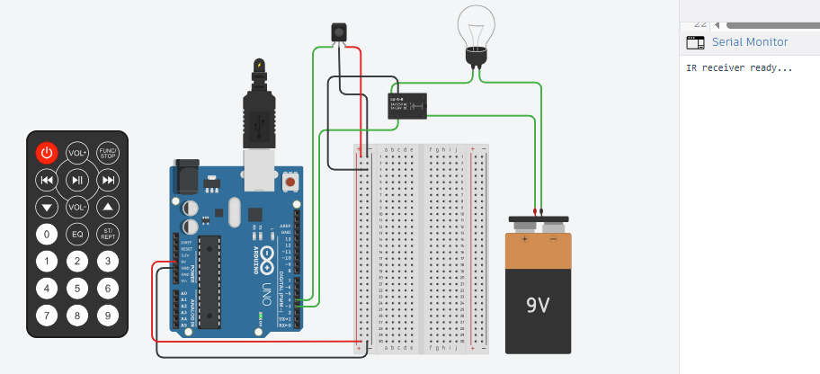
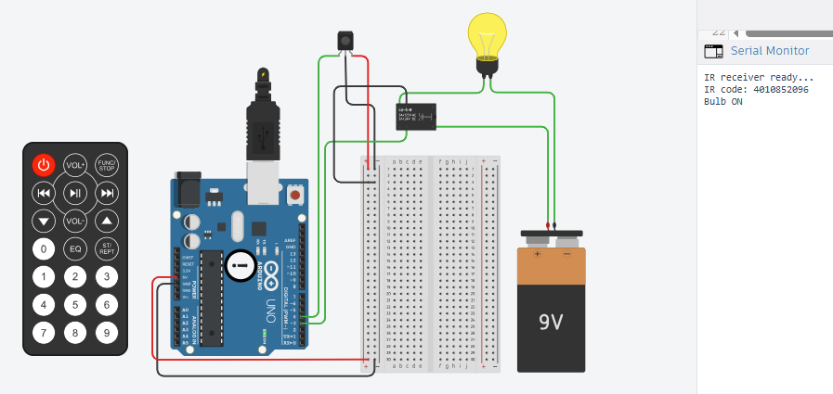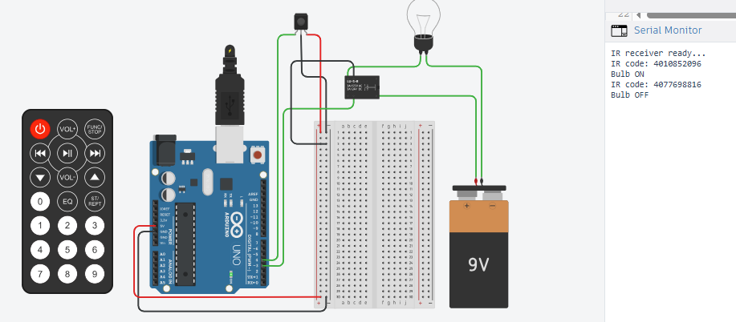
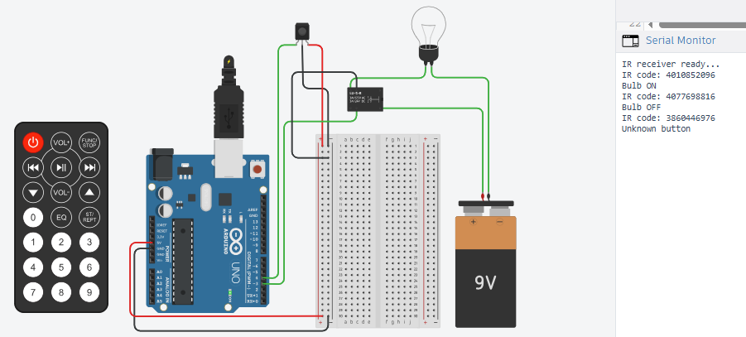

7. Result

After implementing and testing the system, the following observations were recorded:

Pressing the programmed ON button (code 4010852096) energized the relay and the AC bulb turned ON.

Pressing the programmed OFF button (code 4077698816) de-energized the relay and the AC bulb turned OFF.

Other buttons produced “Unknown button” until their codes were added to the switch cases.

The system successfully demonstrated reliable remote switching, confirmed by Serial Monitor outputs and the bulb’s response.

8. Conclusion
This project successfully implemented remote AC load control using an IR remote and Arduino. It demonstrated IR signal decoding with the IRremote library and safe switching of higher-voltage loads using a relay. The Serial Monitor provided a clear method to capture remote button codes and map them to ON/OFF actions.
With minor enhancements (adding more button functions, debouncing/repeat-code handling, and using a proper relay module enclosure), the design can be expanded into a practical home automation-style controller.

