Question A

/home/ohenryiyasere2

Question B

The difference is the csc3320

Question C

$ pwd

Question D

$ Mkdir lab2

Question E

$cd lab2

Question F

The shell interprets the '>' character as a specifier for redirection of standard output. In the example cited, it refers to the standard output of 'cat'. The output is redirected to the file. And Ctrl+D is used to exit the file and return to the command prompt.

Question G

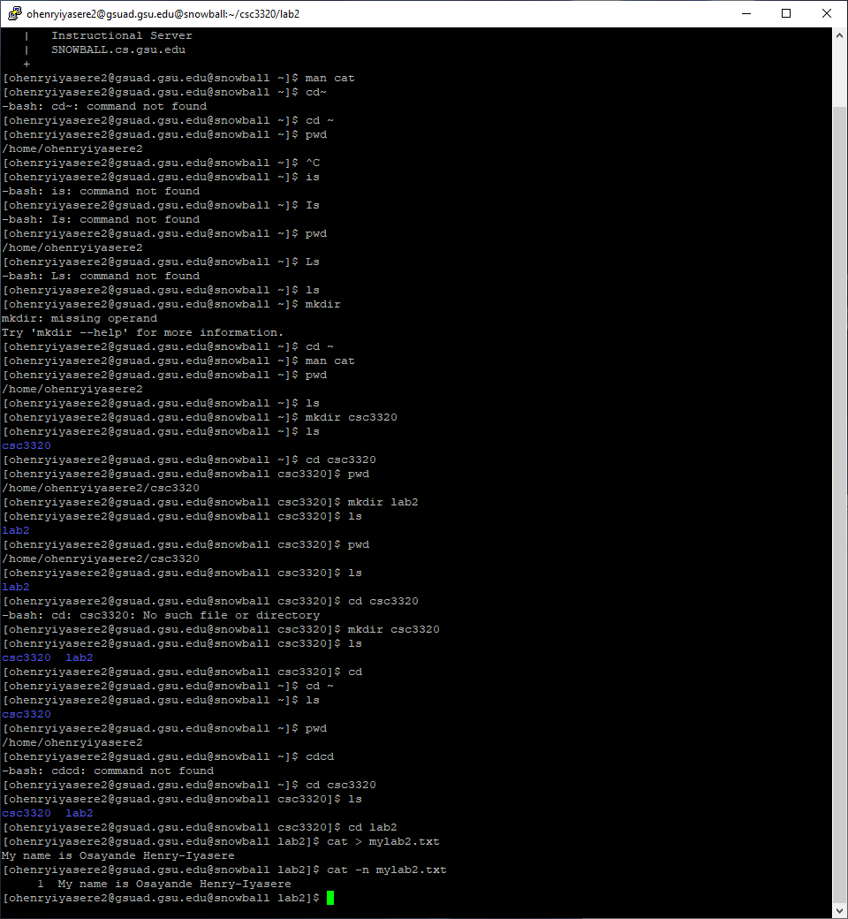

Question H

